Question #1 (6 pts)

A voltage amplifier has the open circuit voltage gain of A_{v} = 2, an input resistance R_{in} of 100KΩ, and an output resistance R_{o} of 10KΩ. The amplifier has a linear characteristic with output saturation at 15V and –7V.

(a) Draw the voltage transfer characteristic of this amplifier. (1 pt)

The amplifier is inserted into the following circuit:

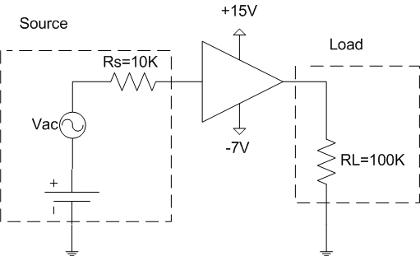
V_{L}
V_{dc}

(b) Determine V_{dc} so that the largest possible output swing can be obtained without voltage clipping. (2 pts)

(c) Assuming V_{dc}=0 and V_{ac}=13.2cos(2000x2πt) Volt, draw the voltage waveform at the output. (1 pt)

(d) Consider V_{dc}=0, V_{ac}=1cos(2000x2πt) mVolt, and the source resistance and the load resistance remain R_{s}=10KΩ and R_{L}=100KΩ, respectively. How many stages of the amplifier are required to obtain the overall voltage gain (V_{L}/V_{ac}) of at least 5.5? (2 pts)
QUESTION 1 (SOLUTION)

(a)
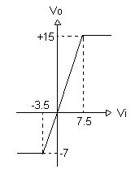
(b) largest possible output swing without voltage clipping is obtained when the input is biased midway between V_{DD} and V_{SS}:

V_{idc}= (7.5+(-3.5))/2 = 2^{V} =$V_{\text{dc}}\frac{R_{\text{in}}}{R_{\text{in}}+R_{s}}$
$$V_{\text{dc}}=V_{\text{idc}}\frac{R_{\text{in}}+R_{s}}{R_{\text{in}}}=2\frac{\text{100}K+\text{10}K}{\text{100}K}=2\text{.}2^{V}$$

(c)
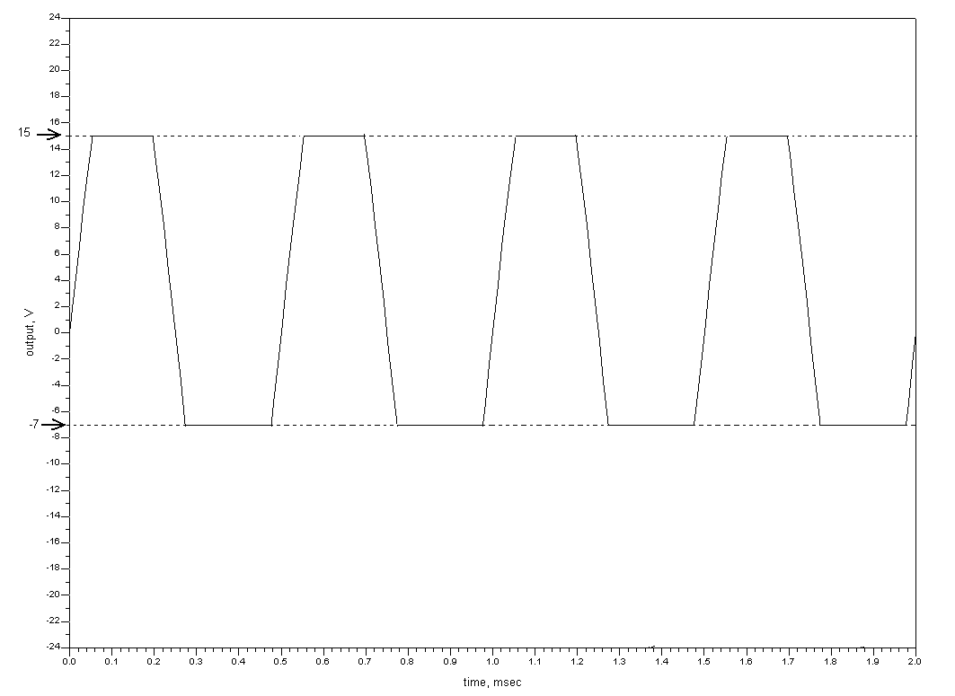

(d) V_{dc}=0 & |V_{ac}|=1^{mV}, thus there’s no voltage clipping even after amplification.

V_{i}=input voltage of the i^{th} amplifier.

$$V_{1}=V_{\text{in}}\frac{R_{\text{in}}}{R_{\text{in}}+R_{s}}=V_{\text{in}}\frac{\text{100}K}{\text{100}K+\text{10}K}=V_{\text{in}}\frac{\text{10}}{\text{11}}$$
$$V_{o1}=2V_{1}=V_{\text{in}}\frac{\text{20}}{\text{11}}$$
$$V_{2}=V_{o1}\frac{R_{\text{in}}}{R_{\text{in}}+R_{o}}=V_{\text{in}}×2×\frac{\text{10}}{\text{11}}×\frac{\text{10}}{\text{11}}$$
$$V_{o2}=2V_{2}=V_{\text{in}}×2×2×\frac{\text{10}}{\text{11}}×\frac{\text{10}}{\text{11}}$$
$$V_{3}=V_{o2}\frac{R_{\text{in}}}{R_{\text{in}}+R_{o}}=V_{\text{in}}×2×2×\frac{\text{10}}{\text{11}}×\frac{\text{10}}{\text{11}}×\frac{\text{10}}{\text{11}}$$
$$V_{o3}=2V_{3}=V_{\text{in}}×2×2×2×\frac{\text{10}}{\text{11}}×\frac{\text{10}}{\text{11}}×\frac{\text{10}}{\text{11}}$$
$$V_{o}=V_{o3}\frac{R_{L}}{R_{L}+R_{o}}=V_{\text{in}}×2×2×2×\frac{\text{10}}{\text{11}}×\frac{\text{10}}{\text{11}}×\frac{\text{10}}{\text{11}}×\frac{\text{10}}{\text{11}}=5\text{.}\text{46}×V_{\text{in}}$$
$⇒$ we must have at least four stages
Question #2 (9 Points)

In the following circuit, all diodes are identical and$I_{s}={\text{10}}^{−9}A,n=2,V_{T}=\text{25}\text{mV}$.

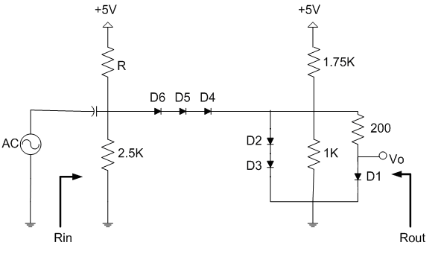

By using the exponential model for all diodes:

(a) Determine R such that V_{o}=0.75V. (3 pts)

(b) Derive the general expression for the small signal resistance of a diode. (1 pt)

(c) Draw the small signal equivalent circuit for the circuit shown above. Make sure to calculate the numerical values of the small signal resistances of all diodes. (3 pts)

(d) From the small signal equivalent circuit, calculate the small signal input and output resistances, R_{in} and R_{out}. (2 pts)

QUESTION 2 (SOLUTION)

(a)
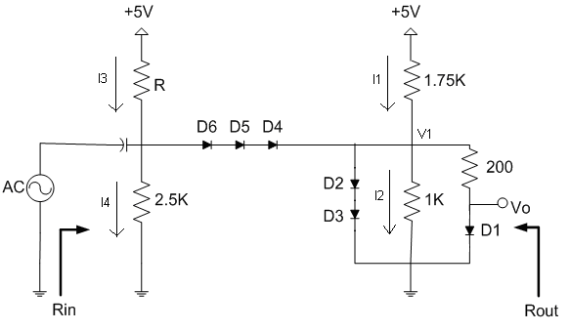

V_{o}= V_{D1}=0.75^{V}
$$I_{D1}=I_{s}(e^{\frac{V_{D1}}{{\text{nV}}_{T}}}−1)=3\text{.}{\text{27}}^{\text{mA}}$$

$$⇒V_{1}=0\text{.}\text{75}+\text{200}×0\text{.}\text{00327}=1\text{.}4^{V}$$
$$⇒V_{D2}=V_{D3}=0\text{.}7^{V}$$
$$⇒I_{D2}=I_{D3}=I_{s}(e^{\frac{V_{D2}}{{\text{nV}}_{T}}}−1)=1\text{.}2^{\text{mA}}$$

I₁=(5-V₁)/1.75K=2^{mA}

I₂=V₁/1K=1.4^{mA}

I_{D4}=I_{D5}=I_{D6}=(I_{D2}+I_{D1}+I₂)-I₁=3.87^{mA}
$$⇒V_{D4}={\text{nV}}_{T}\text{ln}(\frac{I_{D4}}{I_{s}})=0\text{.}{\text{758}}^{V}$$
I₄=(V₁+3V_{D4})/2.5K=1.47^{mA}

I₃=I₄+I_{D4}=5.34^{mA}
$$⇒R=\frac{5−(V_{1}+3V_{D4})}{I_{3}}=\text{248}Ω$$
(b)
$$r_{d}={\left(\frac{∂i_{d}}{∂v_{d}}\right)}^{−1}={\left(\frac{∂}{∂v_{d}}(I_{s}e^{\frac{\text{Vd}}{\text{nVt}}})\right)}^{−1}={\left(\frac{I_{s}e^{\frac{\text{Vd}}{\text{nVt}}}}{{\text{nV}}_{T}}\right)}^{−1}=\frac{{\text{nV}}_{T}}{I_{d}}$$

(c)
$$r_{d}=\frac{{\text{nV}}_{T}}{I_{d}}$$
r_{D1}=15.3 Ω
r_{D2}= r_{D3}= 41.7 Ω
r_{D4}= r_{D5}= r_{D6}= 12.9 Ω

(d)

R₁=(200+15.3)||(1000)||(1750)||(2*41.7)=54.9 Ω

R_{in}=(248||2500)||(38.7+54.9)=66.15 Ω

R_{out}:

Input is shorted:

R_{o}=15.3||(200+(1000||1750||83.4||38.7))=14.32 Ω
Question #3 (10 Points)

Consider the following MOSFET circuit with the device parameters and supply voltages shown in the diagram. The channel length modulation can be ignored for all transistors.

(a) Calculate all drain currents and voltages; i.e. Id1, Id2 and Id3, and Vd1, Vd2, and Vd3. Make sure to verify the assumption you make for the mode of operation of M1, M2 and M3. (10 pts)

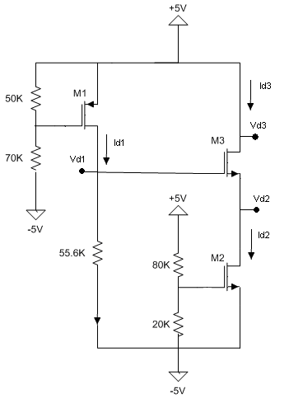
$\begin{aligned}μ_{n}C_{\text{ox}}=\text{50}{μA}/{V^{2}} \\ (\frac{W}{L})_{n}=2 \\ V_{T0n}=1V \\ γ_{n}=0\text{.}5V^{1/2} \\ 2ϕ_{n}=0\text{.}6V \\ \end{aligned}$ $\begin{aligned}μ_{p}C_{\text{ox}}=\text{25}{μA}/{V^{2}} \\ (\frac{W}{L})_{P}=2 \\ V_{T0p}=−1V \\ γ_{p}=0\text{.}5V^{1/2} \\ 2ϕ_{p}=−0\text{.}6V \\ \end{aligned}$

QUESTION 3 (SOLUTION)

Assume that M1 is in saturation mode:
$$\begin{aligned}V_{G1}=−5+\frac{\text{70}K}{\text{50}K+\text{70}K}\text{10}=0\text{.}{\text{83}}^{V} \\ V_{S1}=5^{V}=V_{B1} \\ I_{D1}=\frac{μ_{P}C_{\text{ox}}}{2}(\frac{W}{L})_{P}(|V_{\text{GS}1}|−|V_{T0P}|)^{2}=\frac{\text{25}×{\text{10}}^{−6}}{2}×2×(4\text{.}\text{17}−1)^{2}=\text{250}μA \\ \begin{aligned}\left.⇒V_{G3}=−5+I_{D1}∗\text{55600}=8\text{.}9^{V}>5^{V} | \right\}\end{aligned} \\ \end{aligned}⇒\text{our}\underset{}{}\text{assumption}\underset{}{}\text{was}\underset{}{}\text{incorrect}!⇒M1\underset{}{}\text{is}\underset{}{}\text{in}\underset{}{}\text{triode}\underset{}{}\text{mod}e(|V_{\text{GS}1}|>|V_{T0P}|):\begin{aligned}\left.I_{D1}=μ_{P}C_{\text{ox}}(\frac{W}{L})_{P}((V_{\text{GS}1}−V_{T0P})V_{\text{DS}}−\frac{1}{2}V_{{\text{DS}}^{2}})=\text{25}×{\text{10}}^{−6}×2×(3\text{.}\text{17}(5−V_{D})−\frac{1}{2}(5−V_{D})^{2}) | \right\}\end{aligned}⇒V_{D1}=\begin{aligned}\left\{3\text{.}\text{76} | \right.\end{aligned}$$
M1 is in triode mode!

Assume that M2 and M3 are in saturation mode:

$$\begin{aligned}V_{G2}=−5+\frac{\text{20}K}{\text{20}K+\text{80}K}\text{10}=−3^{V} \\ V_{S2}=−5^{V}=V_{B2} \\ I_{D2}=\frac{μ_{n}C_{\text{ox}}}{2}(\frac{W}{L})_{n}(V_{\text{GS}2}−V_{T0n})^{2}=\frac{\text{50}×{\text{10}}^{−6}}{2}×2×(2−1)^{2}=\text{50}μA \\ ⇒I_{D3}=\text{50}μA \\ I_{D3}=\frac{μ_{n}C_{\text{ox}}}{2}(\frac{W}{L})_{p}(V_{G3}−V_{S3}−(1+γ_{n}(\sqrt{2ϕ_{f}+V_{\text{SB}}}−\sqrt{2ϕ_{f}})))^{2} \\ \text{50}=\text{50}(3\text{.}\text{76}−V_{S3}−(1+0\text{.}5(\sqrt{0\text{.}6+V_{S3}+5}−\sqrt{0\text{.}6})))^{2} \\ ⇒−2\text{.}\text{15}−V_{S3}=0\text{.}5(\sqrt{5\text{.}6+V_{S3}}) \\ ⇒4V_{{S3}^{2}}−\text{18}\text{.}2V_{S3}+\text{12}\text{.}\text{89}=0 \\ ⇒V_{S3}=\frac{\text{18}\text{.}2±\text{11}\text{.}2}{8}=\begin{aligned}\left\{0\text{.}\text{875} | \right.\end{aligned} \\ \end{aligned}$$
$$\begin{aligned}⇒V_{\text{DS}2}=V_{D2}−V_{S2}=0\text{.}\text{875}−(−5)=5\text{.}{\text{875}}^{V}V_{\text{GS}2}−V_{T0n}=2−1=1\end{aligned}⇒M_{2}\underset{}{}\text{is}\underset{}{}\text{in}\underset{}{}\text{saturation}\underset{}{}\text{mod}eV_{\text{DS}3}=V_{D3}−V_{S3}=5−0\text{.}\text{875}=4\text{.}{\text{125}}^{V}V_{\text{GS}3}−V_{\text{Tn}}=2\text{.}\text{885}−(1+0\text{.}5(\sqrt{5\text{.}6+V_{S3}}−\sqrt{0\text{.}6}))=1⇒M_{3}\underset{}{}\text{is}\underset{}{}\text{in}\underset{}{}\text{saturation}\underset{}{}\text{mod}e$$
QUESTION 4 (SOLUTION)

(a) For DC analysis: Body and source voltages are different, therefore body effect should be included in finding the bias point by calculating the new Vt.
For AC analysis: Body and source voltages are the same because of the bypass capacitor across the current source, therefore VSB=0 and there is no need to include the body effect in the small signal model.

(b)Small signal equivalent circuit:

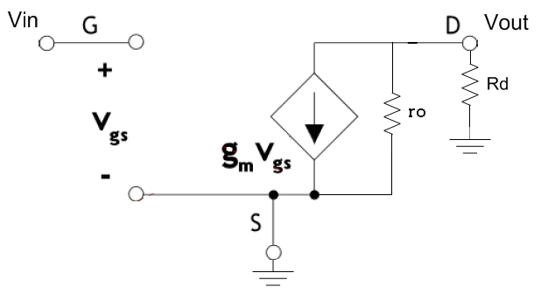

(c)
I_{D1}=g_{m1}V_{in}
V_{out}= -I_{D1}R_{out}= - g_{m1}V_{in} (R_{d}||r_{o1})
A_{v}= -g_{m1}(R_{d}||r_{o1})

(d)
R_{our}= (R_{d}||r_{o1})
R_{in}: VERY LARGE

