ECSE 330

INTRODUCTION TO ELECTRONICS

SPICE ASSIGNMENT

SIMON FOUCHER

ROHINA NEJAT

FRIDA CEJA GÓMEZ

Question 1 Diode Rectifier
- Bridge Rectifier
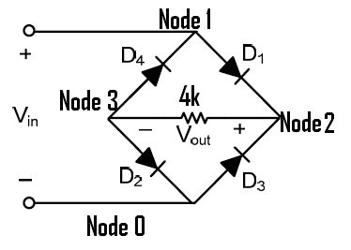

a) Plot the voltage transfer characteristic (VTC) of the rectifier for -10V<Vi<10V.

Bridge Rectifier

******************
*SPICE Assignment*
*ECSE330 *
******************
*********************************
*Q1I) Bridge Rectifier *
*The nodes as identified as *
* 1=top *
* 2=Right *
* 3=Left *
* 0=Bottom *
*********************************
******************
*Circuit Elements*
******************
*Resistor*
**********

R1 2 3 4K

********
*Diodes*
********

D1 1 2 diode
D4 3 1 diode
D2 3 0 diode
D3 0 2 diode

.model diode d(Is=2n n=1.8)

**************
*Power Supply*
**************
Vi 1 0 DC 0
**********
*Analysis*
**********
.op
.DC Vi -10 10 0.01
.probe
.end

Graph of Vout as a function of Vin

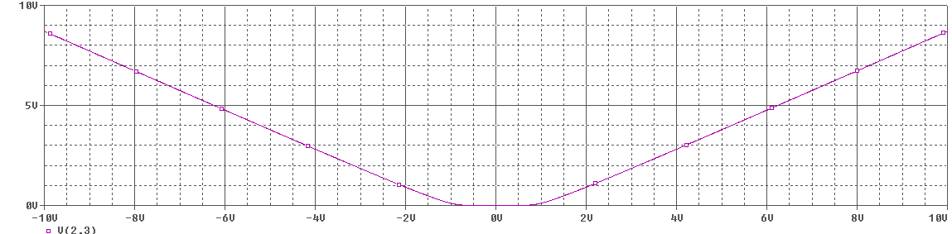

b) Plot Vout for a sinusoidal input with zero dc level, a peak value of 10V, and a frequency of 60Hz.
Bridge Rectifier

******************
*SPICE Assignment*
*ECSE330 *
******************
*********************************
*Q1I) Bridge Rectifier *
*The nodes as identified as *
* 1=top *
* 2=Right *
* 3=Left *
* 0=Bottom *
*********************************

*Circuit Elements*
******************
*Resistor*
**********

R1 2 3 4K

********
*Diodes*
********

D1 1 2 diode
D4 3 1 diode
D2 3 0 diode
D3 0 2 diode

.model diode d(Is=2n n=1.8)

**************
*Power Supply*
**************
Vi 1 0 sin(0 10 60)

**********
*Analysis*
**********

.op
.tran 1u 30m 0 1u
.probe
.end
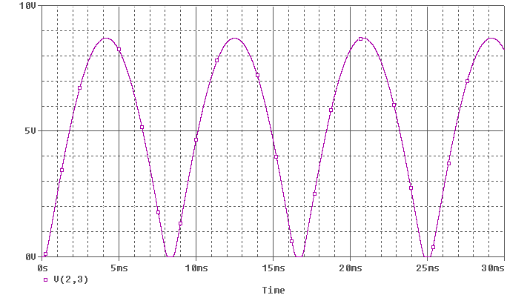

- Peak Rectifier
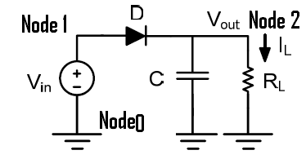

c) Plot the output voltage and find the approximate value of the ripple voltage.
Bridge Rectifier

******************
*SPICE Assignment*
*ECSE330 *
******************
*********************************
*Q1 II)c) Peak Rectifier *
*********************************
******************
*Circuit Elements*
******************
*Resistor*
**********
R1 2 0 5K

********
*Diodes*
********

D5 1 2 diode

.model diode d(Is=2n n=1.8)

***********
*Capacitor*
***********

C1 2 0 50U
**************
*Power Supply*
**************
Vi 1 0 sin(0 10 60)
**********
*Analysis*
**********
.op
.tran 1m 140m 0 1m
.PRINT TRAN V(2)
.probe
.end
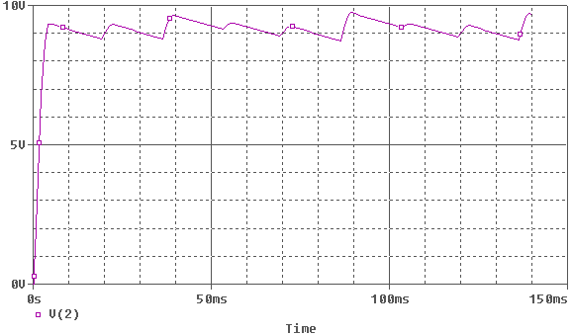

Graph of zoom on a single ripple:
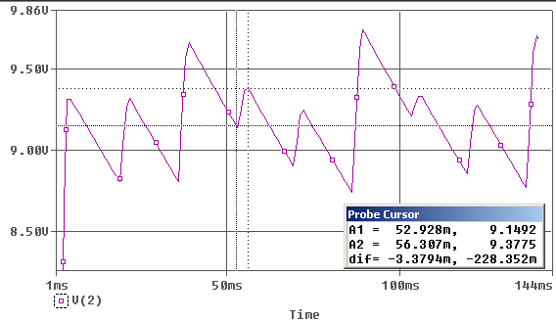
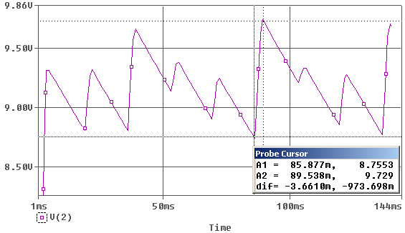
Ripple Voltage Fluctuates between 228mV and 973mV
Q1 D) Bridge and Peak Rectifiers together
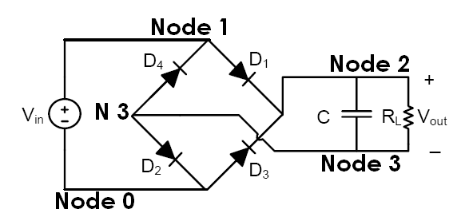

The model used is:
Both together

******************
*SPICE Assignment*
*ECSE330 *
******************
*********************************
*Q1 d) Peak Rectifier And Bridge*
*********************************
******************
*Circuit Elements*
******************
*Resistor*
**********
R1 2 3 5K

********
*Diodes*
********

D1 1 2 diode
D4 3 1 diode
D2 3 0 diode
D3 0 2 diode

.model diode d(Is=2n n=1.8)

***********
*Capacitor*
***********

C1 2 3 50U

**************
*Power Supply*
**************
Vi 1 0 sin(0 10 60)

**********
*Analysis*
**********

.op
.tran 1m 240m 0 1m
.probe
.end

Plot the output voltage
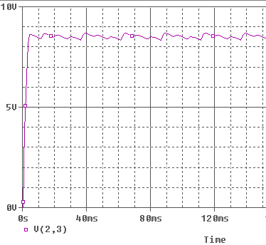

Find the approximate value of the ripple voltage
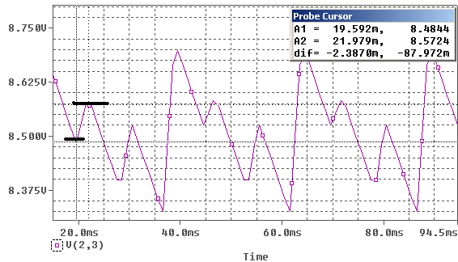
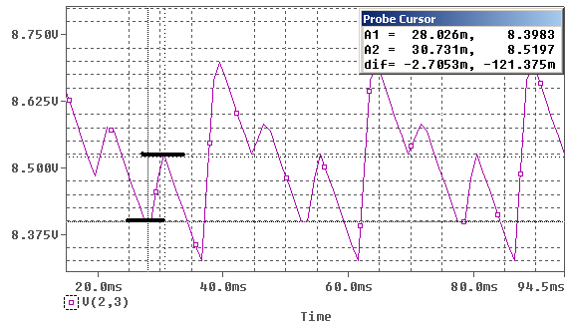
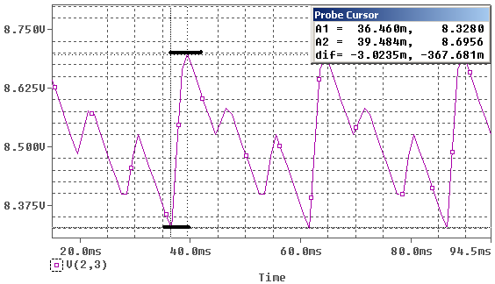

The ripple voltages are inconsistent over time. It has 3 major approximate sizes: 87mV, 121mV and 367mV
Question 2 CMOS Inverter
Consider the following inverter. Use the models provided below for NMOS and PMOS
transistors. VCC = 5V, W1 = 6μm W2 = 12μm, and L1 = L2 = 1.2μm.
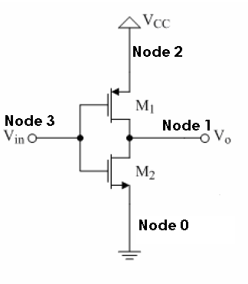

Fig. 2. CMOS inverter.
MOSFET models:
a) Plot the voltage transfer characteristic for this inverter for 0V<Vin<5V.
Question 2 CMOS Inverter

******************
*SPICE Assignment*
*ECSE330 *
******************
*********************************
*Q2 A) VTC *
*********************************
******************
*Circuit Elements*
******************
* FETs *
***********

M1 1 3 2 2 pmos_amp L=1.2u W=6u
M2 1 3 0 0 nmos_amp L=1.2u W=12u

.model pmos_amp pmos (kp=75u Vto=-1 lambda=0.025 gamma=0.9)
.model nmos_amp nmos (kp=150u Vto=+1 lambda=0.025 gamma=0.9)

**************
*Power Supply*
**************
Vi 3 0 DC 0
VCC 2 0 DC 5
**********
*Analysis*
**********
.op
.DC Vi 0 5 0.5
.probe
.end

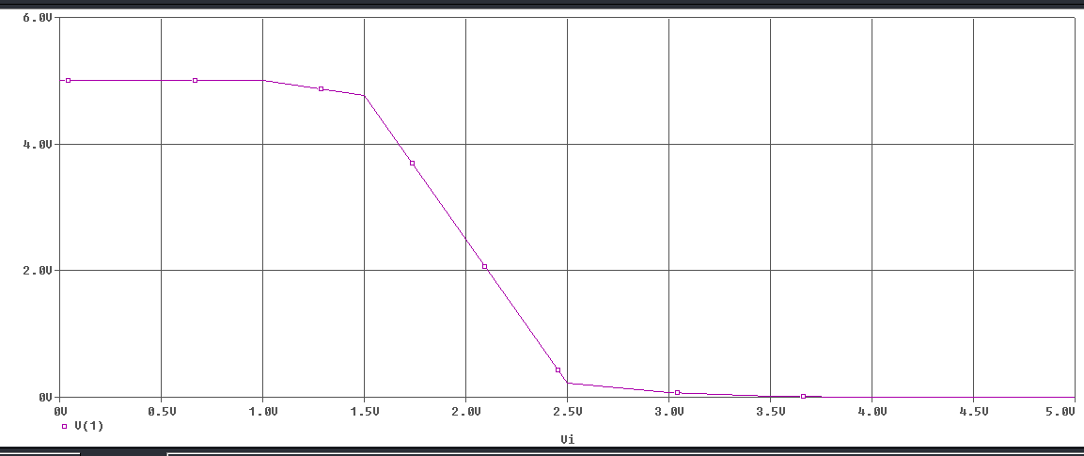

b) Determine the states of the MOSFETS in each region

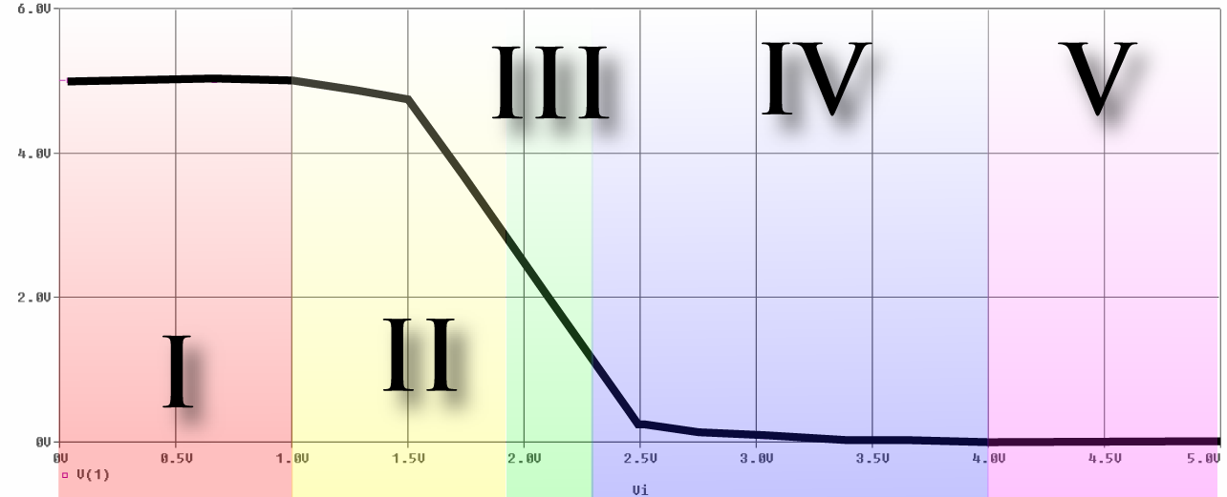

PMOS modes of operation:
Cut Off:
[Vgs > Vt] , in our case [V(3,2) > -1]
Happens whenever 4V < Vin < 5V

Saturation:
[Vgs < Vt] and [Vds > Vgs – Vt], in our case [V(3,2) < -1] and [V(1,2) > V(3,2) – (-1)]
Happens whenever 1.91V < Vin < 4V

Triode:
[Vgs < Vt] and [Vds < Vgs – Vt]
Happens when 0 < Vin < 1,91V

NMOS modes of operation:
Cut Off
[Vgs < Vt] => [V(3.0) < 1]
Happens when Vin < 1V

Saturation:
[Vgs > Vt] and [Vd < Vgs – Vt], in our case [V(3,0) > 1] and [V(1,0) < V(3,0) – 1]
Happens when 1V < Vin < 2.28V

Triode:
[Vgs > Vt] and [Vd > Vg – Vt]
Happens when Vin > 2.28V

c) Change the input signal to a sinusoidal signal of magnitude 1mV and a frequency
of 1Hz. Choose the DC offset of the input signal such that both transistors are in saturation.

The circuit file used is:

Question 2 CMOS Inverter

******************
*SPICE Assignment*
*ECSE330 *
******************
*********************************
*Q2 C) *
*********************************
******************
*Circuit Elements*
******************
* FETs *
***********

M1 1 3 2 2 pmos_amp L=1.2u W=6u
M2 1 3 0 0 nmos_amp L=1.2u W=12u

.model nmos_amp nmos (kp=150u Vto=+1 lambda=0.025 gamma=0.9)
.model pmos_amp pmos (kp=75u Vto=-1 lambda=0.025 gamma=0.9)
**************
*Power Supply*
**************
Vi 3 0 sin(2.005 10M 1)
VCC 2 0 DC 5

**********
*Analysis*
**********

.op
.tran 1u 1.2 0 1m
.probe
.end

PMOS (M1)
Voltage Lables:
Vgs = V(3,2)
Vt = -1
Vds = V(1,2)

NMOS (M2)
Voltage Lables:
Vgs = V(3,0)
Vt = +1
Vds = V(1,0)

In order for an NMOS to be operation in Saturation mode, we need Vds > Vgs – Vt, or in our case, V(1,0) > V(3,0) – 1, which can be manipulated to give 0 > V(3,0)-1-V(1,0)
Similarly, for a PMOS, we need V(1,2) < V(3,2) – (-1), or 0 < V(3,2) + 1 - V(1,2)

To solve this problem, we used a primitive form of numerical analysis. We changed the value of the DC offset in the circuit file and plotted both V(3,0)-1-V(1,0) and V(3,2) + 1 - V(1,2).
By varying the DC offset, we observed variations in the vertical positioning of those graphs. We kept playing with the DC offset values until we observed one graph above the “x” axis and the other below it (meaning that both conditions were met, hence both transistors were operating in Saturation mode. We found the value of the DC offset to be 2.005 V (At which point the response is extremely sensitive to small changes in DC offset)
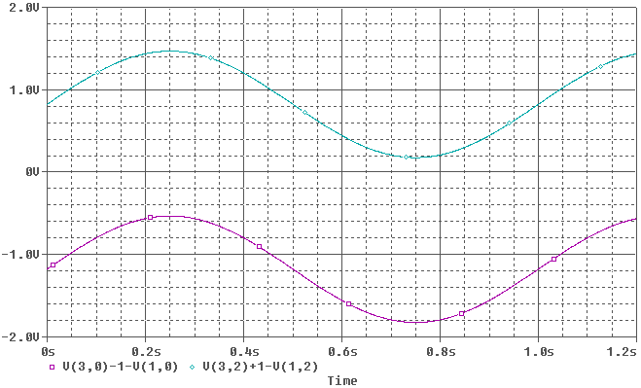

The gain at this point is given by Vo/Vin, or based on our nodes labels V(1)/V(3) (plotted below)
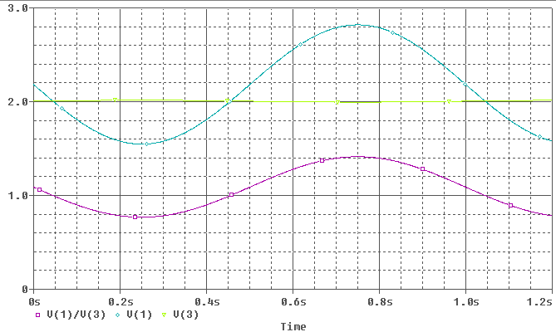

The inverter’s gain is obtained by dividing the peak to peak value of the output by the peak to peak value of the input taken from the plot done in SPICE. This yields 1.2716 / .02 = Vo/Vgs= -63.5.

Analytical value

DC offset is 2.005 volts.
We know from VTC in part a) that when Vin= 2.005 Vo=2.1817
Knowing this value we get V_{GS}= 2.005 V and V_{DS}=2.1817 for the NMOS.
We can also get V_{GS}= -2.95 V and V_{DS}=-2.8183 for the PMOS

Using the formula for the current I_{D} in saturation we get I_{D}= 7.66x 10⁻⁴ A.

The small signal output resistance of both MOSFETS is the same, as lambda and I_{D} are the same for both. Ro=52219.32 ohms.

The transconductance for the NMOS gmn=2I_{D}/(V_{GS} – V_{t})= 1.52437x 10⁻³.
The transconductance for the PMOS gmp=2I_{D}/abs(V_{GS} – V_{t})= 7.6791x 10⁻⁴.

Now, using the small signal model we can see the sources of both MOSFETS are grounded. In Figure X it is clear that:

Vout/ Vgs= - (ron||rop)(gmp+gmn)

Plugging in the values calculated aboved :

Vo EMBED PBrush 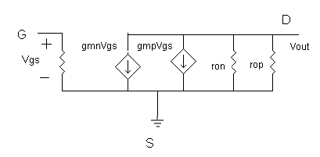

We can observe that the gain obtained theoretically is close to the gain obtained using spice. They have a percentage differe EMBED PBrush 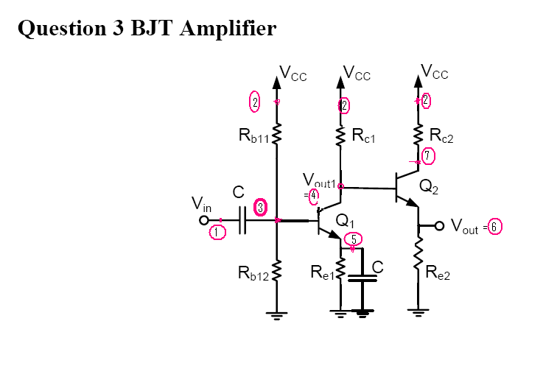
a) DC Analysis

This is the circuit file used for this question:

*********************************
*Question 3
* part a- DC analysis
*********************************
*Circuit elements
*********************************
C1 1 3 1u
C2 5 0 1u
Rb11 2 3 3k
Rb12 3 0 2k
Rc1 2 4 2k
Rc2 2 7 1k
Re1 5 0 1.3k]
Re2 6 0 1.15k

Q1 4 3 5 q
Q2 7 4 6 q
.model q npn (Is=14.34f Bf=200 Vaf=75)

*********************************
Power supply
*********************************

Vcc 2 0 DC 5V
Vin 1 0 DC 0V
*********************************
Analysis
*********************************
.OP
.END
*********************************

Here we can see the output file for the dc analysis of the BJT’s:

**** 04/09/08 20:47:23 *********** Evaluation PSpice (Nov 1999) **************

*Question 3

**** BJT MODEL PARAMETERS

******************************************************************************
q
NPN
IS 14.340000E-15
BF 200
NF 1
VAF 75
BR 1
NR 1
CN 2.42
D .87

**** 04/09/08 20:47:23 *********** Evaluation PSpice (Nov 1999) **************

*Question 3

**** SMALL SIGNAL BIAS SOLUTION TEMPERATURE = 27.000 DEG C

******************************************************************************
NODE VOLTAGE NODE VOLTAGE NODE VOLTAGE NODE VOLTAGE

( 1) 0.0000 ( 2) 5.0000 ( 3) 1.9939 ( 4) 2.9175

( 5) 1.3476 ( 6) 2.2544 ( 7) 3.0494

VOLTAGE SOURCE CURRENTS
NAME CURRENT

Vcc -3.994E-03
Vin 0.000E+00

TOTAL POWER DISSIPATION 2.00E-02 WATTS

**** 04/09/08 20:47:23 *********** Evaluation PSpice (Nov 1999) **************

*Question 3

**** OPERATING POINT INFORMATION TEMPERATURE = 27.000 DEG C

******************************************************************************

**** BIPOLAR JUNCTION TRANSISTORS

NAME Q1 Q2
MODEL q q
IB 5.10E-06 9.74E-06
IC 1.03E-03 1.95E-03
VBE 6.46E-01 6.63E-01
VBC -9.24E-01 -1.32E-01
VCE 1.57E+00 7.95E-01
BETADC 2.02E+02 2.00E+02
GM 3.99E-02 7.54E-02
RPI 5.08E+03 2.66E+03
RX 0.00E+00 0.00E+00
RO 7.36E+04 3.85E+04
CBE 0.00E+00 0.00E+00
CBC 0.00E+00 0.00E+00
CJS 0.00E+00 0.00E+00
BETAAC 2.02E+02 2.00E+02
CBX/CBX2 0.00E+00 0.00E+00
FT/FT2 6.35E+17 1.20E+18

JOB CONCLUDED
TOTAL JOB TIME .01
*********************************

We can note that Ic₁= 1.03 x 10⁻³ A and Ic₂= 1.95 x 10⁻³ A.

We can see the values obtained by hand calculations are pretty close to the ones obtained with SPICE.

b)AC Analysis

We used the same circuit file as before, except that we did an AC linear sweep and we changed Vin.

*********************************
Power supply
*********************************
Vcc 2 0 DC 5V
Vin 1 0 AC 1M 0

*********************************
Analysis
*********************************
.OP
.AC LIN 1000 1 10Meg

.probe

.END
*********************************

The voltage gain Vout/Vin is shown in the following plot, Using the cursor we can see the gain is equ EMBED PBrush 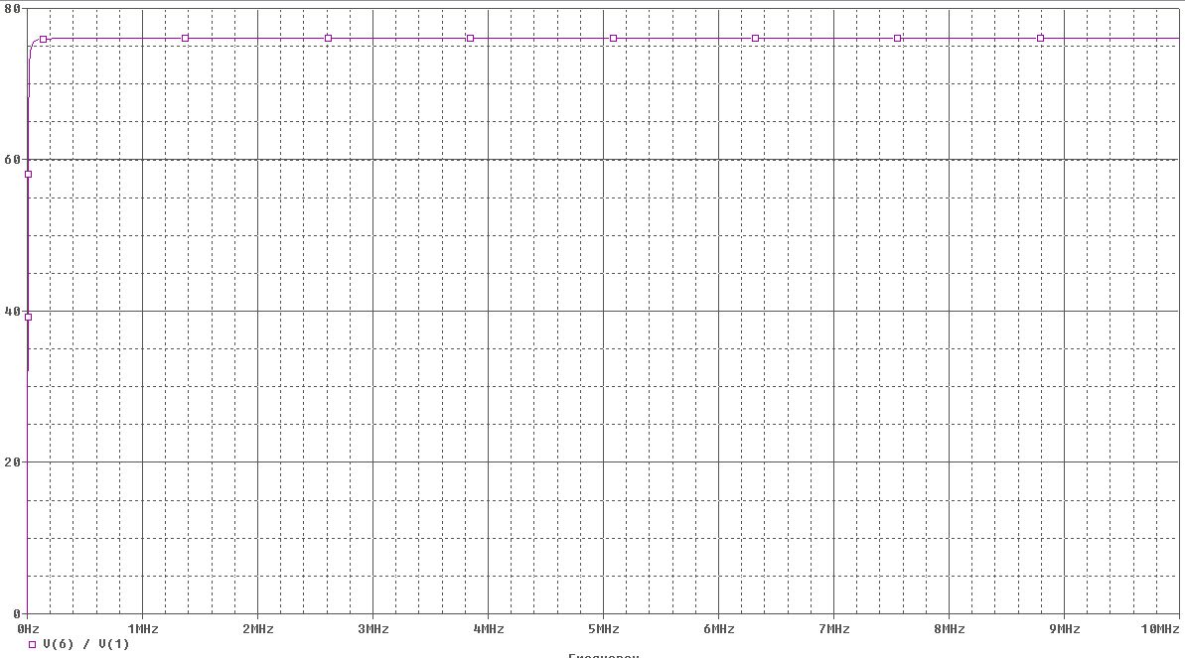The voltage gain Vout1/Vin is shown in EMBED PBrush 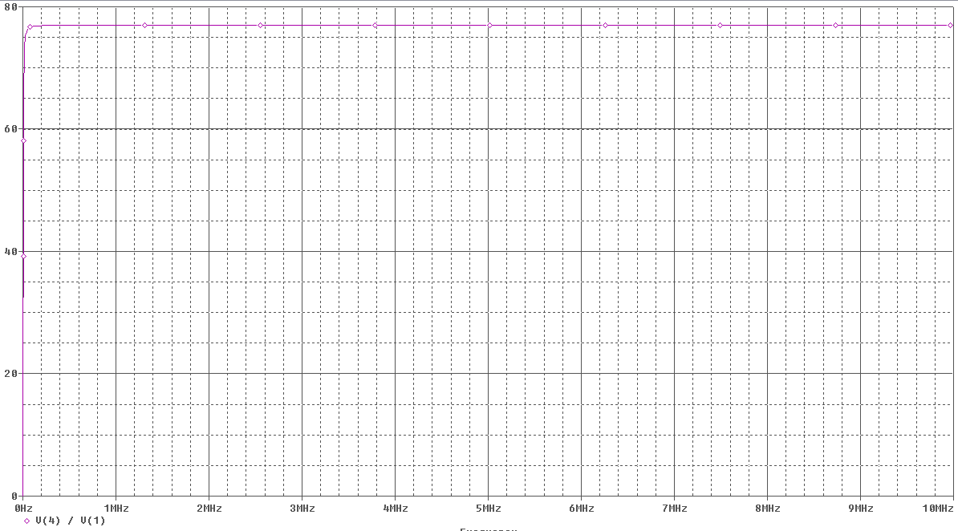

Using the cursor we can see this gain is 76.954.

Analytical Values
Using the following small EMBED PBrush 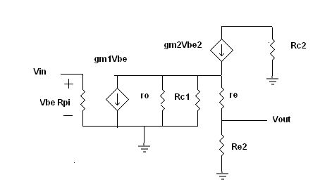

V_{BE}=V_{in}

The voltage across Rc1 is V_{out1}.
V_{out1}= -gmV_{BE}(Rc1|| ro)

We know ro=V_{A}/I_{C1}= 74757.28 ohms
Also re= V_{T}/I_{E2}= 12.6 ohms
And gm1=.0396

V_{out1}/V_{BE}=77.1

Now, V_{out}/V_{out1}= Re2/(re + Re2)=.9108

So V_{out1}/V_{BE}= -70.22

We can see the values are very close to the ones obtained with SPICE.

