ECSE 330

INTRODUCTION TO ELECTRONICS

SPICE ASSIGNMENT

SIMON FOUCHER

ROHINA xxxx

FRIDA CEJA GÓMEZ

Question 1 Diode Rectifier
- Bridge Rectifier
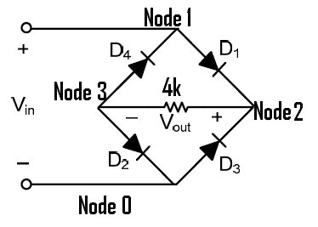

a) Plot the voltage transfer characteristic (VTC) of the rectifier for -10V<Vi<10V.
Graph of Vout as a function of Vin

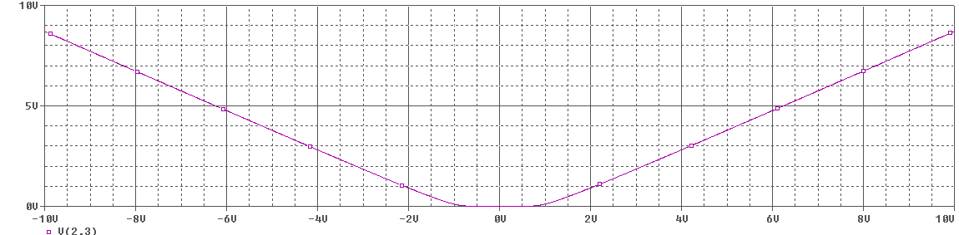

b) Plot Vout for a sinusoidal input with zero dc level, a peak value of 10V, and a frequency of 60Hz.

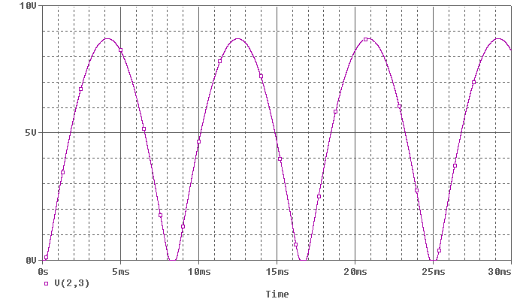

- Peak Rectifier
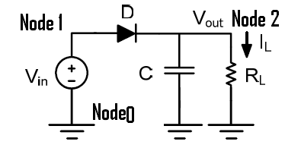

c) Plot the output voltage and find the approximate value of the ripple voltage.
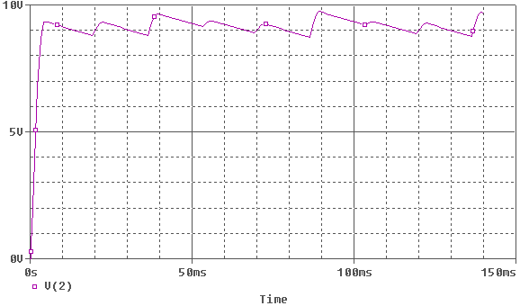

Graph of zoom on a single ripple:
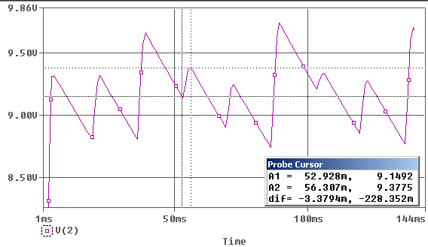
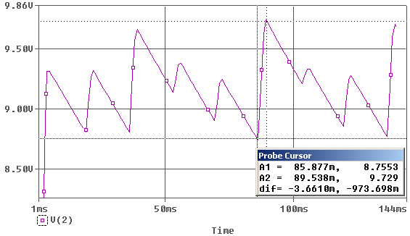
Ripple Voltage Fluctuates between 228mV and 973mV
Q1 D) Bridge and Peak Rectifiers together
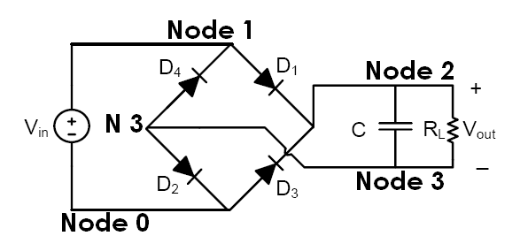

Plot the output voltage
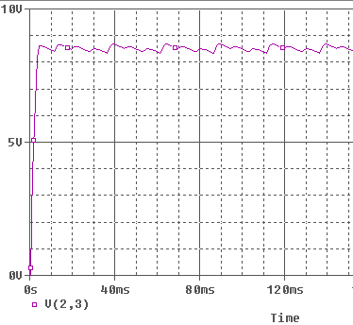

Find the approximate value of the ripple voltage
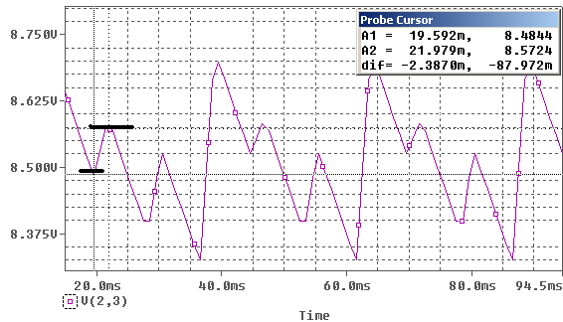
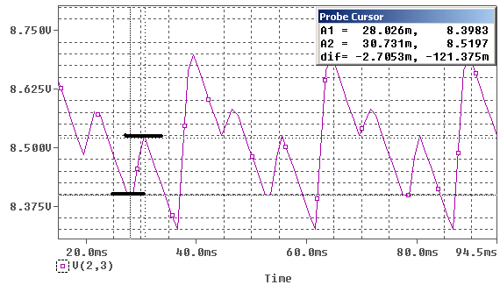
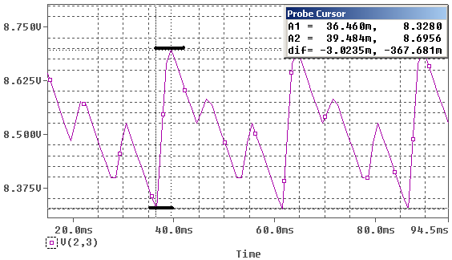

The ripple voltages are inconsistent over time. It has 3 major approximate sizes: 87mV, 121mV and 367mV
Question 2 CMOS Inverter
Consider the following inverter. Use the models provided below for NMOS and PMOS
transistors. VCC = 5V, W1 = 6μm W2 = 12μm, and L1 = L2 = 1.2μm.
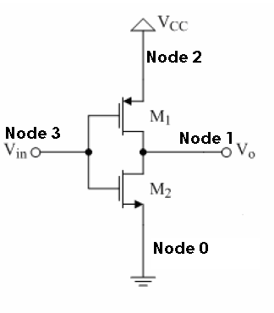

Fig. 2. CMOS inverter.
MOSFET models:
a) Plot the voltage transfer characteristic for this inverter for 0V<Vin<5V.
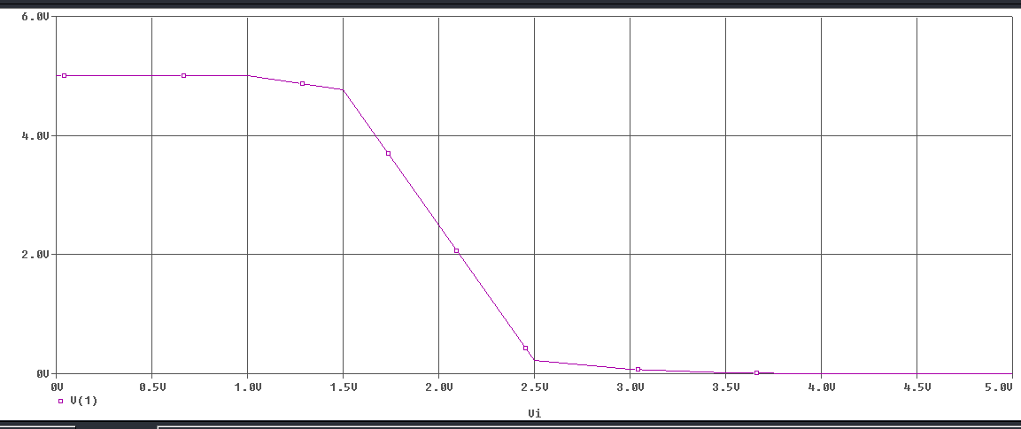

b) Determine the states of the transistors at different regions of the VTC.

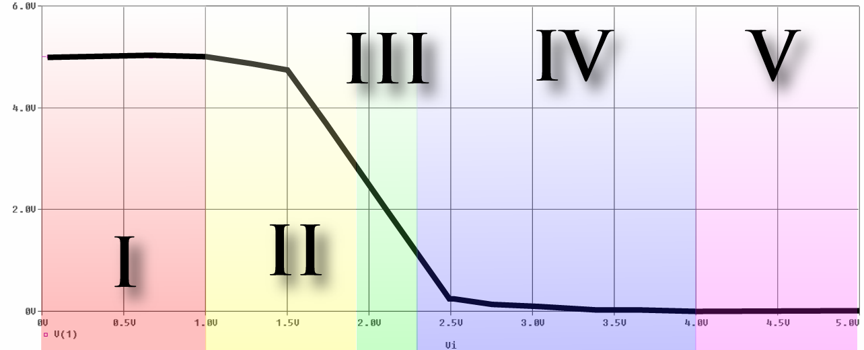

Region | NMOS | PMOS
I | CutOff | Triode
II | Saturation | Triode
III | Saturation | Saturation
IV | Triode | Saturation
V | Triode | CutOff
c) Change the input signal to a sinusoidal signal of magnitude 1mV and a frequency
of 1Hz. Choose the DC offset of the input signal such that both transistors are in
saturation.

PMOS (M1)
Voltage Lables:
Vgs = V(3,2)
Vt = -1
Vds = V(1,2)

NMOS (M2)
Voltage Lables:
Vgs = V(3,0)
Vt = +1
Vds = V(1,0)

In order for an NMOS to be operation in Saturation mode, we need Vds > Vgs – Vt, or in our case, V(1,0) > V(3,0) – 1, which can be manipulated to give 0 > V(3,0)-1-V(1,0)
Similarly, for a PMOS, we need V(1,2) < V(3,2) – (-1), or 0 < V(3,2) + 1 - V(1,2)

To solve this problem, we used a primitive form of numerical analysis. We changed the value of the DC offset in the circuit file and plotted both V(3,0)-1-V(1,0) and V(3,2) + 1 - V(1,2).
By varying the DC offset, we observed variations in the vertical positioning of those graphs. We kept playing with the DC offset values until we observed one graph above the “x” axis and the other below it (meaning that both conditions were met, hence both transistors were operating in Saturation mode. We found the value of the DC offset to be 2.005 V (At which point the response is extremely sensitive to small changes in DC offset)
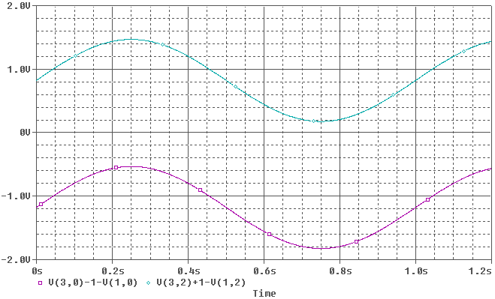

The gain at this point is given by Vo/Vin, or based on our nodes labels V(1)/V(3) (plotted below)
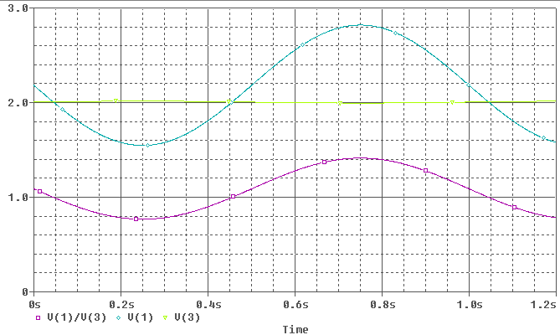

From the plot above we can see the gain Vo/Vgs= -635. This can be done by taking the AC value at the peak of V1, and the value at the same place of V3. Dividing them we obtain the desired gain.

DC offset is 2.005 volts.
We know from VTC in part a) that when Vin= 2.005 Vo=2.1817
Knowing this value we get V_{GS}= 2.005 V and V_{DS}=2.1817 for the NMOS.
We can also get V_{GS}= -2.95 V and V_{DS}=-2.8183 for the PMOS

Using the formula for the current I_{D} in saturation we get I_{D}= 7.66x 10⁻⁴ A.

The small signal output resistance of both MOSFETS is the same, as lambda and I_{D} are the same for both. Ro=522219.32 ohms.

The transconductance for the NMOS gmn=2I_{D}/(V_{GS} – V_{t})= 1.52437x 10⁻³.
The transconductance for the PMOS gmp=2I_{D}/abs(V_{GS} – V_{t})= 7.8564x 10⁻⁴.

Now, using the small signal model we can see the sources of both MOSFETS are grounded. In Figure X it is clear that:

Vout/ Vgs= - (ron||rop)(gmp+gmn)

Plugging in the values calculated aboved :

Vout/Vgs= -603.16

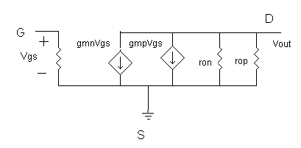

We can observe that the gain obtained theoretically is close to the gain obtained using spice. They have a percentage difference of 5%.

