McGill University DIGITAL SYSTEM DESIGN
Faculty of Engineering ECSE-323B

FINAL EXAMINATION
WINTER 2004 (April 2004)

ANSWER KEY

STUDENT NAME McGILL I.D. NUMBER

Examiner: Prof. J. Clark Associate Examiner: Prof. Tal Arbel

Signature: Signature:

Co-Examiner: Prof. M. Marin

Signature:

Date: April 21 , 2004 Time: 2:00 pm

INSTRUCTIONS: SEE NEXT PAGE.

McGILL UNIVERSITY
Department of Electrical and Computer Engineering
ECSE-323B Winter 2003
FINAL EXAM

Question Maximum Points Points Attained

1 10
2 15
3 20
4 15
5 15
6 15
- 15
- 15
- 15
- 20
- 15
- 10

Total 180 points

Please write down your name: _____________________________________

Please write your student ID: ______________________________________

Instructions/Please read carefully!
This is a close book exam. No books or notes are allowed. You may use a standard calculator.
All work is to be done on the attached sheets and under no circumstance are booklets or loose sheets to be used. Write your name at the top of every sheet.

Read the question carefully. If something appears ambiguous, write down your assumption. The points have been assigned according to the formula that 1 point = 1 exam minute, so please pace yourself accordingly.

Your Name_______________________________________________________
Question 1 : CMOS Circuit Technology (10 points)

Draw the pull-up and the pull-down networks of a CMOS circuit producing the AND-OR-INVERT function of 4 variables whose Boolean algebraic expression is
f (A,B,C,D) = AND-OR-INVERT (A,B,C,D) = NOT[OR[AND(A,B),AND(C,D)]].
Only true variables are available as inputs.
Marking scheme : 5 points for the correct pull-up network and 5 points for the correct pull-down network.
_________________________________________________________________________________________
ANSWER

PULL-UP NETWORK
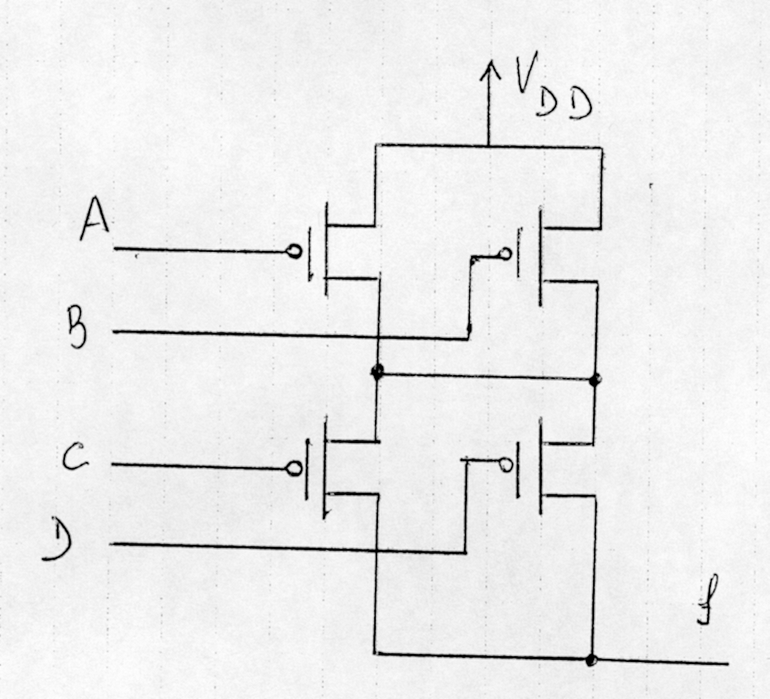

PULL-DOWN NETWORK

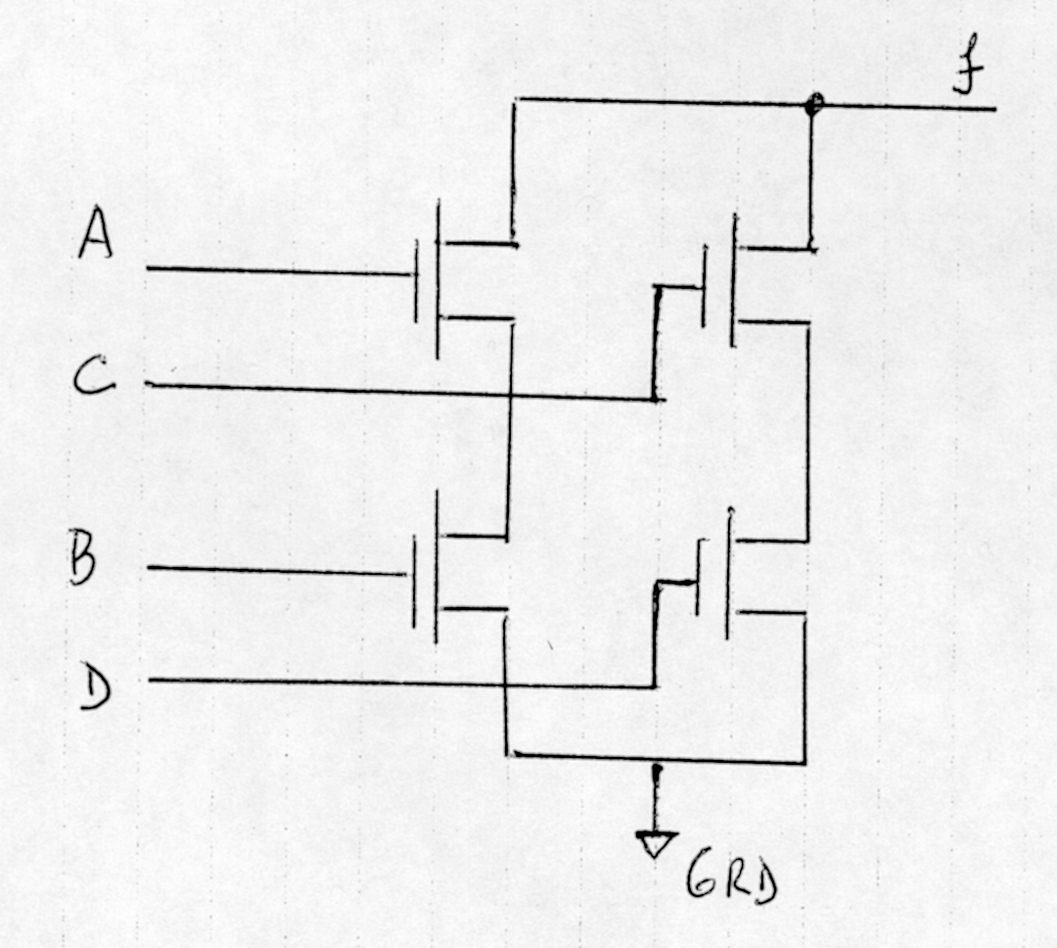

Your Name__________________________________________________________________________________
Question 2 :Boolean Logic Theory (15 points)

Draw the circuit producing the function f(A,B,C,D) = Σm(8,9,10,11,12,13,15) and using ONLY the building block
g(x,y,z) = x‾y + x z. Two such blocks are sufficient.

(5 points) a) Explain CLEARLY your approach to solve this problem.
(5 points) b) Decompose f in terms of g.
(5 points) c) Draw the complete minimal circuit.
_________________________________________________________________
ANSWER
- We map on a K-map the function f . If f is not a Booean constant (0,1) or one of the input variables or their complement, it must be the output of a building block g. Now we try to express x, y, z as functions of A, B, C, D and determine if these functions are Boolean constants, input variables or their complement. If any of them are not, again, they must be outputs of a bulding block g. We iterate this process until input variables or their complement are found. If g is complete, the process converges. If not, there is no solution.
This process is illustrated by the following figure:

f (A,B,C,D) = A‾B + A‾C + A D = A‾B + A(‾C + D )

Comparing f with g , g(x,y,z) = x‾y + x z, we can write f(A,B,C,D) = g(A,B, (‾C + D)) = g(A,B,g(1,C,D))

b) f is expressed in terms of g thus

f(A,B,C,D) = g(A,B, (‾C + D)) = g(A,B,g(1,C,D)).

c) which produces the following circuit

Your Name______________________________________________________________________________
Question 3 : VHDL (20 points)

- (10 points) Using components, write a complete VHDL description of the AND-OR-INVERT circuit represented by the Boolean expression given in Question 1. Assume that design entities for AND, OR, and INVERT gates are already defined.
- (10 points) Using process blocks and arithmetic statements, write a complete VHDL description of a synchronous 10-bit counter circuit that counts in factorial sequence (assume that 0!=0). Provide an asynchronous reset. Assume that the counter wraps back to zero when it reaches the maximum count value.

_________________________________________________________________________________________

a) f=NOT[OR[AND(A,B),AND(C,D)]].

LIBRARY ieee ;
USE ieee.std_logic_1164.all ;
ENTITY and_or_inv IS
PORT ( A,B,C,D : IN STD_LOGIC ;
f : OUT STD_LOGIC) ;
END and_or_inv ;

ARCHITECTURE Structure OF and_or_inv IS

COMPONENT AND2
PORT (x1,x2 : IN STD_LOGIC ;
y : OUT STD_LOGIC) ;
END COMPONENT;
COMPONENT OR2
PORT (x1,x2 : IN STD_LOGIC ;
y : OUT STD_LOGIC) ;
END COMPONENT;
COMPONENT INV
PORT (x : IN STD_LOGIC ;
y : OUT STD_LOGIC) ;
END COMPONENT;

SIGNAL I1, I2, I3 : STD_LOGIC;
BEGIN
A1: AND2 PORT MAP (x1=>A,x2=>B,y=>I1) ;
A2: AND2 PORT MAP (x1=>C,x2=>D,y=>I2) ;
O1: OR2 PORT MAP (x1=>I1,x2=>I2,y=>I3) ;
I1: INV PORT MAP (x=>I3,y=>f) ;
END Structure ;

Continue Question 3 on next page….
Your Name______________________________________________________________________________
Question 3:VHDL (20 points)

b)

LIBRARY ieee ;
USE ieee.std_logic_1164.all ;
USE ieee.std_logic_unsigned.all ;

entity factorial_counter is
port( clk, reset : in std_logic;
fact : out std_logic_vector(9 downto 0));
end factorial_counter;

architecture Q3 of factorial_counter is
signal icount : std_logic_vector(2 downto 0);
begin
count <= icount;
process(clk, reset)
begin
if reset = '1' then
icount <= "000";
fact <= "0000000000";
elsif clk='1' and clk'EVENT then
if icount = 6 then
icount <= "000";
fact <= "0000000000"
else
icount <= icount + 1;
if icount = "000" then
fact <= "0000000001";
else
fact <= fact * (icount + 1);
end if; -- if icount
end if; -- if icount
end if; -- if reset
end process;
end Q3;

Your Name__________________________________________________________________________________
Question 4 : Combinational Circuit Synthesis (15 points)
Design a 2-digit, base-3, adder circuit. This circuit adds 2 digits, A, B, and produces outputs S = A + B (addition in base-3) and C (for Carry). Digits A, B and S are coded in binary such that, being A = {a₁ , a₂}, B = {b₁ ,b₂},
S = {s₁ ,s₂} the code assignment is

A | {a₁ , a₂} | B | {b₁ ,b₂} | S | {s₁ , s₂}
0 | 0 0 | 0 | 0 0 | 0 | 0 0
1 | 0 1 | 1 | 0 1 | 1 | 0 1
2 | 1 0 | 2 | 1 0 | 2 | 1 0

Assume that assignment {1,1} never occurs at the inputs.
(5 points) a) Give the truth table of the outputs.
(5 points) b) Draw the minimal NAND-NAND circuit of the outputs.
(5 points) c) Draw the circuit of the outputs using only 4 x 1 multiplexers and the fewest number of gates.
_________________________________________________________________________________________

a)
Identifier | A = {a₁, a₂} | B = {b₁ ,b₂} | S = {s₁ , s₂} | C (Carry)
0 | 0 0 0 | 0 0 0 | 0 0 0 | 0
1 | 0 0 0 | 1 0 1 | 1 0 1 | 0
2 | 0 0 0 | 2 1 0 | 2 1 0 | 0
3 | 0 0 0 | 3 1 1 | x xx | x
4 | 1 0 1 | 0 0 0 | 1 0 1 | 0
5 | 1 0 1 | 1 0 1 | 2 1 0 | 0
6 | 1 0 1 | 2 1 0 | 0 0 0 | 1
7 | 1 0 1 | 3 1 1 | x xx | x
8 | 2 1 0 | 0 0 0 | 2 1 0 | 0
9 | 2 1 0 | 1 0 1 | 0 0 0 | 1
10 | 2 1 0 | 2 1 0 | 1 0 1 | 1
11 | 2 1 0 | 3 1 1 | x xx | x
12 | 3 1 1 | 0 0 0 | x xx | x
13 | 3 1 1 | 1 0 1 | x xx | x
14 | 3 1 1 | 2 1 0 | x xx | x
15 | 3 1 1 | 3 1 1 | x xx | x

Continue Question 4 on next page………..

Your Name______________________________________________________________________________
Question 4 : Combinational Circuit Synthesis(Continued)

b)

b)

Your Name______________________________________________________________________________
Question 4 : Combinational Circuit Synthesis(Continued)

c)

Your Name_______________________________________________________
Question 5 : Testing of Combinational Circuit(15 points)
For the following circuit

(1 point) a) Give the check points.
(2 points) b) Give the test for fault 3/1.
(7 points) c) Give the minimal test sets.
________________________________________________________
- The check points are 2,3,4,5.

b) f^{3/1} = x₂ ; f = x₁x₂ + x₂x₃ ; f^{3/1} ⊕ f = [x₂ ⊕ (x₁x₂ + x₂x₃) ] = ‾x₃ x₂‾x₁
Therefore, {010} is a test for 3/1.

c)
Tests |  |  | Faults
x₁ | x₂ | x₃ | 2/0 | 2/1 | 3/0 | 3/1 | 4/0 | 4/1 | 5/0 | 5/1
0 | 0 | 0 | 0 | 0 | 0 | 0 | 0 | 0 | 0 | 0
0 | 0 | 1 | 0 | 0 | 0 | 0 | 0 | 0 | 0 | 1
0 | 1 | 0 | 0 | 1 | 0 | 1 | 0 | 0 | 0 | 0
0 | 1 | 1 | 0 | 0 | 1 | 0 | 0 | 0 | 1 | 0
1 | 0 | 0 | 0 | 0 | 0 | 0 | 0 | 1 | 0 | 0
1 | 0 | 1 | 0 | 0 | 0 | 0 | 0 | 1 | 0 | 1
1 | 1 | 0 | 1 | 0 | 0 | 0 | 1 | 0 | 0 | 0
1 | 1 | 1 | 0 | 0 | 0 | 0 | 0 | 0 | 0 | 0

After selecting the tets covering only one fault (essential), which are {010,011,110}, the fault table reduces to

Tests |  |  | Faults
x₁ | x₂ | x₃ | 2/0 | 2/1 | 3/0 | 3/1 | 4/0 | 4/1 | 5/0 | 5/1
0 | 0 | 1 | 0 | 0 | 0 | 0 | 0 | 0 | 0 | 1
1 | 0 | 0 | 0 | 0 | 0 | 0 | 0 | 1 | 0 | 0
1 | 0 | 1 | 0 | 0 | 0 | 0 | 0 | 1 | 0 | 1
which produces the cover {101}. Therefore, the minimum test set is {010,011,110,101}

You Name_____________________________________________________________________________
Question 6: Sequential circuits (15 points)
Analyze the following circuit

(5 points) a) Prove with a state-transition-diagram (4 states) that this circuit is not a latch.
Modify it by replacing one EX-OR gate with an AND gate.
(5 points) b) Give the characteristic and excitation equations (or tables) of this modified latch, called
EX-OR/AND latch.
(5 points) c) Give the circuit of a JK-type latch using the EX-OR/AND latch circuit as a bulding block and fewest additional gates.
____________________________________________________________________________________
a)
P⁺ = Q ⊕ x
Q⁺ = P ⊕ y

The state-transition-table will show the satable and unsateble sates:

Present State | Next State: P⁺ Q⁺
P Q | x y = 00 | 01 | 10 | 11
0 0 | 00 | 01 | 10 | 11
0 1 | 01 | 11 | 00 | 01
1 0 | 01 | 00 | 11 | 10
1 1 | 11 | 10 | 01 | 00

If P = ‾Q (second and third row), then we observe that for xy = 01, 10, the present sate does not equal the next sate, and thus the circuit oscillates for these two inputs. Therefore x must be equal to y to prevent oscillation. If this is the case, then from state 01, either xy = 00 or xy = 11 will lock the circuit into sate 01 permanently. And from state 10, xy = 00 will toggle the outputs locking them permanently to 01, and xy = 11 will lock the outputs to 10. Note that sate 10 cannot be reached from sate 01 !

If P = Q (which contradicts the properpy of a latch for which P = ‾Q ) then the circuit is stable for x y = 00.
We conclude that the circuit in question is not a latch.

You Name_____________________________________________________________________________
Question 6: Sequential circuits (15 points) (Continues)

b)
Let us analyse this circuit
P⁺ = Q • x
Q⁺ = P ⊕ y

Present State | Next State: P⁺ Q⁺
P Q | x y = 00 | 01 | 10 | 11
0 0 | 00 | 01 | 00 | 01
0 1 | 00 | 01 | 10 | 11
1 0 | 01 | 00 | 01 | 00
1 1 | 01 | 00 | 11 | 10

For this circuit to be a latch, P must be equal to ‾Q. If this condition is satisfied,then the circuit presents only one stable state, namely, sate 01 and, therefore, it is useless as a bistable (memory) device.

c) In view of the conclusion reached in b) this circuit cannot be use as a building block to construct a JK-type latch. Thre is no solution to this part of the question.

Your Name___________________________________________________________________________________
Question 7: Counter Design (15 points)
Design a 3-bit self-starting UP/DOWN Johnson counter. When the UP/DOWN input is HIGH the counter counts up and when it is LOW the counter counts down. The state-transition-diagram of the counter is
(5 points) a) Give the state-transition-table of the counter
(5 points) b) Give the minimal sum-of-products of the excitation equations of the D-type flip-flops.
(5 points) c) Give the complete circuit using NAND gates.
Hint: Pay special attention to the self-starting requirement while constructing the state-transition-table.
- If the counter reaches an off-sequence sate, ten we assume the next sate to be 000.
A B C | U/D = 0 | U/D = 1
0 0 0 | 1 0 0 | 0 0 1
0 0 1 | 0 0 0 | 0 1 1
0 1 0 | 0 0 0 | 0 0 0
0 1 1 | 0 0 1 | 1 1 1
1 0 0 | 1 1 0 | 0 0 0
1 0 1 | 0 0 0 | 0 0 0
1 1 0 | 1 1 1 | 1 0 0
1 1 1 | 0 1 1 | 1 1 0
A⁺ B⁺ C⁺
PRESENT NEXT
STATE STATE
C⁺ = U/D (‾A‾B) + C ‾A B + $\overline{U/D}$(A B)
B⁺ = U/D (C‾A) + C A B + $\overline{U/D}$(‾C A )
A⁺ = U/D (C B) + ‾C A B + $\overline{U/D}$(‾C ‾B )

Your Name___________________________________________________________________________________
Question 7: Counter Design (15 points) (Continues)

Your name ________________________________________________________________________________
Question 8: Circuit Implementation Strategies/Logic arrays(15 points)
Using the PAL schematic shown in the next page, which has 6 inputs and 5 outputs, two of which may be folded,
produce the following functions:

f₁ = ‾E F‾D + ‾E FC + B
f₂ = ‾D + C +‾E F B
f₃ = A B‾D‾E F.

(7 points) a) Decompose the funtions so that they can be produced with the given PAL.
(8 points) b) Complete the PAL program by marking clearly the required connections.
Not all connections are needed.
____________________________________________________________________________
a)

f₁ = (‾E F )(‾D + C ) + B
f₂ = (‾D + C ) + (‾E F ) B
f₃ = A B‾D (‾E F ).

(‾E F ) and (‾D + C ) can be folded

We assume that all inputs and their complements are possible inputs to each AND gate.
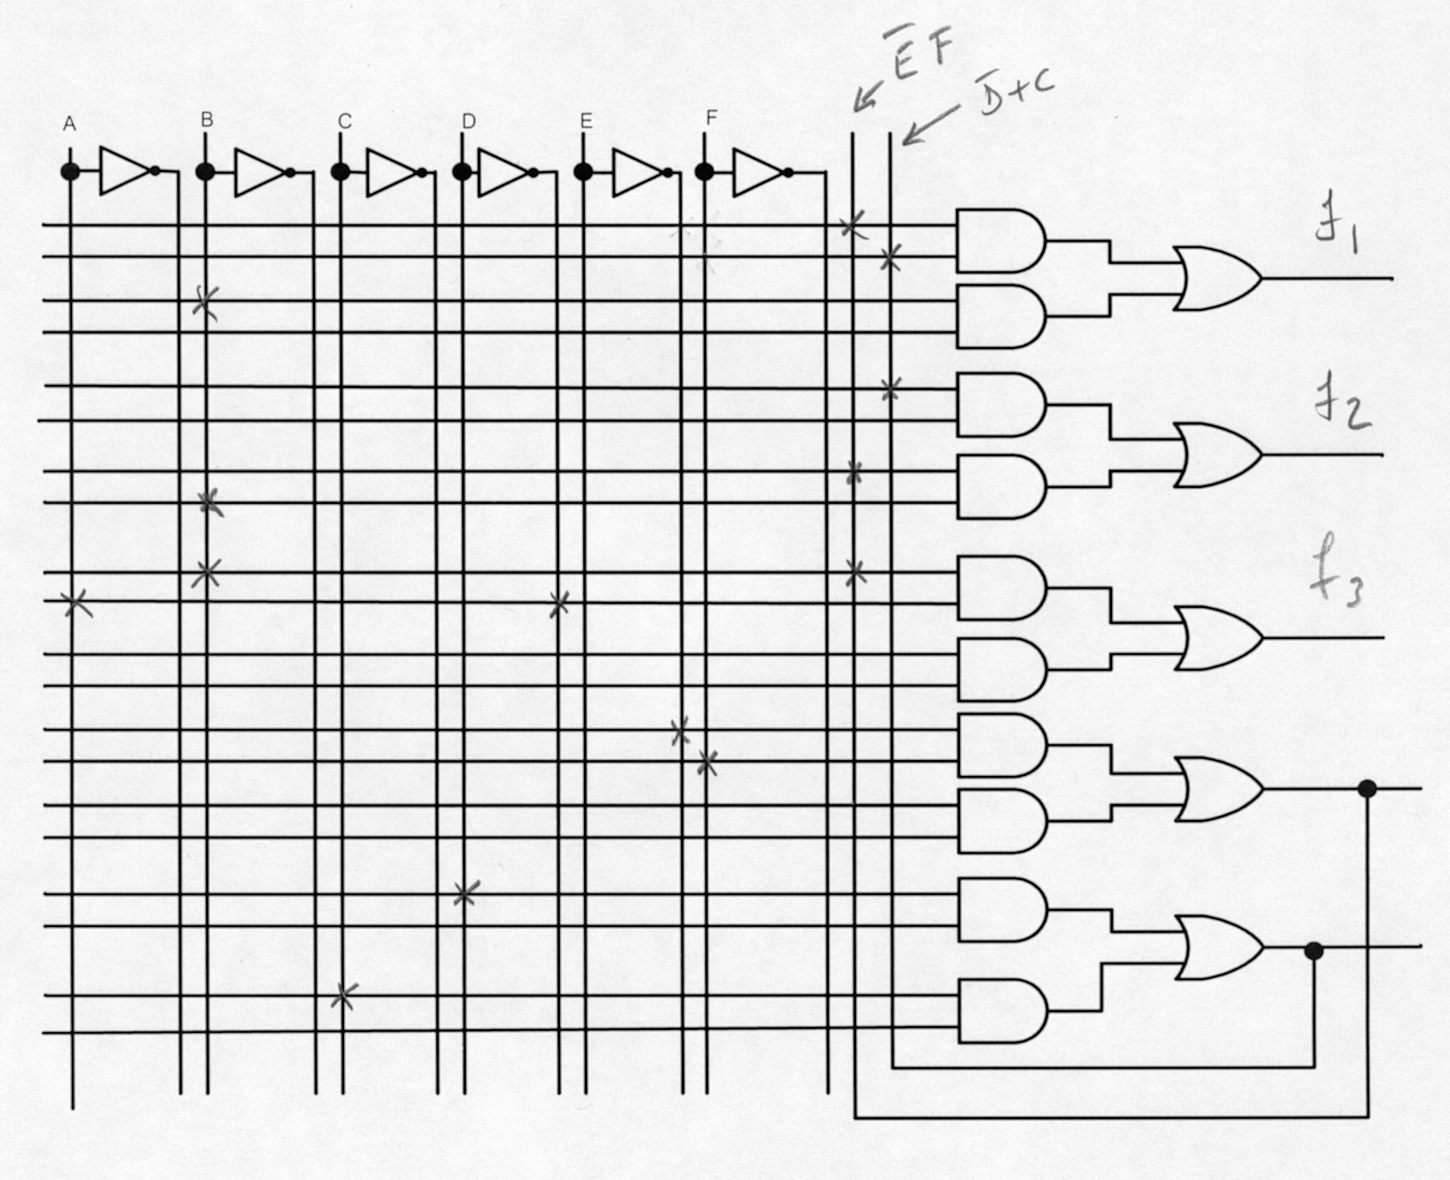

Your Name_______________________________________________________________________________
Question 9: Finite State Machine Design(15 points)

Design a Mealey type Finite State Machine that detects the reception of at least 25 cents. There are three inputs, N for nickel, D for dime and Q for quarter. When the machine totalizes 25 cents or more, then the output is asserted HIGH, and the machine remains in that state until it is manually reset, otherwise its output is asserted LOW.
The insertion of a coin is signaled by the associated signal going from low to high. The
signal will always go low before the next coin insertion.

(5 points) a) Give the minimal state-transition-diagram of this FSM.
(3 points) b) Give the ONE-HOT ASSIGNMENT state-transition-table .
(4 points) c) Give the complete circuit using D-type flip-flops and AND, OR, NOT gates.
(3 points) d) Give the formula to compute the maximum clock rate of this FSM.

____________________________________________________________________________
a) All transitions branches are asserted when RESET is not asserted. This condition garantees that when the external RESET signal is asserted to 1, all FFs, except the “0” flip-flop which is set to 1, are set to 0. This condition is not shown in the State-transition-table(diagram) but it is shown in the final circuit.

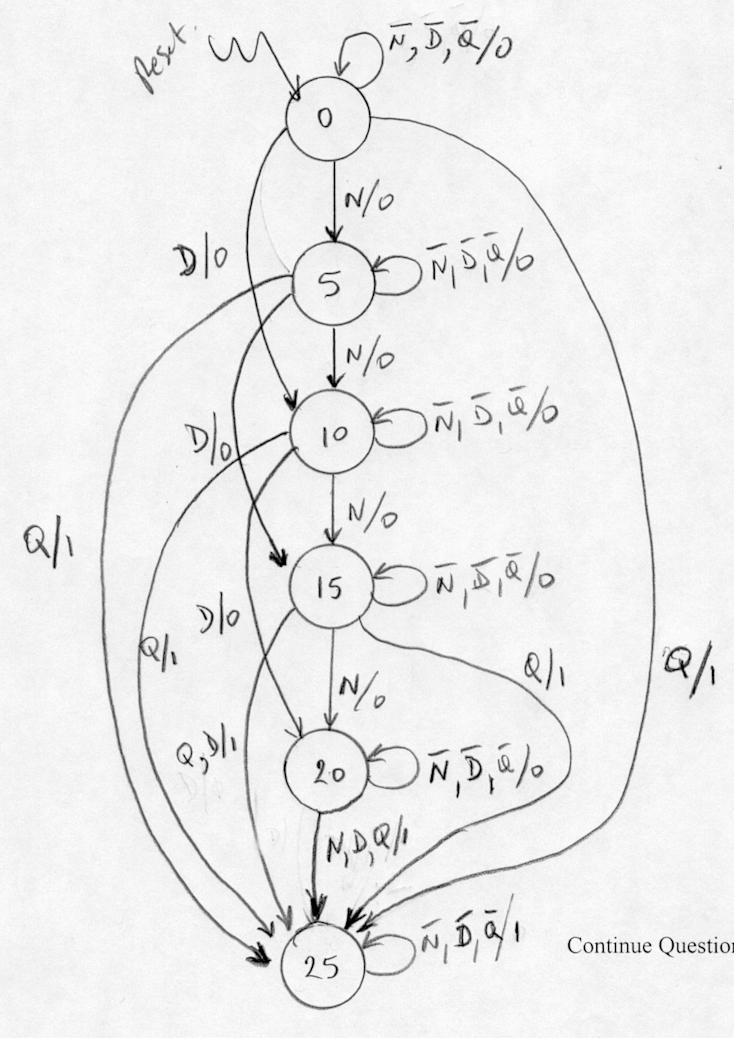

b)
NEXT STATE
P.S. | N | D | Q | ‾N,‾D,‾Q
0 | 5 | 10 | 25 | 0
5 | 10 | 15 | 25 | 5
10 | 15 | 20 | 25 | 10
15 | 20 | 25 | 2 | 15
20 | 25 | 25 | 25 | 20
25 | 25 | 25 | 25 | 25

The output of the circuit, which is not shown in the circuit drawing, corresponds to the function
OUTPUT = “0” Q + “ 5” Q + “10” Q + “15” (Q + D) + “ 20”(N + D + Q) + “25” (‾N +‾D +‾Q )

Continue Question 9 on next page -------------→
Your Name_______________________________________________________________________________
Question 9: Finite State Machine Design(15 points) (Continues)
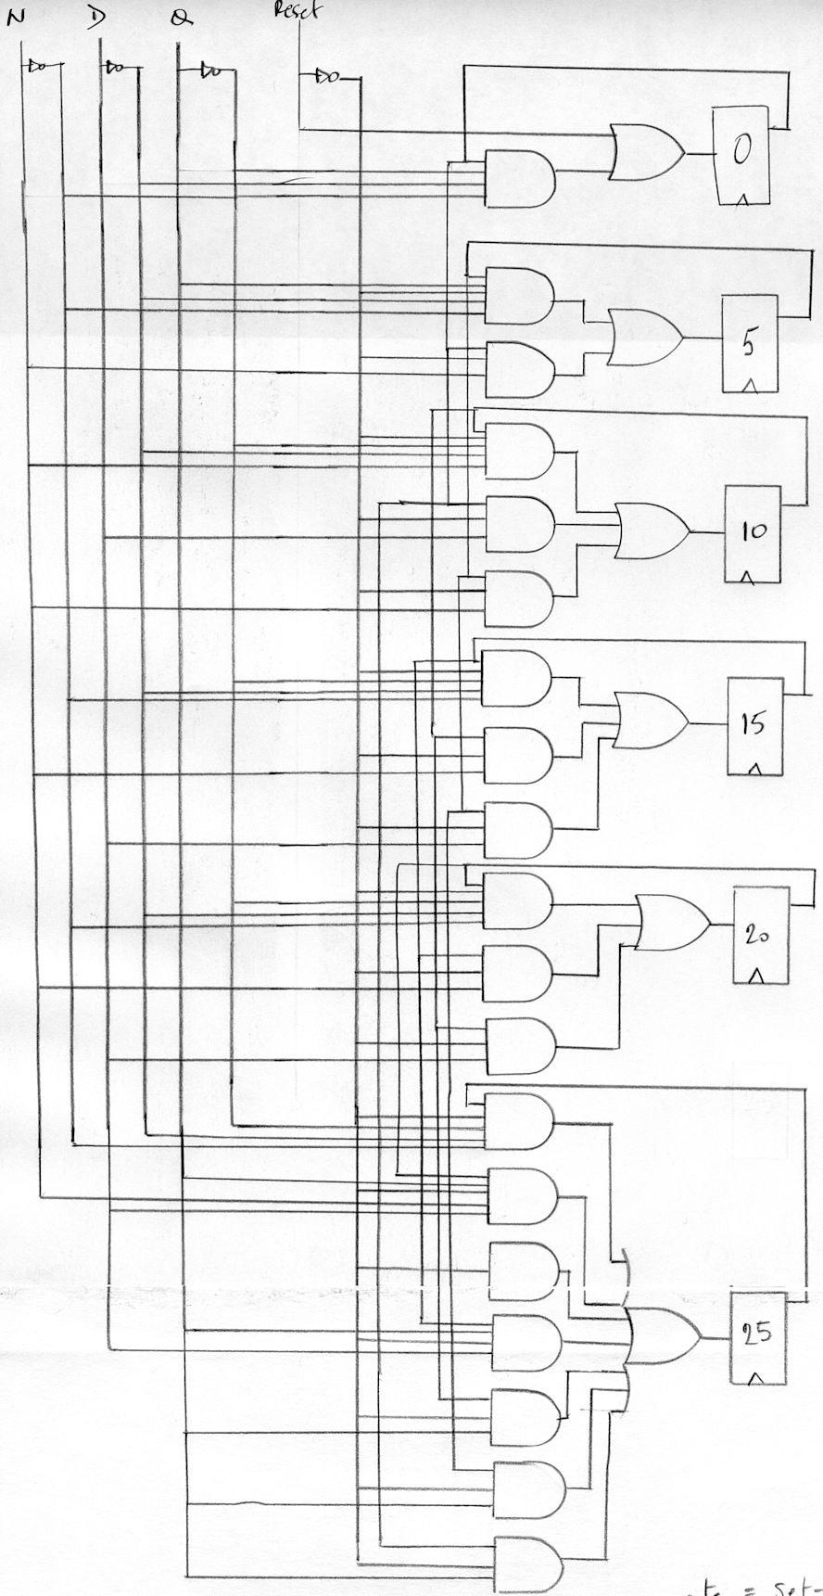

d) f_{clock} = 1/T = 1/(t_{su} + t_{cc} + t_{p}) where, t_{su} is the set-up time, t_{cc} is he propagation delay of the combinational circuit and t_{p} is the propagation delay of the flip-flop.
Your Name_______________________________________________________
Question 10 : Design of Sequential Systems (20 points)

Using a synchronous Datapath/Controller approach, design a system that multiplies two 8-bit numbers using the Shift-and-Add technique.

- (5 points) Draw the block diagram for the system, showing all of the datapath elements and all control signals.
- (5 points) Draw the state-transition diagram for the controller.
- (10 points) Write a complete VHDL description of the system.
____________________________________________________________________________
A*B

a)

CONTROLLER
LD_SR1
SHL_SR1
LD_SR2
SHR_SR2
LD_AR
CLR_AR
CLR_CNT
EN_CNT
SR2_OUT

AREG
LD_AR
CLR_AR
RESET
COUNT7

CLOCK

ADDER
CLOCK

16 bit SREG1
8bit SREG2
LD_SR1
SHL_SR1
LD_SR2
SHR_SR2
SR2_OUT

CLOCK

CLOCK

0 A

B

COUNT7

3-bit Counter
EN_CNT
CLR_CNT

S1

[LD_AR]
[EN_CNT]
[SHL_SR1]
[SHR_SR2]
CLOCK

SR2_OUT=1
COUNT7=0

b)
START

[CLR_AR]
[CLR_CNT]
[LD_SR1]
[LD_SR2]
DONE
SR2_OUT=1

COUNT7=1

SR2_OUT=1
COUNT7=0

SR2_OUT=0
COUNT7=0

S2

[EN_CNT]
[SHL_SR1]
[SHR_SR2]
COUNT7=1

SR2_OUT=0

RESET

SR2_OUT=0
COUNT7=0

Your Name_________________________________________________________________________________
Question 10 (continued)

LIBRARY ieee ;
USE ieee.std_logic_1164.all ;

entity shift_add_mult is
port( clk, reset : in std_logic;
A, B : in std_logic_vector(7 downto 0);
AB : out std_logic_vector(15 downto 0));
end shift_add_mult;

architecture Q10 of shift_add_mult is
type state_type is (START,S1,S2,DONE);
signal state : state_type;
begin
process(clk, reset)
begin
if reset = '1' then
state <= START;
elsif clk='1' and clk'EVENT then
case state is
when START =>
if SR2_OUT='1' then state<=S1;
else state<=S2' end if;
when S1 =>
if COUNT7='1' then state<=DONE;
elsif SR2_OUT='0' then state<=S2;
else state<=S1; end if;
when S1 =>
if COUNT7='1' then state<=DONE;
elsif SR2_OUT='1' then state<=S1;
else state<=S2; end if;
when DONE => state <= DONE;
end case;
end if; -- if reset
end process;

process(state) –- output logic
begin
CLR_AR <= '0'; -- provide defaults
LD_SR1 <= '0';
LD_SR2 <= '0';
LD_AR <= '0';
CLR_CNT <= '0';
EN_CNT <= '0';
SHR_SR2 <= '0';
SHL_SR1 <= '0';
case state is
when START =>
CLR_AR <= '1';
LD_SR1 <= '1';
LD_SR2 <= '1';
CLR_CNT <= '1';
when S1 =>
LD_AR <= '1';
EN_CNT <= '1';
SHR_R2 <= '1';
SHL_R1 <= '1';
when S2 =>
EN_CNT <= '1';
SHR_R2 <= '1';
SHL_R1 <= '1';
when DONE =>
end case;
end process;
end Q10;

Your Name__________________________________________________________________________________
Question 11 :Optimization of Finite State Machines (15 points)

Using the partitioning method reduce the following state transition table so that it contains the minimum number of states.

Present State | Next State  X = 0 X =1 |  | Outputs  Z₁ Z₂
A | E | C | 0 | 0
B | C | A | 0 | 0
C | B | G | 0 | 0
D | G | A | 0 | 0
E | F | B | 1 | 0
F | E | D | 0 | 0
G | D | G | 0 | 0

(5 points) First partition
(5 points) Second partition
(5 points) Final reduced transition table
____________________________________________________________________________
(A B C D E F G)

First partition: (A B C D F G) (E) different outputs

Second partition: (AF) (BCDG) (E)

Third and final partition: (A) (F) (BD) (CG) (E)

Reduced table:

Present State | Next State  X = 0 X =1 |  | Outputs  Z₁ Z₂
A | E | C | 0 | 0
B | C | A | 0 | 0
C | B | C | 0 | 0
E | F | B | 1 | 0
F | E | B | 0 | 0

Your Name_______________________________________________________
Question 12 : Testing of Sequential Circuits (10 points)

- (5 points) Draw a scan-path implementation of a 4-bit Johnson counter (i.e. a counter which has the count sequence 0000,0001,0011,0111,1111,1110,…).
- (2 points) What does the acronym JTAG stand for?
- (3 points) Briefly explain the idea behind the Boundary Scan test technique.

a)
TEST Q0 Q1 Q2 Q3
SCAN_IN

D Q

CLK

D Q

CLK

D Q

CLK Q

D Q

CLK
1

0
SCAN_OUT

CLOCK

b) JTAG = Joint Test Activities Group

c) The boundary scan technique inserts a register on every signal pin in a chip. These registers are connected together to form one long shift register, called the boundary scan register. The purpose of the boundary scan technique is to allow the connections on a printed circuit board to be tested. Test data can be shifted in, to drive the associated pin to a specific voltage, or the test data can be read out to read the voltage on a pc-board line that the pin is connected to.

