McGill University DIGITAL SYSTEM DESIGN
Faculty of Engineering ECSE-323A

FINAL EXAMINATION
WINTER 2003 (April 2003)

STUDENT NAME
McGILL I.D. NUMBER

Examiner: Prof. J. Clark Co-Examiner: Prof. M. Marin

Signature: Signature:

Date: April 30, 2003 Time: 2:00 pm

INSTRUCTIONS: SEE NEXT PAGE.

McGILL UNIVERSITY
Department of Electrical and Computer Engineering
ECSE-323B Winter 2003
FINAL EXAM

Question Maximum Points Points Attained

1 10
2 15
3 20
4 15
5 15
6 15
- 15
- 15
- 15
- 20
- 15
- 10

Total 180 points

Please write down your name: _____________________________________

Please write your student ID: ______________________________________

Instructions/Please read carefully!
This is a close book exam. No books or notes are allowed. You may use a standard calculator.
All work is to be done on the attached sheets and under no circumstance are booklets or loose sheets to be used. Write your name at the top of every sheet.

Read the question carefully. If something appears ambiguous, write down your assumption. The points have been assigned according to the formula that 1 point = 1 exam minute, so please pace yourself accordingly.

Your Name_______________________________________________________
Question 1 : MOS Circuit Technology (10 points)
(5 points) a) For the following circuit, find Z = f ( X, Y )
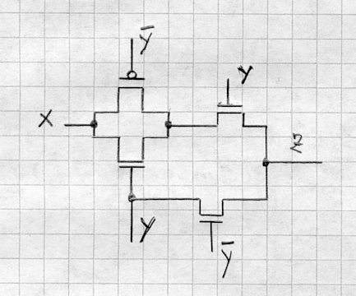

ANSWER____________________________________________________________

(5 points) b) For the following circuit, fill in the given table

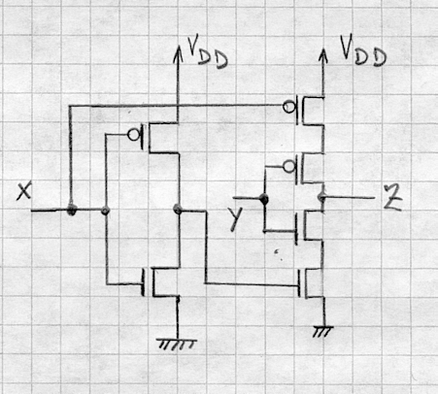

X Y Z
- 0
- 1
- 0
1 1

Your Name_______________________________________________________
Question 2 :Boolean Logic Theory (15 points)
Analyze the two-output circuit shown below:
(5 points) a) Indicate the logic expressions of the two outputs.
(5 points) b) Draw the two-level minimal NOR-NOR equivalent circuit producing the two output functions.
(5 points) c) Draw a three-level circuit that will share gates (as many as possible) among the two output functions.
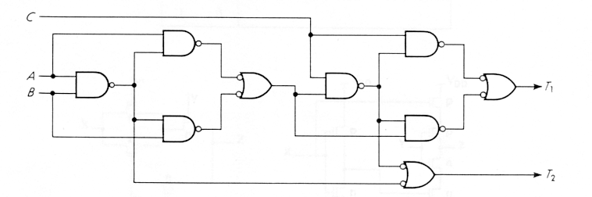

_________________________________________________________________

Your Name_______________________________________________________

Question 3 : VHDL (20 points)

(10 points) a) Write a complete VHDL description of the circuit shown in the figure of Question 2 of this exam (i.e. the one on the previous page!). Use one concurrent signal assignment statement for each gate shown in the figure.

(10 points) b) Write only the architecture for the NOR-NOR gate implementation of the circuit derived in part (b) of Question 2 (don't worry if you think your answer for 2b is wrong, just describe in VHDL what you answered).
Use component instantiations for the NOR gates. Don't forget the component declaration!
_________________________________________________________________________________________

Continue Question 3 on next page….
Your Name_______________________________________________________
Question 3:VHDL (20 points)

Your Name_______________________________________________________
Question 4 : Combinational Circuit Synthesis (15 points)
Design a combinational circuit that identifies the number of 1's at its input lines. This circuit has 4 inputs. A,B,C,D and 5 outputs: ZERO, ONE, TWO, THREE, FOUR. The outputs assume the value 1 when the corresponding number of 1's are found at the inputs. Example: For (ABCD) = (0110) output TWO equals to 1 and the remaining outputs assume the value 0. For (ABCD) = (1101) output THREE equals to 1 and the remaning outputs assume the value 0.
(5 points) a) Give the minimal two-level sum-of-products expression of each output function.
(5 points) b) Draw the circuit producing the 5 output functions using one 1-out-of-16 decoder as a building block and OR gates as needed.
(5 points) c) Using the fewest number of 3-LUT'S, draw the circuit for output function THREE.
_________________________________________________________________________________________

Continue Question 4 on next page………..

Your Name_______________________________________________________
Question 4 : Combinational Circuit Synthesis(Continued)

Your Name_______________________________________________________
Question 5 : Testing of Combinational Circuit(15 points)
Consider the following circuit

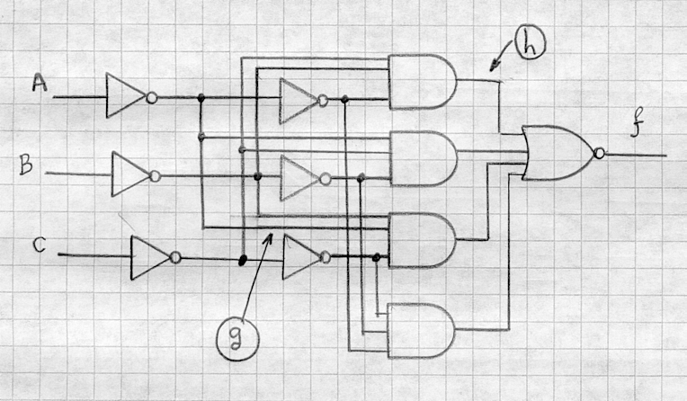

Determine all the test sets to detect:
(8 points) a) Lead h stuck at 0.
(7 points) b) Lead g stuck at 1.
_________________________________________________________________________________________

You Name_______________________________________________________
Question 6: Sequential circuits (15 points)
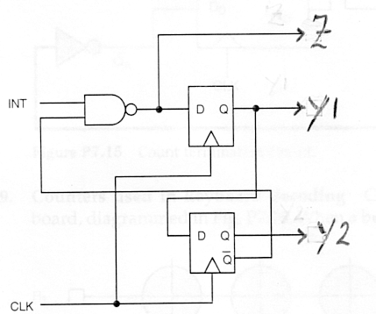
For the following circuit

(5 points) a) Give its state transition diagram
(5 points) b) Is this a Mealy or a Moore type of Finite State Machine?
(5 points) c) Give the equivalent circuit using only T-type Flipflops
________________________________________________________________________

Your Name_______________________________________________________
Question 7: Counter Design (15 points)

For the following circuit

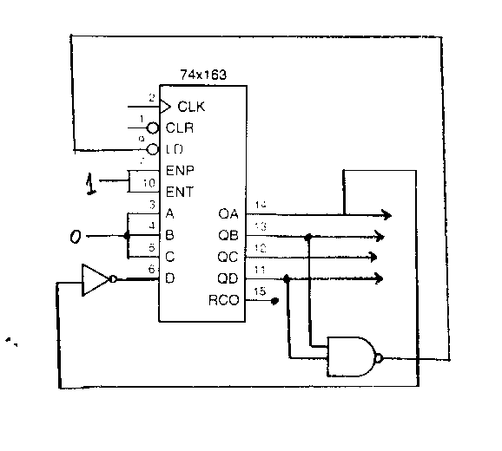
(5 points) a) Give the sequence Q_{D} Q_{C} Q_{B} Q_{A} that the counter will step through.
(5 points) b) If this circuit is not self-starting, modify it to be self-starting in a way that does not use the CLR input.
(5 points) c) Draw an alternative design that is self-starting and that does use the CLR input.
NOTE: CLR (CLEAR) and LD (LOAD) are synchronous inputs, meaning, that they affect the counter on the following rising edge of the clock.
_________________________________________________________________________________________
ANSWER:
a)
________________________________________________________________________________________
b)

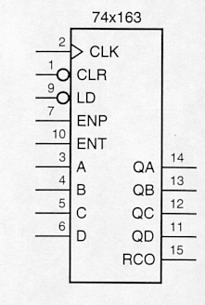

________________________________________________________________________________________
c)

Your name ______________________________________________
Question 8: Circuit Implementation Strategies/Logic arrays(15 points)

A PLA with 4 external inputs and 5 outputs is shown below. Two of the outputs can be folded back as additional inputs. On the schematic given below, draw the connections that produce the following three functions of 6 variables:

(5 points) a) X = ‾E F (‾D + C ) + B
(5 points) b) Y = ‾D + C + ‾E F B
(5 points) c) Z = A B‾D‾E F
_____________________________________________________________________________

ANSWER
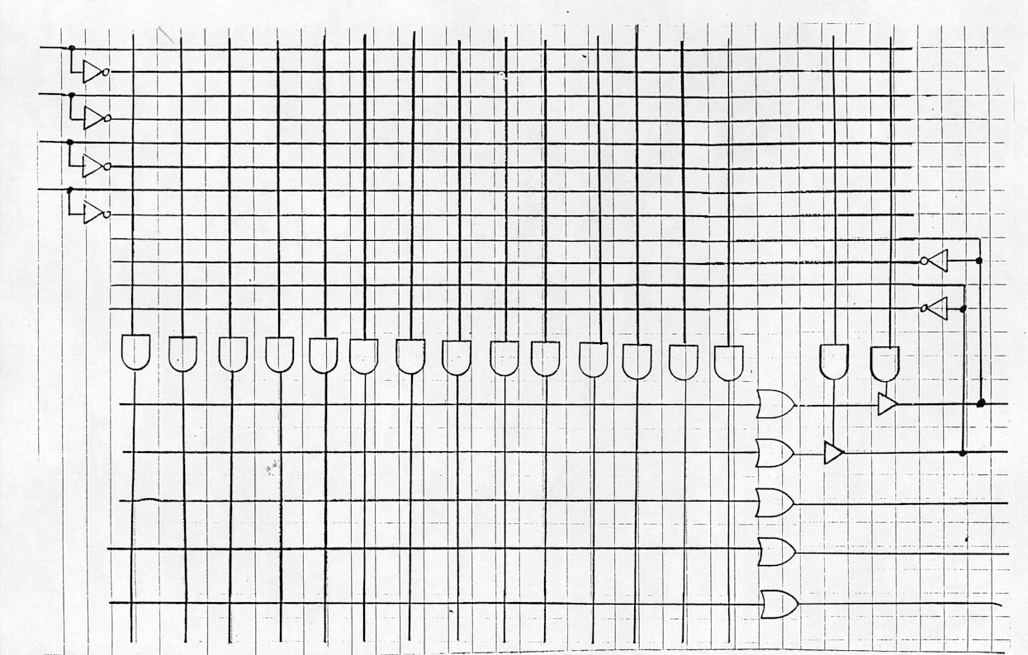

Your Name_______________________________________________________________________________
Question 9: Finite State Machine Design(15 points)

Design and draw the circuit of a Mealy-type FSM that will convert a 16-bit binary number X = x₁₅ x₁₄ … x₁ x₀
into its 2's complement Y = y₁₅ y₁₄ … y₁ y₀ . This circuit has two inputs: X, which takes the value x_{i} , 0 ≤ x_{i} ≤ 15, and RESET, and one output Y which takes the value y_{i}, 0 ≤ y_{i} ≤ 15. At each clock cycle i , 0 ≤ i ≤ 15 , the value x_{i} enters the input line X. After 16 clock cycles the input RESET resets the circuit into its initial state. In the initial state a flag is set to 0. For every x_{i} , 0 ≤ x_{i} ≤ 15, if flag = 0 then y_{i} = x_{i} and flag = x_{i}; else y_{i} = ‾x_{i} .
Hint: Use two states: s₀ = (flag = 0) and s₁ = (flag = 1).
(5 points) a) Give the state transition diagram of this FSM.
(5 points) b) Give the ONE-HOT ASSIGNMENT circuit implementation of this machine
(5 points) c) Give the equivalent circuit of this machine using a T-type flip-flop.
____________________________________________________________________________

Your Name_______________________________________________________
Question 10 : VHDL and Design of Sequential Systems(20 points)

Design an 3-bit synchronous counter circuit, implemented as a Moore Finite State Machine, that increments the counter when an input signal FORWARD goes high, and decrements the counter when an input signal BACKWARD goes high. In the unlikely event that both signals go high during the same clock cycle the count should not change. The circuit should have an asynchronous reset, which sets the count to 0. The count value should not wrap around, i.e. if the count is 7 the counter should not be incremented. Likewise if the count is 0 the counter should not be decremented.

(5 points) a) Draw the state transition diagram. Remember, this is a Moore machine.
(15 points) b) Write a complete VHDL description of your counter circuit.
____________________________________________________________________________

Continue Question 10 on next page….

Your Name_______________________________________________________
Question 10 (continued)

Your Name_______________________________________________________
Question 11 :Optimization of Finite State Machines (15 points)

Using the partitioning method reduce the following state transition table so that it contains the minimum number of states.
PRESET NEXT STATE OUTPUT
STATE Present input Present input
00 01 10 00 01 10
A E C B 1 0 1
B C F E 0 1 1
C B A D 1 0 1
D C F E 0 1 1
E A F B 0 1 1
F C E C 0 1 1

(5 points) First partition
(5 points) Second partition
(5 points) Third partition and reduced transition table
____________________________________________________________________________

Your Name_______________________________________________________
Question 12 : Testing of Sequential Circuits (10 points)

(2 points) a) Write down the count sequence that the circuit shown below generates.

ANSWER:
____________________________________________________________________________

Q2
Q1
T Q

Q

T Q

Q

T Q

Q

Q3
1
Clock

____________________________________________________________________________

(8 points) b) Convert the circuit to one that uses a scan-path for testing purposes.
Draw the circuit diagram of the modified circuit.

ANSWER:

