McGILL UNIVERSITY
Electrical and Computer Engineering Department
304-323B Winter 2002
FINAL EXAM

Question Maximum Points Points Attained

1 10
2 15
3 20
4 15
5 15
6 15
- 15
- 15
- 15
- 20
- 15
- 10

Total 180 points

Please write down your name: _____________________________________

Please write your student ID: ______________________________________

Instructions/Please read carefully!
This is a close book exam. No books or notes are allowed. You may use a standard calculator.
All work is to be done on the attached sheets and under no circumstance are booklets or loose sheets to be used. Write your name at the top of every sheet.

Read the question carefully. If something appears ambiguous, write down your assumption. The points have been assigned according to the formula that 1 point = 1 exam minute, so please pace yourself accordingly.

Your Name_______________________________________________________

Question 1 : MOS Circuit Technology (10 points)

Show the k-map of the functions f and g of the MOS network given in the following figure:
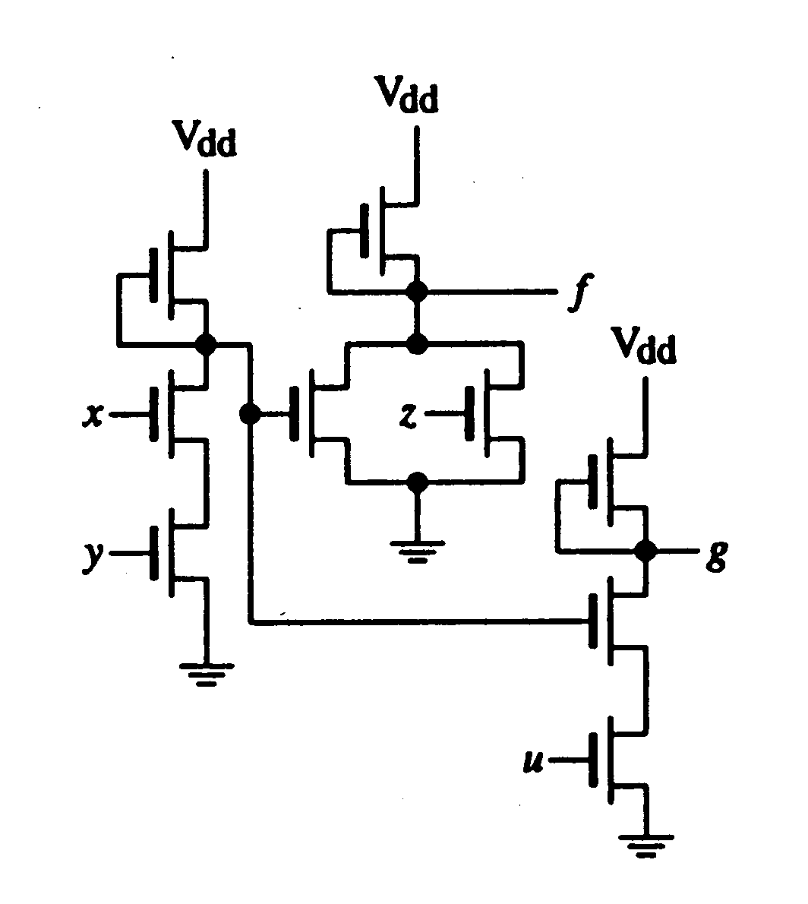

(5 points) for the k-map of f
(5 points) for the k-map of g
________________________________________________________________________

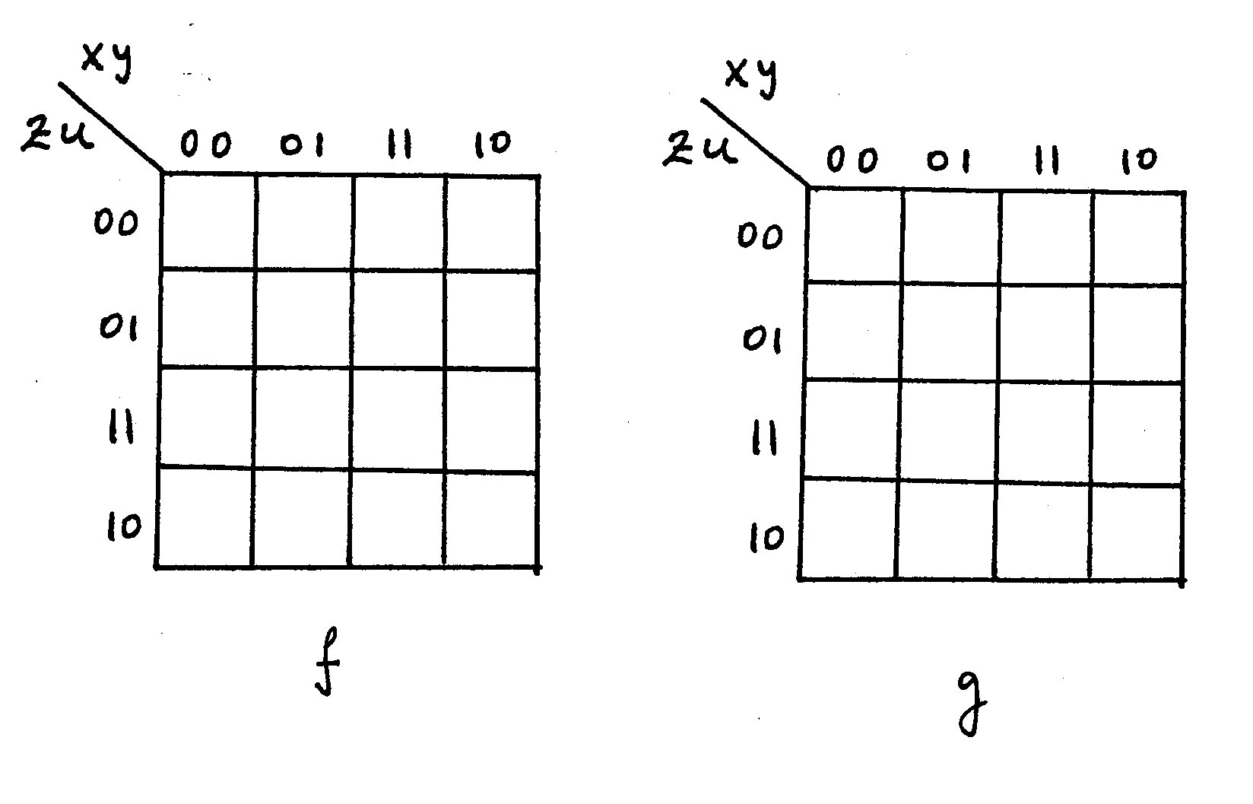

Your Name_______________________________________________________
Question 2 :Boolean Logic Theory (15 points)
For each of the following statements answer TRUE or FALSE by circling T or F respectively;

T F If the minimal sum-of-products expression for a function f is unique, then all the prime implicants for f are essential prime implicants.

T F If the minimal sum-of-products expression for the function f is unique, then the minimal product-of-sums of f is unique.

T F If p is an arbitrary prime implicant of f , then there is a minimal sum-of-products of f that has p.

T F The minimal sum-of-products expression of a completely specified function f is unique. A completely specified function does not have DON’T cares, all values are specified to be either 0 or 1.

T F The number of sums in a minimal product-of-sums expression for f is equal to the number of products in a minimal sum-of-products expression for f.

T F Some or all of the products of the minimal sum-of-products expression of the Petrick function represent all minimal sum-of- products expressions for f .

T F All the essential prime implicants of f must appear in every minimal sum-of-products expression of f.

T F If f is incompletely specified (contains DON’T CARES), its minimal sum-of-products is obtained by complementing its minimal product- of-sums expression.

(2 points) for the first 7 statements
(1 point) for the last statement
________________________________________________________________________

Your Name_______________________________________________________

Question 3 : VHDL (20 points)
(15 points) a) Write a behavioral VHDL code that represents a 16-bit up/down counter with an asynchronous reset and a parallel load of an initial seed (a non-zero value form which the counter starts counting).

(5 points) b) Design a 32-bit up/down counter using structural VHDL. As this new counter differs from the one in part a) only in size (preserving the same functionality), use the 16-bit counter from part a) as a component in your VHDL code.

Continue Question 3 on next page….
Your Name_______________________________________________________

Question 3:VHDL (20 points)

Your Name_______________________________________________________

Question 4 : Combinational Circuit Synthesis (15 points)

Produce two different designs of a 4-input bit count circuit. This circuit has 4-inputs (A,B,C,D) and its output (X,Y,Z) is the binary representation of the number of 1’s at the inputs. For example, if the input is (1,0,1,1), then the output is (0,1,1) = 3; if the input is (1,1,1,1), then the output is (1,0,0) = 4.
(10 points) (a) Give a minimal two-level NAND-NAND implementation of the circuit
(Share product terms among outputs if possible)
(5 points) (b) Give a two-level 4 x 1 MUX implementation of the circuit
(Use (A, B) variables as control variables for each one of the MUX’s that generate the outputs)
_______________________________________________________________________

Continue Question 4 on next page………..

Your Name_______________________________________________________

Question 4 : Combinational Circuit Synthesis(Continued)

Your Name_______________________________________________________

Question 5 : Testing of Combinational Circuit(15 points)

Give the minimal tests set for the following circuit
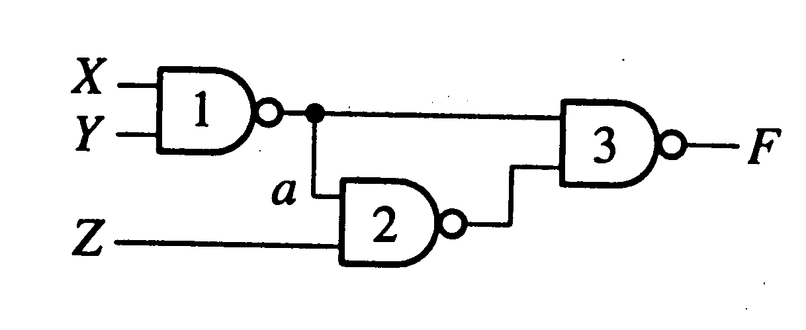

(5 points) a) Give the fault table with checkpoint faults only
(8 points) b) Give the Covering, the Petrick function and the minimal tests set
(2 points) c) Is input a of gate 2 detectable? Reason your answer.
______________________________________________________________________

Continu Question 5 on next page….

Your Name_______________________________________________________

Question 5 : Testing of Combinational Circuits (continued)

You Name_______________________________________________________

Question 6: Sequential circuits (15 points)
Consider the following synchronous sequential circuit
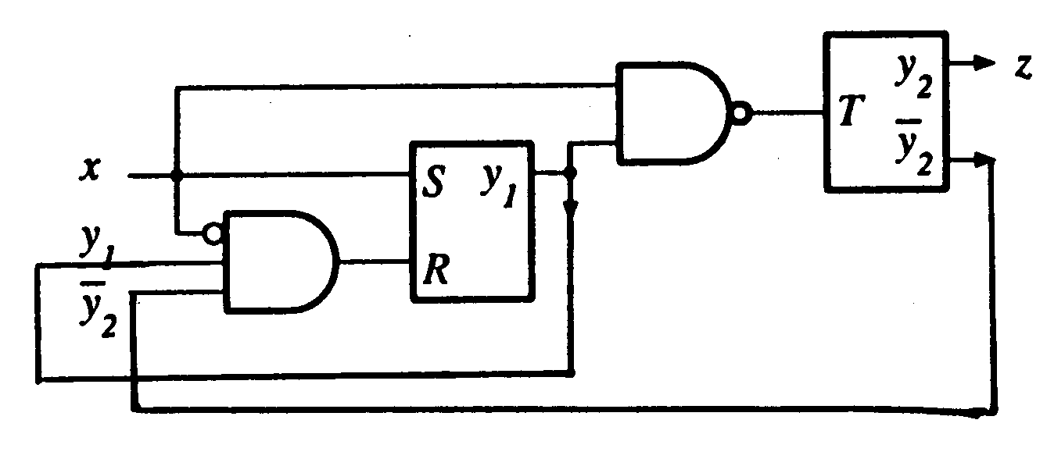

(5 points) a) Give the state transition diagram of this circuit
(5 points) b) Is this a Mealy or a Moore type Finite State Machine?
(5 points) c) Give the equivalent circuit using only T-type Flipflops
________________________________________________________________________

Your Name_______________________________________________________

Question 7: Register and Counter Design (15 points)
Draw the circuit of a 4-bit multifunction register R that performs according to the following table:

Mode Selection Funtion peformed
x y z

0 0 0 R is reset to 0
0 0 1 R = R + 1 (Add 1 to previous contents of R)
0 1 0 R = R + 2 (Add 2 to previous contents of R)
0 1 1 R = R + 4 (Add 1 to previous contents of R)
1 0 0 R is set to 1
1 0 1 R = R - 1 (Subtract 1 to previous contents of R)
1 1 0 R = R - 2 (Subtract 2 to previous contents of R)
1 1 1 R = R - 4 (Subtract 4 to previous contents of R)

For full credit use only 4 Full-adders and 4 8 x 1 MUX’s and inverters if needed.
(2 points) will be assigned for each correct add and subtract function,
(1 point) for each correct reset and set functions, and
(1 point) for correct readable drawing.
______________________________________________________________________

Your name ______________________________________________

Question 8: Circuit Implementation Strategies/Logic arrays(15 points)
(7 points) a) Draw an AND-OR PLA implementation of a circuit that carries out the following Boolean expressions:

f_1 = (a + b + (not c)) xor d
f_2 = (c xor b + a) xor d
f_3 = (a xor c + b) d
f_4 = ((not b) d xor a c)

(8 points) b) Draw a NOR-NOR PAL implementation of the same circuit.
___________________________________________________________________

Your Name_______________________________________________________
Question 8 (continued)

Your Name_______________________________________________________

Question 9: Finite State Machine Design(15 points)

The behavior of a certain MOORE-type FSM is given by the following state transition diagram
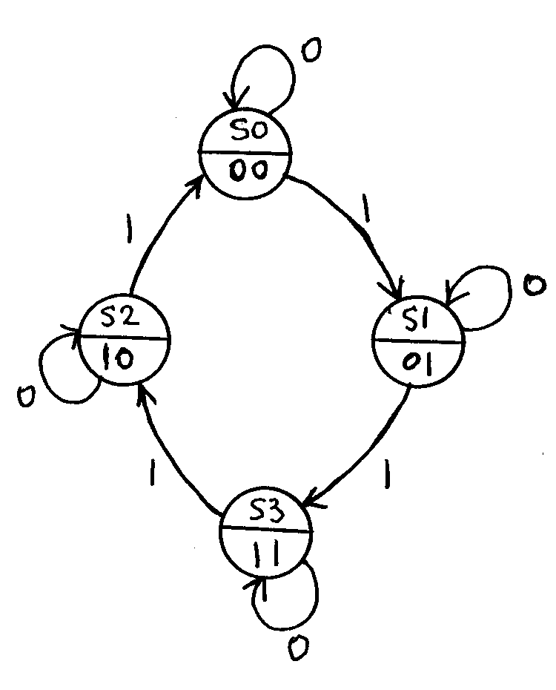

(10 points) a) Give the ONE-HOT ASSIGNMENT circuit implementation of this machine
(5 points) b) Give the circuit of the outputs using one 4-to-2 encoder
____________________________________________________________________

Your Name_______________________________________________________

Question 10 : Testing and Microcontroller Design (20 points)
Let us assume, that the testing features of your design consist of a scan chain used to supply an initial seed to the test pattern generator in a form of an LFSR. The LFSR and automatically, the scan chain, is of length 8.

Test scenario:
In the test mode, the initial seed is shifted in serially to the scan from the primary input pin. Then, after this process is completed, the content of the scan chain is loaded in parallel into the LFSR.

LFSR runs then for the next 30 clock cycles generating at each clock cycle a single test vector. After 30 clock cycles the operation of the LFSR is terminated, and its content (the last test vector generated) is loaded back in parallel into the scan chain.

Eventually, the content of the scan chain is shifted out in series through the primary output pin.

Assuming the length of the scan chain and the LFSR to be 8 (like specified at the beginning of this question), and the number of test vectors generated by the LFSR to be 30, design a register-based microprogrammed controller, which controls the operation of the scan chains and the LFSR.

(5 points) a) Present a schematic design of the register-based microprogrammed controller with the clear indication of all the control lined coming from and going to the scan chain and the LFSR.

(15 points) b) Derive a complete set of microcode instructions realizing the test scenario. Write all the instruction in a pseudo code with the clear explanations of the meaning of each abbreviation you are using. Include the binary format of a microinstruction with the clear explanation of the size and the meaning of data stored at each field of a microinstruction.
_______________________________________________________________

Continue Question 10 on next page….

Your Name_______________________________________________________

Question 10 (continued)

b) Idle: All control lines at '0'. Wait for startn signal to continue
Shift-in: Initial seed is shifted-in serially for 8 consecutive counts (cc's)
Then continu. Only scan-shift control is high.
Ifsr_load: Ifsr_load is high for 1 cc, then continue
Ifsr_start: Repeat this instruction for 30 cc's. Ifsr_start is high waiting for mod-30 signal to continue.
Ifsr_stop: Execution finished. Ifsr_stop and scan-load for 1 cc, load back in parallel the last vector.
Shift-out: Last vector shifted out of the scan chain serially for 8 cc's .Waiting for mod 8 to continue.
End: Return to idle state.

___________________________________________________________________________
Simulation
Address Brach Address Select Line ss sl ll lst lstop

Idle 000 000 100 0 0 0 0 0
Shift_in 001 001 010 1 0 0 0 0
Sr_load 010 010 000 0 0 1 0 0
Sr_start 011 011 011 0 0 0 1 0
Sr_stop 100 100 000 0 1 0 0 1
Shift-out 101 101 010 1 0 0 0 0
End 110 000 001 0 0 0 0 0
_____________________________________________________________________________
To select which Contrtol lines abreviations
cond. will be are explained in part a) above
used to choose
between: current
address, +1 or
branch address

Your Name_______________________________________________________
Question 11 :Optimization of Finite State Machines (15 points)

Using the partitioning method reduce the following state transition table so that it constains the minimum number of sates.

Present Next Sate Output
x = 0 x = 1 x = 0 x = 1

A C B 0 1
B C A 1 1
C E B 0 1
D F A 0 0
E A G 0 1
F D C 1 1
G E C 1 1

(5 points) First partition
(5 points) Second partition
(5 points) Third partition and reduced transition table
__________________________________________________________________

Your Name_______________________________________________________

Question 12 : Testing of Sequential Circuits (10 points)
(5 points) a) Design a TYPE 1 LFSR implementing the following polynomial: $P(x)=1+x+x^{2}+x^{4}$.
(5 points) b) Prove through simulations whether this polynomial is primitive.
_______________________________________________________________________

