McGill University DIGITAL SYSTEM DESIGN
Faculty of Engineering ECSE-323A

FINAL EXAMINATION
FALL 2003 (December 2003)

STUDENT NAME
McGILL I.D. NUMBER

Examiner: Prof. J. Clark Co-Examiner: Prof. M. Marin

Signature: Signature:

Date: December 16, 2003 Time: 2:00 pm

INSTRUCTIONS: SEE NEXT PAGE.

McGILL UNIVERSITY
Department of Electrical and Computer Engineering
ECSE-323B Winter 2003
FINAL EXAM

Question Maximum Points Points Attained

1 10
2 15
3 20
4 15
5 15
6 15
- 15
- 15
- 15
- 20
- 15
- 10

Total 180 points

Please write down your name: _____________________________________

Please write your student ID: ______________________________________

Instructions/Please read carefully!
This is a close book exam. No books or notes are allowed. You may use a standard calculator.
All work is to be done on the attached sheets and under no circumstance are booklets or loose sheets to be used. Write your name at the top of every sheet.

Read the question carefully. If something appears ambiguous, write down your assumption. The points have been assigned according to the formula that 1 point = 1 exam minute, so please pace yourself accordingly.

Your Name_______________________________________________________
Question 1 : CMOS Circuit Technology (10 points)
Draw the circuirof a 2 x 4 decoder using only transmission gates and two inverters. The truth table of a 2 x 4 decoder is the following:

X Y A B C D
0 0 1 0 0 0
0 1 0 1 0 0
1 0 0 0 1 0
1 1 0 0 0 1

Marking scheme: 5 points for correct approach, 5 points for correct circuit.
_________________________________________________________________________________________

Your Name_______________________________________________________
Question 2 :Boolean Logic Theory (15 points)
Express the function
G = ‾A ‾B C + ‾A B D + A ‾B‾C + A B‾D
In terms of the function H = ‾X Y + X Z.
Assume that ‾H is also available if needed.
Hint: You may find the Shannon Expansion useful.
Marking scheme: 5 points for explaining clearly your approach, 10 points for correct result showing clearly your work.
_________________________________________________________________

Your Name_______________________________________________________

Question 3 : VHDL (20 points)

(10 points) a) Write a complete VHDL description, using only selected signal assignment statements, of a circuit that implements the Boolean function F = A xor B xor C. Assume that the signals A,B,C as well as their complements are available as inputs.

(10 points) b) Write a complete VHDL description of a shift register that keeps track of the number of '1' bits that have been shifted out since the last reset (up to a total of 15). The inputs to the circuit should be the shift input, a synchronous shift enable, a clock signal, and an asynchronous reset signal. The outputs should be shift output, the 4-bit count, and an overflow signal, which goes high when the 16th '1' bit is shifted out.
_________________________________________________________________________________________

Continue Question 3 on next page….
Your Name_______________________________________________________
Question 3:VHDL (20 points)

Your Name_______________________________________________________
Question 4 : Combinational Circuit Synthesis (15 points)
Design a BCD 9's complementer. A 9's complementer is a circuit that receives as input a BCD-coded decimal digit N , 0 < N < 9 , and produces another BCD-coded decimal digit N' , such that N' = 9 - N.
(5 points) a) Give the truth table of the outputs.
(5 points) b) Draw the minimal NAND-NAND circuit of the outputs.
(5 points) c) Draw the circuit of the outputs using only 4 x 1 multiplexers and minimal number of gates needed.
_________________________________________________________________________________________

Continue Question 4 on next page………..

Your Name_______________________________________________________
Question 4 : Combinational Circuit Synthesis(Continued)

Your Name_______________________________________________________
Question 5 : Testing of Combinational Circuit(15 points)
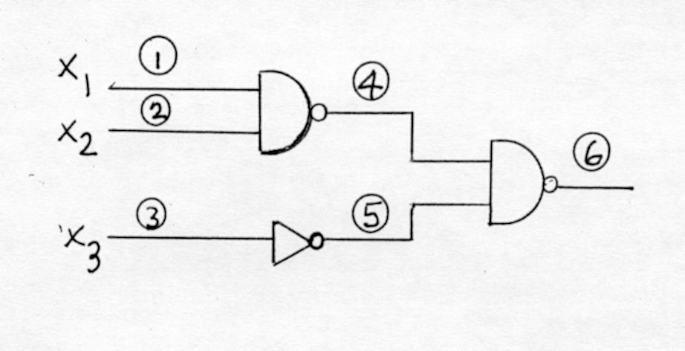
For the following circuit

(1 point) a) Give the check points.
(2 points) b) Give the test for fault 4/1.
(7 points) c) Give the minimal test sets.
________________________________________________________

You Name_______________________________________________________
Question 6: Sequential circuits (15 points)
Analyze the following circuit
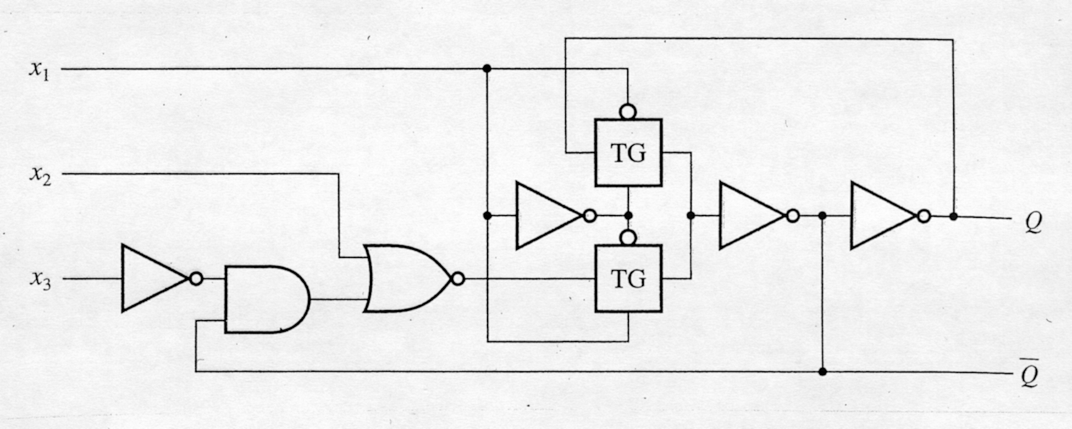

(5 points) a) Give its state transition table.
(5 points) b) Give its characteristic and excitation equations.
(5 points) c) Give the circuit of a JK-type latch using this circuit as bulding block and fewest additional gates.
________________________________________________________________________

Your Name_______________________________________________________
Question 7: Counter Design (15 points)

Design a 3-bit self-starting counter that has two counting modes depending on the value of a mode selection input S. If S = 0, then the counter follows the odd natural sequence 1, 3 , 5, 7, 1, 3, 5, 7, …, and if S = 1 then it counts following the even natural sequence 0,2,4,6,0,2,4,6,…
(5 points) a) Give the state-transition-table of the counter
(5 points) b) Give the minimal sum-of-products of the excitation equations of the D-type flip-flops.
(5 points) c) Give the complete circuit using NAND gates.
Hint: Pay special attention to the self-starting requirement while constructing the sate-transition-table.
_________________________________________________________________________________________

Your name ______________________________________________
Question 8: Circuit Implementation Strategies/Logic arrays(15 points)

The equation of a 9-bit parity checker function is the following:
P = A ⊕ B ⊕ C ⊕ D ⊕ E ⊕ F ⊕ G ⊕ H ⊕ J.
The PLA shown on next page is to be used to produce this function.
(7 points) a) Decompose the funtion so that it can be produced with the given PLA.
Hint: DON’ T expand P directly in terms of nine-variable minterms!. Instead express P in terms of blocks of three-variable EXCLUSIVE-OR functions. Then synthezise the three-variable EXCLUSIVE-OR blocks by programming their minterms and by using some of the feedback lines.
(8 points) b) Complete the PLA program by showing carefully the required connections.
Not all connections are needed.
____________________________________________________________________________

Continue Question 8 on next page -------------→
Your name ______________________________________________
Question 8: Circuit Implementation Strategies/Logic arrays(15 points) (Continues)

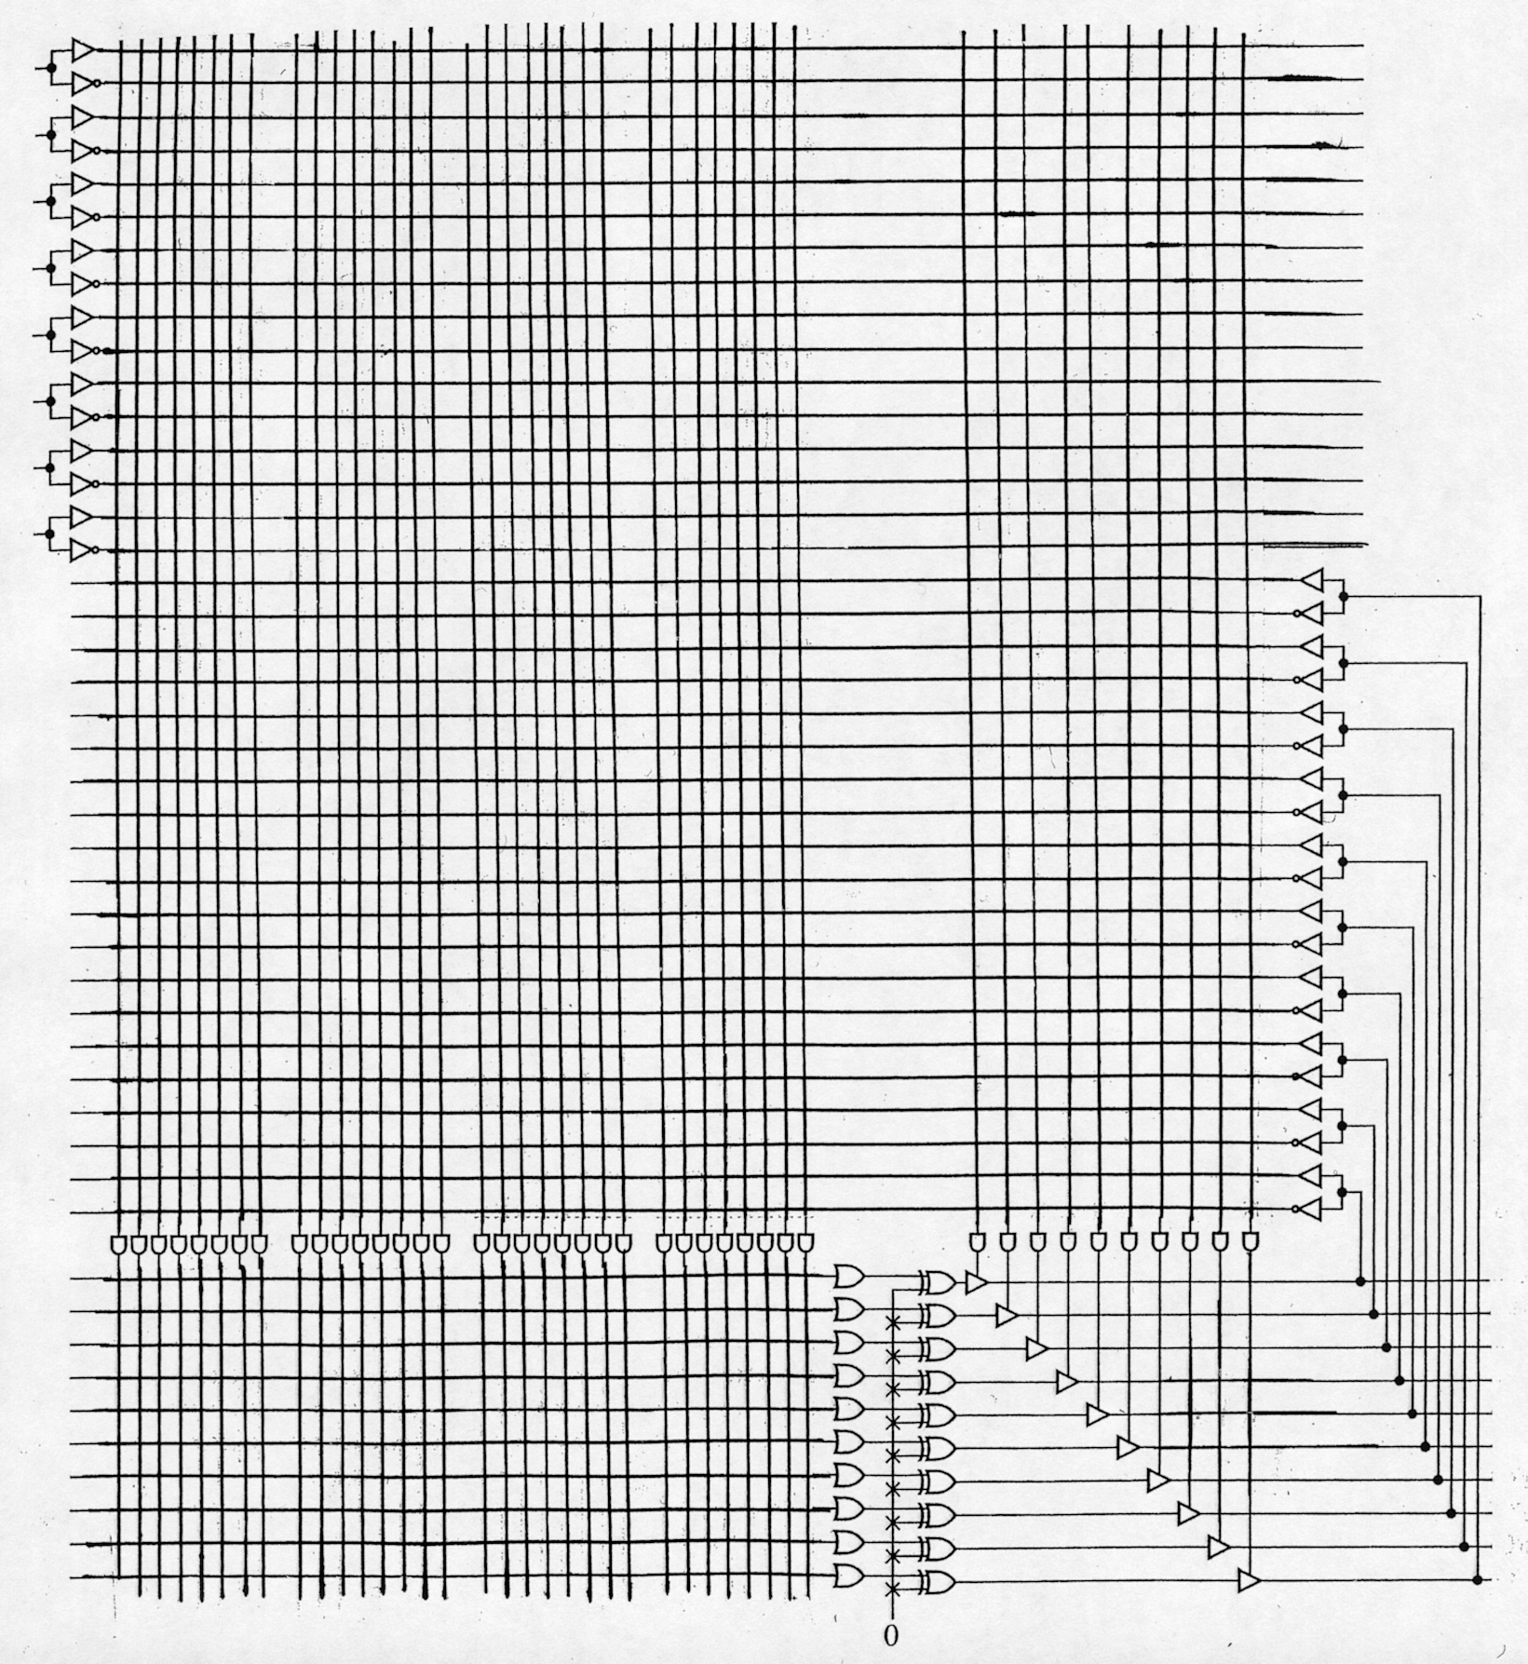
NOT USED

Your Name_______________________________________________________________________________
Question 9: Finite State Machine Design(15 points)

A 3-bit SERIAL code converter is a finite state machine that has one input and one output and that serially converts, from on code to another, an input message (A,B,C) into an output message (X,Y,Z). The least significant bit of the message, namely C, enters the FSM first. You are to design a serial converter, Mealy-type FSM, that converts a 3-bit binary-coded message (A,B,C) into a 3-bit Gray-coded message (X,Y,Z).
The code conversion table is shown below:

Binary code Gray code
A B C X Y Z

0 0 0 0 0 0
0 0 1 0 0 1
0 1 0 0 1 1
0 1 1 0 1 0
1 0 0 1 1 0
1 0 1 1 1 1
1 1 0 1 0 1
1 1 1 1 0 0

(5 points) a) Give the state-transition-diagram of this FSM.
(3 points) b) Give the ONE-HOT ASSIGNMENT state-transition-table .
(4 points) c) Give the complete circuit using D-type flip-flops and AND, OR, NOT gates.
(3 points) d) Give the formula to compute the maximum clock rate of this FSM.

____________________________________________________________________________

Continue Question 9 on next page -------------→
Your Name_______________________________________________________________________________
Question 9: Finite State Machine Design(15 points) (Continues)
Your Name_______________________________________________________
Question 10 : VHDL and Design of Sequential Systems (20 points)

Design a datapath/controller system that can compute an on-going histogram of 3-bit input values. That is, the system has 8 output registers, each corresponding to a possible input value (0-7). Each time a particular input value is observed, the corresponding histogram output register is incremented. Assume that the input register is inspected whenever an external control signal named INSPECT goes high. An asynchronous RESET input sets all the histogram registers to 0 when the RESET is high.

(5 points) a) Draw a block diagram of a datapath/controller implementation, showing all datapath elements, the controller, and with all control signals labelled.
(5 points) b) Draw the state transition diagram. Remember, this is a Moore machine.
(10 points) c) Write the architecture block portion of the VHDL description of the controller.
____________________________________________________________________________

Continue Question 10 on next page….

Your Name_______________________________________________________
Question 10 (continued)

Your Name_______________________________________________________
Question 11 :Optimization of Finite State Machines (15 points)

Using the partitioning method reduce the following state transition table so that it contains the minimum number of states.
PRESET NEXT STATE OUTPUT
STATE Present input Present input
X = 0 X = 1 X = 0 X = 1
A B C 0 0
B D E 0 0
C F G 0 0
D H I 0 0
E J K 0 0
F L N 0 0
G N P 0 0
H A A 0 0
I A A 0 1
J A A 0 0
K A A 0 1
L A A 0 0
M A A 0 0
N A A 0 0
P A A 0 0

(5 points) First partition
(5 points) Second partition
(5 points) Final reduced transition table
____________________________________________________________________________

Your Name_______________________________________________________
Question 12 : Testing of Sequential Circuits (10 points)

(4 points) a) Give two reasons why an LFSR based built-in self-test unit might not detect the presence of a given fault in a circuit.

ANSWER:

i)__________________________________________________________________________________

ii)__________________________________________________________________________________

(6 points) b) Draw a scan-path version of a 4-bit accumulator circuit (an accumulator is a module that adds its input to the stored value, when enabled). Assume that the accumulator circuit consists of a 4-bit input register, a 4-bit binary adder, and a 4-bit accumulation register. Overflows and carries are ignored, and there is no carry in.
_____________________________________________________________________________

