McGill University DIGITAL SYSTEM DESIGN
Faculty of Engineering ECSE-323A

FINAL EXAMINATION
FALL 2002 (December 2002)

STUDENT NAME McGILL I.D. NUMBER

Examiner: Prof. J. Clark Co-Examiner: Prof. M. Marin

Signature: Signature:

Date: December 17, 2002 Time: 2:00 pm

INSTRUCTIONS: SEE NEXT PAGE.

McGILL UNIVERSITY
Department of Electrical and Computer Engineering
ECSE-323A Fall 2002
FINAL EXAM

Question Maximum Points Points Attained

1 10
2 15
3 20
4 15
5 15
6 15
- 15
- 15
- 15
- 20
- 15
- 10

Total 180 points

Please write down your name: _____________________________________

Please write your student ID: ______________________________________

Instructions/Please read carefully!
This is a close book exam. No books or notes are allowed. You may use a standard calculator.
All work is to be done on the attached sheets and under no circumstance are booklets or loose sheets to be used. Write your name at the top of every sheet.

Read the question carefully. If something appears ambiguous, write down your assumption. The points have been assigned according to the formula that 1 point = 1 exam minute, so please pace yourself accordingly.

Your Name_______________________________________________________

Question 1 : CMOS Circuit Technology (10 points)

Consider the CMOS circuit shown below. This circuit has four inputs A,B,C,D and one output Z. X indicates an internal connection meaning that the terminals labelled X are connected together
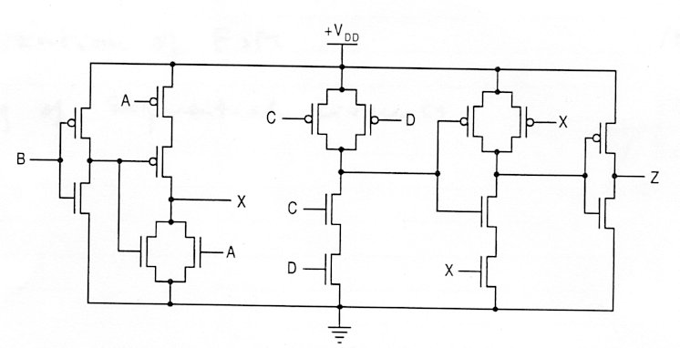

(5 points) a) By completing the table shown below, construct the truth table for this circuit taking into account all possible combinations of L and H inputs.

A B C D Z
L L L L
L L L H
L L H L
L L H H
L H L L
L H L H
L H H L
L H H H
H L L L
H L L H
H L H L
H L H H
H H L L
H H L H
H H H L
H H H H

(5 points) b) Give the k-map expression of Z assuming positive-logic.

AB
CD 00 01 11 10
00
01
11
10

Your Name_______________________________________________________

Question 2 :Boolean Logic Theory (15 points)

You are given: one 3-input NAND gate,
one 2-input OR gate and
one 2-input AND gate.
Using only these gates draw the circuit producing the function:

T(A,B,C,D) = ‾A B + ‾B C + B ‾D

(8 points) a) Describe briefly your approach
(7 points) b) Draw the circuit.
Hint You may find helpful the k-map of T
__________________________________________________________________________________________

Your Name_______________________________________________________

Question 3 : VHDL (20 points)

(10 points) a) Write a complete VHDL description of a combinational circuit whose output is high when one 4-bit input, A, has more ‘1’ bits than another 4-bit input, B. Do not use process blocks for this description.

(10 points) b) Draw the circuit diagram for the circuit described by the following VHDL code :

ENTITY bcd_adder IS
PORT( A, B : IN STD_LOGIC_VECTOR(3 downto 0);
Cin : IN STD_LOGIC;
S : OUT STD_LOGIC_VECTOR(3 downto 0);
Cout : OUT STD_LOGIC);
END bcd_adder;

architecture bcd_a1 of bcd_adder is

COMPONENT full_adder
PORT( A, B, CI : IN STD_LOGIC;
S, CO : OUT STD_LOGIC);
END COMPONENT;

SIGNAL Ci1, Ci2, Ci3, Ci4, Ci5, Ci6 : STD_LOGIC;
SIGNAL zero, Si1, Si2, Si3, CoutI, aa1, aa2 : STD_LOGIC;

begin
FA0: full_adder PORT MAP (A => A(0), B => B(0), CI => Cin, CO => Ci1, S => S(0));
FA1: full_adder PORT MAP (A => A(1), B => B(1), CI => Ci1, CO => Ci2, S => Si1);
FA2: full_adder PORT MAP (A => A(2), B => B(2), CI => Ci2, CO => Ci3, S => Si2);
FA3: full_adder PORT MAP (A => A(3), B => B(3), CI => Ci3, CO => Ci4, S => Si3);
FA4: full_adder PORT MAP (A => CoutI, B => Si1, CI => zero, CO => Ci5, S => S(1));
FA5: full_adder PORT MAP (A => CoutI, B => Si2, CI => Ci5, CO => Ci6, S => S(2));

aa1 <= Si3 and Si2;
aa2 <= Si3 and Si1;
CoutI <= aa1 or aa2 or Ci4;
Cout <= CoutI;
S(3) <= Si3 xor Ci6;
zero <= '0';

end bcd_a1;
__________________________________________________________________________________________

Continue Question 3 on next page….
Your Name_______________________________________________________

Question 3: VHDL continues (20 points)

Continue Question 3 on next page….
Your Name_______________________________________________________

Question 3: VHDL continues (20 points)

Your Name_________________________________________________________________________________

Question 4 : Combinational Circuit Synthesis (15 points)

Design a combinational circuit which will produce a function F of four variables A, B, C, D, such that F = 1 iff (if and only if) A + B + C + D = 2 or 3 ( the + sign indicates arithmetic sum)

(5 points) (a) Give a minimal two-level NAND-NAND implementation of the circuit
producing F.
(5 points) (b) Give a two-level 4 x 1 MUX implementation of the circuit
(Use A, B variables as control variables for the output MUX)
(5 points) (c) Give an LUT realization of F using 3-input LUTs.
____________________________________________________________________________________________

Continue Question 4 on next page………..

Your Name_______________________________________________________

Question 4 : Combinational Circuit Synthesis continues

Your Name_______________________________________________________

Question 5 : Testing of Combinational Circuit(15 points)

Using the Petrick function, find the minimal FDTS (fault detection test sets) from the following fault table
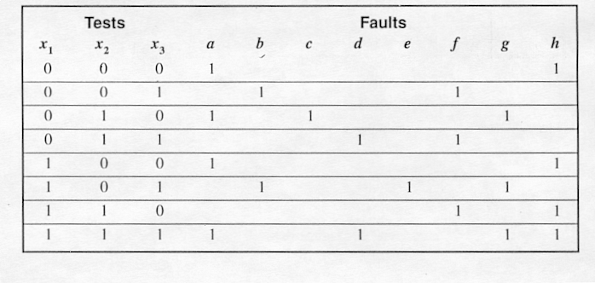

(5 points) a) Give the Petrick function
(5 points) b) Give the reduced Petrick function
(5 points) c) Give the complete test sets.
______________________________________________________________________

Continue Question 5 on next page…

Your Name_______________________________________________________

Question 5 : Testing of Combinational Circuits continues

You Name_______________________________________________________
Question 6: Sequential circuits (15 points)
Consider the following synchronous sequential circuit
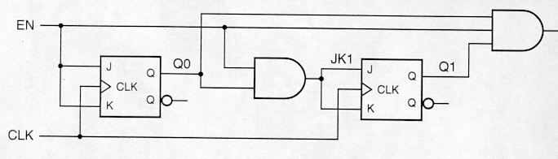

(5 points) a) Give the state transition diagram of this circuit
(3 points) b) Give the excitation, transition and output tables
(2 points) b) Is this a Mealy or a Moore type Finite State Machine?
(5 points) c) Give the equivalent circuit using only T-type Flipflops
(Note:Partial credit will be given if only JK flip-flops are replaced by their equivalent T-flipflops).
________________________________________________________________________

Your Name_________________________________________________________________________________

Question 7: Register and Counter Design (15 points)

Design a modulo-129 counter using ONLY two 74x163's and a single inverter. For convinience the schematic of the 74x163 are given below. Note that the ENP, ENT inputs are connected together and set to active 1 for the device to be enabeled. Input A and output QA are the Most-Significant-Bits of inputs and outputs respectively.
The 74x163 is a 4-bit binary up counter with synchronous CLEAR, meaning that when CLR is asserted the next clock pulse clears the counter.
___________________________________________________________________________________________

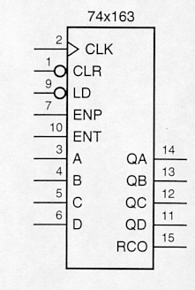

Your name ______________________________________________

Question 8: Circuit Implementation Strategies/Logic arrays(15 points)

(5 points) a) Draw an AND-OR PLA implementation of a circuit that produces the following Boolean
expressions:

F₁ = Σm (0,2,5,6,13)
F₂ = Σm (0,5,11,13,15)
F₃ = Σm (0,4).

(10 points) b) Draw a NOR-NOR PAL circuit producing the three functions of part a).
____________________________________________________________________________________________

Continue Question 8 on next page….

Your Name_______________________________________________________

Question 8 continues

Your Name_________________________________________________________________________________

Question 9: Finite State Machine Design(15 points)

Design a MOORE-type FSM that will detect, by asserting its output Z to 1, the presence of the sequence 001 at its input line X. Otherwise Z = 0. Assume that the machine has an external RESET input which puts the machine into its initial state before the X input is received.
(5 points) a) Give the state transition diagram of this FSM. (4 states are needed)
(5 points) b) Give the ONE-HOT ASSIGNMENT circuit implementation of this machine
(2 points) c) Give the circuit of the output Z using one 4-to-2 encoder.
(3 points) d) Compute the maximum clock rate assuming: one gate delay of 1 ns, set-up time of 2 ns and propagation delay of the flip flop equal to 4 ns.
____________________________________________________________________________________________

Your Name_______________________________________________________

Question 10 : Data Path Controller Design (20 points)

Design, using a Datapath/Controller architecture, a circuit that implements a recursive exponential averaging operation. This should implement the formula Y(t) = aY(t-1) + (1-a)X(t), where X(t) is an external input value, Y(t) is the current output, Y(t-1) is the previous output, and a is a filter coefficient assumed to be held in a register. Assume that the value of (1-a) has been precomputed and is also available in a register. The operation should be executed on the rising edge of an asynchronous input signal named SampleClock. There should be an asynchronous reset signal. The value of Y should be set to zero on a reset. Do not worry about the specifics of the arithmetic operations (such as whether the numbers are represented as integer or floating point).

- (10 points) Draw the block diagram of the system, showing all datapath elements and their interconnection, as well as the controller block, indicating all control signals.
- (10 points) Draw the state transition diagram for the controller. Use a Moore machine for the controller.
____________________________________________________________________________________________

Continue Question 10 on next page….

Your Name_______________________________________________________

Question 10 (continued)

Your Name_______________________________________________________
Question 11 :Optimization of Finite State Machines (15 points)

Using the partitioning method reduce the following state transition table so that it constains the minimum number of sates.

Present Next Sate Output
state x = 0 x = 1 x = 0 x = 1

1 1 1 0 0
2 1 6 1 1
3 4 5 0 0
4 1 7 1 0
5 2 3 0 0
6 4 5 0 0
7 2 3 0 1

(10 points) Give all partitions needed for the complete reduction of states
(5 points) Give the reduced transition table
__________________________________________________________________

Your Name_______________________________________________________

Question 12 : Testing of Sequential Circuits (10 points)

Design a 4-bit synchronous decade counter (i.e. a counter that counts from 0-9) that is fully testable. Use D-flipflops and employ a scan-path approach to implement the testability.
__________________________________________________________________

