McGill University
Department of Electrical and Computer Engineering

Course: ECSE - 323 Winter 2008
Assignment #7
with solutions
TOPIC: Registers and Counters
Registers (Section 7.8, page 399)
Problem 1
Design a circuit that adds 3 to the contents of a 4-bit register. Originally the register contains a 4-bit number N , where 000< N < 1100. After one single clock pulse the register contents should be N + 0011.
a) Explain briefly your design approach
b) Draw the complete circuit using JK-type edge-trigger flip-flops, full adders and NAND gates as needed.
____________________________________________________________________________
ANSWER
a) Load each flip-flop of the register with the output of a full-adder which has, respectively, as inputs the previous contents and the corresponding bit of the number 0011. Carry should ripple from one order to the next.
b)
Note that a D-type flip-flop can be built with a JK-type and an inverter thus
Problem 2
Design a 4-bit multifunction register that will behave according to the following table:
A B | Function performed
00 | Clear register
01 | Complement register contents
10 | Add 1 to register contents
11 | Load register from input lines

Where A, B are the mode select inputs. Use 4 x 1 multiplexers for mode selection
_______________________________________________________________________
ANSWER
Di = ‾A‾B [ 0 ] +‾A B [‾Qi ] + A‾B [Si] + A B [Ii]
where Si = Qi + Ci ( + means here arithmetic addition) for i = 0,1,2,3 with C0 = 1.

Counters
Problem 3
Using the 74X163 4-bit programmable counter, with synchronous CLEAR and LOAD inputs, whose block diagram is shown below, and the fewest number of gates possible, draw a circuit of a counter having 4 different counting sequences depending on the values of two mode selection variables s₁ s₂ . The 4 counting sequences of the counter are the following

Mode selection s₁ s₂ | Counting sequence
00 | 0 to 15
01 | 0 to 7
10 | 0 to 9
11 | 0 to 12

Use one 4 x 1 multiplexer for mode selection. Assume that the counter is self starting, meaning that the counter will always fall into the correct selected counting sequence after certain number of counts have elapsed.
____________________________________________________________________________
ANSWER:
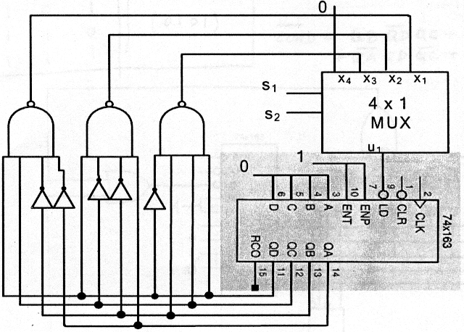

Problem 4
Using the 74x163 4-bit programmable counter, with synchronous CLEAR and LOAD
Inputs, whose block diagram is shown below, and the fewest number of gates possible draw a SERLF-STARTING counter that will count following the sequence 5,6,7,8,9,10,5,6,7,8,9,10….
____________________________________________________________________________
ANSWER
Out-of-sequence detection logic
 | Present state  QD QC QB QA | Next state  QD+ QC+ QB+ QA+
0 | 0 0 0 0 | Load  (0101)
1 | 0 0 0 1 | Load  (0101)
2 | 0 0 1 0 | Load  (0101)
3 | 0 0 1 1 | Load  (0101)
4 | 0 1 0 0 | Load  (0101)
5 to  10 | Counting  sequence | Counting  sequence
11 | 1 0 1 1 | Load  (0101)
12 | 1 1 0 0 | Load  (0101)
13 | 1 1 0 1 | Load  (0101)
14 | 1 1 1 0 | Load  (0101)
15 | 1 1 1 1 | Load  (0101)

_____
LOAD = QB‾QD QC +
+QA‾QD QC + ‾QA QD ‾QC + ‾QB QD‾QC

************END OF ASSIGNMENT #7 WITH SOLUTIONS************

