McGill University
Department of Electrical and Computer Engineering

Course: ECSE - 323 Winter 2008

Assignment #5
with solutions

TOPIC: Circuit Implementation Strategies/Logic Arrays

From Brown’s textbook (2nd. Edition):

Programmable Logic Devices/Logic Arrays/LUT's (Section 3.6, pp 94 to 110; Section 6.8 Solved Examples pp. 364 to 370)

1.- Problem 3.37
________________________________________________________________________
ANSWER

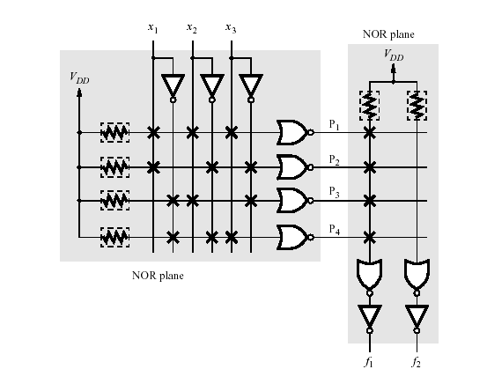

2.-
a) Program the following PLA device to produce the functions:

F₁ = ‾C B‾A + C ‾B + D‾B‾A
F₂ = C + A‾B
F₃ = B‾A + C B + D‾B
Hint: Rewrite the algebraic expressions of F₁, F₂, F₃ and program the 6 terms of the AND array.
__________________________________________________________________
ANSWER
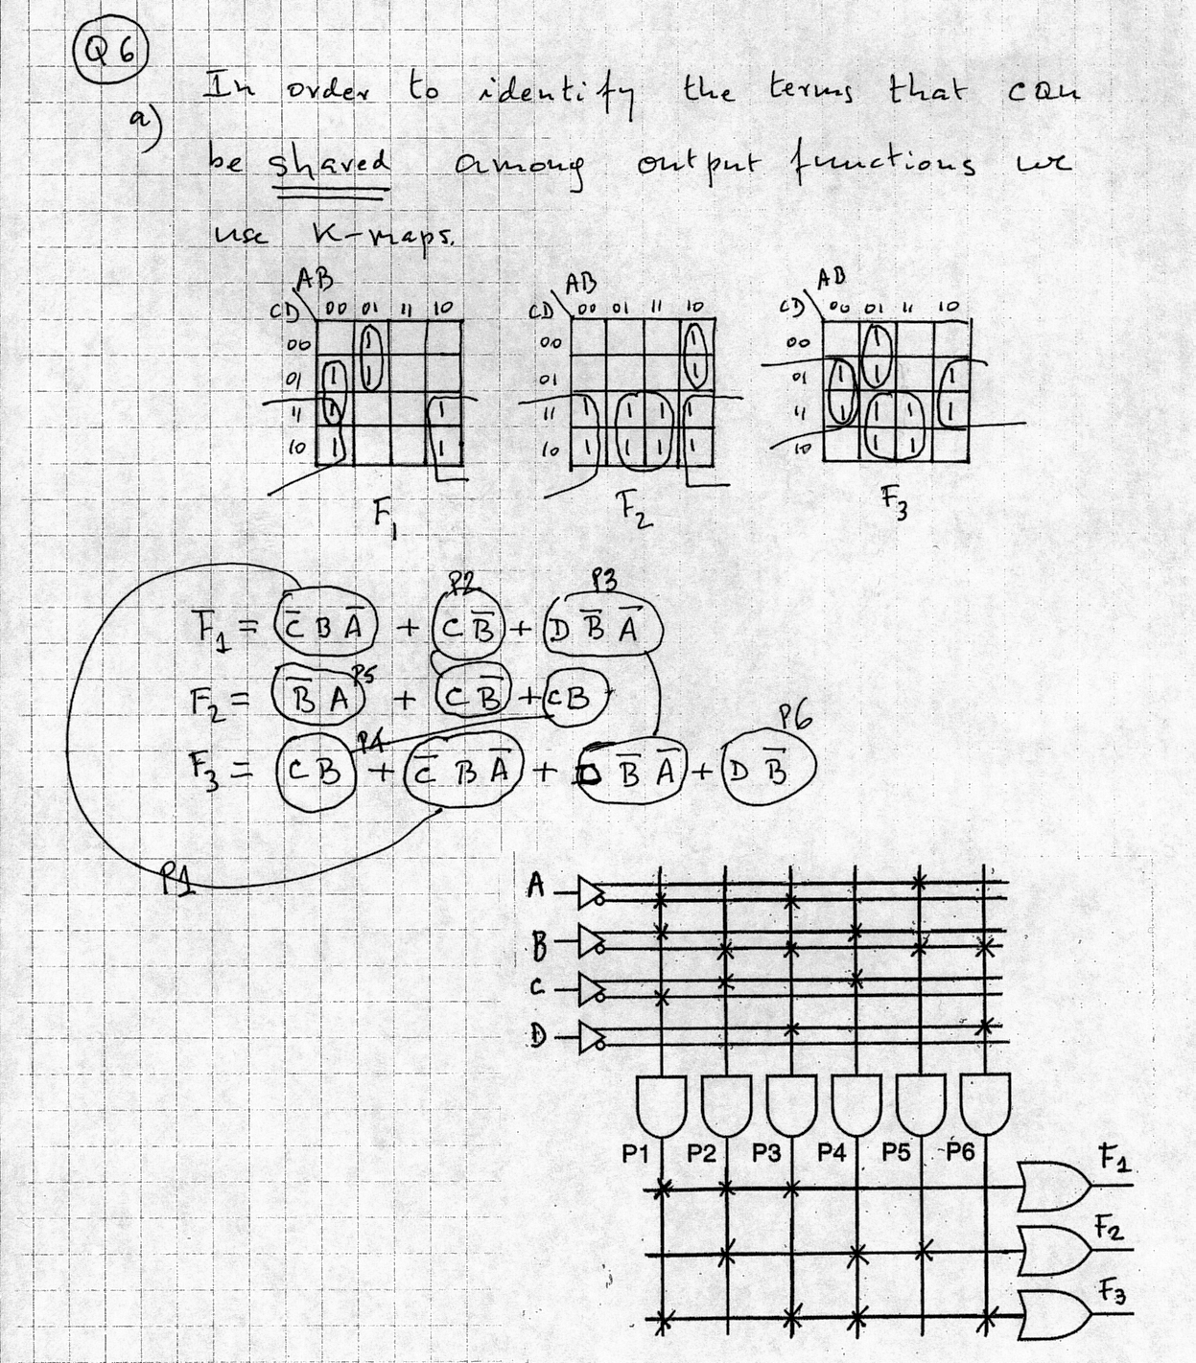

3.- Problem 3.44
___________________________________________________________________________
ANSWER

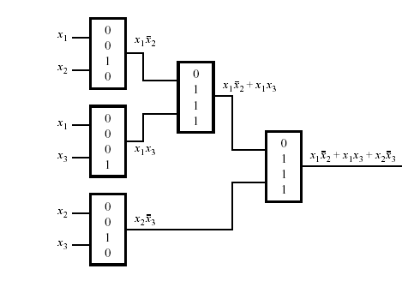

4.- Problem 3.47
__________________________________________________________________________
ANSWER

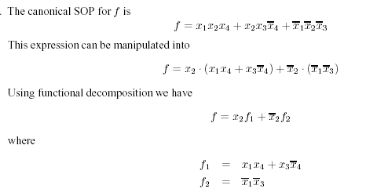

_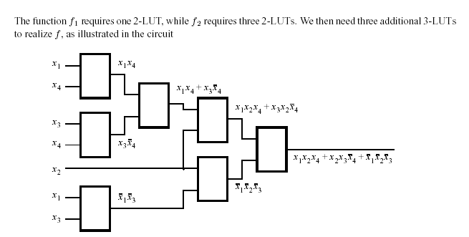

5.- Problem 5.26
_________________________________________________________________________
ANSWER
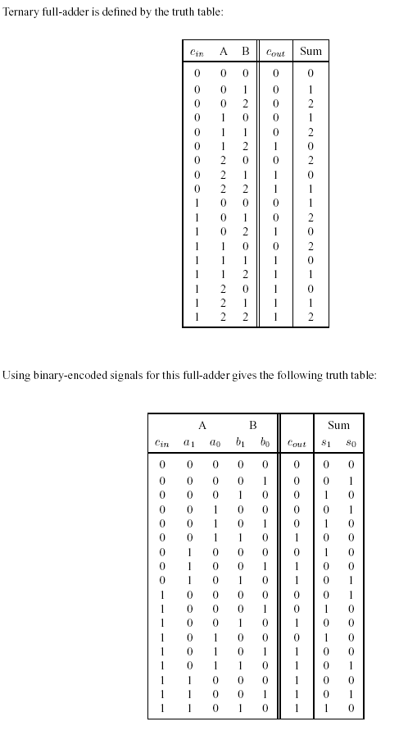
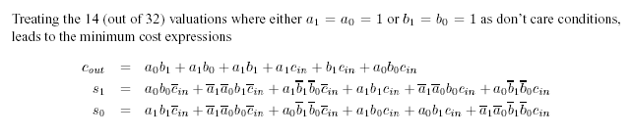

6.- Problem 6.31
________________________________________________________________________
ANSWER
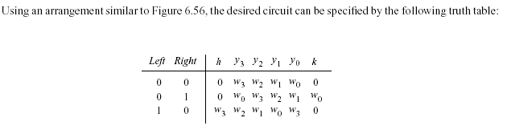

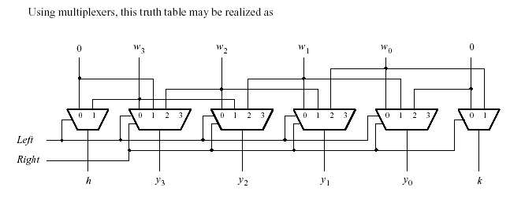
******************END OF ASSIGNMENT #5(with solutions)********************

