McGill University
Department of Electrical and Computer Engineering

Course: ECSE 323 -Digital Systems Design Winter 2008

Assignment #2
(with solutions)

TOPIC: CMOS CIRCUIT TECHNOLOGY
PART I .-CMOS CIRCUITS

1.- Find a CMOS complementary circuit producing the function
F (A,B,C,D) = ∑m (3,5,7,11,12,13,14,15).
using a minimum number of transistors. Assume that only true variables are available as inputs.
ANSWER
F_{min} = A B + C D + BD ‾F = (‾A +‾B)(‾C +‾D)(‾B +‾D)

AB  CD | 00 | 01 | 11 | 10
00 | 0 | 0 | 1 | 0
01 | 0 | 1 | 1 | 0
11 | 1 | 1 | 1 | 1
10 | 0 | 0 | 1 | 0
AB  CD | 00 | 01 | 11 | 10
00 | 0 | 0 | 1 | 0
01 | 0 | 1 | 1 | 0
11 | 1 | 1 | 1 | 1
10 | 0 | 0 | 1 | 0
Note that we have minimized both true and complemented expressions of the given function F and we have implemented F as the pull-down-network and ‾F as the pull-up-network. The inverter at the output produces the function F. In this way we avoid the need to produce the complement of the input variables.
__________________________________________________________________________
2.- What function does the following circuit produce ?

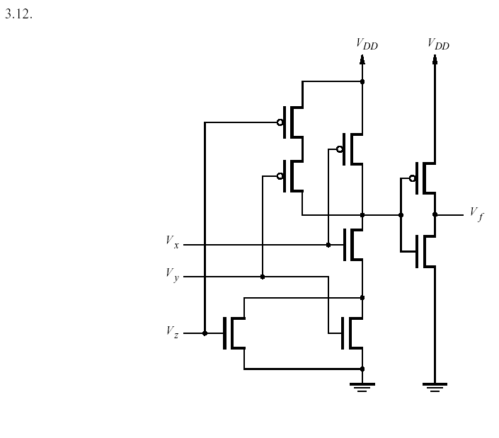
a) Give the truth table of the function V_{f} in terms of the polarities H, L assumed by the input variables V_{x} , V_{y} , V_{z}
b) If H = 1 and L = 0, give the algebraic expression of the Boolean function F
produced by the given circuit
_______________________________________________________________________
ANSWER
a) b)
V_{x} V_{y} V_{z} | V_{f}
L L L | L
L L H | L
L H L | L
L H H | L
H L L | L
H L H | H
H H L | H
H H H | H
X Y Z | F
0 0 0 | 0
0 0 1 | 0
0 1 0 | 0
0 1 1 | 0
1 0 0 | 0
1 0 1 | 1
1 1 0 | 1
1 1 1 | 1
F = X ( Y + Z) = X Y + X Z
______________________________________________________________________
3.- Consider the following fully complementary CMOS circuit

a) Is there anything wrong with this circuit?
b) What function does it produce?
c) By looking at the configuration of the pull-up-network and the pull-down-network, can you assert that the function produced by the circuit is self-dual? Prove your answer.
_____________________________________________________________________
ANSWER
a) There is nothing wrong with this circuit. The PUN is mutually exclusive with the PDN. There are no floating outputs (undefined output values). The output values are completely specified for each one of the input valuations.
b) The function produced by the circuit is F = B + B‾A = B.
c) By inspection of the circuit, we see that the topologies of the PUN and PDN are the same. Since the function realized by the PUN is the dual function of the one realized by the PDN, this function must be self-dual because the circuits producing the function and its dual are the same. Effectively, the circuit produces F = B, which is self dual.
_______________________________________________________________________

4.- Consider de following CMOS circuit

a) What function does this circuit produce?

b) What is wrong with this circuit? Does F have equal fan-out power for every valuation of the inputs? What can you say about this way of using pass transistors in synthesizing CMOS circuits?
_______________________________________________________________________
ANSWER
a) Analyzing the topology of the pass transistors in the circuit, we observe that B selects one of two mutually exclusive paths. Similarly does A, which offers 4 ( 2 x 2 mutually exclusive paths) to pass either C or ‾C onto F via the corresponding path selected by B. What this means, in Boolean algebra terms, is represented by the following expression:

F = B[A C +‾A‾C ] + ‾B [‾A C + A‾C] = B [ A ‾⊕ C] + ‾B [A ⊕ C] = B ⊕ A ⊕ C.

b) There is nothing wrong with this circuit. However, we observe that the polarity that F assumes is the polarity that C has. C is an input and does not get regenerated inside the circuit. When F assumes the value ‾C, than it has full fan-output power because its polarity comes from the output of the inverter complementing the input C. We can say that we must be careful when realizing circuits with pass transistors. The fun-out of the circuit produced may not be equal for every valuation of the inputs.

PART II.- Transmission gates

6.- A circuit is to be produced that indicates when a carry signal is produced by a two-bit binary adder. The circuit behaves according to the following table

A B | Carry
0 0 | 0
0 1 | 0
1 0 | 0
1 1 | 1

Draw a circuit producing the function Carry using THE FEWEST NUMBER OF TRANSMISSION GATES (T-gates) and inverters if needed.
________________________________________________________________________
ANSWER

Note that we must produce the 0’s as well as the 1’s of the function. The Carry output has full fan-out power.

---------------------------------------END OF ASSIGNMENT #2-----------------------------------

