McGILL UNIVERSITY
Department of Electrical and Computer Engineering
ECSE-323 Winter 2006
MIDTERM EXAM

Question Maximum Points Points Attained
1 10

2 10
3 15

4 15
5 10

6 15
Total 75 points
Please write down your name: ANSWER KEY

Please write your student ID: ______________________________________
Instructions/Please read carefully!
This is a close book exam. No books or notes are allowed. You may use a standard calculator.
All work is to be done on the attached sheets and under no circumstance are booklets or loose sheets to be used. Write your name at the top of every sheet.
Read the question carefully. If something appears ambiguous, write down your assumption. The points have been assigned according to the formula that 1 point = 1 exam minute, so please pace yourself accordingly.

Your Name_______________________________________________________

Question 1 :Boolean Logic Theory (10 points)
Using the Quine-McCluskey method, find ALL minimal two-level sum-of-products expressions of the function

F (A,B,C,D) = Σm(0,4,5,8,10,13,14,15).

(5 points) a) Give the list of all prime implicants of F

(5 points) b) Using the PETRICK FUNCTION, find ALL MINIMAL two-level sum-of- products expressions of F .
___________________________________________________________________________
ANSWER
First Reduction No further reduction
List of Prime implicants

‾A ‾C‾D
‾B‾C‾D
‾A B‾C
A‾ B‾D
B‾ C D
A C‾D
A B‾D
A B C
ID | A B C D
√ 0 | 0 0 0 0
√ 4  √ 8 | 0 1 0 0  1 0 0 0
√ 5  √ 10 | 0 1 0 1  1 0 1 0
√ 13  √ 14 | 1 1 0 1  1 1 1 0
√ 15 | 1 1 1 1
ID | A B C D
0,4 | 0 - 0 0
0,8 | - 0 0 0
4,5 | 0 1 0 -
8,10 | 1 0 - 0
5,13 | - 1 0 1
10,14 | 1 - 1 0
13,15 | 1 1 - 0
14,15 | 1 1 1 -
Covering Table
| <--------------------minterms ---------------------------------->|
P.I. | Group |  | 0 | 4 | 5 | 8 | 10 | 13 | 14 | 15
P1 | 0,4 | ‾A‾C‾D | √ | √
P2 | 0,8 | ‾B‾C‾D | √ |  |  | √
P3 | 4,5 | ‾A B‾C |  | √ | √
P4 | 8,10 | A‾B‾D |  |  |  | √ | √
P5 | 5,13 | B ‾C D |  |  | √ |  |  | √
P6 | 10,14 | A C‾D |  |  |  |  | √ |  | √
P7 | 13,15 | A B‾D |  |  |  |  |  | √ |  | √
P8 | 14,15 | A B C |  |  |  |  |  |  | √ | √

Your Name_______________________________________________________

Question 1 :Boolean Logic Theory (10 points) (Continues)

There are no essential prime implicants and no reduction of the covering table is possible.
The Petrick function should give us the minimal forms.

P = (P1 + P2) (P1 + P3) (P3 + P5) (P2 + P4) (P4 + P6) (P5 + P7) (P6 + P8)(P7 + P8)
= (P1 + P2P3)(P3 + P1P5)(P4 + P2P6)(P7 + P5P8)(P8 +P6P7)
= (P1P3 + P1P5 + P2P3)(P4 + P2P6)(P7P8 + P6P7 + P5P8)
= (P1P3P4 + P1P5P4 + P2P3P4 + P2P3P6 + P1P3P2P6 +P1P5P2P6) )(P7P8 + P6P7 + P5P8) = P1P5P4P8 + P2P3P6P7 +P1P3P4P7P8 + P1P5P4P7P8 + ……
|←---minimal--→| |←---------- not minimal--------------→|

There are two minimal two-level sum-of-products expressions of F, namely,

F_{min} = P1 + P5 + P4 + P8 = ‾A‾B‾C + B‾C D + A‾B‾D + A B C

F_{min} = P2 + P3 + P6 + P7 = ‾B‾C‾D +‾A B‾C + A C‾D + A B‾D.

Your Name_______________________________________________________

Question 2 : Application of Boolean Theory (10 points)

(5 points) a) Show, by means of a truth table, that the dual function of the function NAND(A,B,C) is equal to the function NOR(A,B,C).

(5 points) b) Show that any function F, of any number of variables, which is expressible as a single literal, is self-dual. For example, if F (A,B,C,D) = B, then F is self-dual; if F (A,B,C,D,E,H) = ‾C, then F is self-dual.
___________________________________________________________________________
ANSWER
Applying the rule of Duality:
A B C | NAND (A,B,C)
0 0 0 | 1
0 0 1 | 1
0 1 0 | 1
0 1 1 | 1
1 0 0 | 1
1 0 1 | 1
1 1 0 | 1
1 1 1 | 0
A B C | NOR (A,B,C)
1 1 1 | 0
1 1 0 | 0
1 0 1 | 0
1 0 0 | 0
0 1 1 | 0
0 1 0 | 0
0 0 1 | 0
0 0 0 | 1
Changing ALL 0’s into 1’s
and ALL 1’s into 0’s ,
we obtain the truth table
of the NOR function.

b) The rule of duality states that the dual of a function F is obtained by interchanging OR and AND operators, all constants 0 into 1 and vive versa, and keeping the variables unchanged.

If a function F can be expressed as a single literal (one variable with either true or complemented form), then F does not have any OR and AND operators and therefore, its dual has the same form because the literal does not change when applying the duality rule. Such a function is invariant under duality and thus, is self-dual.

Your Name_______________________________________________________

Question 3 : VHDL (15 points) .

- (5 marks) List five (5) errors in the following VHDL description:

LIBRARY ieee ;
USE ieee.std_logic_1164.all ;
ENTITY Q3 IS
PORT MAP ( A,B : IN STD_LOGIC_VECTOR(1 DOWNTO 0) ;
X : IN std_logic;
y : OUT STD_LOGIC_VECTOR(3 DOWNTO 0) ) ;
END ENTITY ;

ARCHITECTURE AA OF Q3 IS
BEGIN
X <= ‘0’;
Y(3) <= A(1) AND X;
Y(2 downto 1) <= A & B(1);
Y(0) <= not Y(3);
END Q3;

1. "port map" should be just "port" .

2. "end entity" should be "end Q3" .

3. X is an input port, and hence cannot be assigned to, and thus cannot be on the LHS side of an assignment statement. .

4. Y(2 downto 1) is a 2-bit std_logic_vector, whereas the RHS of the assignment statement evaluates to a 3-bit std_logic_vector. .

5. Y(3) is an output port, and hence cannot show up on the RHS of an assignment statement.

Other errors include (6) The final END should be "END AA".

Question 3 continues on next page ---→
Your Name_______________________________________________________

Question 3 : VHDL (15 points) (Continues)

- (10 marks) Let X be a 3-bit inputs, and let N be a 2-bit output which represents the number of ‘1’ bits in X (e.g. if X=110 then N=10). Write a complete VHDL description of a circuit that implements this function. Use only simple signal assignment statements, and use only AND, NOT, and OR operators. You do not have to simplify the function.

Begin by determining the function to be implemented. The simplest way is to write down the truth tables, or write the canonical expressions for the output bits.

N0 = !X2*!X1*X0 + !X2*X1*!X0 + X2*!X1*!X0 + X2*X1*X0
N1 = !X2*X1*X0 + X2*!X1*X0 + X2*X1*!X0 + X2*X1*X0
where !X indicates the complement of X, * indicates the AND operation, and + indicates the OR operation.

LIBRARY ieee;
USE ieee.std_logic_1164.all;

ENTITY Q3b IS
PORT (X : IN STD_LOGIC_VECTOR(2 DOWNTO 0);
N : OUT STD_LOGIC_VECTOR(1 DOWNTO 0));
END Q3b ;

ARCHITECTURE F OF Q3b IS
BEGIN
N(0) <= (not X(2) and not X(1) and X(0)) or
(not X(2) and not X(0) and X(1)) or
(not X(1) and not X(0) and X(2)) or
(X(2) and X(1) and X(0));
N(1) <= (not X(2) and X(1) and X(0)) or
(not X(1) and X(0) and X(2)) or
(not X(0) and X(1) and X(2)) or
(X(2) and X(1) and X(0));
END F;

Your Name_______________________________________________________

Question 4 : CMOS Circuit Technology Design (15 points)
Consider the following Boolean function of four variables

F(A,B,C,D) = A B + B C + C D + D A.

(5 points) a) Draw the pull-up and the pull-down networks of a fully
complementary CMOS circuit producing F. ONLY TRUE VARIABLES ARE AVAILABLE AS INPUTS.
(10 points) b) Using ONLY transmission gates, draw a circuit that produces F.
TRUE AND COMPLEMENTED VARIABLES ARE AVAILABLE AS INPUTS.

a) Since only true variables are available as inputs, we implement ‾F followed by an inverter.

‾F = (‾A + ‾B)(‾B + ‾C)(‾C +‾D)(‾D +‾A)
Pull-up network: ‾F = (‾B +‾A‾C )(‾D +‾C‾A)
(PUN) ‾F = ‾B‾D + ‾A‾C.

Pull-down network: F = AB + B C + C D + D A.
(PDN)
The complete circuit is shown below.
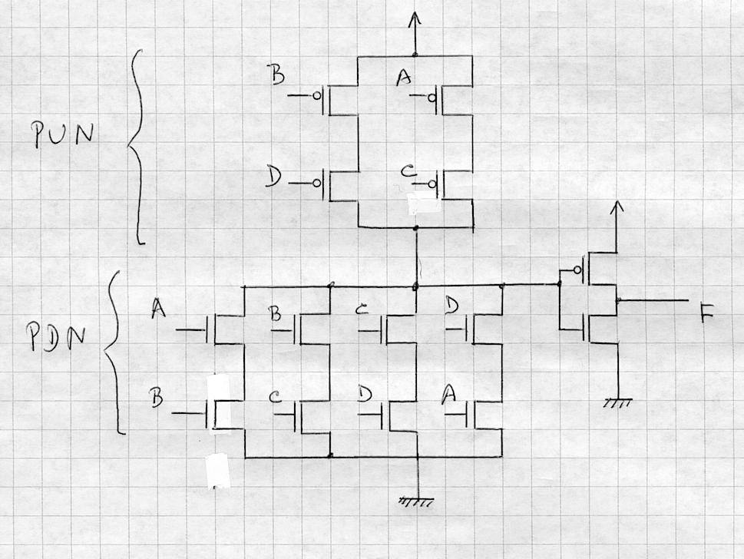
Continue Question 4 (b) on next page -----------→
Your Name_______________________________________________________

Question 4 : (Continues)
b) At every logic level we expand F by the Shannon expansion about one of the variables until we reach a single input variable and/or a fixed polarity 0, 1. We choose, arbitrarily, the variable A for the first level.

F = AB + BC + CD + DA
First logic level: F_{A} = ‾A[BC + CD] + A[B + D]
Second logic level: [BC + CD]_{B} = ‾B[CD] +B[1]
[B + D]_{B} = ‾B[D] + B[1]
Third logic level: [CD]_{C} = ‾C[0] + C[D]

The resulting circuit is shown below:
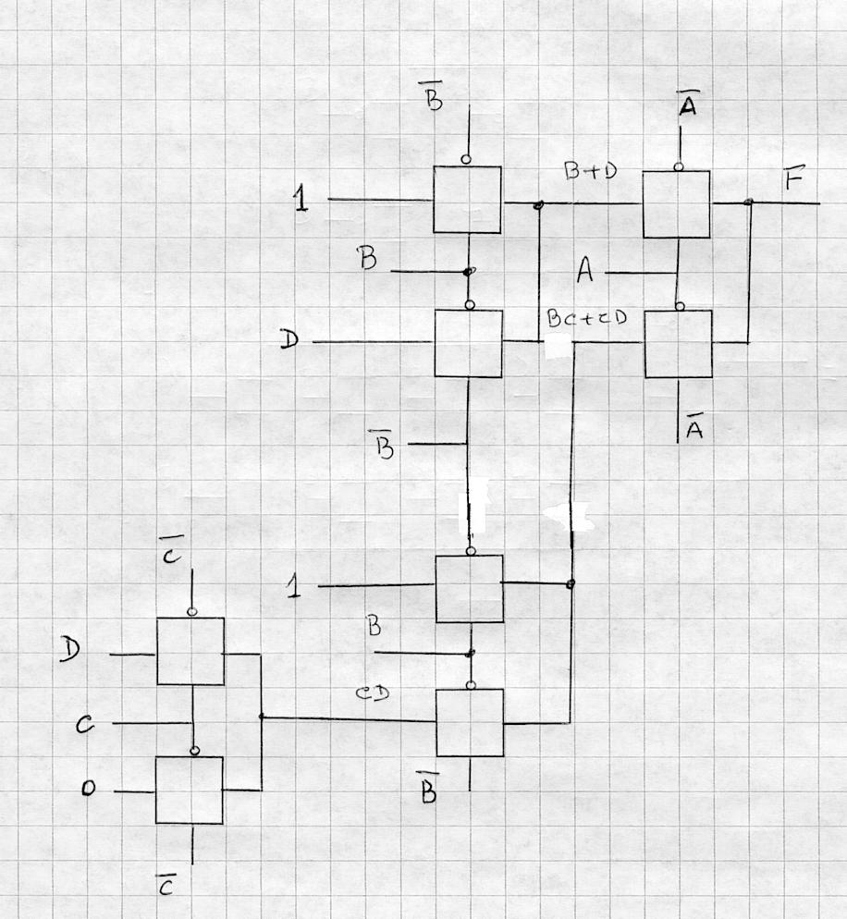

Your Name_______________________________________________________

Question 5 : Circuit Implementation Strategies/Logic Arrays (10 point)

Given the following Boolean functions

P = A ⊕ B ⊕ C ⊕ D ⊕ E
Q = A ⊕ B ⊕ C ⊕ F ⊕ G

(5 points) a) Decompose the functions in such a way that they can be produced with a network having only three 3-input LUTS.
(5 points) b) Draw the complete circuit specifying the truth table of each LUT.
___________________________________________________________________________
ANSWER
a) Let R = A ⊕ B ⊕ C
Then, P = R ⊕ D ⊕ E and Q = R ⊕ F ⊕ G, which suggest the following 3 3-LUT circuit

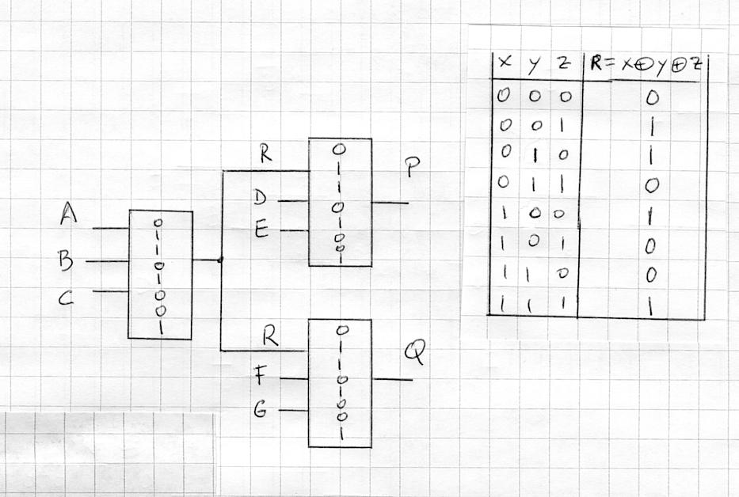

Your Name_______________________________________________________

Question 6 : Combinational Circuits Synthesis (15 points)

Using only full-adders as building blocks, draw a circuit that will receive as input a 4-bit number N and will produce as output a binary number Z such that Z = 9 N, i.e. Z is the result of multiplying N by 9.
Marking scheme: 5 points for the correct approach if properly explained.
5 points for the correct circuit.
5 points for the circuit with least number of full-adders.
___________________________________________________________________________
ANSWER

We observe that Z = 9 N = 8 N + N.
Since multiplication by 8 is equivalent to shifting left the multiplicand N three times, the multiplication of N by 9 can be done by adding N to the result of expanding N with three zeros in the three right most positions.
Let N = A₃A₂A₁A₀. Then, Z = 8 N + N = (A₃ A₂ A₁ A₀ 0 0 0) + (0 0 0 A₃ A₂ A₁,A₀), which can be produced by cascading 7 full-adders as shown by the following circuit:

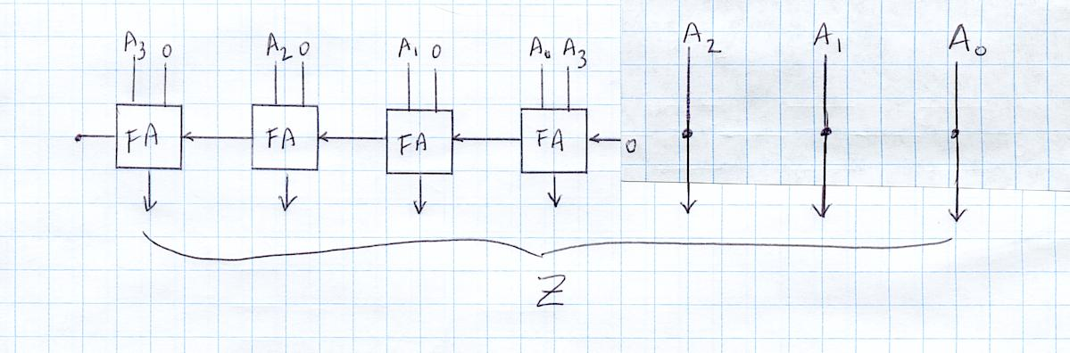
Note that there is no need of full-adders in the three most right orders, and that all full-adders can be replaced by half-adders. Since the problem stated to use only full-adders, the circuit shown above answers correctly the question asked.

