McGILL UNIVERSITY
Department of Electrical and Computer Engineering
ECSE-323 Fall 2005
MIDTERM EXAM

Question Maximum Points Points Attained
1 10

2 10
3 15

4 15
5 10

6 15
Total 75 points
Please write down your name: ANSWER KEY
Please write your student ID: ______________________________________
Instructions/Please read carefully!
This is a close book quiz. No books or notes are allowed. You may use a standard calculator.
All work is to be done on the attached sheets and under no circumstance are booklets or loose sheets to be used. Write your name at the top of every sheet.
Read the question carefully. If something appears ambiguous, write down your assumption. The points have been assigned according to the formula that 1 point = 1 exam minute, so please pace yourself accordingly.

Your Name_______________________________________________________

Question 1 :Boolean Logic Theory (10 points)
Consider the following circuit
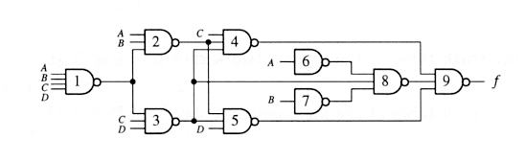

(5 points) a) Give the k-map corresponding to F.

(5 points) b) Give the minimal two-level NOR-NOR circuit producing F. _________________________________________________________________
ANSWER
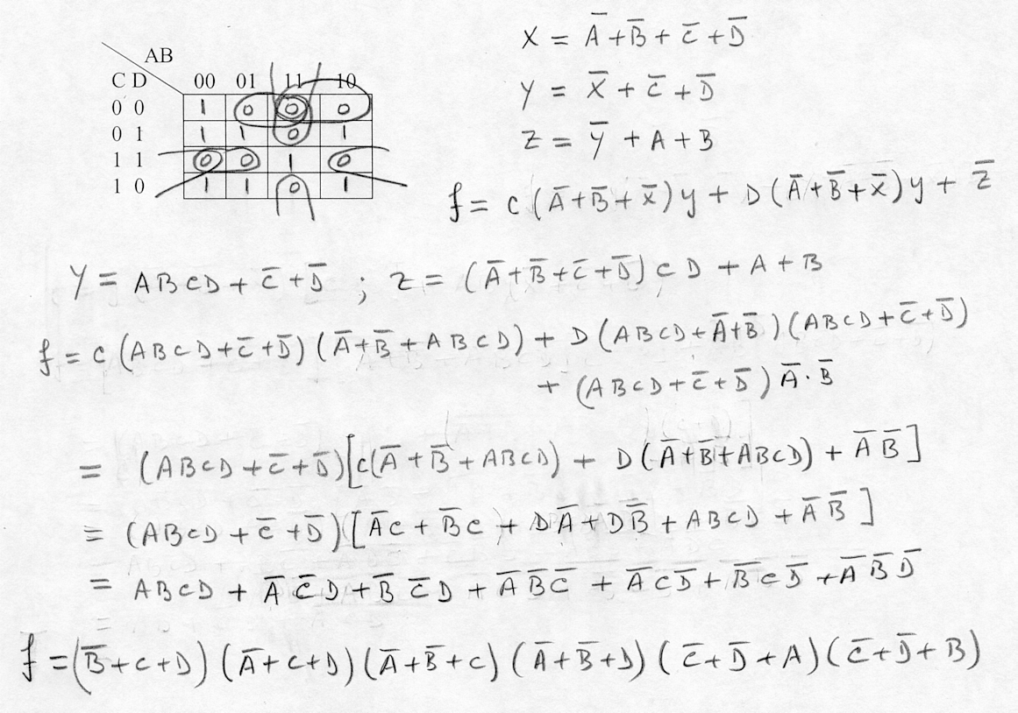

Your Name_______________________________________________________

Question 1 :Boolean Logic Theory (10 points) (Continues)
b)
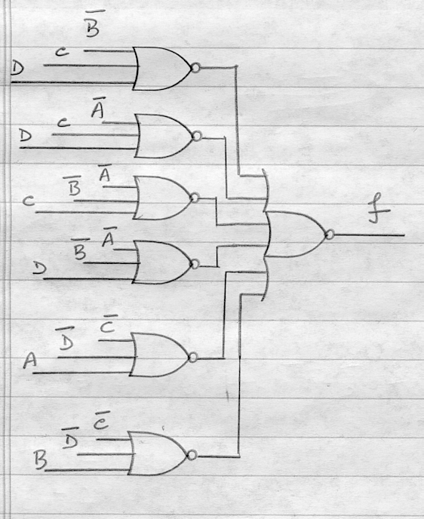

Your Name_______________________________________________________

Question 2 : Application of Boolean Theory (10 points)
The covering table in the Quine-McCluskey method was made equivalent to a Boolean function, called the Petrick function, for the purpose of finding all minimal two-level expressions of a given function. In a similar way, i.e. by means of constructing and simplifying the proper Boolean function, solve the following problem:
Five students A,B,C,D,E are planning a trip. Let us define Boolean variables A, B, C, D, E
associated with each student. If variable A=1, then student A goes, and if variable A = 0, then student A stays. The same convention applies to variables B, C, D and E. Students must satisfy ALL the following conditions:
1.- Either A or B, or both A and B go on the trip.
2.- Either C or E, but not both go on the trip.
3.- Either both A and C go, or neither go on the trip.
4.- If D goes, then E also goes on the trip.
5.- If B goes, then both A and D go on the trip.
Obtain all possible combinations of person to go on the trip.
Hint: Produce a logic equation for each of the above conditions. For example, the first condition is equivalent to the logic equation A + B = 1. Then produce a logic equation, similar to the Petrick function, equivalent to the simultaneous validity of all the conditions.
Marking scheme: 1 point for each correct condition. 5 points for correct logic expression of all conditions and correct answer.
___________________________________________________________________________
ANSWER
1.- A + B = 1
2.- C ‾E + ‾C E = 1
3.- A C + ‾A‾C = 1
4.- ‾D + E = 1
5.- ‾B + A D = 1

All conditions hold iff
(A + B) (C ‾E + ‾C E) (A C + ‾A‾C)(‾D + E )(‾B + A D) = 1.
By expanding this equation , we obtain
(A C‾E + A‾C E + B C ‾E + B‾C E)(A C +‾A‾C)(‾D‾B + E‾B + A D E) =1
(A C‾E + A B C‾E +‾A B‾C E)(‾D‾B + E‾B + A D E) = 1
A‾B C‾D‾E = 1
which means that A and C go on the trip.

Your Name_______________________________________________________
Question 3 : VHDL (15 points) .
- (5 points) List at least 5 errors in the following VHDL description:

LIBRARY ieee ;
USE ieee.std_logic_1164.all ;

ENTITY Q3 IS
PORT (X, Y : IN STD_LOGIC_VECTOR(1 DOWNTO 0) ;
Z : IN std_logic;
W : OUT STD_LOGIC_VECTOR(1 DOWNTO 0) ) ;
END Q3;

ARCHITECTURE A OF Q3 IS
SIGNAL I1;
BEGIN
I1 <= W(1);
W <= "00" WHEN X(1)='0' ELSE
"10" WHEN Y(0)="1" ELSE
"01" WHEN Z="10" ELSE
"00" WHEN Y="01" ELSE
"11" WHEN X="00" ELSE
"0000";
X(1) <= not Y(0);
W <= X;
END Q3;

- i) Output port signal cannot be present on RHS of a signal assignment statement.

- ii) Signal Z has 1 bit but is being compared to a signal with 2 bits.

- iii) Signal W has 2 bits but is being assigned a value which has 4 bits.

- iv) Input port signal cannot be present on LHS of a signal assignment statement.

- v) This is the second time W is being assigned. Only one assignment is allowed.

There are more than 5 errors. #6 is that the last END statement should be labeled END A;.

Question 3 continues on next page ---→

Your Name_______________________________________________________

Question 3 : VHDL (15 points) (Continues)
b) (10 points) Suppose A, B and C are 8-bit input operands, and E is a 18-bit output. Using only component instantiation statements, write a complete VHDL description of a circuit that implements the operation E=A*B+C*(A+B). Use components to implement the multiply and add operations. You do not have to provide the design entities for the multiplier and adder components, but you do have to supply component declarations for them (make reasonable choices for their port names).

LIBRARY ieee ;
USE ieee.std_logic_1164.all ;

ENTITY Q3b IS
PORT (A, B, C : IN STD_LOGIC_VECTOR(7 DOWNTO 0) ;
E : OUT STD_LOGIC_VECTOR(17 DOWNTO 0) ) ;
END Q3b;

ARCHITECTURE A OF Q3b IS
SIGNAL M1 : std_logic_vector(15 downto 0);
SIGNAL M2 : std_logic_vector(16 downto 0);
SIGNAL A1 : std_logic_vector(8 downto 0);
COMPONENT adder16_17
PORT(IN16 : IN std_logic_vector(15 downto 0);
IN17 : IN std_logic_vector(16 downto 0);
SUM : OUT std_logic_vector(17 downto 0));
END COMPONENT;
COMPONENT adder8_8
PORT(IN1, IN2 : IN std_logic_vector(7 downto 0);
SUM : OUT std_logic_vector(8 downto 0));
END COMPONENT;
COMPONENT mult8_8
PORT(IN1, IN2 : IN std_logic_vector(7 downto 0);
PROD : OUT std_logic_vector(15 downto 0));
END COMPONENT;
COMPONENT mult8_9
PORT(IN8 : IN std_logic_vector(7 downto 0);
IN9 : IN std_logic_vector(8 downto 0);
PROD : OUT std_logic_vector(16 downto 0));
END COMPONENT;
BEGIN
mult1 : mult8_8 PORT MAP(IN1=>A, IN2=>B, PROD=>M1);
mult2 : mult8_9 PORT MAP(IN8=>C, IN9=>A1, PROD=>M2);
add1 : adder8_8 PORT MAP(IN1=>A, IN2=>B, SUM=>A1);
add2 : adder16_17 PORT MAP(IN16=>M1, IN17=>M2, SUM=>C);
END A;

[Give part marks if the students use just one type of multiplier and adder]

Your Name_______________________________________________________
Question 4 : CMOS Circuit TechnologyDesign (15 points)
Consider the following nMOS circuit
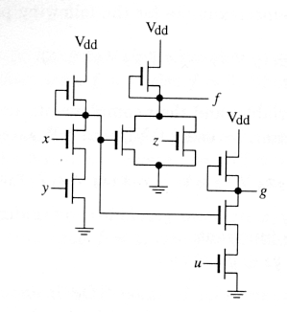

(5 points) a) Give the algebraic expressions of f and g.
(10 points) b) Produce the fully complementary CMOS circuit producing f and g.
Hint: Produce the pull-up-network and use a modified version of the given circuit as the pull-down-network.
Two answers are given:
Answer #1 Assumes that only true variables are available as inputs

‾f = w + z g = ‾u +‾w ‾f = w + z ‾w = x y g = ‾u + x y f = ‾w‾z ‾g = u w
Replacing w and ‾w in f and g we obtain f = x y‾z g =‾u + x y.
b) To obtain the CMOS circuit we replace each one of the pull-up transistors by a pull-up-network. Each one of them is the dual of the corresponding pull-down-network.
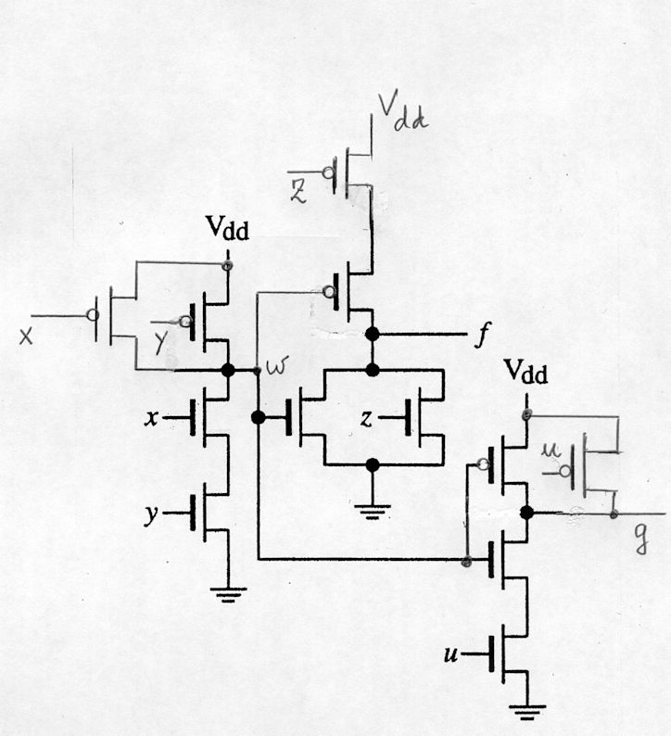
The circuit is

ANSWER #2 assumes that true and complemented variables are available as inputs.

The following equations, derived from the given circuit, are used to produce the PULL UP and PULL DOWN networks
‾f = w + z g = ‾u +‾w ‾f = w + z
‾w = x y g = ‾u + x y f = ‾w‾z
‾g = u w
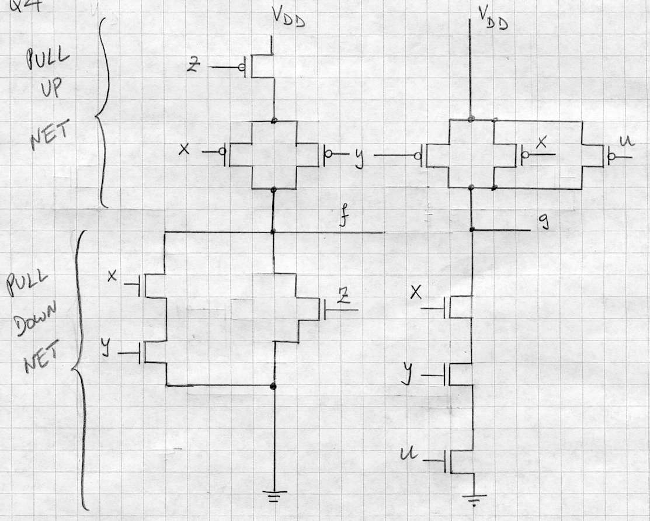

Your Name_______________________________________________________

Question 5 : Circuit Implementation Strategies/Logic Arrays (10 point)

The following three functions X, Y, Z of 7 variables are to be produced with the PLA shown on the next page. This PLA has 4 inputs and 8 outputs. The 5 outputs can be used either as inputs, as outputs or for folding purposes depending on the programming of the tristate devices associated with them.

X = A D E + B D E + C D E + G
Y = B H + C H + D H + A E G
Z = A E H + B C

(5 points) a) Rewrite the above equations such that they can be produced with the given PLA.
(5 points) b) Program the PLA.
_____________________________________________________________________________

ANSWER
_________
- X = (‾A ‾B‾C) D E + G
________
Y = H (‾B‾C‾D) + A E G

Z = A E H + B C

Answer part (b) by using the drawing on next page -----→

Your Name_______________________________________________________
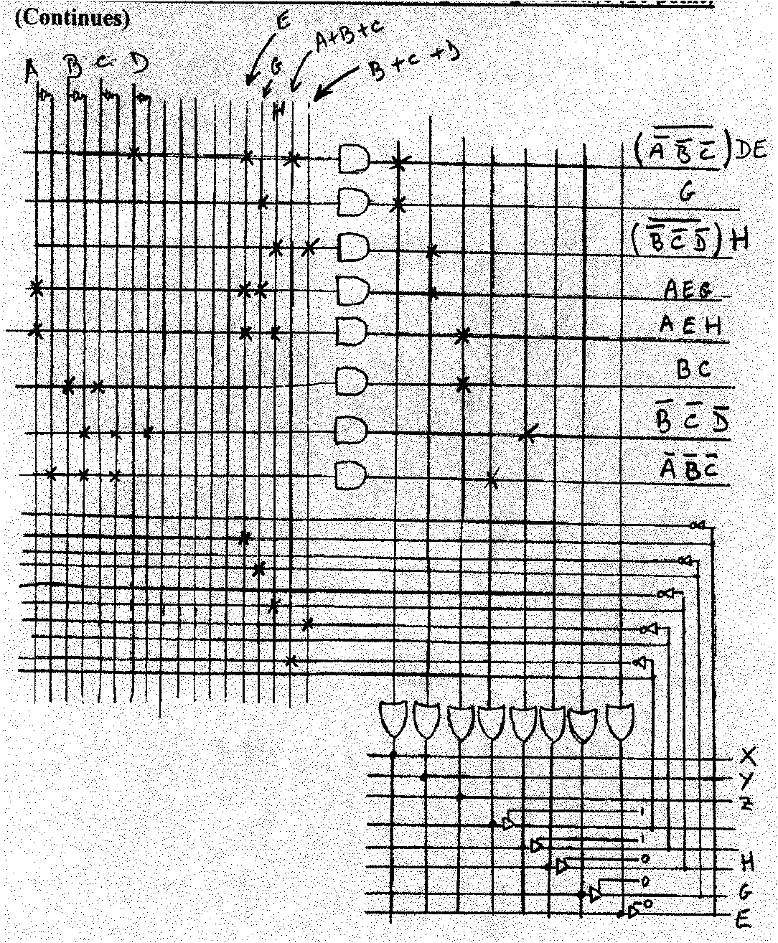

Your Name_______________________________________________________
Question 6 : Sequential Circuits (15 points)

Consider the asynchronous sequential circuit shown below
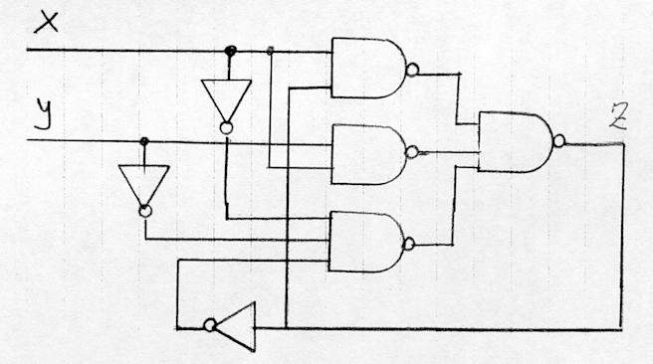

(5 points) a) Produce the state table of this circuit.
(5 points) b) Identify with a circle on the state table the stable states and give the unstable states if there are any.
(5 points) c) Identify the critical and non-critical races (if there are any) by showing the corresponding state transitions.
______________________________________________________________________________
ANSWER

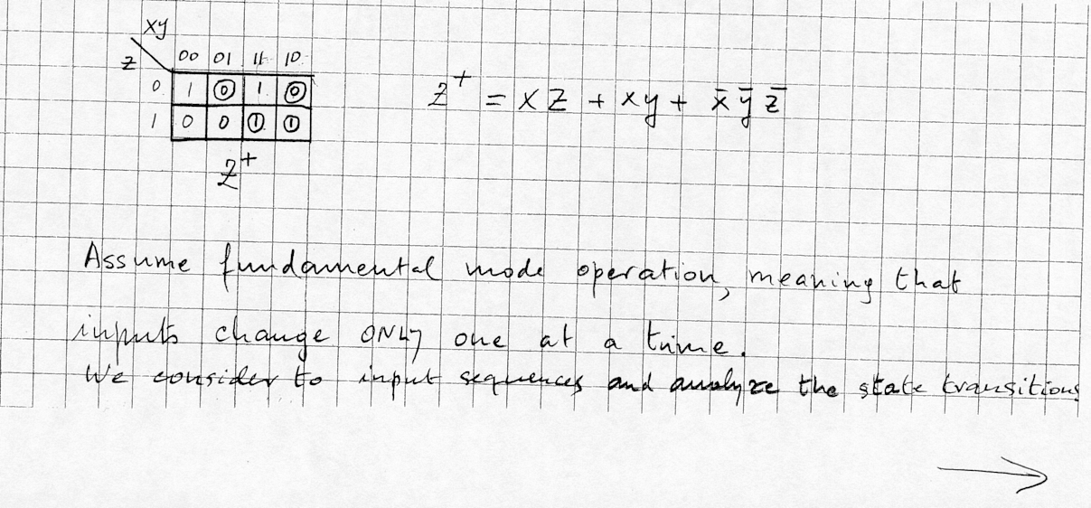

Continues on next page-→

Your Name_______________________________________________________
Question 6 : Sequential Circuits (15 points) (Continues)

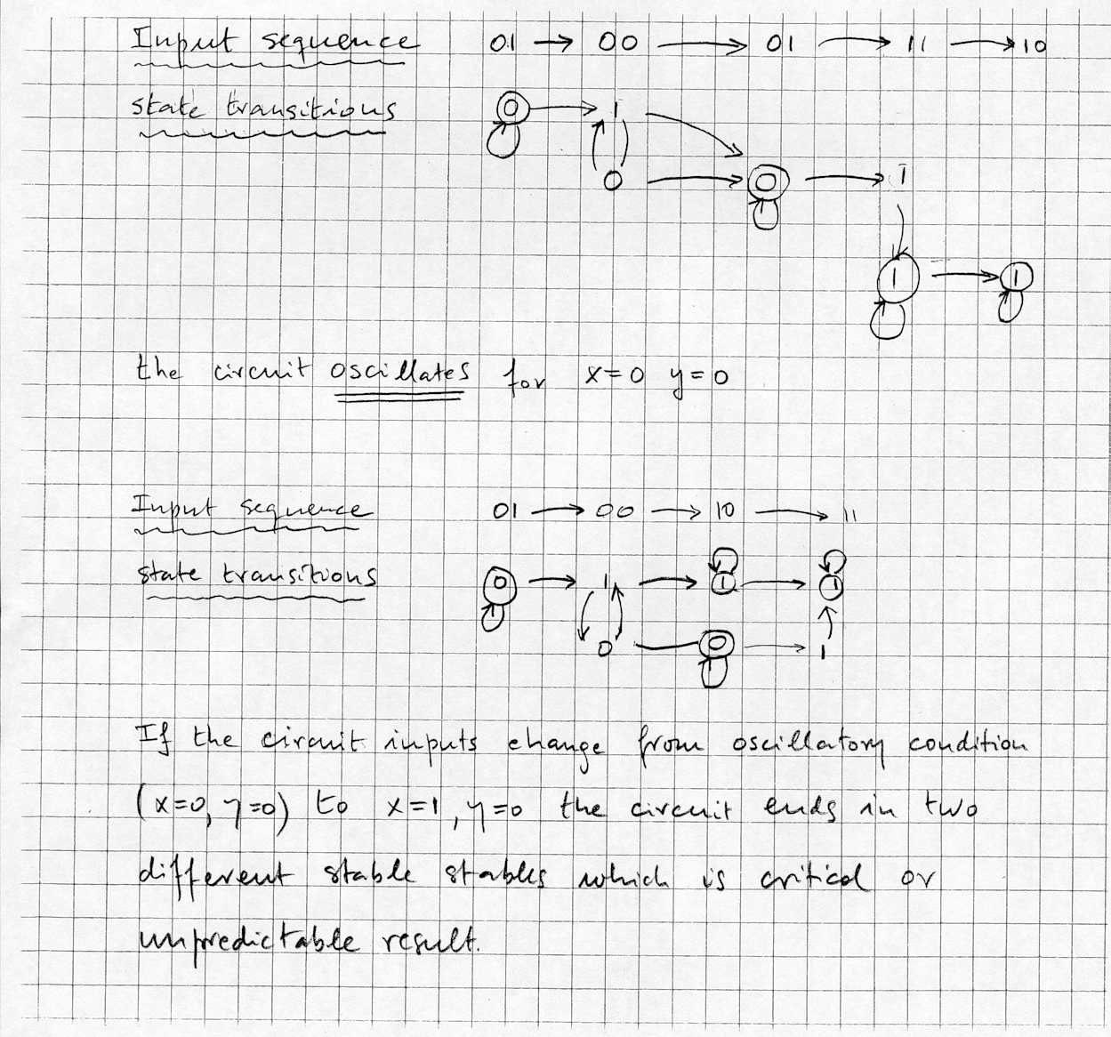

************END OF MIDTERM FALL 2005 ANSWER KEY**********

