McGILL UNIVERSITY
Electrical and Computer Engineering Department
ECSE-323 Fall 2004
MIDTERM EXAM

Question Maximum Points Points Attained
1 10

2 10
3 15

4 15
5 10

6 15
Total 75 points
Please write down your name: ANSWER KEY

Please write your student ID: ______________________________________
Instructions/Please read carefully!
This is a close book quiz. No books or notes are allowed. You may use a standard calculator.
All work is to be done on the attached sheets and under no circumstance are booklets or loose sheets to be used. Write your name at the top of every sheet.
Read the question carefully. If something appears ambiguous, write down your assumption. The points have been assigned according to the formula that 1 point = 1 exam minute, so please pace your self accordingly.

Your Name_______________________________________________________

Question 1 :Boolean Logic Theory (10 points)
Consider the following circuit
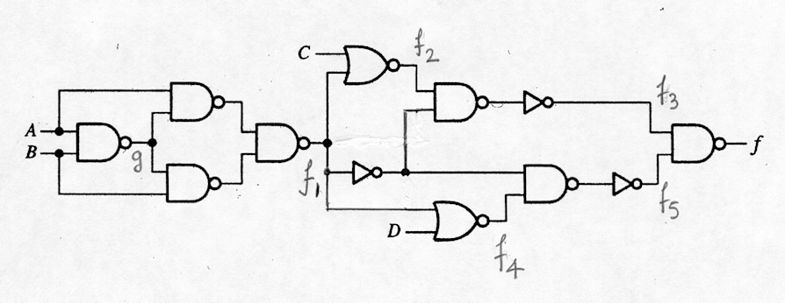

(5 points) a) Produce the algebraic expression of the minimal sum-of-products of f.
(5 points) b) Produce the algebraic expression of the minimal product-of sums of f.

Hint: You may use either k-maps of Quine-McCluskey method, which ever you think is best suited for this problem.
_________________________________________________________________

ANSWER:
g = ‾A + ‾B
f₁ = A g + B g = A (‾A +‾B ) + B (‾A + ‾B )
f₂ = ‾C ‾f₁ = ‾C (A B + ‾A ‾B) = A B ‾C +‾C‾A‾B
f₃ ₌ ‾f₁ f₂ = ‾C ‾f₁ =‾C (A B +‾A‾B)
f₅ = f₄‾f₁ = ‾f₁‾D =‾D (A B +‾A‾B)
f₄ = ‾f₁ ‾D
___ ________________
f = f₃ f₅ = ‾C ‾D (A B +‾A‾B) = C + D + A ⊕ B
which is already minimal. Therefore,
The minimal algebraic sop expression of f is f = C + D + A ⊕ B.
The minimal algebraic pos expression of f is
f = (A + B + C +D)(C +D + ‾A + ‾B), because f has two disjoint maxterms.

Your Name_______________________________________________________

Question 2 : CMOS Circuit Technology (10 points)
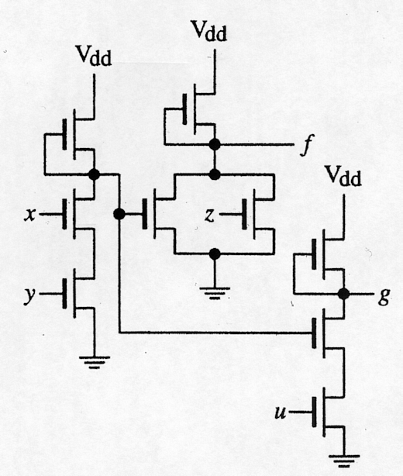
Given the following nMOS circuit

(5 points) (a) Produce the algebraic expression of f and g.
(5 points) (b) Draw a CMOS circuit that produces f and g.
ONLY TRUE VARIABLES ARE AVALABLE AS INPUTS
Marking remark: A solution with 12 transistors or less will be given full mark.
______________________________________________________________________________
ANSWER
‾f = w + z g = ‾u +‾w ‾f = w + z ‾w = x y g = ‾u + x y f = ‾w‾z ‾g = u w
Replacing w and ‾w in f and g we obtain f = x y‾z g =‾u + x y.
b) To obtain the CMOS circuit we replace each one of the pull-up transistors by a pull-up-network. Each one of them is the dual of the corresponding pull-down-network.
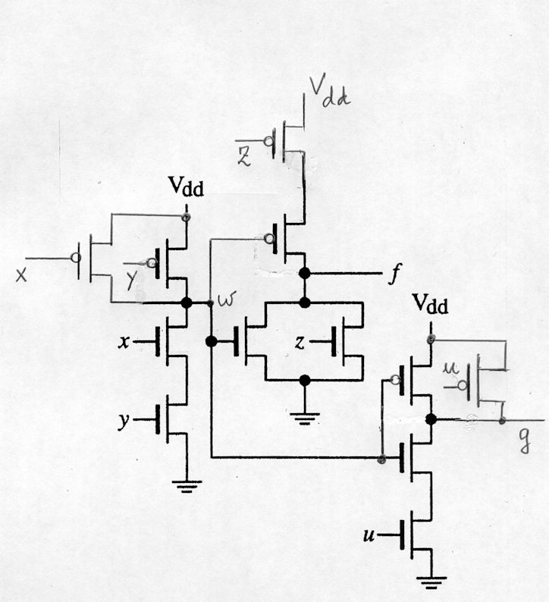
The circuit is

Your Name_______________________________________________________

Question 3 : VHDL (15 points) .

(10 points) a) Write a complete VHDL description of the circuit shown in the diagram in Question 1 of this exam. Use one (1) simple concurrent assignment statement for each gate (including the inverters).

entity Q3 is
port( A,B,C,D : in std_logic;
f : out std_logic);
end Q3;

architecture midterm of Q3 is
signal g,f1,f2,f3,f4,f5,f6,f7,f8,f9,f10 : std_logic;
begin
g <= not(A and B);
f6 <= not(A and g);
f7 <= not(B and g);
f1 <= not(f6 and f7);
f2 <= not(C or f1);
f8 <= not f1;
f9 <= not(f2 and f8);
f3 <= not f9;
f4 <= not(D or f1);
f10 <= not(f4 and f8);
f5 <= not f10;
f <= not(f3 and f5);
end midterm;

Question 3 continues on next page ---→

Your Name_______________________________________________________

Question 3 : VHDL (15 points) (Continues)

(5 points) b) Draw the circuit that is described by the following VHDL design entity:

entity Q3 is
port( x : in std_logic_vector(1 downto 0);
y : in std_logic;
z : out std_logic);
end Q3;

architecture midterm of Q3 is
begin
with x select
z <= y when “00”,
‘1’ when “01”,
‘0’ when “10”,
not y when others;
end midterm;

00
4:1 MUX
01
out
10

11 select
y

1

0

z

x(1) x(0)

Your Name_______________________________________________________

Question 4 : Combinational Circuit Synthesis (15 points)

Using ONLY 3-input LUT’s

(5 points) a) Give the algebraic expression of a 5-input majority function. This function assumes the value 1 when the inputs have more 1’s than 0’s and assumes the value 0 otherwise.
(10 points) b) Draw the circuit producing f using fewest number of 3-input LUT’s.

Marking remark: A circuit containing 7 LUT’s or less will be given full mark.

ANSWER:
a) The function is expanded thus
f(x₁,x₂,x₃,x₄,x₅) = g₀ (x₁,x₂,x₃)‾x₄‾x₅ + g₁ (x₁,x₂,x₃)‾x₄ x₅ + g₂ (x₁,x₂,x₃) x₄‾x₅ + g₃ (x₁,x₂,x₃)x₄ x₅

f(x₁,x₂,x₃,x₄,x₅) = [g₀ (x₁,x₂,x₃)‾x₄ + g₂ (x₁,x₂,x₃) x₄]‾x₅ + [g₁ (x₁,x₂,x₃)‾x₄ + g₃ (x₁,x₂,x₃)x₄ ] x₅

where
g₀ (x₁,x₂,x₃) = x₁ x₂ x₃
g₁ (x₁,x₂,x₃) = g₂ (x₁,x₂,x₃) = x₁x₂+ x₂x₃+ x₁x₃
g₃ (x₁,x₂,x₃) = x₁ + x₂ + x₃

b) The circuit is
Your Name_______________________________________________________

Question 5 : Circuit Implementation Strategies/Logic Arrays (10 point)

Given the following set of functions

Z₀ = x₀ +‾x₁ x₃ + x₁‾x₃

Z₁ = ‾x₀x₂‾x₃ + ‾x₁ x₃ + x₁‾x₃ + x₂x₃

Z₂ = x₃(x₀⊕ x₁⊕ x₂)

(5 points) a) Decompose/factor the functions such that they can be produced by the PLA device shown on next page.
(5 points) b) On the given PLA device schematic, program the PLA to produce the given functions. _________________________________________________________________

ANSWER
a)
g = ‾x₁ x₃ + x₁‾x₃

Z₀ = x₀ + g

Z₁ = ‾x₀x₂‾x₃ + g + x₂x₃

Z₂ = x₃ ‾x₀ ‾x₁ x₂ + x₃ ‾x₀ x₁‾x₂ + x₃ x₀‾x₁ ‾x₂ + x₃ x₀ x₁x₂ +

Answer to part (b) on next page ---------------------------→
Your Name_______________________________________________________

Question 5 : Circuit Implementation Strategies/Logic Arrays (10 point) (Continues)
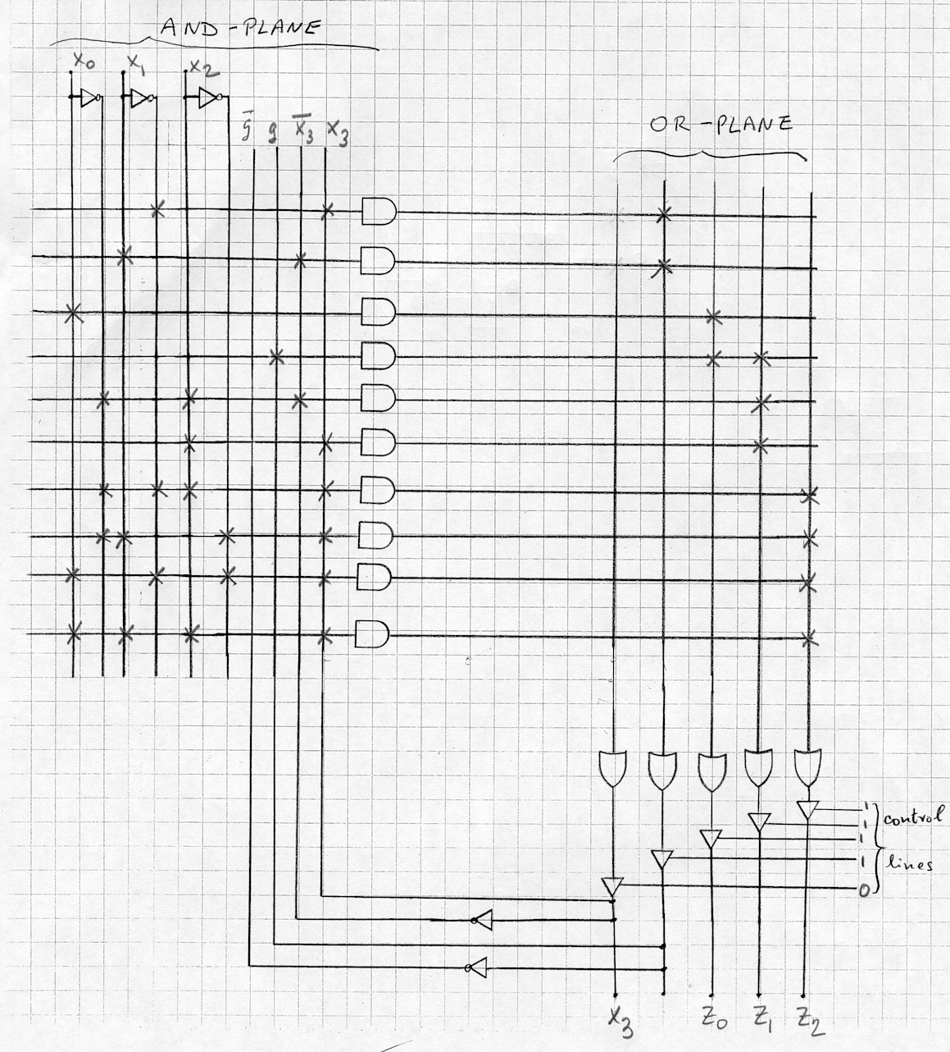

Your Name_______________________________________________________

Question 6 : Sequential Circuits (15 points)

Consider the following asynchronous sequential circuit operating in fundamental mode:

(5 points) a) Produce the state transition table (flow table) and encircle the stable states.
(5 points) b) For the input sequence 00 → 01→ 11 → 10 → 00, give the corresponding unstable and stable states. Show the stable states with a circle and the unstable states without a circle.
(5 points) c) Is there any input values for which the circuit oscillates? If so, give such input values.

__________________________________________________________________________

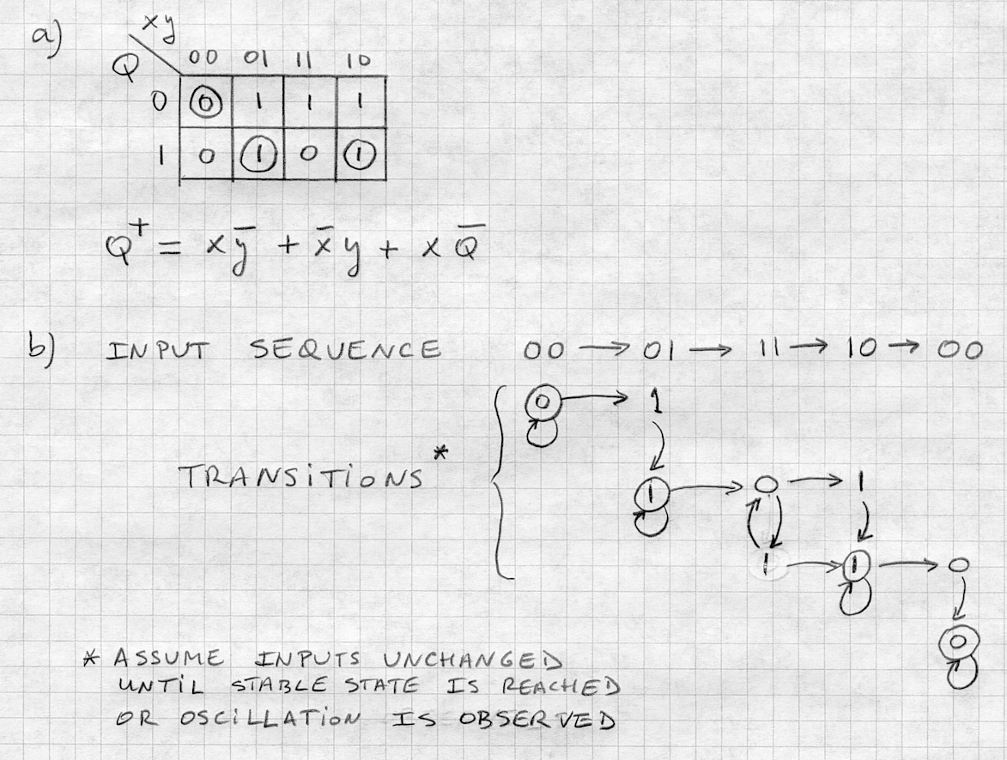
ANSWER

