McGILL UNIVERSITY
Electrical and Computer Engineering Department
ECSE-323 Winter 2005
MIDTERM EXAM

Question Maximum Points Points Attained
1 10

2 15
3 20

4 20
5 10

Total 75 points

ANSWER KEY
Please write down your name: _____________________________________

Please write your student ID: ______________________________________

Instructions/Please read carefully!

This is a close book quiz. No books or notes are allowed. You may use a standard calculator.
All work is to be done on the attached sheets and under no circumstance are booklets or loose sheets to be used. Write your name at the top of every sheet.
Read the question carefully. If something appears ambiguous, write down your assumption. The points have been assigned according to the formula that 1 point = 1 exam minute, so please pace your self accordingly.

Question 1 :Boolean Logic Theory (10 points)

(5 points) a) Find P and Q such that

A C + B‾C +‾B‾C D = B P + ‾B Q.

(5 points) b) Find X and Y such that

A C + B‾C +‾B‾C D = (A + X) (‾A + Y).

NOTE: To obtain full mark it is mandatory to explain clearly the steps followed.
_____________________________________________________
ANSWER

- The Shannon Expansion with respect to B gives: B [AC +‾C] +‾B [AC +‾C D]. Thus
P = [AC +‾C] and Q = [AC +‾C D.
b) Using the K-map of F , we find the expression for ‾F

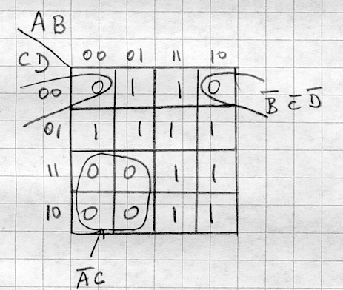

‾F = ‾AC +‾B‾C‾D.
Expanding‾F with respect to A, we obtain ‾F = ‾A [C +‾B‾C‾D] + A [‾B‾C‾D ].
Using the DeMorgan’s Theorem on ‾F ,we obtain:
____________ ________
F = (A + [C + ‾B‾C‾D] ) (‾A + [‾B‾C‾D ] ), which is of the form
(A + X ) (‾A + Y). Thus:
X = ‾C B +‾C D and Y = B + C + D.

Question 2 : CMOS Circuit Technology (15 points)

Consider the function of 4 variables F(A,B,C,D) = Σm (3,5,6,7,9,10,11,12,13,14,15).
Design a CMOS circuit that produces the function F with the minimum number of transistors.
ONLY TRUE VARIABLES ARE AVALABLE AS INPUTS.
Marking Scheme: 5 points for correct PUN, 5 points for correct PDN and 5 point if the correct circuit contains 26 or less total number of transistors.
______________________________________________________________________________
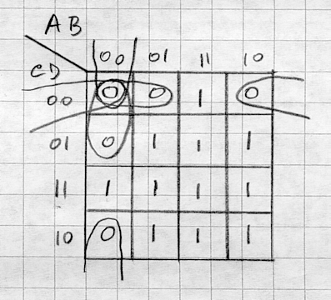
ANSWER

Using the K-map of F we obtain ‾F.
F = AB + AC + AD + BC + BD + CD.
‾F = ‾B‾C‾D + ‾A‾B‾C +‾A‾C‾D + ‾A‾B‾D.

We produce a CMOS circuit (PUN and PDN) to implement ‾F and use an inverter at the output to produce F. Thus we use only 26 transistors.
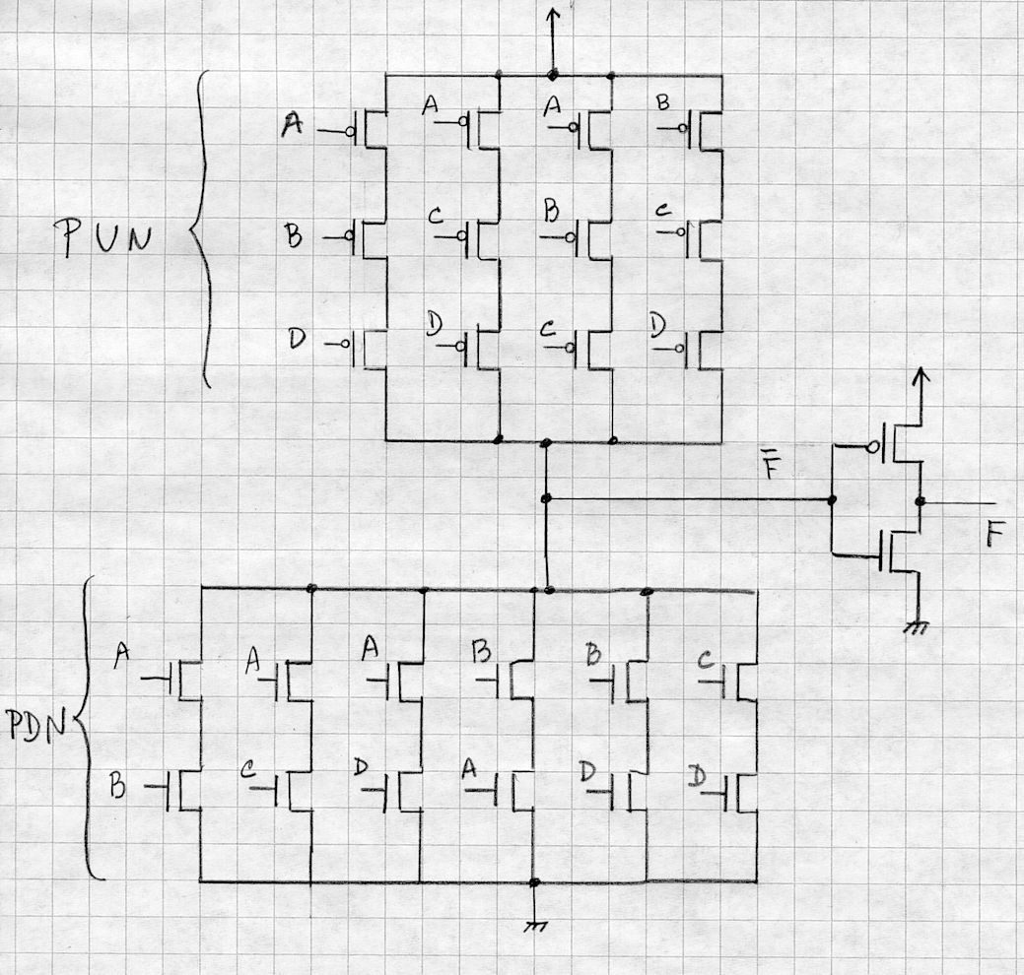

Question 3 : VHDL (20 points) .

(10 points) a) Using only AND2, OR2, and INVERTER gate component instantiation statements in the architecture concurrent statements area, write a complete VHDL description (including both the entity declaration and architecture body) of a module that implements the Boolean function:
Y = (A xor B) and (not C).

You need to implement the XOR operation using AND, OR, and INVERTER gates. Therefore expand "A xor B" as (A and not B) or (not A and B).

entity Q3a is
port(A, B, C : in std_logic;
Y : out std_logic);
end Q3a;
architecture midterm of Q3a is
signal AI, BI, CI, G1, G2, G3 : std_logic;
component AND2
PORT(x,y : IN std_logic;
z : OUT std_logic);
end component;
component OR2
PORT(x,y : IN std_logic;
z : OUT std_logic);
end component;
component INVERTER
PORT(x : IN std_logic;
z : OUT std_logic);
end component;
begin
A1 : AND2 port map (x=>A,y=>BI,z=>G1);
A2 : AND2 port map (x=>AI,y=>B,z=>G2);
A3 : AND2 port map (x=>G3,y=>CI,z=>Y);
O3 : OR2 port map (x=>G1,y=>G2,z=>G3);
I1 : INVERTER port map (x=>A, z=>AI);
I2 : INVERTER port map (x=>B, z=>BI);
I3 : INVERTER port map (x=>C, z=>CI);
end midterm;

Question 3 continues on next page ---→
Your Name_______________________________________________________

Question 3 : VHDL (15 points) (Continued)

(5 points) b) Find at least five (5) errors in the following VHDL description:

entity Q3 is
ports( DATA : in std_logic_vector(7..0);
CARRY : in std_logic;
result : out BIT);
end Q3;

architecture Q3 of midterm is
signal MODE : std_logic_vector(3 downto 0);
begin
MODE => DATA(6 downto 4);
with MODE select
RESULT <= CARRY when “0000”,
‘1’ when “0001”,
‘0’ when “1000”;
Y <= CARRY and result;
end midterm;

- – "ports" should be "port".
- – "7..0" should be "7 downto 0".
- – "Q3 of midterm" should be "midterm of Q3".
- – "=>" should be "<=".
- – "DATA(6 downto 4)" defines a 3-bit value. It must be a 4-bit value since the LHS signal (MODE) has a 4-bit value.
- The signal CARRY cannot be assigned to the signal RESULT, since they have different types (CARRY is std_logic, RESULT is BIT).
- – the selected signal assignment statement does not handle all cases, it should be terminated with a WHEN OTHERS clause.
- the signal "Y" has not been declared.
- – "result" is an OUT port, therefore it cannot be put on the RHS of an assignment statement.

Question 3 continues on next page ---→
Question 3 : VHDL (15 points) (Continues)

(10 points) b) Find at least five (5) errors in the following VHDL description:

entity Q3 is
ports( DATA : in std_logic_vector(7..0);
CARRY : in std_logic;
result : out BIT);
end Q3;

architecture Q3 of midterm is
signal MODE : std_logic_vector(3 downto 0);
begin
MODE => DATA(6 downto 4);
with MODE select
RESULT <= CARRY when “0000”,
‘1’ when “0001”,
‘0’ when “1000”;
Y <= CARRY and result;
end midterm;

Your Name_______________________________________________________

Question 4 : Combinational Circuit Synthesis (20 points)

Design a binary-coded, two-digit, base-3 divider. This unit, shown below, has 4 inputs,
A = {a₁, a₂}, called dividend and B = {b₁, b₂}, called divisor, and 4 outputs, C R = {c₁, c₂ r₁, r₂}, where C R stands for quotient and remainder respectively. A, B, C and R are ternary digits, they assume values from the set of ternary digits {0,1,2}, and a₁, a₂ ,b₁, b₂, c₁, c₂ , r₁, r₂ are the binary variables corresponding to the binary-coded ternary digits. Example: if A = 1 = (01) and B = 2 = (10) then C R = (0 1) = (0 0 1 0). If A = 2 = (10) and B = 2 = (10) then
C R = (10) = (0 1 0 0).
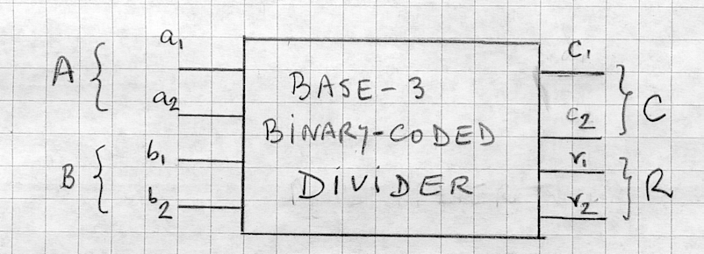
The binary code assigned to each ternary digit is: “0” = 00, “1” = 01, “2” = 10. You can assume that the 11 combination and the value B = 0 never occurs at the inputs.

(10 points) a) Produce the minimal two-level NAND-NAND circuit of the divider.
(5 points) b) Using only 4 x 1 Multiplexers, draw the divider circuit.
(5 points) c) Using only 2-input LUTs, draw the divider circuit.

ANSWER
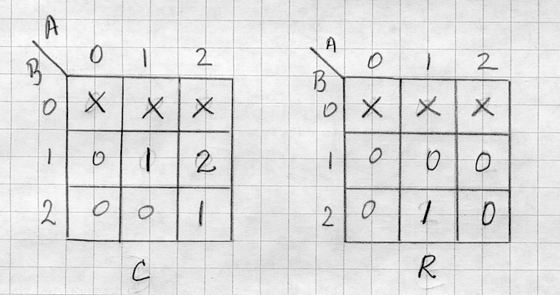
The division table is

From this table we obtain the K-maps of r₁, r₂ , c₁, c₂ by assigning to each ternary digits its corresponding binary code.

Continue Question 4 on next page →

Question 4 : Combinational Circuit Synthesis (20 points) (Continued)
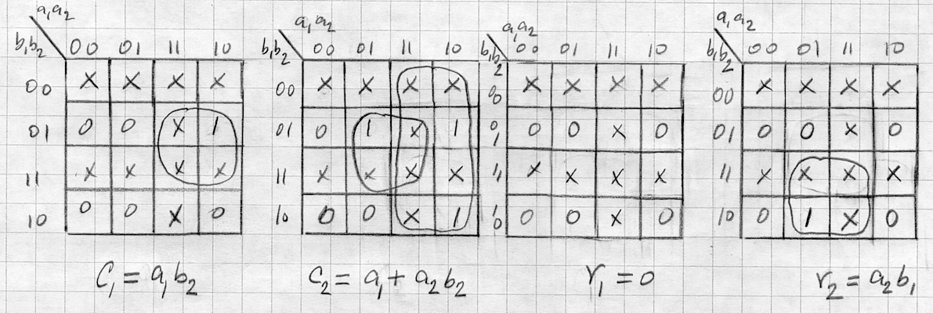

- The NAND-NAND two-level b) The MUX implementation is
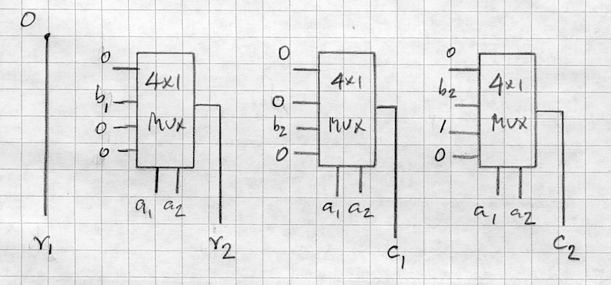
circuit of the divider is
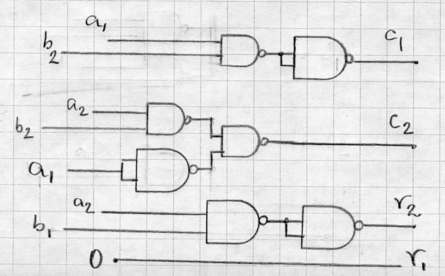

c) One possible LUT implementation of the divider is
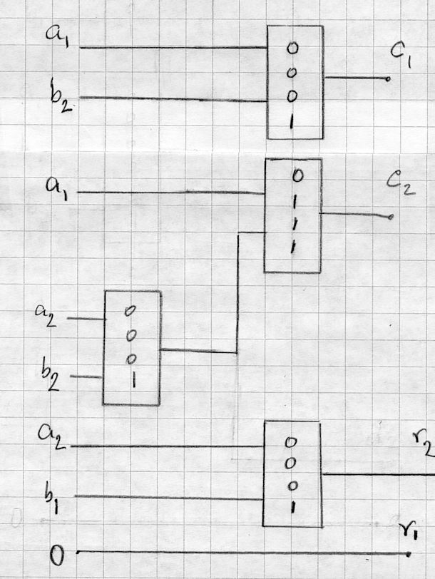

Question 5 : Circuit Implementation Strategies/Logic Arrays (10 points)

Use the PLD shown on next page to implement the following function

T = [ A + BC] [‾D‾E (‾C +‾AB +‾AC) ] + B‾D +‾B D +‾B‾C D E.

(5 points) a) Identify clearly the subfunctions and terms such that they can be produced with the components of the given PLD device shown on next page.
(5 points) b) On the given PLD device schematic, program the PLD to produce the given function. _________________________________________________________________
ANSWER

a) We select 3 folding subfunctions and use the the 4th OR gate to produce T.

The chosen subfunctions are
F₁ = ‾D‾E
F₂ = ‾C + ‾AB +‾A C
F₃ = A + BC.

The tristate devices are programmed accordingly to either allow the folding to take place or to deliver the output function T.

Note that there may be other selections that can be made producing the same result. The one chosen is readily seen from the given expression of T.

Part (b) is shown on next page ------------------→

Question 5 : Circuit Implementation Strategies/Logic Arrays (15 point) (Continues)

