McGILL UNIVERSITY
Electrical and Computer Engineering Department
ECSE-323 Fall 2003
2nd MIDTERM EXAM

Question Maximum Points Points Attained
1 10

2 10
3 15

4 15
5 10

6 15

Total 75 points

Please write down your name: ANSWER KEY (Reviced Nov 27, 2003)

Please write your student ID: ______________________________________

Instructions/Please read carefully!
This is a closed book exam. No books or notes are allowed. You may use a standard calculator.
All work is to be done on the attached sheets and under no circumstance are booklets or loose sheets to be used. Write your name at the top of every sheet.
Read the question carefully. If something appears ambiguous, write down your assumption. The points have been assigned according to the formula that 1 point = 1 exam minute, so please pace yourself accordingly.

Your Name_______________________________________________________

Question 1 : Sequential Circuits (10 points)

Consider the following circuit
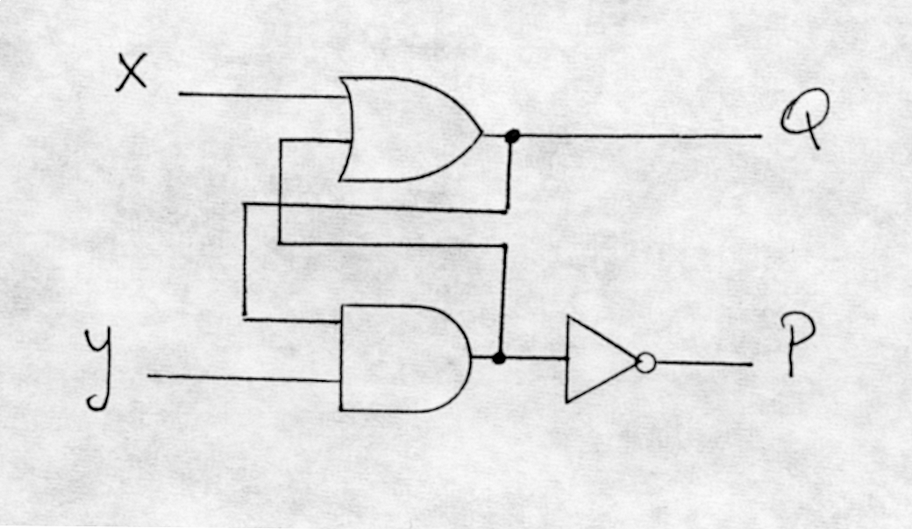

(2 points) a) Give the restrictions, if any, on x, y so that P = ‾Q under steady-state
conditions.
(2 points) b) Give the characteristic table of the circuit.
(2 points) c) Give the excitation table of the circuit.
(4 points) d) Give the circuit that converts the given circuit into a T-type memory element.
_________________________________________________________________________
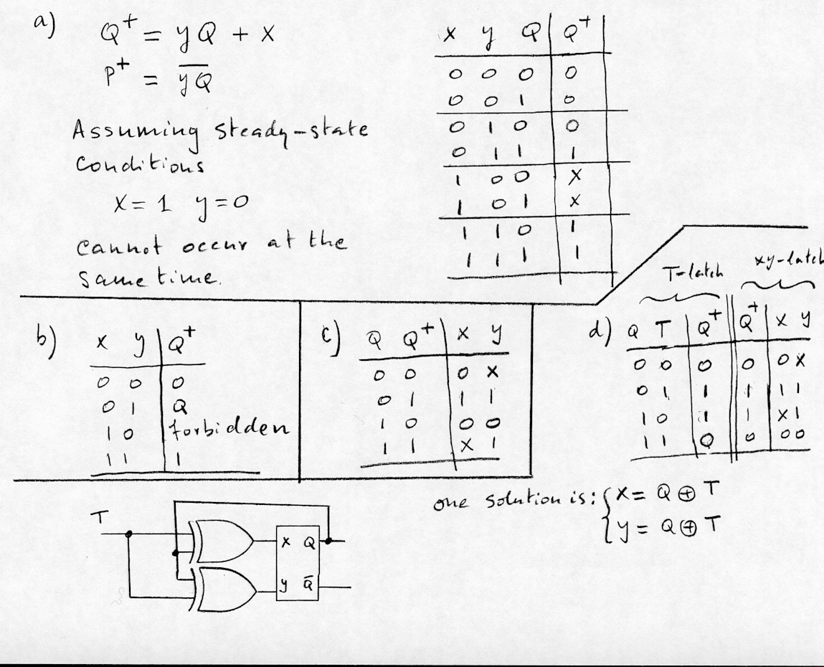

Your Name______________________________________________________

Question 2 : Registers (10 points)

Design a circuit of a four bit register that adds 3 to its contents. Originally the register contains the 4-bit number N, where 0000 < N < 1100 . After one single clock pulse the register contents should be N + 0011.

(2 points) a) Explain briefly your design approach.
(8 points) b) Draw the complete circuit using JK-type flipflops, full adders and NAND gates as needed.
____________________________________________________________________________
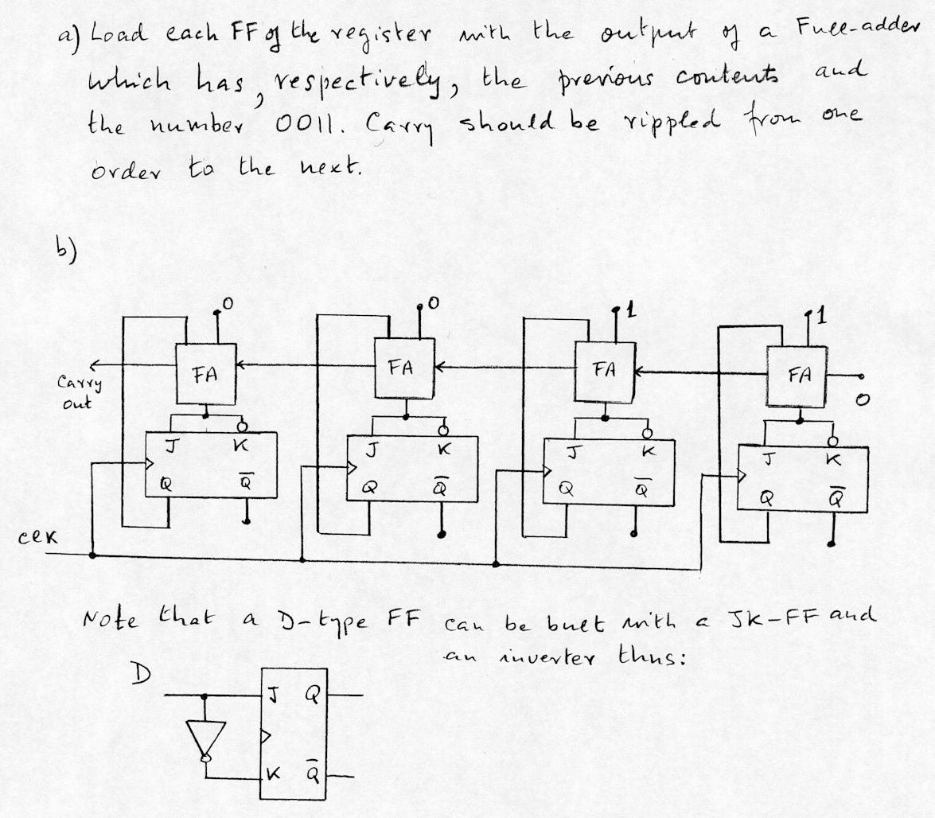

Your Name_______________________________________________________

Question 3 : Analysis of Synchronous Sequential Circuits (15 points)

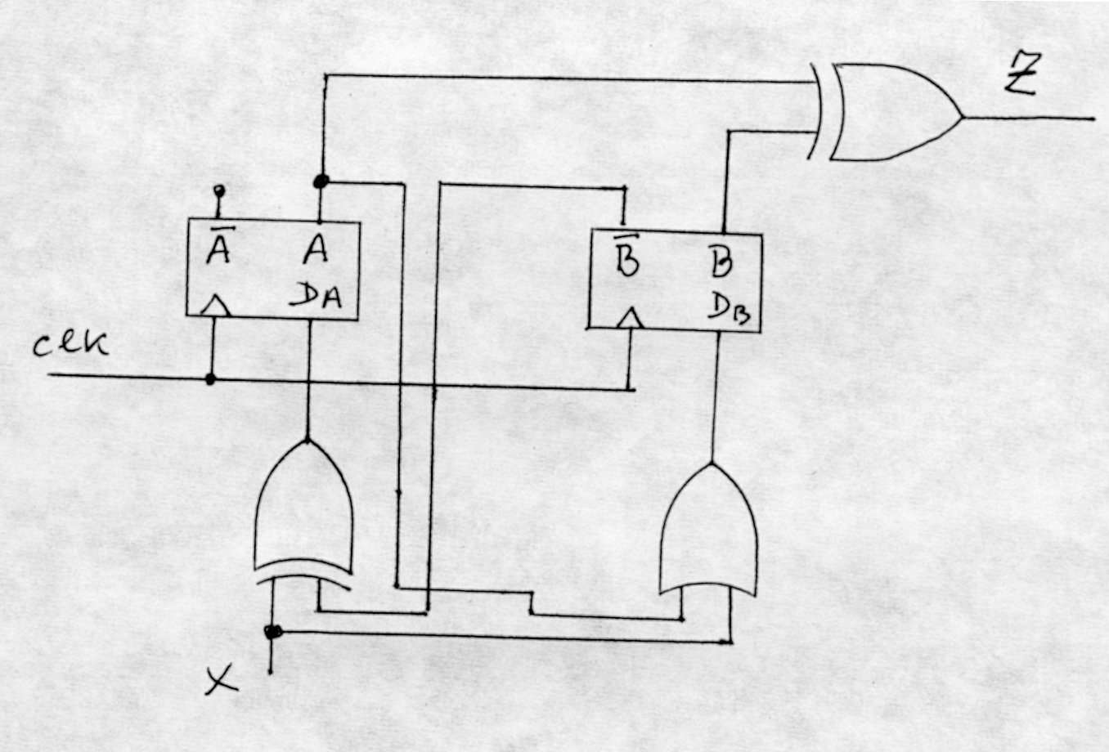
Consider the circuit shown below:

(5 points) a) Give the state transition diagram of the circuit.
(5 points) b) Is this circuit a Moore or Mealy type of Finite State Machine?
Justify your answer.
(5 points) c) If the circuit is a Moore-type FSM, give the state transition diagram of
the Mealy-type equivalent, or, vice versa, if it is a Mealy-type give the
state transition digram of its Moore-type equivalent.
___________________________________________________________________

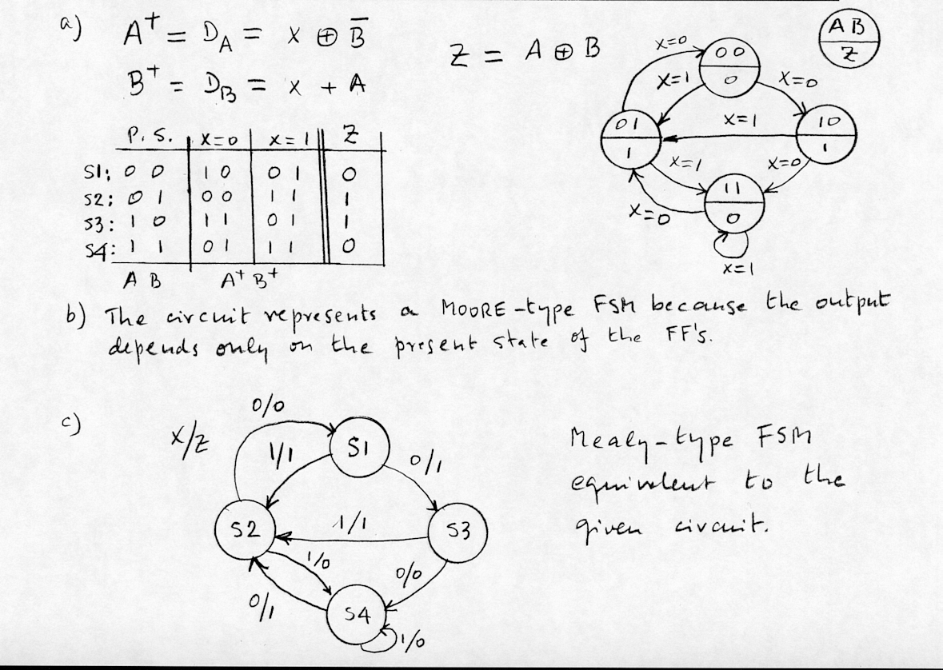

Your Name_______________________________________________________

Question 4 : Conter Design(15 points)

Using the 74X163 4-bit programmable counter, with synchronous CLEAR and LOAD inputs, whose block diagram is shown below, and the fewest number of gates possible, draw a circuit of a counter that will count following the sequence 5,6,7,8,9,10,5,6,7,8,9,10,5,6,7….

Marking scheme: (5 points) Correct starting sequence and self starting capability

(5 points) Correct termination sequence and re-starting

(5 points) Complete circuit with fewest possible gates
NOTE: CLR (CLEAR) and LD (LOAD) are synchronous inputs, meaning, that they affect the counter on the following rising edge of the clock. ENP and ENT should be 1 for the counter to be ENABLED. QD is the most significant bit of the counter. RCO is the Ripple-Carry-Output signal.
__________________________________________________________________________________________

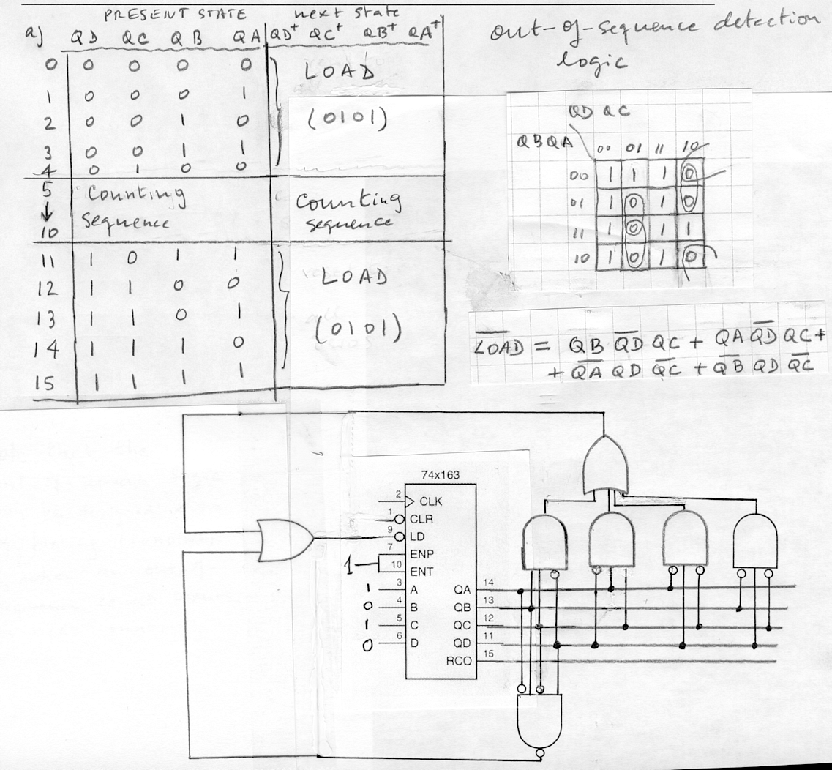

Your Name_______________________________________________________

Question 5 : Finite State Machine Design (10 points)

Design a MEALY-type Finite State Machine which accepts one input X and produces one output Z.
Four consecutive, serially inputted, values of X represent a binary number N, 0000 < N < 1010. The least significant bit of N is entered first. The corresponding, serially produced, values of Z represent the number N' = N + 5. The least significant bit of N' is produced first.
Example: If at time t₃ t₂ t₁ t₀
X = 0 1 1 1 then
Z = 1 1 0 0.

(5 points) a) Give the State Transition Diagram of this Finite State Machine, where fewer than 8 states are needed.
(5 points) b) Give the complete circuit using three D-type flip-flops.
__________________________________________________________________________________________
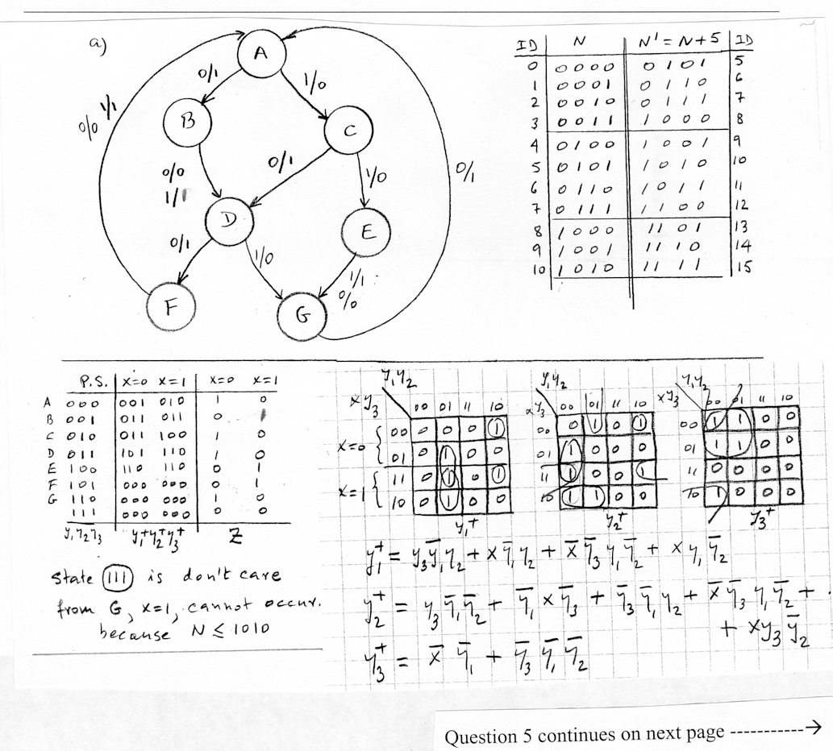

Question 5 continues on next page -----------→

Your Name_______________________________________________________

Question 5 : Finite State Machine Design (10 points) (Continues)
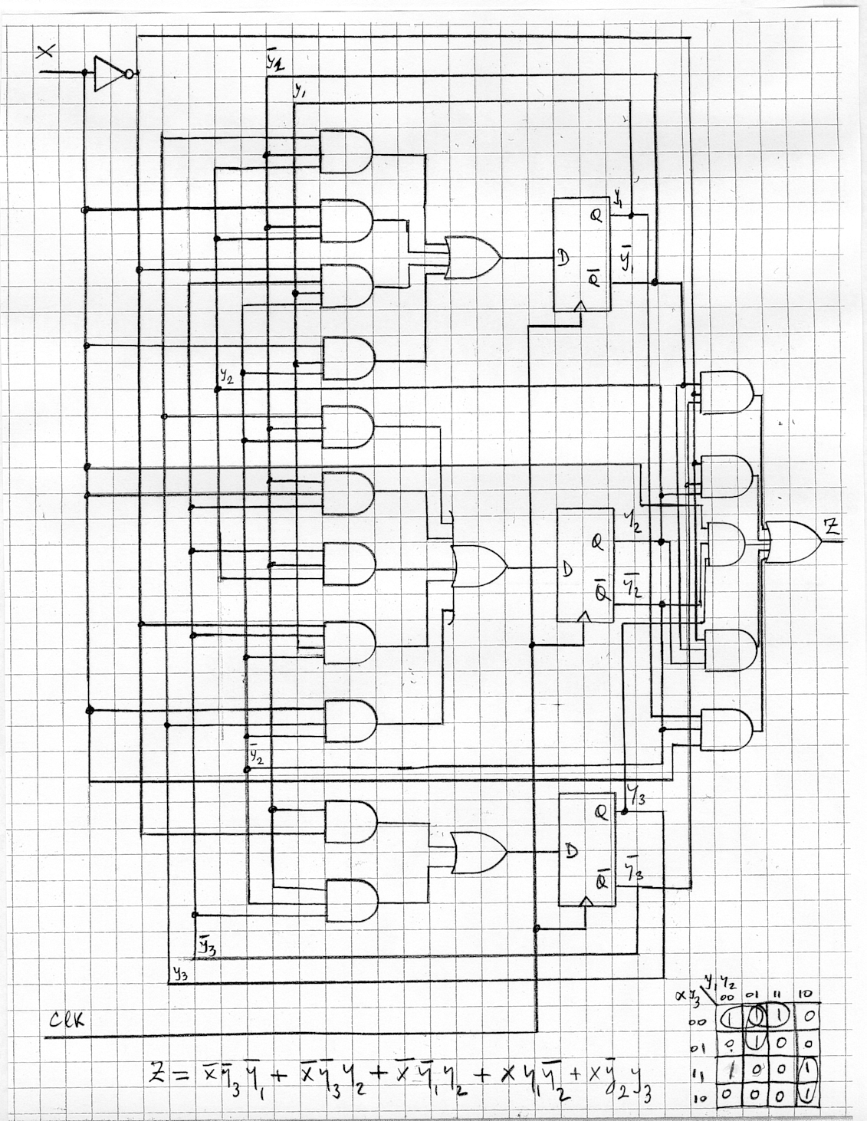
Your Name______________________________________________________

Question 6 : VHDL (15 points)

(10 points) a) Write a complete VHDL description of a synchronous sequential circuit that counts in the sequence:
{0, 1, 3, 6, 10, 15, 14, 12, 9, 5, 0, 1, 3,…}.

(5 points) b) Consider the following fragment of a VHDL description. Suppose that during a simulation, right before the process exam_process is evaluated in response to a rising edge event on the signal clk, the value of the signal f_out is equal to 6. Determine the values of the signals f_out and y right after the process block has been evaluated, when the signal mode has the value of '0' and when it has the value of '1'. Assume that the signal reset is always '0'.

architecture a of exam_entity is
signal f_out : integer range –20 to 20;
signal y : std_logic;
begin

exam_process : process (clk, reset)
begin
y <= '0';
if reset = '1' then f_out <= 0;
elsif clk'EVENT and clk='1' then
f_out <= f_out + 6;
if mode = '1' then f_out <= 6 - f_out;
end if;
y <= mode;
if f_out = 0 then y <= not mode; end if;
end process;

end a;

Continue Question 6 on next page -------------→
Your Name______________________________________________________

Question 6 : VHDL (15 points) (Continue)
SOLUTIONS

a) There are many different solutions possible. The following solution is fairly efficient.

library ieee;
use ieee.std_logic_1164.all;

entity counter is
port(clk, reset : in std_logic;
count_out : out integer range 0 to 15);
end counter;

architecture a of counter is
signal count : integer range 0 to 15;
signal up : std_logic;
signal increment : integer range 1 to 5;
begin

exam_process : process (clk, reset)
begin
count_out <= count;
if reset = '1' then
count <= 0;
increment <= 1;
up <= '1';
elsif clk'EVENT and clk='1' then
increment <= increment + 1;
if increment = 5 then
increment <= 1;
up <= not up;
end if;
if up = '1' then
count <= count + increment;
else
count <= count - increment;
end if;
end if;
end process;
end a;

Part b) continues on next page ------→
b) mode = '0'

exam_process : process (clk, reset)
begin
y <= '0'; y=0, f_out=6
if reset = '1' then f_out <= 0;
elsif clk'EVENT and clk='1' then
f_out <= f_out + 6; y=0, f_out=12
if mode = '1' then f_out <= 6 - f_out;
end if;
y <= mode; y=0, f_out=12
if f_out = 0 then y <= not mode; end if;
end process;

The last assignments for y and f_out are y=0, f_out=12

b) mode = '1'

exam_process : process (clk, reset)
begin
y <= '0'; y=0, f_out=6
if reset = '1' then f_out <= 0;
elsif clk'EVENT and clk='1' then
f_out <= f_out + 6; y=0, f_out=12
if mode = '1' then f_out <= 6 - f_out; y=0, f_out=-6
end if;
y <= mode; y=1, f_out=-6
if f_out = 0 then y <= not mode; end if;
end process;

The last assignments for y and f_out are y=1, f_out=-6

