Question 1 :Boolean Logic Theory (10 points)
A function f(A,B,C,D) is self-dual if the dual of f, f^{D}, is such that f = f^{D} , where
f^{D} = ‾f (‾A,‾B,‾C, ‾D).
(5 points) a) For the function shown below, specify values of the don’t care entries so that the function is self dual.

(5 points) b) How many solutions are there? . Give the minimal sum-of- products expression of each solution.
_________________________________________________________________
- Let the don’t cares be labelled, a,b,c,d, column wise, and let us construct the k-map of
‾f (‾A,‾B,‾C,‾D) by complementing both: the values of the variables and also the values of the corresponding value of the function f . Then, we shall find out the conditions that must satisfy the don’t cares for the two maps, the map of f (A,B,C,D) and the map of ‾f (‾A,‾b,‾C,‾D) to be equal.

f = f^{D}

To satisfy the equality f = f^{D}, the following relations must be satisfied:
a = ‾c, b = 0, and‾d = 0, producing two different valuations of the don’t cares:
a = 0, b = 0, c = 1, d = 1 and a = 1, b = 0, c = 0, d = 1.

Question 1 continues on next page----------------→
Question 1 :Boolean Logic Theory (Continues)

b) As shown in part a), there are two solutions:
Solution #1

f_{min} = A‾C‾D + A C D +‾A C‾D + A B C
f_{min} = A‾C‾D + A C D +‾A C‾D + A B‾D
f_{min} = A‾C‾D + A C D +‾A C‾D + B C‾D.

Solution #2:

There is only one minimal form for this function

f_{min} = A (‾C‾D + C D ) + ‾A(‾C D + C‾D ) =
= A ⊕ C ⊕ D.

Your Name_______________________________________________________
Question 2 : Two-level minimization (Quine-McCluskey method) (10 points)
Given the following Boolean function

f (A,B,C,D) = ∑m(0,4,5,7,8,10,11,14,15)

(5 points) (a) List all the prime implicants of f by following the Quine-McCluskey
method.
(5 points) (b) Give all minimal sum-of-products expressions of f by showing the covering table and by using the Petrick function.
______________________________________________________________________________
(a)
- 0000 √ (0,4) 0-00 (10,11,14,15) 1-1-
- 0100 √ (0,8) -000
- 1000 √ (4,5) 010-
- 0101 √ (8,10) 10-0
- 1010 √ (5,7) 01-1
- 0111 √ (10,11) 101- √
11 1011 √ (10,14) 1-10 √
14 1110 √ (7,15) -111
15 1111 √ (11,15) 1-11 √
(14,15) 111- √

Grouping by number First reduction Second and final
of 1’s in midterm reduction
representation
List of prime implicants:
‾A‾C‾D, ‾B‾C‾D, ‾A B‾C, A‾B D, ‾A B D, B C D, A C.
 | ABCD | 0 | 4 | 5 | 7 | 8 | 10 | 11 | 14 | 15
(0,4) | 0 – 0 0 | √ | √
(0,8) | - 0 0 0 | √
(4,5) | 0 1 0 - |  | √
(8,10) | 1 0 - 1 |  |  |  |  | √ | √
(5,7) | 0 1 - 1 |  |  | √ | √
(7,15) | - 1 1 1 |  |  | √ |  |  |  |  |  | √
(10,11,14,15) | 1 - 1 - |  |  |  |  |  | √ | √ | √ | √

The prime implicant of the last row, A C, is essential . It covers points 10,11,14 and 15. Eliminating these columns from the table we obtained the following reduced table:

 | ABCD | 0 | 4 | 5 | 7 | 8
P₁ = (0,4) | 0 – 0 0 | √ | √
P₂ = (0,8) | - 0 0 0 | √ |  |  |  | √
P₃ = (4,5) | 0 1 0 - |  | √ | √
P₄ = (8,10) | 1 0 - 1 |  |  |  |  | √
P₅ = (5,7) | 0 1 - 1 |  |  | √ | √
P₆ = (7,15) | - 1 1 1 |  |  |  | √

The minimal form is so far f _{min} = A C + …..
To find the possible covers of the remaining uncovered minterms we use the Petrick function.

P = (P₁ + P₂)(P₁ + P₃) (P₃ + P₅)(P₅ + P₆)(P₂ + P₄)

Which reduces to

P = P₁ P₅ P₂ + P₁ P₅ P₄ + P₂ P₃ P₅ + P₂ P₃ P₆ + (other terms with more than 4 different P_{i}’s).

These terms represent the 4 minimal sum-of-products forms of f , which are:

f_{min} = P₇ + P₁ + P₅+ P₂ = A C + ‾A‾C‾D +‾A B D + ‾B‾C‾D
f_{min} = P₇ + P₁ + P₅+ P₄ = A C + A‾C‾D +‾A B D + A‾B D
f_{min} = P₇ + P₂ + P₃+ P₅ = A C + ‾B‾C‾D +‾A B‾C + A‾B D
f_{min} = P₇ + P₂ + P₃+ P₆ = A C + B‾C‾D + ‾A B‾C + A B C.

Your Name_______________________________________________________

Question 3 : VHDL (15 points) .

- (7 points) Draw the circuit described by the following VHDL description:

LIBRARY ieee ;
USE ieee.std_logic_1164.all ;
ENTITY if2to4 IS
PORT ( w : IN STD_LOGIC_VECTOR(1 DOWNTO 0) ;
enable : IN std_logic;
y : OUT STD_LOGIC_VECTOR(3 DOWNTO 0) ) ;
END if2to4 ;

ARCHITECTURE Structure1 OF if2to4 IS
BEGIN
y <= "0000" WHEN enable='0' ELSE
"1000" WHEN w="11" ELSE
"0100" WHEN w="10" ELSE
"0010" WHEN w="01" ELSE
"0001" WHEN w="00" ELSE
"0000";
END Structure1;
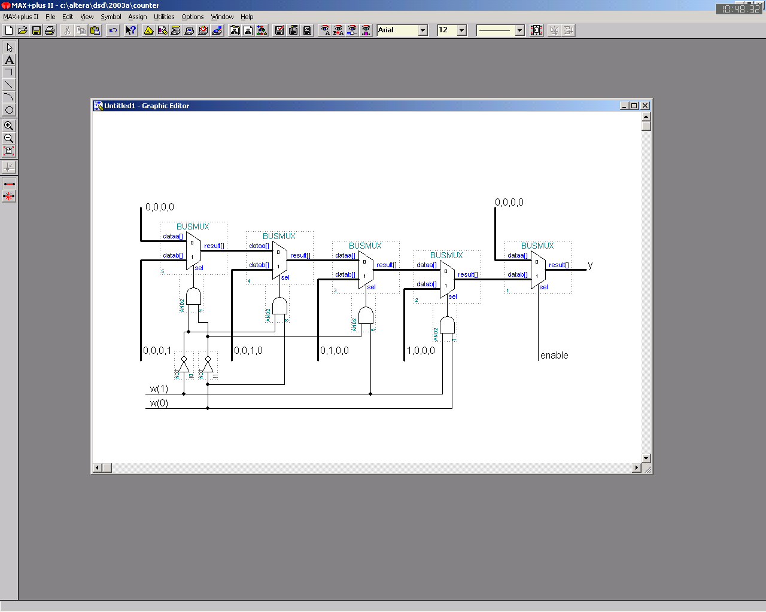
Question 3 continues on next page ---→
Your Name_______________________________________________________

Question 3 : VHDL (15 points) (Continues)

- (8 points) Using only simple concurrent signal assignment statements, write a complete VHDL description of a full-adder circuit (i.e. a 1-bit adder with carry in and carry out).

LIBRARY ieee;
USE ieee.std_logic_1164.all;
ENTITY full_adder IS
PORT ( a, b, c_in : IN STD_LOGIC;
sum, c_out : OUT STD_LOGIC);
END full_adder;

ARCHITECTURE midterm OF full_adder IS
BEGIN
sum <= (a xor b) xor c_in;
c_out <= (a and b) or (a and c_in) or (b and c_in);
END midterm;

Your Name_______________________________________________________
Question 4 : CMOS Circuit Technology Design (15 points)
The circuit shown below is supposed to produce the following function
f = A B C + B‾C + ‾A‾C.

After close examination of this circuit, it is realized that the circuit does not work properly.
(5 points) a) What is the problem with this circuit?
(10 points) b) Using no more than 4 transmission gates (TG’s) and as many inverters as needed, draw a well behaving circuit that produces f .
Marking scheme for (b). Up to 5 points will be given for a correct circuit using more than 4 TG’s,. Extra 5 points will be given for a circuit fully answering the question.

ANSWER

a) For C = 0, A and B are passing to f. Therefore, the output f can be pulled-up and pulled-down simultaneously when A =0 and B = 1 and also when A = 1 and B = 0.

Question 4 continues on next page -----------→
Your Name_______________________________________________________
Question 4 : (Continues)

b) The circuit can be easily be corrected by producing two mutually exclusive output paths, as suggested by the Shannon expansion of f with respect to C.

_{___-----------_________}
f = ‾C [B +‾A] + C [A B] or f = ‾C [‾B A] + C [A B]

Your Name_______________________________________________________
Question 5 : Design Problem (10 point)

Design a combinational circuit that will detect overflow in 2-digit binary-coded-decimal addition.
An overflow occurs when the result of the addition of the two digits is > 9 which results in an illegal sum digit. Example: 9 + 3 = 12; 8 + 8 = 16 are illegal results.

(5points) a) Assuming that the result of the addition is represented by the binary variables (s₄ s₃ s₂ s₁ s₀), give the algebraic expression of the overflow function.
(5 points) b) Draw the circuit producing the overflow function, using only 2 x 1 multiplexers.
Marking scheme for b): If the overflow function obtain in a) is not correct but the circuit produces correctly the obtained function, then full mark for b) will be given.
_________________________________________________________________
- The truth table of the overflow function is the following:

16 8 4 2 1 Overflow
s₄ s₃ s₂ s₁ s₀ function

0 0 0 0 0 0 0
1 0 0 0 0 1 0
2 0 0 0 1 0 0
3 0 0 0 1 1 0
4 0 0 1 0 0 0
5 0 0 1 0 1 0
6 0 0 1 1 0 0
7 0 0 1 1 1 0
8 0 1 0 0 0 0
9 0 1 0 0 1 0
10 0 1 0 1 0 1 By inspection of the table and using the don’t care
11 0 1 0 1 1 1 cases we can write directly the algebraic form of the
12 0 1 1 0 0 1 overflow function: Overflow = ‾s₄ (s₃s₁ +s₃s₂) + s₄
13 0 1 1 0 1 1 which readily suggests the multiplexer circuit
14 0 1 1 1 0 1 shown on the next page.
15 0 1 1 1 1 1
16 1 0 0 0 0 1
17 1 0 0 0 1 1
18 1 0 0 1 0 1
19 to 31 NEVER OCCURE because we assume that the adder will not accept addends and augends larger than 9, i.e. 9 + 9 = 18 is the maximum value of the output.
Question 5 : Design Problem (Continues)

Question 6 : Circuit Implementation Strategies/Logic Arrays (15 points)
Given the following two functions

f = ‾A‾C‾D + A B C‾D + A‾B C D + A B‾C D
g = A‾C‾D + A‾B‾D + A B C D + A‾B‾C

By using the complement of one function as part of the other, draw the PLA circuit producing both functions.

(10 points) a) Express the complement of one function as part of the other.
(5 points) b) Using the schematic provided on next page, draw the PLA circuit producing both functions.

Marking scheme: Up to 5 points will be given for each function. Full marks will be given for simplest solution. Partial credit will be given if error propagates form part a) into part b).
__________________________________________________________________________

  - Using the bridging method, we shall try to express f in terms of ‾g .
In other words, given f and ‾g , find Q such that f = ‾g • Q.
f = ‾g • Q

Since Q exists, f can be expressed in terms of ‾g thus: f = ‾g •Q =‾g (A + ‾C‾D),
where ‾g = ‾A + B(‾C D + C‾D) +‾BC D.

The resulting PLA circuit is shown on next page.

Note that we could also have expressed g in terms of ‾f and compare which solution needs less connections in the PLA. This comparison, however, was not asked in the problem.

Question 6 : Circuit Implementation Strategies/Logic Arrays (Continues)

