McGill University
Department of Electrical and Computer Engineering

Course: ECSE - 323 Fall 2008

Assignment #6
with solutions

TOPIC : Sequential Circuits

Consider the following combinational circuit with feedback which can be thought of as a basic memory element, M.
a) Determine the stable states and the input values for which oscillation occurs by showing with a circle the corresponding entries in its state transition map.
b) Using the given memory element, M, as a building block and additional NAND gates as needed, design and draw the circuit of a JK-type memory element.
________________________________________________________________________
ANSWER

a)
Q+ = ‾x‾y + Q x y + ‾Q‾x next state map

x y  Q | 00 | 01 | 11 | 10
0 | 1 | 1 | 0 | 0
1 | 1 | 1 | 1 | 0

Q+

For the input values x = 0, y = 1 the circuit oscillates
For the other input values the circuit is stable.
b)
Solving for x and y as functions of J, K and Q
we obtain
Q -> Q+ |  |  |  | J K |  | X Y
0 0 |  |  |  | 0 * |  | 1 *
0 1 |  |  |  | 1 * |  | 0 0
1 0 |  |  |  | * 1 |  | 1 0
1 1 |  |  |  | * 0 |  | 1 1
J K  Q | 00 | 01 | 11 | 10
0 | 1 | 1 | 1 | 0
1 | 1 | 1 | 1 | 1
x = Q + ‾J

J K  Q | 00 | 01 | 11 | 10
0 | 0 | 0 | 0 | 0
1 | 1 | 1 | 1 | 1
y = Q‾K

with the condition ‾x y = 0 to present oscillation
The resulting circuit is
TOPIC : Registers and |Counters
Problem 1
Design a circuit that adds 3 to the contents of a 4-bit register. Originally the register contains a 4-bit number N , where 000< N < 1100. After one single clock pulse the register contents should be N + 0011.
a) Explain briefly your design approach
b) Draw the complete circuit using JK-type edge-trigger flip-flops, full adders and NAND gates as needed.
________________________________________________________________________ANSWER
a) Load each flip-flop of the register with the output of a full-adder which has, respectively, as inputs the previous contents and the corresponding bit of the number 0011. Carry should ripple from one order to the next.
b)
Note that a D-type flip-flop can be built with a JK-type and an inverter thus

Problem 2
Design a 4-bit multifunction register that will behave according to the following table:

A B | Function performed
00 | Clear register
01 | Complement register contents
10 | Add 1 to register contents
11 | Load register from input lines

Where A, B are the mode select inputs. Use 4 x 1 multiplexers for mode selection
_______________________________________________________________________
ANSWER
Di = ‾A‾B [ 0 ] +‾A B [‾Qi ] + A‾B [Si] + A B [Ii]
where Si = Qi + Ci ( + means here arithmetic addition) for i = 0,1,2,3 with C0 = 1.

Counters
Problem 3
Using the 74X163 4-bit programmable counter, with synchronous CLEAR and LOAD inputs, whose block diagram is shown below, and the fewest number of gates possible, draw a circuit of a counter having 4 different counting sequences depending on the values of two mode selection variables s₁ s₂ . The 4 counting sequences of the counter are the following

Mode selection s₁ s₂ | Counting sequence
00 | 0 to 15
01 | 0 to 7
10 | 0 to 9
11 | 0 to 12

Use one 4 x 1 multiplexer for mode selection. Assume that the counter is self starting, meaning that the counter will always fall into the correct selected counting sequence after certain number of counts have elapsed.
________________________________________________________________________ANSWER:

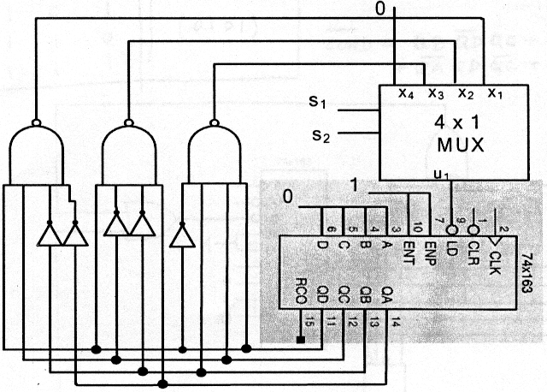

Problem 4
Using the 74x163 4-bit programmable counter, with synchronous CLEAR and LOAD
Inputs, whose block diagram is shown below, and the fewest number of gates possible draw a SERLF-STARTING counter that will count following the sequence 5,6,7,8,9,10,5,6,7,8,9,10….
________________________________________________________________________ANSWER
Out-of-sequence detection logic
 | Present state  QD QC QB QA | Next state  QD+ QC+ QB+ QA+
0 | 0 0 0 0 | Load  (0101)
1 | 0 0 0 1 | Load  (0101)
2 | 0 0 1 0 | Load  (0101)
3 | 0 0 1 1 | Load  (0101)
4 | 0 1 0 0 | Load  (0101)
5 to  10 | Counting  sequence | Counting  sequence
11 | 1 0 1 1 | Load  (0101)
12 | 1 1 0 0 | Load  (0101)
13 | 1 1 0 1 | Load  (0101)
14 | 1 1 1 0 | Load  (0101)
15 | 1 1 1 1 | Load  (0101)

_____
LOAD = QB‾QD QC +QA‾QD QC + ‾QA QD ‾QC + ‾QB QD‾QC

