McGill University
Department of Electrical and Computer Engineering

Course: ECSE - 323 Fall 2008

Assignment #5
(with solutions)

TOPIC: Circuit Implementation Strategies/Logic Arrays
1.- The Boolean function expressing the logic behaviour of a 9-bit parity checker is

P = A ⊕ B ⊕ C ⊕ D ⊕ E ⊕ F ⊕ G ⊕ H ⊕ J.

The PLA shown on next page is to be used to produce this function.
a) Decompose the function so that it can be produced with the given PLA
b) Program the PLA by showing carefully, on the given PLA schematic, the required connections. Not all connections are needed.
________________________________________________________________________
ANSWER
a)
Decomposing P in terms of blocks of 3 variables EX-OR’s we obtain the following circuit
P = Y1 ⊕ Y2 ⊕ Y3. where Y1 =A ⊕ B ⊕ C ,Y2 =D ⊕ E ⊕ F, and Y3 =G ⊕ H ⊕ J.
b)
The PLA program is shown on next page.
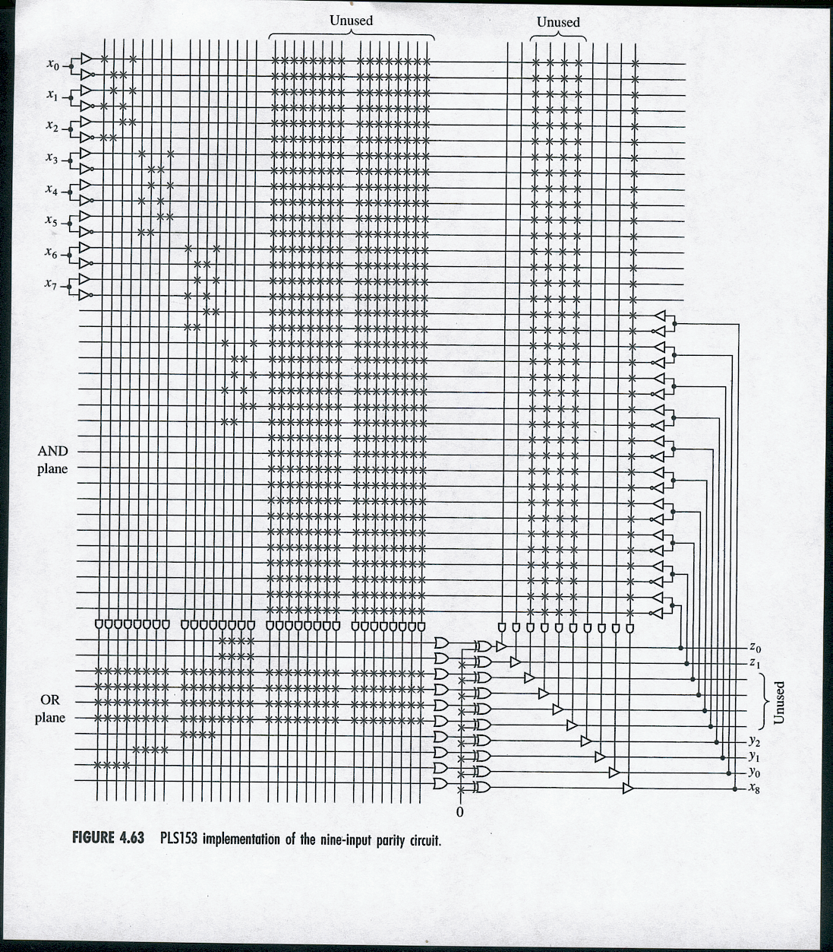

2.- Implement the following functions

F1(A,B,C,D) = ∑m(0,1,2,3,6,9,11)
F1(A,B,C,D) = ∑m(0,1,6,8,9)
F1(A,B,C,D) = ∑m(2,3,8,9,11)

using

a) a 4x1 decoder and logic gates
b) a PLA schematic
c) a PAL schematic.
__________________________________________________________________
ANSWER
a)

b)

Note that the functions can be written thus to obtain maximum sharing of terms

F1 = ‾A‾B‾C +‾A‾B D + A‾B D
F2 = ‾A‾B‾C + A‾B‾C +‾A B C‾D
F3 = ‾A ‾B C + A‾B‾C + A‾B D

c) The PAL implementation is shown on next page
Note that in this case no sharing of terms is possible.

3.- Design a switching network that has five input variables, A,B,C,D,E, and one output variable, F. Four of the input variables , A,B,C,D, represent BCD digits, and the fifth variable, E, is a control line. While the control line, E, is at logic 0, the output, F, should be logic 1 only if the BCD digit is greater or equal to 5. While the control line, E, is at logic 1, the output, F, should be logic 1 only if the BCD digit is less or equal to 5.
a) Give the k-map of the output function, F.
b) Produce a minimal NAND-NAND realization of F
c) Produce a minimal OR-NAND realization of F.
d) A PLA schematic
e) A PAL schematic
f) Produce F using fewest number of 3-LUT’s
___________________________________________________________________________
ANSWER

a)

AB  CD | 00 | 01 | 11 | 10
00 | 0 | 0 | X | 1
01 | 0 | 1 | X | 1
11 | 0 | 1 | X | X
10 | 0 | 1 | X | X
AB  CD | 00 | 01 | 11 | 10
00 | 1 | 1 | X | 0
01 | 1 | 1 | X | 0
11 | 1 | 0 | X | X
10 | 1 | 0 | X | X
‾E E

F(A,B,C,D) =‾E ( A + B C + D B ) + E (‾B‾A +‾A‾C)
or B‾C
b)

c)

‾F(A,B,C,D,E) = ( E +‾A)(‾B +‾D + E)(E +‾C +‾B)(B + A +‾E)( C +A +‾E)

d)
The PLA implementation of F follows

e)
The PAL implementation follows
We use the expression F(A,B,C,D,E) = ‾E (A + B C + D B) + E (‾B‾A +‾A‾C)
f)
We use the following expression of F

F(A,B,C,D,E) =‾E ( A + B C + D B ) + E (‾B‾A +‾A‾C)

F(A,B,C,D,E) =‾E R1 + E R2
R1 = ( A + B C + D B ) and R2 = (‾B‾A +‾A‾C)
R1 = A + B(C + D) which is of the form R1 = a + b f1 where a = A, b = B and
f1 = C + D
The corresponding truth tables are

A B C | R2 | E R2 R1 | F
0 0 0 | 1 | 0 0 0 | 0
0 0 1 | 1 | 0 0 1 | 1
0 1 0 | 1 | 0 1 0 | 0
0 1 1 | 0 | 0 1 1 | 1
1 0 0 | 0 | 1 0 0 | 0
1 0 1 | 0 | 1 0 1 | 0
1 1 0 | 0 | 1 1 0 | 1
1 1 1 | 0 | 1 1 1 | 1
a b f1 | R1
0 0 0 | 0
0 0 1 | 0
0 1 0 | 0
0 1 1 | 1
1 0 0 | 1
1 0 1 | 1
1 1 0 | 1
1 1 1 | 1

************************END OF ASSIGNMENT #5*****************************

