1. The game starts, initial deal gets done automatically. Every player has 2 cards, dealer has one. Player names are to be entered in their respective dialogue box.
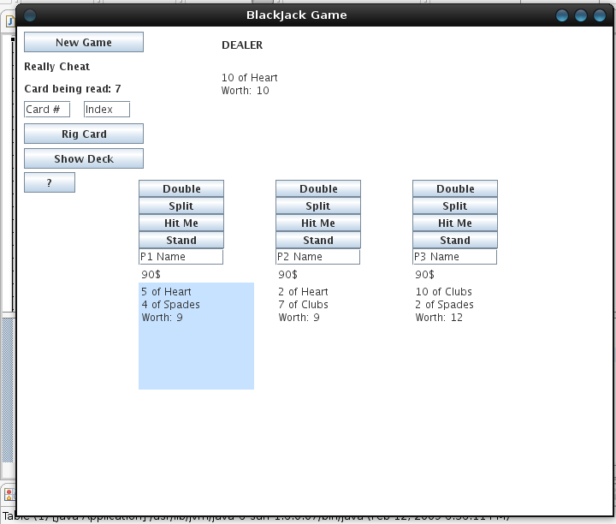
2. Enhances cheating applications have been set up. At any time, click ‘?’ button to display all the details.

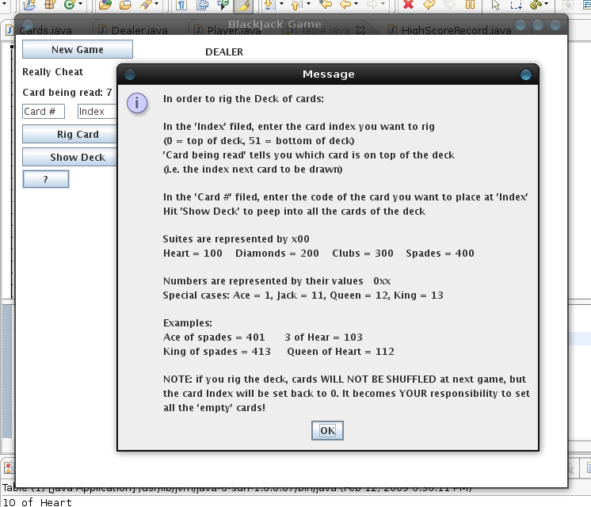
3. To enhance cheatability even more, a ‘Show Deck’ Button has been set up, and at any time shows the content of the deck of cards. All cards are indexed. The next card to be dealt is “Card Being Red : xx” on the top left of the window.
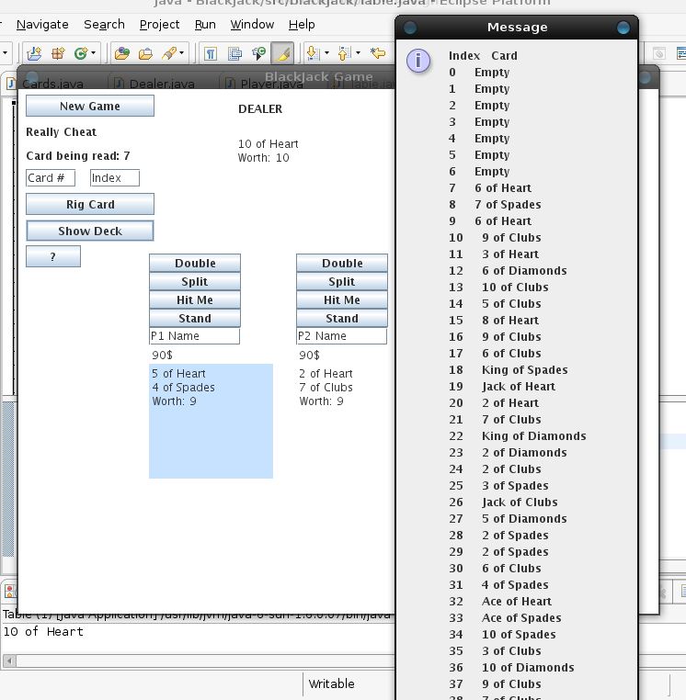
4. You may rig any card in the deck, and using this cheat function allows you to have duplicate cards on the deck. Enter the card code in the card # dialogue (pres ‘?’ for info on card cores), enter the desired card index in the ‘index’ dialoigue and hit ‘Rig Card’ to insert it in the deck at the desired position.

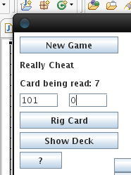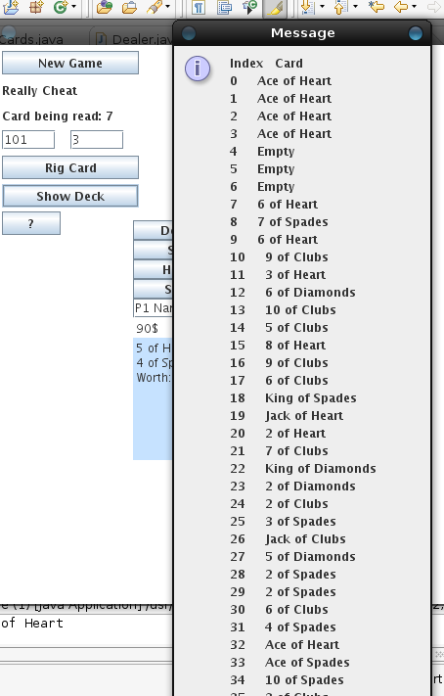

You may hit the ‘Show Deck’ button afterwards to ensure that you entered the desired cards at the desired index.
5. Cards are read sequentially in the deck, so after rigging the deck, the card index will still be at its previous location (see page before, card index remained at 7) To take advantage of rigging initial cards, just hit ‘New Game’ and the cards will be dealt with the deck ‘As Is’, without shuffling. The inserted rigged cards will be dealt first, then empty spots ignored and the remaining cards dealt sequentially.

Note, once the card index reached the last card on the deck, the deck will be shuffled automatically.
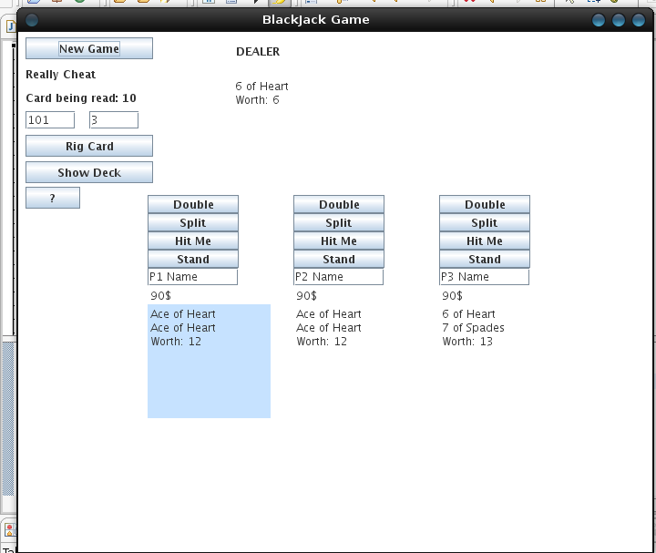
6. The game flow is pretty straight forward if you are familiar with blackjack. Every player gets his turn to play, afterwards the dealer plays. The current hand being played is displayed in blue.

A player may split his hand provided he has at least 10$ to cover the new bet, 2 identical cards and that he hasn’t hit or passed yet.

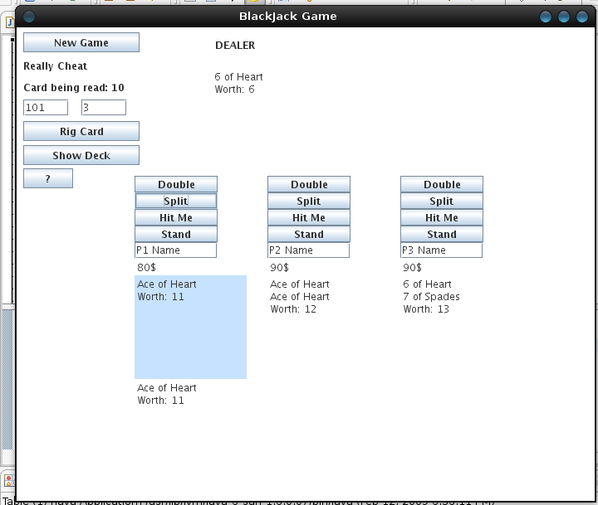
7. A player may purchase “Insurance” By hitting the “Insurance” button provided the dealer has an Ace and the player has at least 5$ in his account. In the event of a Dealer blackjack, the player will receive 10$ back. (Note, the ‘Insurance’ Button got added last and doesn’t appear on all the screen Shots!)

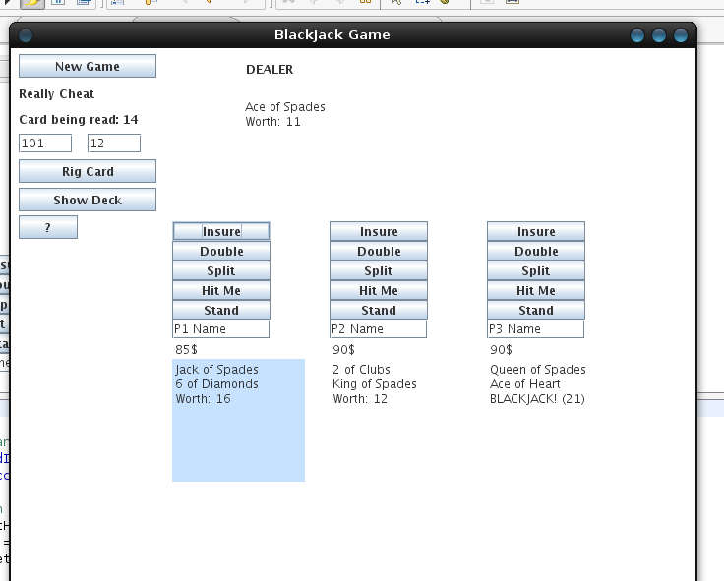
8. Once a player hits ‘Stand’, the game shifts either to his split hand or to the next player.
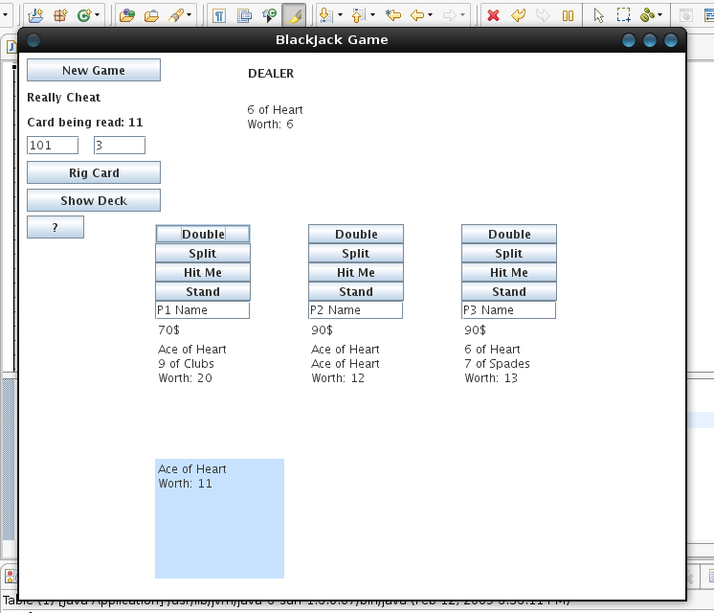
9. To receive a card on the played hand, press ‘Hit Me’ while it is highlighted.
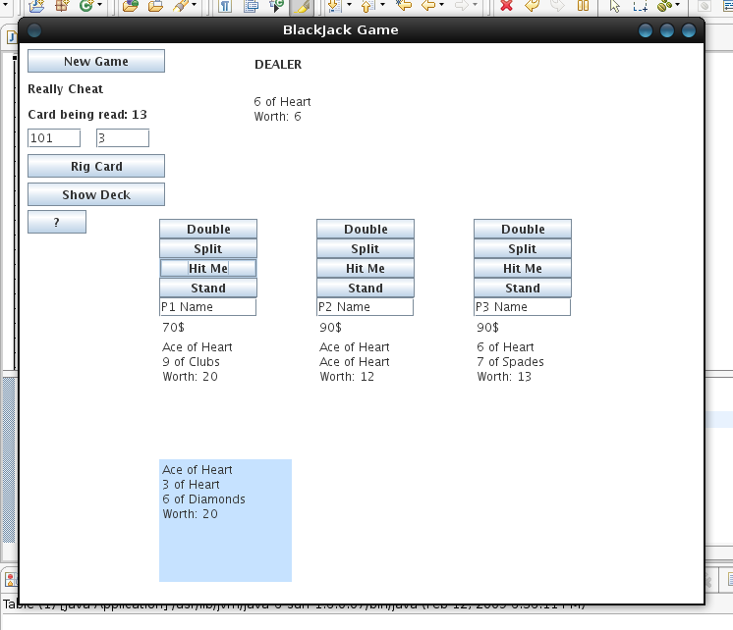
10. Player may hit a hand until he passes or busts over 21. The hand’s score is automatically computed.
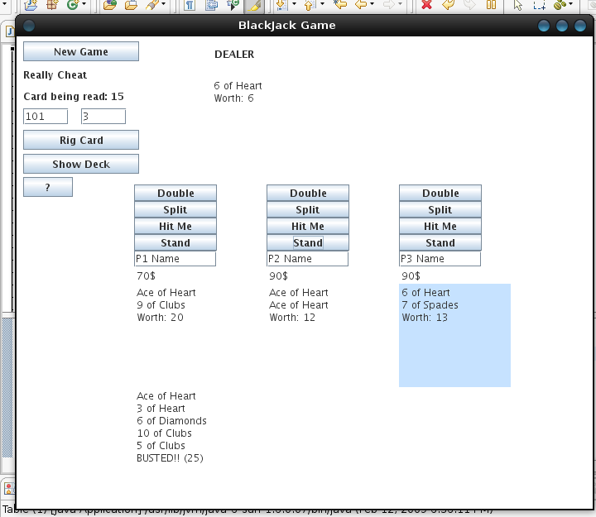
11. If a player has a blackjack, he will not be allowed to hit. His turn will be automatically passed. After all players have played; the dealer’s hand is automatically played, based on blackjack rules. Based on the card results, weather they doubled or split, their hand = dealer’s hand, etc… players will get paid at the end of every round if needed.

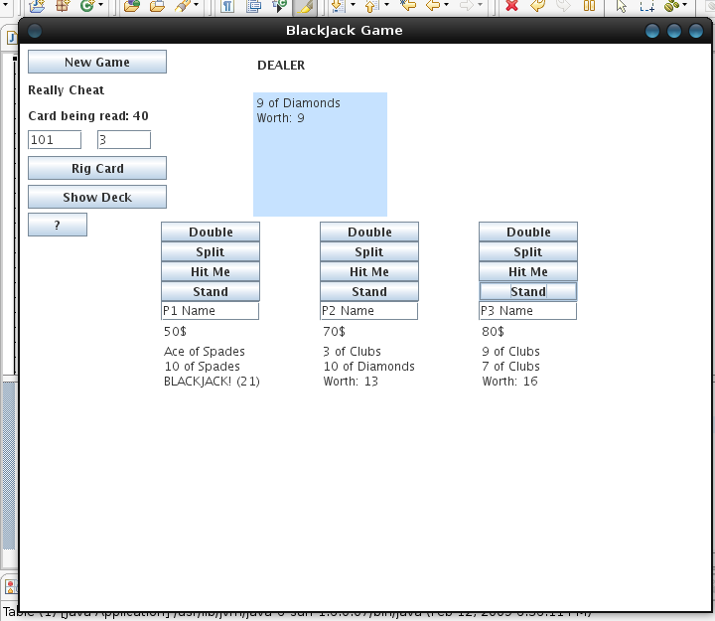
12. When a player’s account reaches less than 10, he is removed from the game. 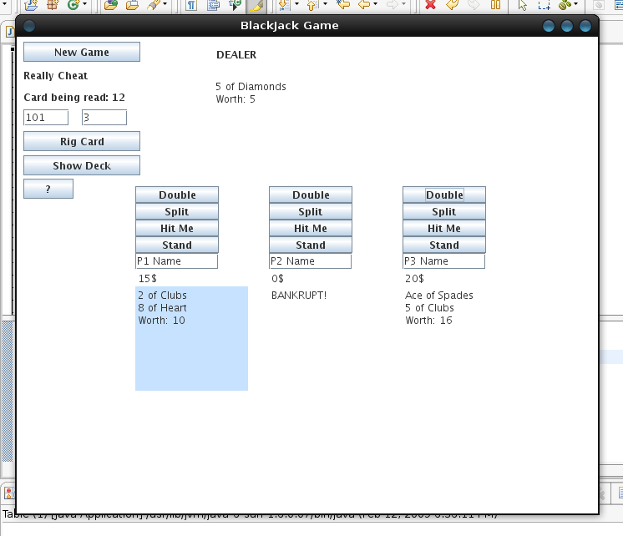
13. When there is only a single player remaining, the game is over and he wins. (see green dialogue) High scores are recorded for the current session and displayed on the top right corner after every game. The name entered in the high score is the name typed in the player’s dialogue box. At this point, user needs to hit new game or close the program.

