Q3 A- 4 bit adder which performs the following function:

F0 | F1 | F(a,b)
0 | 0 | a
0 | 1 | a+b
1 | 0 | a-b
1 | 1 | a
The logic for the Cin is the following:
Cin = (F0.F1’)
Here is the circuit of my 4 bit adder:
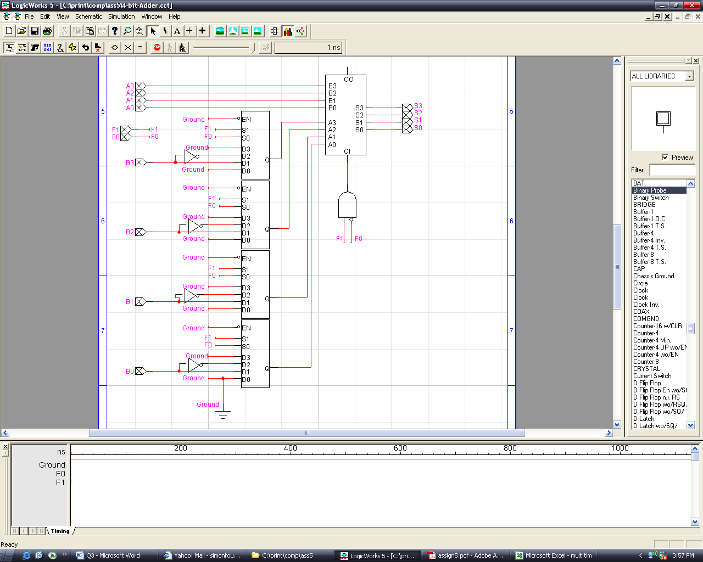

I tested every possibility with the encapsulation, and got exact same results:
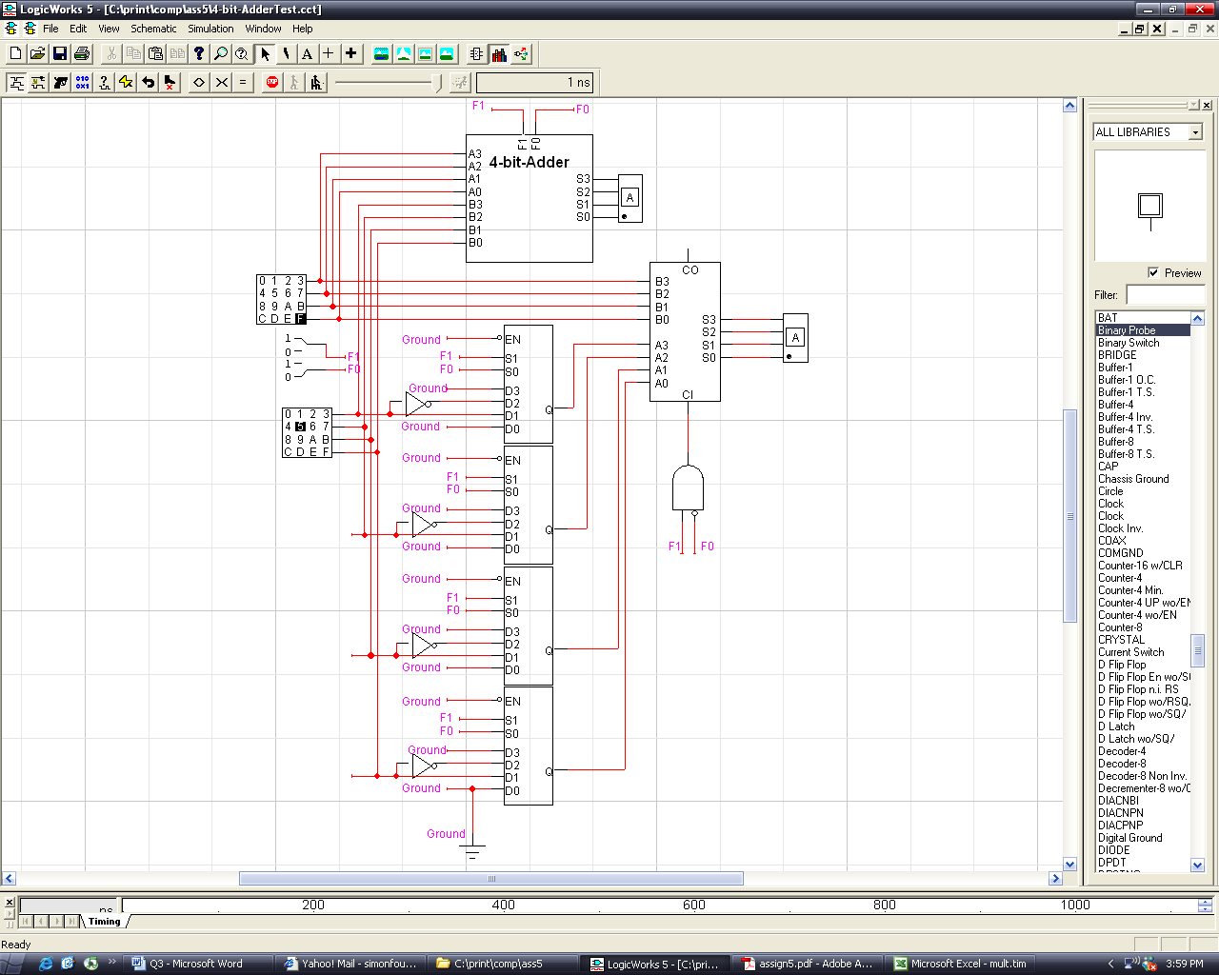

Q3B - Shift Register

Here is the circuit for my shift register:

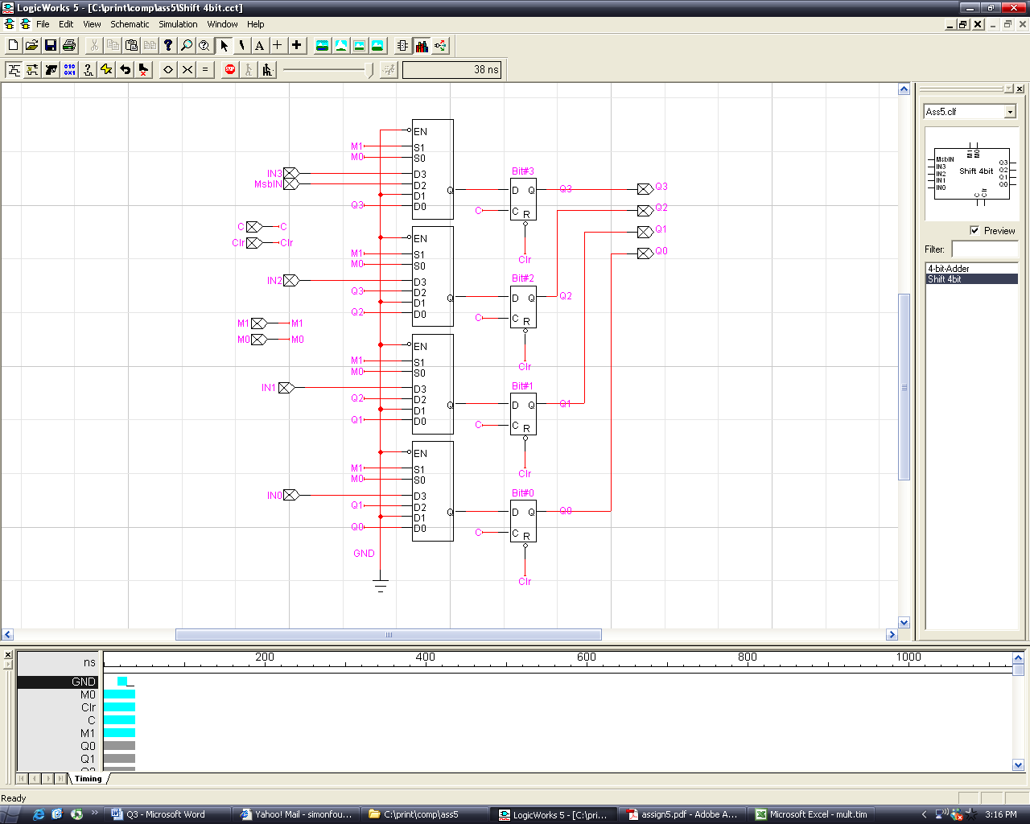

And Performed the same tests with the shift register and its encapsulation:
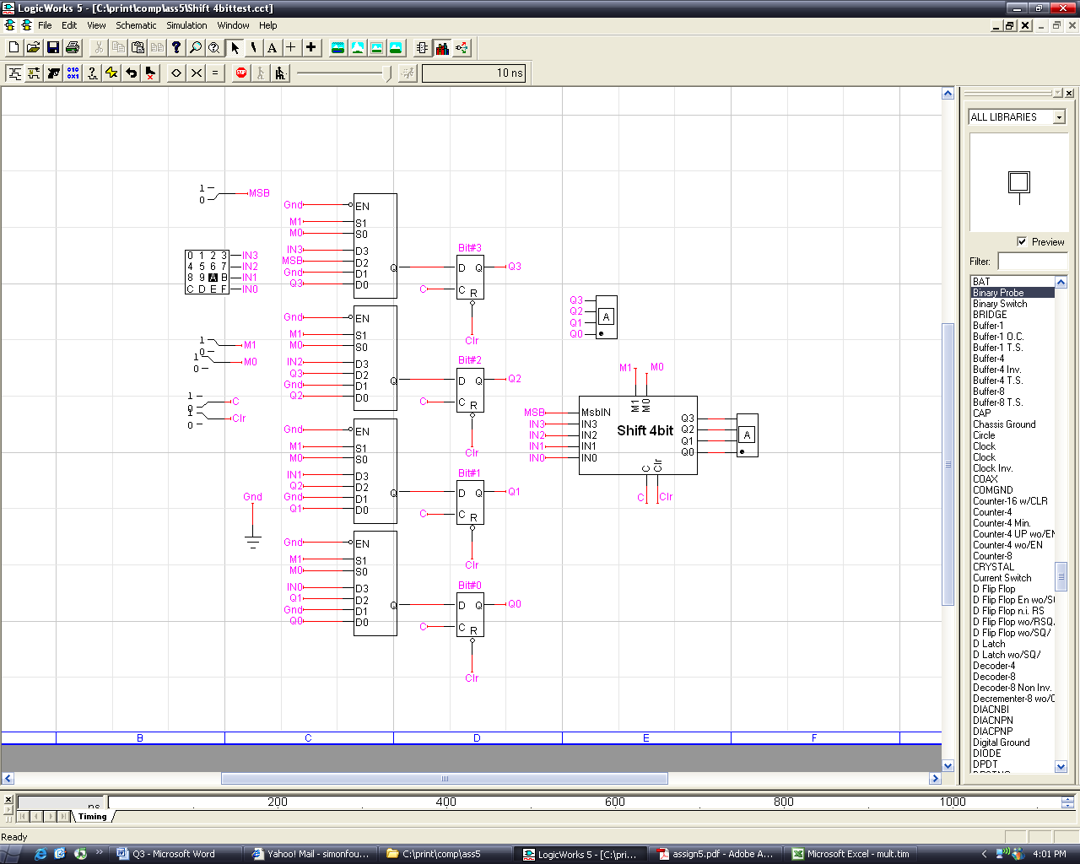

Q3C Booth’s Algorithm Hardware Implementation

Here is the implementation of Booth’s Algorithm:
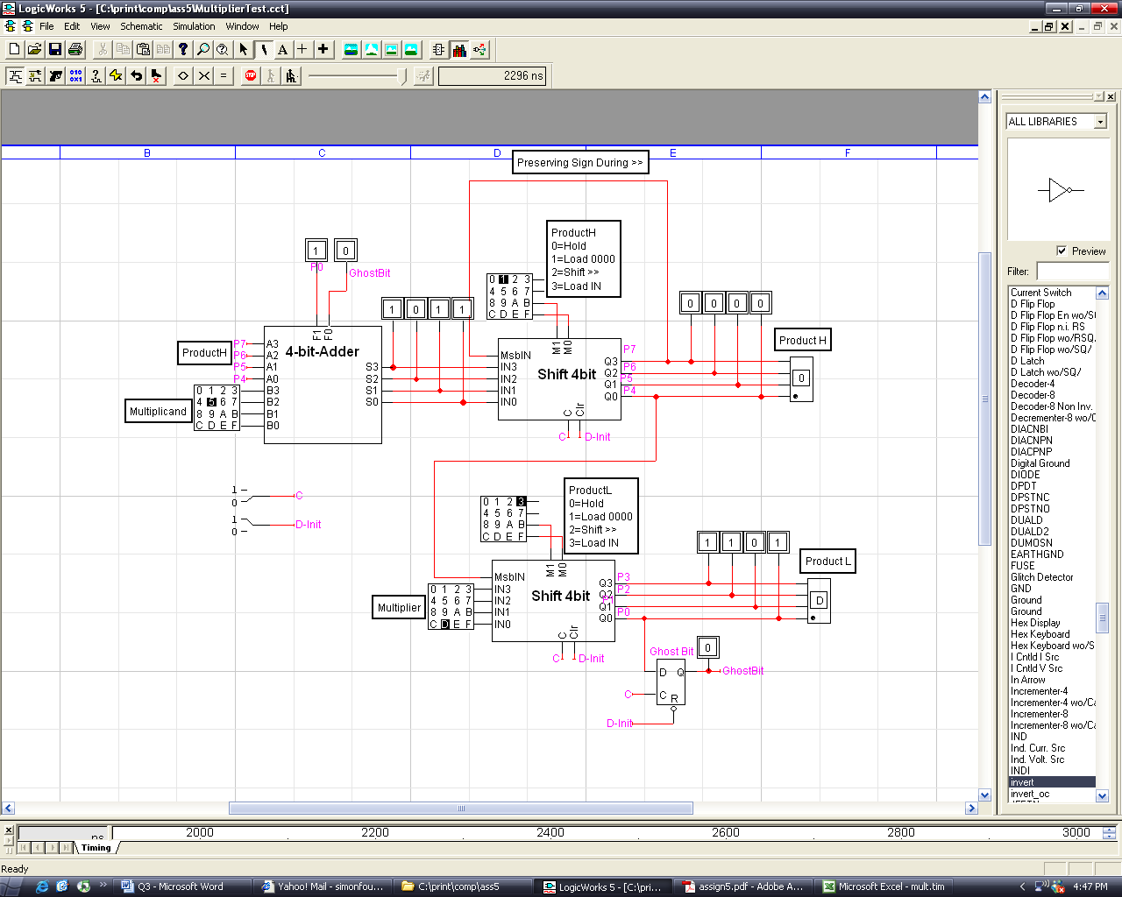
First set D-Init=0 for 1 clock cycle, then put it back to 1
Innitialisation (1 Clock cycle):
- ProductH=1(Load 0000)
- ProductL=3 (Load Multiplier)

Add/Shift (Repeat 4 times)
First Clock Pulse:
- ProductH=3 (Load ALU output)
- ProductL=0 (Hold current value)

Second Clock Pulse:
- ProductH=2 (Shift >>1)
- ProductL=2 (Shift >>1)

The result will be stored in ProductH and ProductL
Q3D: State transition

I didn’t really understand the question. If we do the sate transition with regards to P7, P6, …P1 with regards to M1, M0 of both ProductH and ProductL and Dinit, it will take 4096 lines. If we add the clock, 8192 lines.
But looking at the next question, I gathered you want the next state of the control lines. I just don’t get what the Q on the headline of Q3D mean. So this is what I got for you. Hope it makes sense and is close to what you want:
Step | Q3 | Q2 | Q1 | Q0 | HM1 | HM0 | LM1 | LM0 | Dinit | Hex | ProductH | PtoductL
1 | 0 | 0 | 0 | 0 | 0 | 0 | 0 | 0 | 0 | 0 | Reset | Reset
2 | 0 | 0 | 0 | 1 | 0 | 1 | 1 | 1 | 1 | F | Load 0000 | Load Multiplicand
3 | 0 | 0 | 1 | 0 | 1 | 0 | 1 | 0 | 1 | 15 | >> | >>
4 | 0 | 0 | 1 | 1 | 1 | 1 | 0 | 0 | 1 | 19 | Load ALU Out | Hold
5 | 0 | 1 | 0 | 0 | 1 | 0 | 1 | 0 | 1 | 15 | >> | >>
6 | 0 | 1 | 0 | 1 | 1 | 1 | 0 | 0 | 1 | 19 | Load ALU Out | Hold
7 | 0 | 1 | 1 | 0 | 1 | 0 | 1 | 0 | 1 | 15 | >> | >>
8 | 0 | 1 | 1 | 1 | 1 | 1 | 0 | 0 | 1 | 19 | Load ALU Out | Hold
9 | 1 | 0 | 0 | 0 | 1 | 0 | 1 | 0 | 1 | 15 | >> | >>

From here, I implemented a PROM with Q3-Q0 as address input. The output is of 5 bits, each representing a control line. To use this circuit, Enter Multiplicand and Multiplier in the appropriate hex keyboard. Set the keyboard connected to the controller to 0 and the clock (c)=0. Then increment the controller keyboard to 1. Flip the clock to 1 then back to 0. Set the controller keyboard to 1 and flip the clock to 1 then 0. Keep doing this until you reach #8 on the controller sequence (after 9 steps). The result will be stored in ProductH and ProductL.

For the example of (-7) x (6)

This is what should be happening (1011x0110):
Step | ProductH | ProductL | Ghost Bit
Init: | 0 0 0 0 | 0 1 1 0 | 0
00=Hold | 0 0 0 0 | 0 1 1 0 | 0
>> | 0 0 0 0 | 0 0 1 1 | 0
10=Sub | 0 1 1 1 | 0 0 1 1 | 0
>> | 0 0 1 1 | 1 0 0 1 | 1
11=Hold | 0 0 1 1 | 1 0 0 1 | 1
>> | 0 0 0 1 | 1 1 0 0 | 1
01=Add | 1 0 1 0 | 1 1 0 0 | 1
>> | 1 1 0 1 | 0 1 1 0 | 0

The result is ProductH=1101 and ProductL=0110

And these are exactly the results I get:
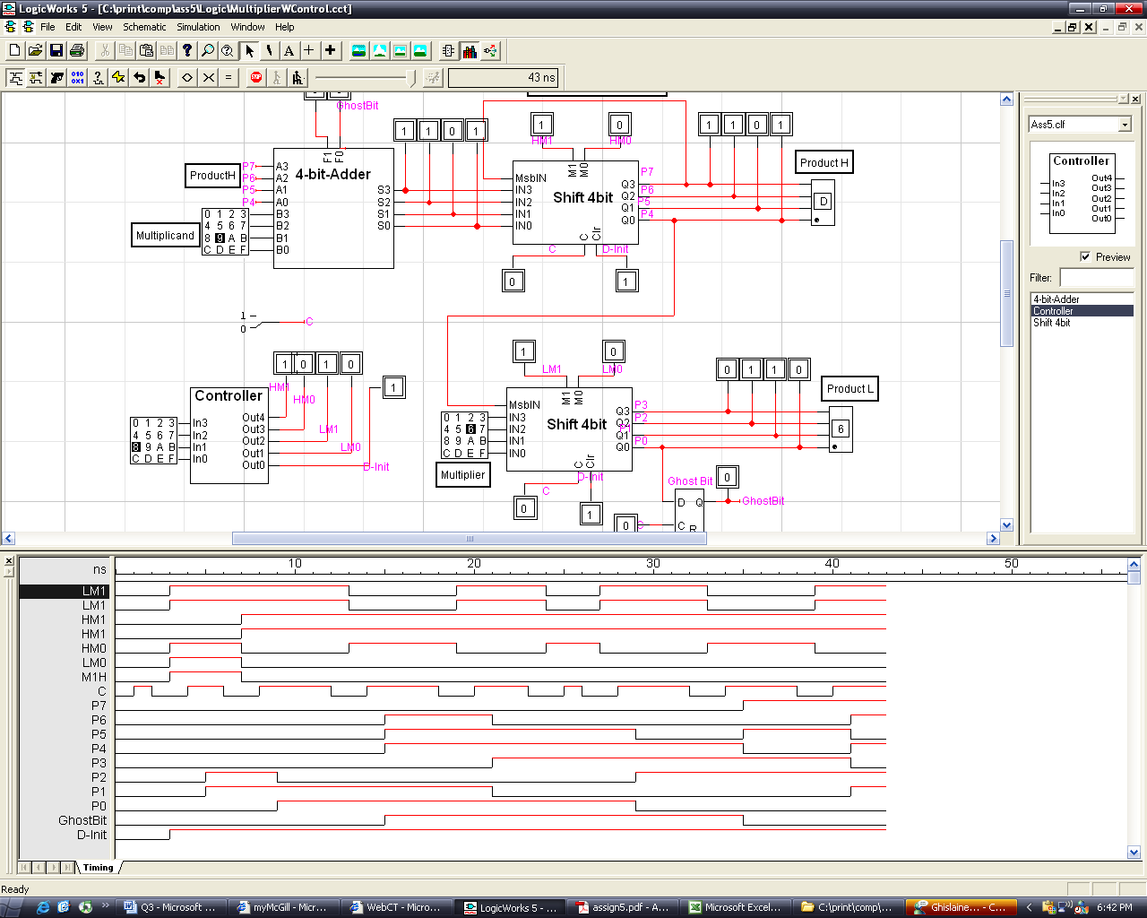

The irregularity of the clock pulses is due to the fast that they are set manually.

