Q3 A- 4 bit adder which performs the following function:
If you’re going to open the circuits, since I changes the folder name a few times, I sometimes get errors when I open them. Hope they work the first time for you.

F0 | F1 | F(a,b)
0 | 0 | a
0 | 1 | a+b
1 | 0 | a-b
1 | 1 | a
The logic for the Cin is the following:
Cin = (F0.F1’)
Here is the circuit of my 4 bit adder:
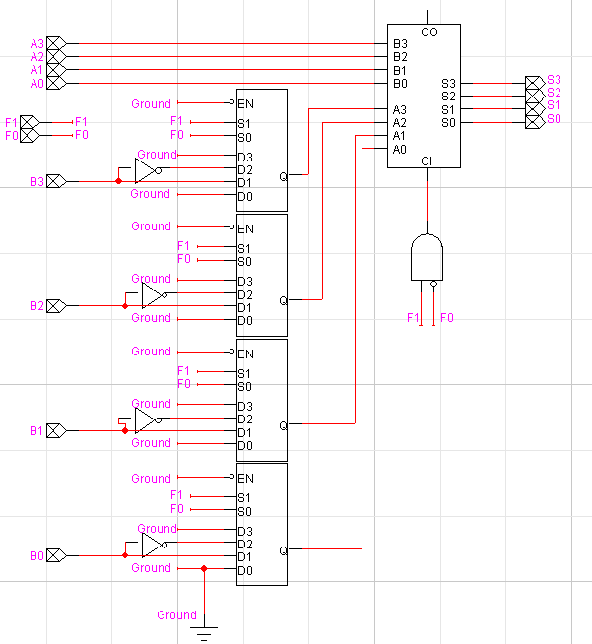

I tested every possibility with the encapsulation, and got exact same results:
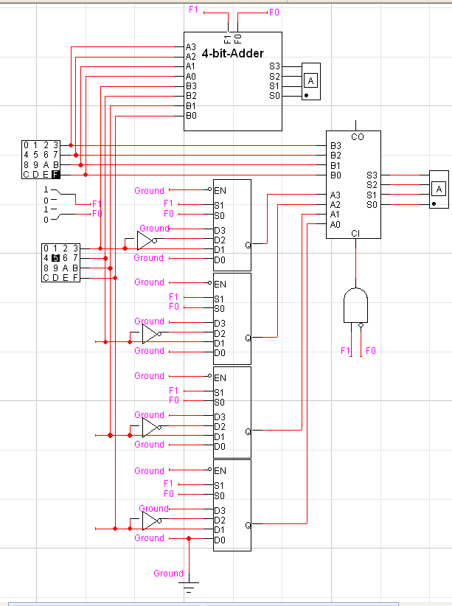

Q3B - Shift Register

Here is the circuit for my shift register:

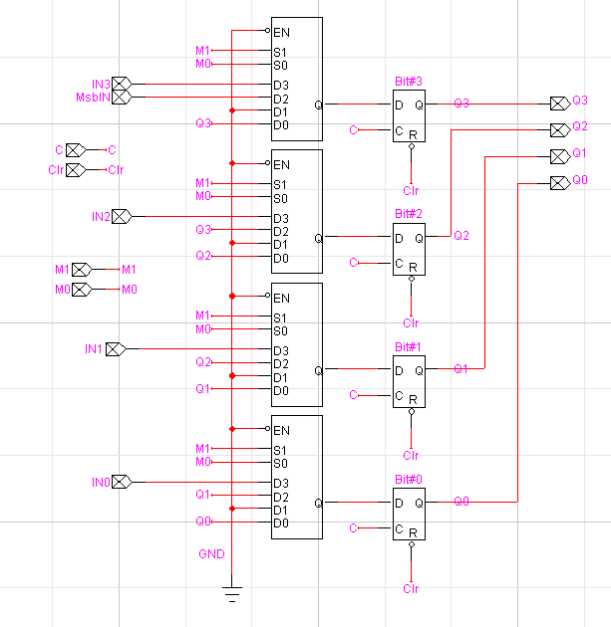

And Performed the same tests with the shift register and its encapsulation:
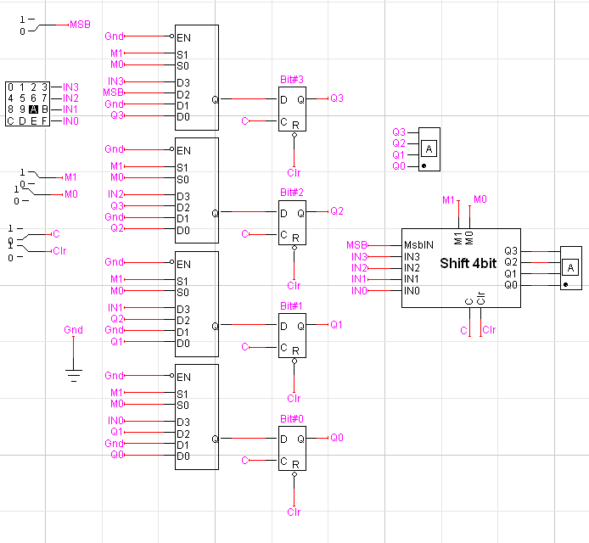

Q3C Booth’s Algorithm Hardware Implementation

Here is the implementation of Booth’s Algorithm:
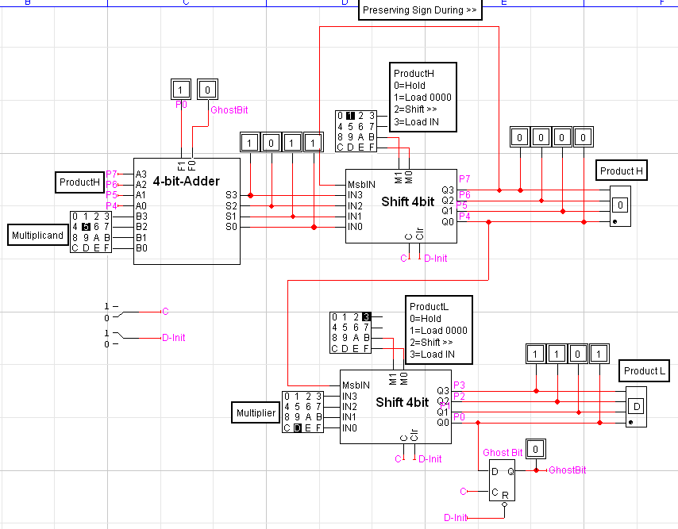
First set D-Init=0 for 1 clock cycle, then put it back to 1
Innitialisation (1 Clock cycle):
- ProductH=1(Load 0000)
- ProductL=3 (Load Multiplier)

Add/Shift (Repeat 4 times)
First Clock Pulse:
- ProductH=3 (Load ALU output)
- ProductL=0 (Hold current value)

Second Clock Pulse:
- ProductH=2 (Shift >>1)
- ProductL=2 (Shift >>1)

The result will be stored in ProductH and ProductL

Q3D: State transition

I didn’t really understand the question. If we do the sate transition of P7, P6, …P1 with regards to M1, M0 of both ProductH and ProductL and Dinit, it will take 4096 lines. If we add the clock, 8192 lines.
But looking at the next question, I gathered you want the next state of the control lines. I just don’t get what the Q on the headline of Q3D mean. So this is what I got for you. Hope it makes sense and is close to what you want:
Step | ProductH | PtoductL | Dinit | HM1 | HM0 | LM1 | LM0 | Hex
1 | Reset | Reset | 0 | 0 | 0 | 0 | 0 | 0
2 | Load 0000 | Load Mcand | 1 | 0 | 1 | 1 | 1 | 7
3 | >> | >> | 1 | 1 | 0 | 1 | 0 | A
4 | Load ALU Out | Hold | 1 | 1 | 1 | 0 | 0 | C
5 | >> | >> | 1 | 1 | 0 | 1 | 0 | A
6 | Load ALU Out | Hold | 1 | 1 | 1 | 0 | 0 | C
7 | >> | >> | 1 | 1 | 0 | 1 | 0 | A
8 | Load ALU Out | Hold | 1 | 1 | 1 | 0 | 0 | C
9 | >> | >> | 1 | 1 | 0 | 1 | 0 | A

And here is a drawing of the state transition, showing D, HM1, HM0, LM1, LM0
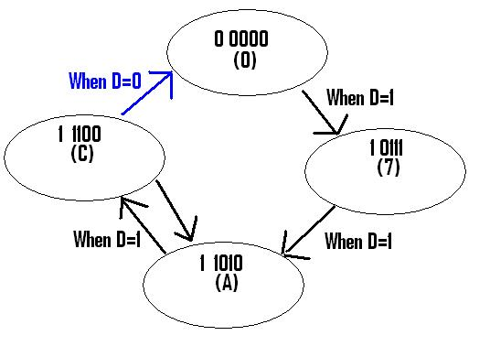

Q3E – Implementation of Booth’s Algorithm using a PROM as a control line

From this, I implemented a PROM with the following entries:
7 X X X
X X X A
X X C X
A X X X

As an input for the PROM, I used its output passing through a multiplexer with D-Init as a select line, which selects between the PROM output and 0. Therefore, whenever D-Init is reset to 0, the PROM input goes to 0 as well. On top of that, I have also installed some D-Flip/Flops on the lines. This enables us to regulate the state transition with the same clock that regulates the whole circuit. (I understand that I could have done that without the multiplexer, because the Clr line of my D Flip/Flops I also hooked up to D-Init, but as mentioned in class, Clr is an asynchronous function that should only be used to reset a flip flop. I just kinda felt like cheating, because it would have been an unclocked function.)

Here is what the controller looks like (I already had a previous controller called “controller”, and didn’t want to delete it right away, this is why this one is called “SuperController”)
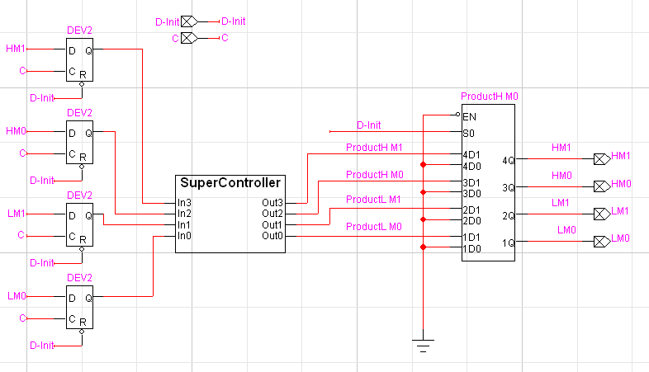

.

So this is what I get for a final circuit.
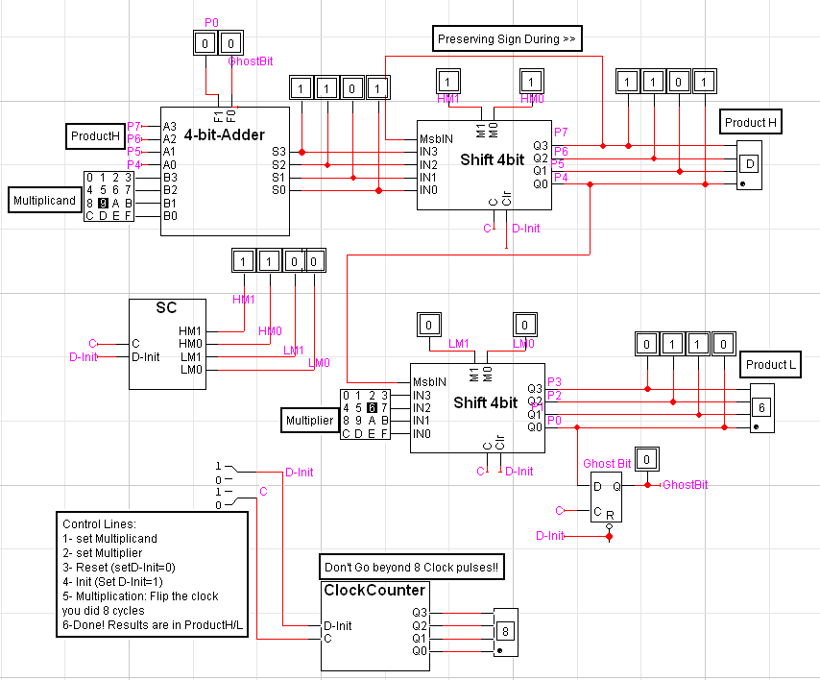

There are basically 4 inputs.
- First, set the hex keyboards for Multiplicand and Multiplier.
- Then reset the system by sending D-Init to 0, for one clock cycle. This will reset everything (the controller-SC-, the ProductH/L shift registers, the ALU and the clock counter).
- Put D-Init to 1 and you’re ready to start.
- Manually flip the clock high and low until you have done 8 cycles. I’ve installed a clock pulse counter, so just look at the clock count hex display and as soon as it reaches 8, you’re done
- The final result is stored in ProductH and ProductL.

Here is an image of my clock pulse counter:
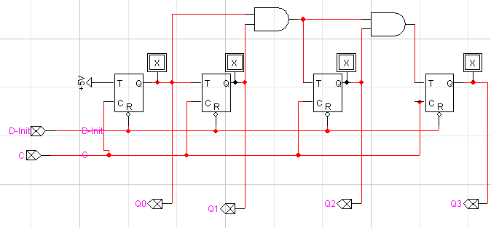

For the example of (-7) x (6)

This is what should be happening (1011x0110):
Step | ProductH | ProductL | Ghost Bit
Init: | 0 0 0 0 | 0 1 1 0 | 0
00=Hold | 0 0 0 0 | 0 1 1 0 | 0
>> | 0 0 0 0 | 0 0 1 1 | 0
10=Sub | 0 1 1 1 | 0 0 1 1 | 0
>> | 0 0 1 1 | 1 0 0 1 | 1
11=Hold | 0 0 1 1 | 1 0 0 1 | 1
>> | 0 0 0 1 | 1 1 0 0 | 1
01=Add | 1 0 1 0 | 1 1 0 0 | 1
>> | 1 1 0 1 | 0 1 1 0 | 0

The final result is ProductH=1101 (D) and ProductL=0110 (6)
And these are exactly the results I get:
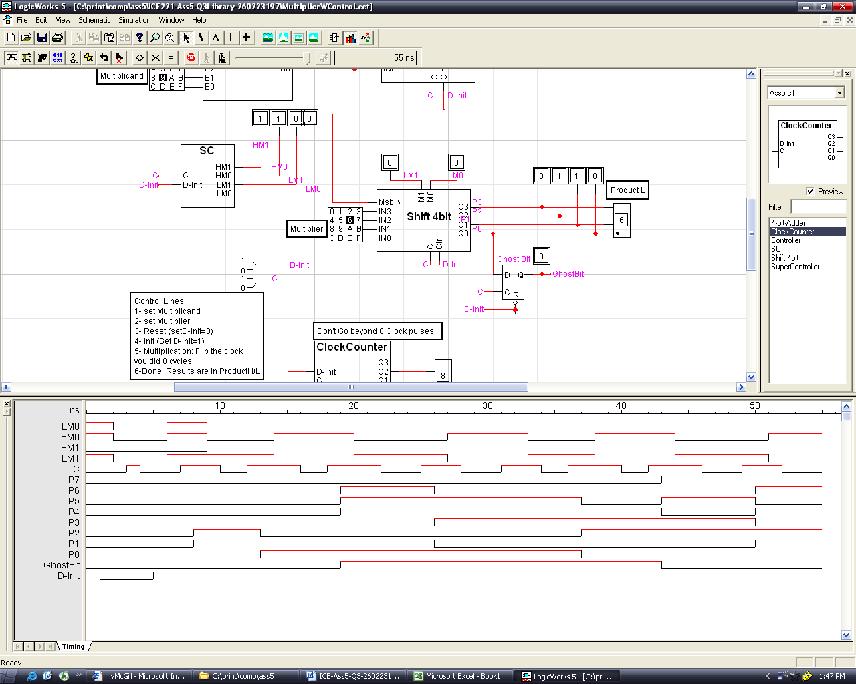
(The irregularity of the clock pulses is due to the fact that they are set manually)

