Q2-A

Finding the 6 Flip Flop equation for J0, K0, J1, K1, J2, K2

Since the circuit is in NAND NAND logic, we will apply De Morgan’s law to convert it to OR/AND logic, which is easier to white in a test editor.
The transition made is the following:

{[A B C]’ [A B C]’}’ = [A B C] + [A B C]

Here are the logic equations:

J2 = [M’ Q0’ Q1’] + [M Q0 Q1’] + [Q0 Q1 M’]

K2 = [Q0’ Q1’] + [M’ Q1’]

J1 = [M Q0’ Q2’] + [M Q0 Q2] + [Q0 M’ Q2’]

K1 = [M Q0’ Q2’] + [Q2 M’ Q0’] + [M Q0 Q2]

J0 = [Q2 M’] + [MQ2’] + [Q1]

K0 = [M’ Q1’] + [MQ1] + [Q2]

From that we can find the next state equations for the Flip/Flops. From the Karnaugh map of a JK flip flop, we know that (since there doesn’t seem to have Q^ in ANSII, we will use “Ố” to represent the next state of Q^) Ố = JQ’ + K’Q

Ố2 = J2 Q2’ + K2’ Q2
Ố2 = {[M’ Q0’ Q1’]+[M Q0 Q1’]+[Q0 Q1 M’]} [Q2’]+{[Q0’ Q1’]+[M’ Q1’]}’ [Q2]

Ố1 = J1 Q1’ + K1’ Q1
Ố1 = {[MQ0’Q2’]+[MQ0Q2]+[Q0M’Q2’]}[Q1’] + {[MQ0’Q2’]+[Q2M’Q0’]+[MQ0Q2]}’ [Q1]

Ố0 = J0 Q0’ + K0’ Q0
Ố0 = {[Q2M’]+[MQ2’]+[Q1]}[Q0’] + {[M’ Q1’] + [M Q1] + [Q2]}’ Q0

We can now implement these equations in Logic Works, and using a Hex keyboard, we can easily derive the following state transition table:

M | Q2 | Q1 | Q0 | Ố2 | Ố1 | Ố0
0 | 0 | 0 | 0 | 1 | 0 | 0
0 | 0 | 0 | 1 | 0 | 1 | 0
0 | 0 | 1 | 0 | 0 | 1 | 1
0 | 0 | 1 | 1 | 1 | 0 | 1
0 | 1 | 0 | 0 | 0 | 1 | 1
0 | 1 | 0 | 1 | 0 | 0 | 0
0 | 1 | 1 | 0 | 1 | 0 | 1
0 | 1 | 1 | 1 | 1 | 1 | 0
1 | 0 | 0 | 0 | 0 | 1 | 1
1 | 0 | 0 | 1 | 1 | 1 | 1
1 | 0 | 1 | 0 | 0 | 0 | 1
1 | 0 | 1 | 1 | 0 | 1 | 0
1 | 1 | 0 | 0 | 0 | 0 | 0
1 | 1 | 0 | 1 | 1 | 1 | 0
1 | 1 | 1 | 0 | 1 | 0 | 1
1 | 1 | 1 | 1 | 1 | 0 | 0

Which leads to the following state diagram:
I – When M=0

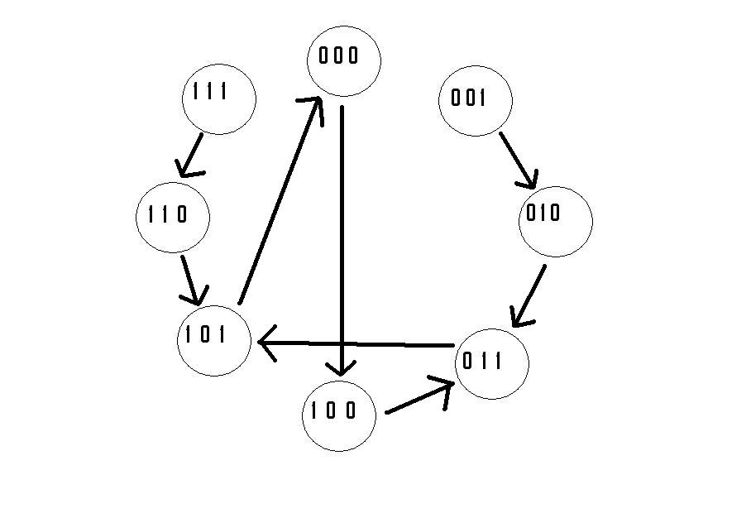
And when M = 1:
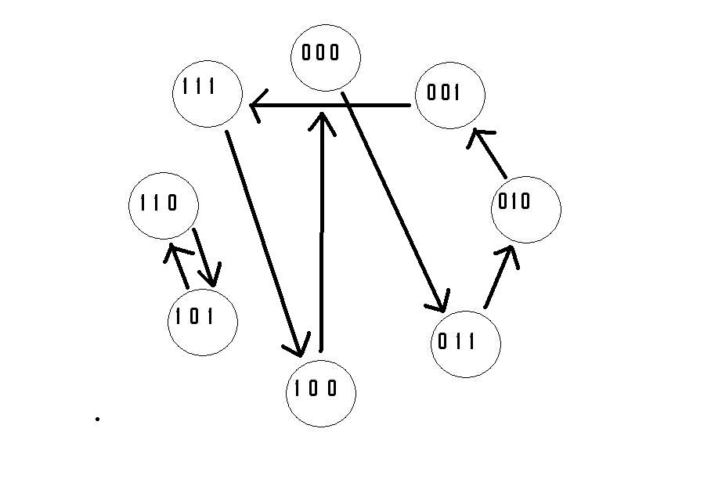

Q2B

To determine the maximum operating frequency with:
Tsu = 2nS
Th = 2nS
Tpd = 6nS
Tcl = 1nS/Gate
Tcl’= 1.5nS/Gates

To figure out Tcl, we will use the maximum present in the circuit, e.i. for J0, the signal needs to cross 2 x Gates’ x 1.5nS/Gates’ = 3nS

Now this is our timing

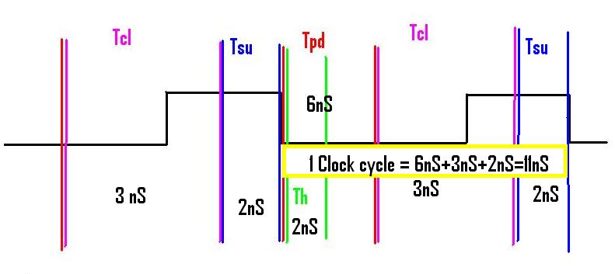

From the falling edge of the clock, we need minimum of 6nS for the signal to leave JK and stabilize Qnext, then 3nS minimum to go through the combinational logic and produce a stable J and K, which need to be held constant for 2nS before they are grabbed by the FlipFlop.

So the max operating frequency of the clock is
1/(11 x 10^9s) / 1 000 000MHrz/Hrz = 90.91Mhz

Q2C

So basically, we built a circuit with a multiplexer that will allow us either to leave the circuit to do its thing at S=0, or load new values at S=1. We need to be able to load new values because the state transition table doesn’t go in a circle. Some values will never be reached with certain inputs.

This is the circuit we used.
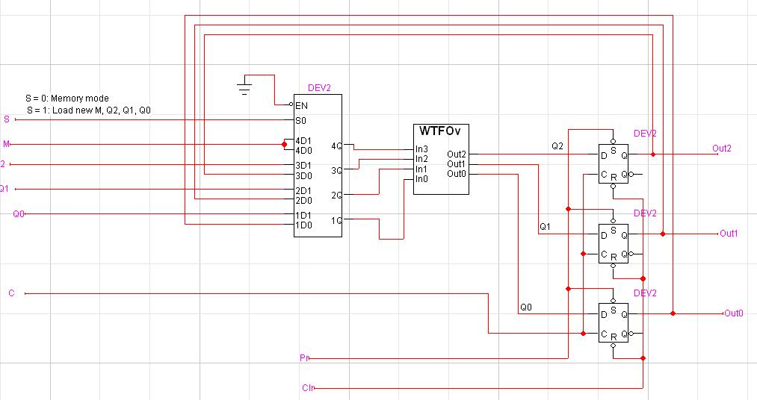
The 3 bit register is in memory mode when S=0, selecting the address of the next state in the PROM, and when S=1, we load a specific address from the PROM.

These are the values entered in the PROM:
0100 0010 0011 0101
4 2 3 5
0011 0000 0101 0110
3 0 5 6
0011 0111 0001 0010
3 7 1 2
0000 0110 0101 0100
0 6 5 4
(only the hex values were loaded!!)

With the following timing when M=0:

$T | $D | $I C | $I M | $I S | $I Q2 | $I Q1 | $I Q0 | $I Pr | $I Clr
0 | 100 | 1 | 0 | 1 | 0 | 0 | 1 | 0 | 1
 | 100 | 0 | 0 | 1 | 0 | 0 | 1 | 0 | 1
 | 100 | 1 | 0 | 1 | 0 | 0 | 1 | 1 | 1
 | 100 | 0 | 0 | 1 | 0 | 0 | 1 | 1 | 1
 | 100 | 1 | 0 | 0 | 0 | 0 | 0 | 1 | 1
 | 100 | 0 | 0 | 0 | 0 | 0 | 0 | 1 | 1
 | 100 | 1 | 0 | 0 | 0 | 0 | 0 | 1 | 1
 | 100 | 0 | 0 | 0 | 0 | 0 | 0 | 1 | 1
 | 100 | 1 | 0 | 0 | 0 | 0 | 0 | 1 | 1
 | 100 | 0 | 0 | 0 | 0 | 0 | 0 | 1 | 1
 | 100 | 1 | 0 | 0 | 0 | 0 | 0 | 1 | 1
 | 100 | 0 | 0 | 0 | 0 | 0 | 0 | 1 | 1
 | 100 | 1 | 0 | 0 | 0 | 0 | 0 | 1 | 1
 | 100 | 0 | 0 | 0 | 0 | 0 | 0 | 1 | 1
 | 100 | 1 | 0 | 0 | 0 | 0 | 0 | 1 | 1
 | 100 | 0 | 0 | 0 | 0 | 0 | 0 | 1 | 1
 | 100 | 1 | 0 | 0 | 0 | 0 | 0 | 1 | 1
 | 100 | 0 | 0 | 0 | 0 | 0 | 0 | 1 | 1
 | 100 | 1 | 0 | 0 | 0 | 0 | 0 | 1 | 1
 | 100 | 0 | 0 | 0 | 0 | 0 | 0 | 1 | 1
 | 100 | 1 | 0 | 0 | 0 | 0 | 0 | 1 | 1
 | 100 | 0 | 0 | 1 | 1 | 1 | 1 | 1 | 1
 | 100 | 1 | 0 | 1 | 1 | 1 | 1 | 1 | 1
 | 100 | 0 | 0 | 0 | 0 | 0 | 0 | 1 | 1
 | 100 | 1 | 0 | 0 | 0 | 0 | 0 | 1 | 1
 | 100 | 0 | 0 | 0 | 0 | 0 | 0 | 1 | 1
 | 100 | 1 | 0 | 0 | 0 | 0 | 0 | 1 | 1
 | 100 | 0 | 0 | 0 | 0 | 0 | 0 | 1 | 1
 | 100 | 1 | 0 | 0 | 0 | 0 | 0 | 1 | 1
 | 100 | 0 | 0 | 0 | 0 | 0 | 0 | 1 | 1
 | 100 | 1 | 0 | 0 | 0 | 0 | 0 | 1 | 1
 | 100 | 0 | 0 | 0 | 0 | 0 | 0 | 1 | 1
 | 100 | 1 | 0 | 0 | 0 | 0 | 0 | 1 | 1
 | 100 | 0 | 0 | 0 | 0 | 0 | 0 | 1 | 1
 | 100 | 1 | 0 | 0 | 0 | 0 | 0 | 1 | 1
 | 100 | 0 | 0 | 0 | 0 | 0 | 0 | 1 | 1
 | 100 | 1 | 0 | 0 | 0 | 0 | 0 | 1 | 1

0-200 nS, we are Preseting the D flip/flops.

200-400nS we load the values Q2=0, Q1=0, Q0=1.
From our state transition table, we can see that after 8 clock pulses, we will be in a 4 clock pulse loop and the cycle will start over and over and over.

Therefore after 8.5 clock pulses, we will se S=1 again to load 111. Why 8.5 and not 9 you ask? Because I made a mistake and don’t feel like redoing the following diagram ☺. Result is the same.

After 2 clock pulses, we will get back to the same loop and all the transitions from M=0 will have been covered.

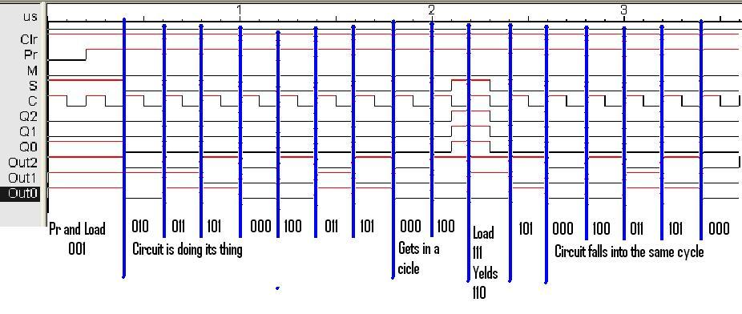

Now for when M=1.
We use the same circuit because we used 4 bit addresses in the PROM and the multiplexer is already set up. As a matter of fact, we could have done both M=0 and M=1 during the same simulation, but this is what the question asks for.

So using this timing file
$T | $D | $I C | $I M | $I S | $I Q2 | $I Q1 | $I Q0 | $I Pr | $I Clr
0 | 100 | 1 | 1 | 1 | 0 | 0 | 1 | 0 | 1
 | 100 | 0 | 1 | 1 | 0 | 0 | 1 | 0 | 1
 | 100 | 1 | 1 | 1 | 1 | 0 | 0 | 1 | 1
 | 100 | 0 | 1 | 1 | 1 | 0 | 0 | 1 | 1
 | 100 | 1 | 1 | 0 | 0 | 0 | 0 | 1 | 1
 | 100 | 0 | 1 | 0 | 0 | 0 | 0 | 1 | 1
 | 100 | 1 | 1 | 0 | 0 | 0 | 0 | 1 | 1
 | 100 | 0 | 1 | 0 | 0 | 0 | 0 | 1 | 1
 | 100 | 1 | 1 | 0 | 0 | 0 | 0 | 1 | 1
 | 100 | 0 | 1 | 0 | 0 | 0 | 0 | 1 | 1
 | 100 | 1 | 1 | 0 | 0 | 0 | 0 | 1 | 1
 | 100 | 0 | 1 | 0 | 0 | 0 | 0 | 1 | 1
 | 100 | 1 | 1 | 0 | 0 | 0 | 0 | 1 | 1
 | 100 | 0 | 1 | 0 | 0 | 0 | 0 | 1 | 1
 | 100 | 1 | 1 | 0 | 0 | 0 | 0 | 1 | 1
 | 100 | 0 | 1 | 0 | 0 | 0 | 0 | 1 | 1
 | 100 | 1 | 1 | 0 | 0 | 0 | 0 | 1 | 1
 | 100 | 0 | 1 | 0 | 0 | 0 | 0 | 1 | 1
 | 100 | 1 | 1 | 0 | 0 | 0 | 0 | 1 | 1
 | 100 | 0 | 1 | 0 | 0 | 0 | 0 | 1 | 1
 | 100 | 1 | 1 | 0 | 0 | 0 | 0 | 1 | 1
 | 100 | 0 | 1 | 0 | 0 | 0 | 0 | 1 | 1
 | 100 | 1 | 1 | 0 | 0 | 0 | 0 | 1 | 1
 | 100 | 0 | 1 | 0 | 0 | 0 | 0 | 1 | 1
 | 100 | 1 | 1 | 1 | 1 | 0 | 1 | 1 | 1
 | 100 | 0 | 1 | 1 | 1 | 0 | 1 | 1 | 1
 | 100 | 1 | 1 | 0 | 0 | 0 | 0 | 1 | 1
 | 100 | 0 | 1 | 0 | 0 | 0 | 0 | 1 | 1
 | 100 | 1 | 1 | 0 | 0 | 0 | 0 | 1 | 1
 | 100 | 0 | 1 | 0 | 0 | 0 | 0 | 1 | 1
 | 100 | 1 | 1 | 0 | 0 | 0 | 0 | 1 | 1
 | 100 | 0 | 1 | 0 | 0 | 0 | 0 | 1 | 1
 | 100 | 1 | 1 | 0 | 0 | 0 | 0 | 1 | 1
 | 100 | 0 | 1 | 0 | 0 | 0 | 0 | 1 | 1
 | 100 | 1 | 1 | 0 | 0 | 0 | 0 | 1 | 1
 | 100 | 0 | 1 | 0 | 0 | 0 | 0 | 1 | 1
 | 100 | 1 | 1 | 0 | 0 | 0 | 0 | 1 | 1

This is what we got:
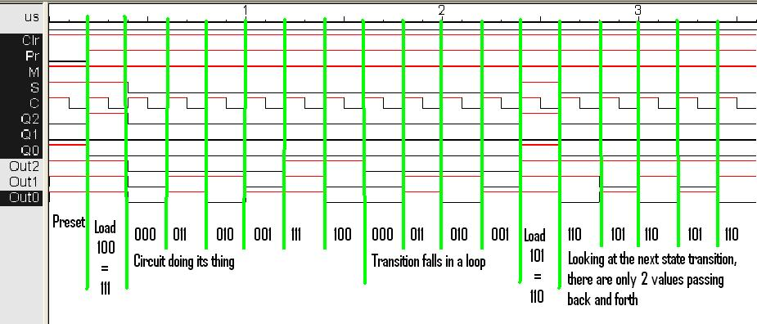

It coincides exactly with the next-state transition diagram presented earlier.

