Q1:

Let’s denote S and R the input of the Master flip/flop and X and Y its output. By definition, X and Y will also serve as input to the slave flip/flop, and we will denote Q and Q’ to be its output, and, by definition, the output of the whole D flip/flop.

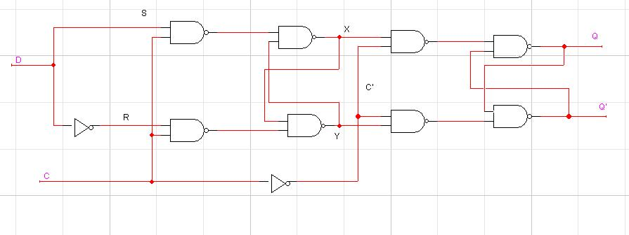

Looking at the master flip/flop, the set up time initially is 1nS longer than usual, because the signal going to the R needs to go through an inverter before it is ready to be caught when the clock goes high. After the first clock cycle, this set up time for the master flip/flop overlaps the propagation delay, because D can be inverted while the circuit is working on the Q result, in to be ready and stable at S=D and R=D’ when the clock gets high. And since the circuit usually needs a clock cycle to get in a stable state anyway, we can disregard this detail when calculating minimum clock pulses.

Doing a timing analysis a nS at a time, this is that we get.

At time -1nS to 0ns:
The clock is low. The master flip/flop is in memory mode and the slave is stabilising. From 0-1nS, the one of the branches of the D signal goes through an inverter gate.

(This step is only required for the first time)

Then, generally, there are 2 cases.

First, the D passes from 0-1:
Initially, this is the state of the circuit:
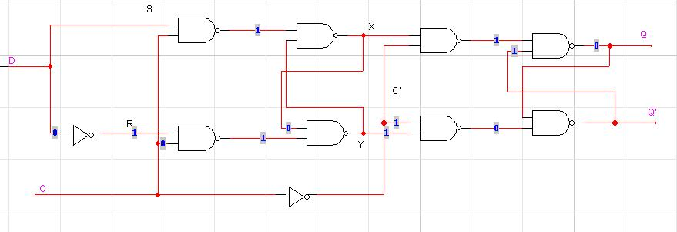

Time 0-1 ns (C=0)

The clock is 0, the master is in memory mode.
The slave is doing whatever.
D must be held stable at 1 and is passing through its inverter to prepare the signal D’ that will be fed to R

Tsu is over. Here starts Th
***************************************

Time 1-2nS (C=1)

Clock just went high.
S=D=1 is NANDed with the clock (0) = D’=0
R=D’=0 is NANDed with the clock (0) = D=1

The values are through the clocked gates. The clock can now change value

At time 2nS. Clock goes high=1
Hold time is over.
Start of Tpd

2-3nS
D can fluctuate, the master latch is in memory mode.
The slave is still in memory mode, because the clock hasn’t made it through the inverter yet.
The clock gets inverted.
The S’ (0) gets NANDed with Y(1), making X=1
The R’ (1) gets NANDed with X(0) making Y=0

3-4nS
The clock state is irrelevant at this point. (since we are not interested in the max clock frequency, but in the Tpd. Even if the clock flips, the slave will still have time to produce a stable output while the master prepares X and Y)
X NAND C’ = X’
1 NAND 1 = X’=0

Y NAND C’ = Y’
0 NAND 1 = Y’ = 1

Time 4-5nS

X’ NAND Q’(t) will yield a new Q’(t+1)
0 NAND 1 = Q’(t+1)=1

Y’ NAND Q(t) will yield a new Q(t+1)
1 NAND 0 = Q(t+1) = 1

Time 5-6nS
Finally,
X’ NAND Q’(t+1) = Q’(t+2)
0 NAND 1 = 1

And
Y’ NAND Q(t+1) = Q(t+2)
1 NAND 1 = 0

Afterwards, it is obvious that as long as X’ and Y’ are stable, the state of Q and Q’ will no longer change, because
X’ NAND Q’(t) = Q’(t+x)
0 NAND 1 = 1

And
Y’ NAND Q(t) = Q(t+x)
1 NAND 1 = 0

End of Tpd.

So when D goes from 0-1, Tsu is 1nS, Th is 1nS and Tpd is 4nS

Second case: D goes from 1 to 0.
This is the initial state of the circuit:
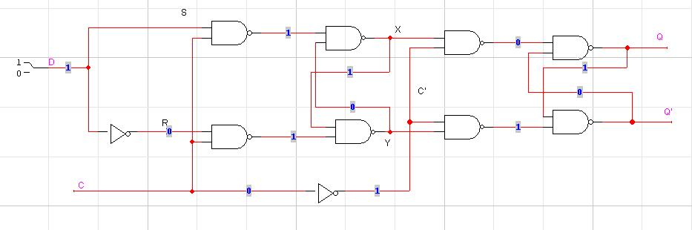
Time 0-1 ns (C=0)

The clock is 0, the master is in memory mode.
The slave is doing whatever.
D must be held stable at 0 and is passing through its inverter to prepare the signal D’ that will be fed to R

End of Tsu
Start of Th

Time 1-2nS (C=1)

Clock just went high
S=D=0 is NANDed with the clock (1) = D’=1
R=D’=1 is NANDed with the clock (1) = D=0

2-3nS
The clock is still high. (if operating at max frequency)
The slave is still in memory mode
S’ NAND Y(t) = X (t+1)
1 NAND 0 = 1

R’ NAND X(t) = Y(t+1)
0 NAND 1 = 1
The values are through the clocked gates. The clock can now change value

At time 3nS. Clock goes high=1
Th is over.
Start of Tpd

3-4nS
D can fluctuate, the master latch is in memory mode.
The slave is still in memory mode, because the clock hasn’t made it through the inverter yet.
The clock gets inverted.
S’ is NANDed with Y(t+1) = T(t+2)
1 NAND 1 = 0
R’ is NANDed with X(t+1) = Y(t+2)
0 NAND 1 = 1

From now on, X(t+1) = X(t) and Y(t+1)=Y(t)
The master latch have reached a stable state.

4-5nS
Master is in memory mode. The output X and Y are stable. Not much is happening there.
The clock signal just got inverted.
Slave is now in active more (C=0, C’=1)
The slave Flip/flop grabs the values at X and Y, which are stablized at 0 and 1 respectivelly.

X NAND C’ = X’
0 NAND 1 = 1

Y NAND C’ = Y’
1 NAND 1 = 0

5-6nS
The clock state is irrelevant at this point for the slave flip flop (since we are not interested in the max clock frequency, but in the Tpd. Even if the clock flips, the slave will still have time to produce a stable output while the master prepares X and Y)
X’ NAND Q’(t) = Q(t+1)
1 NAND 0 = X’= 1

Y’ NAND Q(t) = Q’(t+1)
0 NAND 1 = Y’ = 1

Time 6-7nS
Finally,
X’ NAND Q’(t+1) = Q’(t+2)
0 NAND 1 = 1

And
Y’ NAND Q(t+1) = Q(t+2)
1 NAND 1 = 0

Afterwards, it is obvious that as long as X’ and Y’ are stable, the state of Q and Q’ will no longer change, because
X’ NAND Q’(t) = Q’(t+x)
0 NAND 1 = 1

And
Y’ NAND Q(t) = Q(t+x)
1 NAND 1 = 0

End of Tpd.

So when D goes from 1-0, Tsu = 1, Th = 2nS and Tpd is 4nS

Since we have different values, we will use the largest one of both for a global value for the whole circuit:
Tsu = 1nS
Th = 3nS
Tpd = 4nS

Here is a drawing of the circuit operating at max frequency:
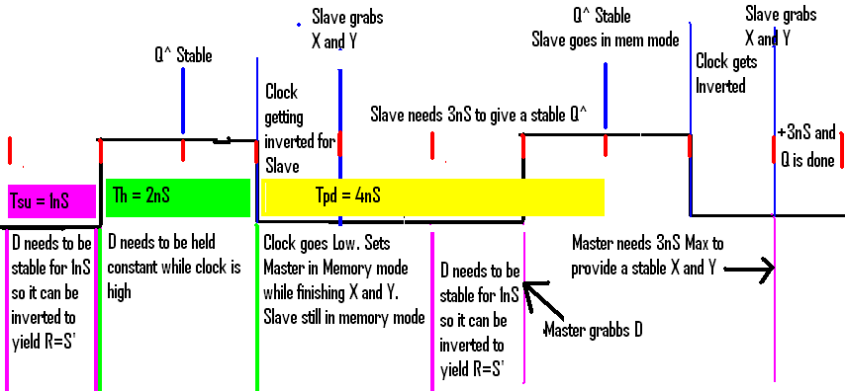

It is important to be mentioned when considering maximum clock frequency that Tpd overlaps Tsu and 1nS of Th.

Timing file used to test the circuit:

$T | $D | $I D | $I C
0 |  | 1 | 0
10 |  | 1 | 1
20 |  | 1 | 0
30 |  | 1 | 1
38 |  | 0 | 1
40 |  | 1 | 0
50 |  | 1 | 1
57 |  | 0 | 1
60 |  | 1 | 0
70 |  | 0 | 1
80 |  | 0 | 0
90 |  | 0 | 1
99 |  | 1 | 1
100 |  | 0 | 0
110 |  | 0 | 1
118 |  | 1 | 1
120 |  | 0 | 0
130 |  | 1 | 1
140 |  | 1 | 0
150 |  | 1 | 1
158 |  | 0 | 1
160 |  | 1 | 0
170 |  | 1 | 1
177 |  | 0 | 1
180 |  | 1 | 0
190 |  | 0 | 1
200 |  | 0 | 0
And this is the result we got, proving out theory:
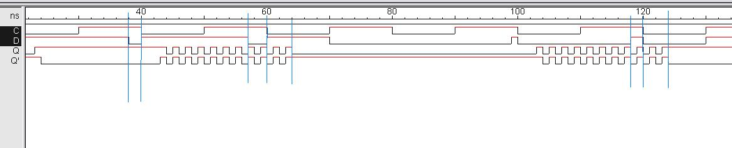

Q1b: Comparing the D flip Flop we built to the falling edge pre-built in Logic works.

This is the circuit I used:
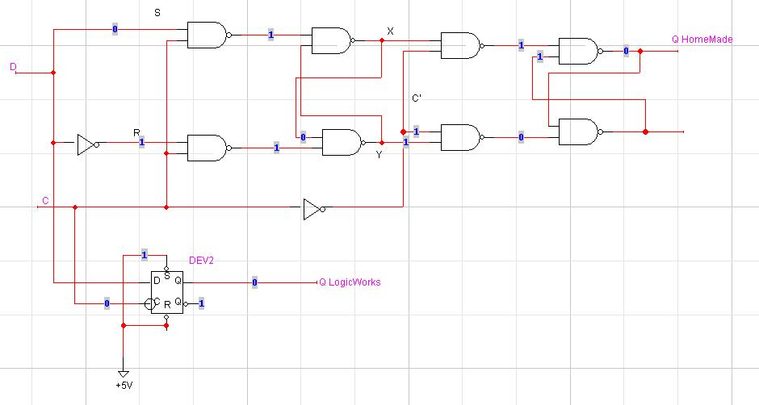

Using the same timing file as in Q1a:
$T | $D | $I D | $I C
0 |  | 1 | 0
10 |  | 1 | 1
20 |  | 1 | 0
30 |  | 1 | 1
38 |  | 0 | 1
40 |  | 1 | 0
50 |  | 1 | 1
57 |  | 0 | 1
60 |  | 1 | 0
70 |  | 0 | 1
80 |  | 0 | 0
90 |  | 0 | 1
99 |  | 1 | 1
100 |  | 0 | 0
110 |  | 0 | 1
116 |  | 1 | 1
120 |  | 0 | 0
130 |  | 1 | 1
140 |  | 1 | 0
150 |  | 1 | 1
158 |  | 0 | 1
160 |  | 1 | 0
170 |  | 1 | 1
177 |  | 0 | 1
180 |  | 1 | 0
190 |  | 0 | 1
200 |  | 0 | 0

This is the result I got:
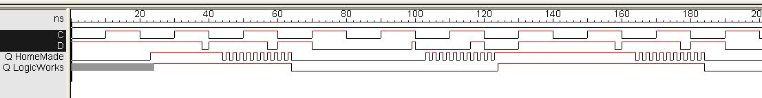

We can observe that both circuits have the same Tpd and Tse. The main difference is that in the circuit we built, when we make a change in the input while the clock is high and hold it for a period shorter than the minimum, out Q gets in an unstable mode, where ad the D flipFlop built in Logic Works simply ignores the value. The reason for that is that out circuit is not a falling edge triggered flip-flop, where as the one in logic works is. So for the model in Logic Works, even though we tweeked it so that the Tpd and Tse would be the same as our circuit, it remains a falling edge flip flop, and if Tse is not respected, it simply consider the change the same way it would consider a noise on D and simply ignores it.

Question 1 C JK FlipFlops.

This is the circuit we used to compare both JK Flip/Flops
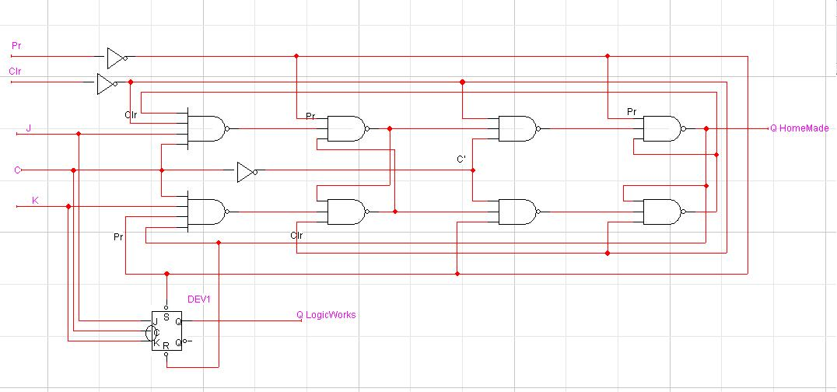

First, it is important to mention that the JK master/slave Flip Flop does NOT respond very well to noise on the line, or Tsu shorter than 3nS. The logic used to build the JK Flip/Flop implies that Q is not equal to Q’. This is due to the fact that the inputs are directly a result of the output, and when we make a change in the input shorter than the minimum Tsu, we set Q = Q’ and the flip flop goes into an unstable fluctuation, which will make the inputs unstable until we either Preset or Clear the circuit.
A JK flip Flop can not exist unless Q and Q’ are opposite values. Therefore Q and Q’ can never be equal, which becomes the case when we change the inputs (other than to J=0 and K=0; memory mode) for a period shorter than Tsu min.

If for some reason, the circuit gets in such an unstable state, it needs to be either preset or cleared, as shown here.

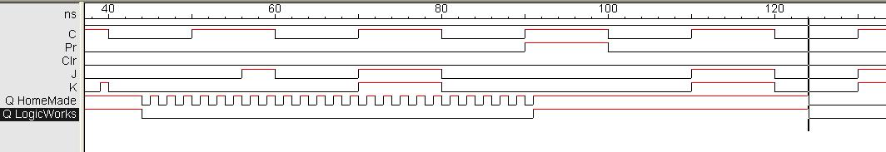

We can also observe the same situation in the Built in flip flop. Trying to set them at 56-60nS, or toggle from 70-80nS just didn’t do anything. The only thing that can fix the situation is a preset or a clear (70-80nS). The built in FlipFlop doesn’t show the unstable fluctuation, but the flip flop just stops working until it is either set or reset. We can see that both FlipFlops started to work afterwards (Toggle at 110-120nS)

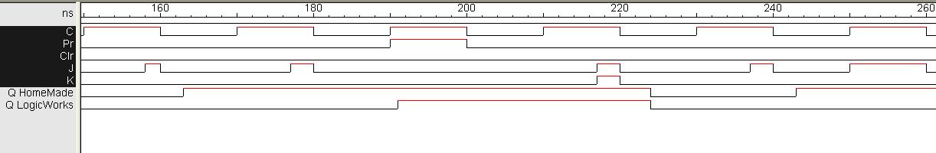
There is a very strange phenomenon that happens in the circuit. It seems that after we destabilised the JK flip flop from logic works, it can only toggle. We can see here that it doe not respond to a 2nS change to set the circuit. The circuit we built can handle such a short period as explained earlier in Q1a, but the one built in LogicWorks has its Tsu set a 3nS, unconditionally. But afterwards, it ignores a 3nS se input at 237nS-240nS, yet managed to toggle with an input from 217nS-220nS.

Furthermore, from the following timing
$T | $D | $I C | $I Pr | $I Clr | $I J | $I K
0 | 10 | 0 | 1 | 0 | 0 | 0
10 |  | 1 | 1 | 0 | 0 | 0
20 |  | 0 | 0 | 0 | 0 | 0
30 |  | 1 | 0 | 0 | 1 | 1
40 |  | 0 | 0 | 0 | 0 | 0
50 |  | 1 | 0 | 0 | 1 | 0
56 |  | 1 | 0 | 0 | 1 | 0
60 |  | 0 | 0 | 0 | 0 | 0
70 |  | 1 | 0 | 0 | 1 | 1
80 |  | 0 | 0 | 0 | 0 | 0
90 |  | 1 | 0 | 0 | 0 | 0
100 |  | 0 | 0 | 0 | 0 | 0
110 |  | 1 | 0 | 0 | 1 | 1
120 |  | 0 | 0 | 0 | 0 | 0
130 |  | 1 | 0 | 0 | 0 | 0
140 |  | 0 | 0 | 0 | 0 | 0
150 |  | 1 | 0 | 0 | 1 | 0
158 |  | 1 | 0 | 0 | 1 | 0
160 |  | 0 | 0 | 0 | 0 | 0
170 |  | 1 | 0 | 0 | 0 | 0
177 |  | 1 | 0 | 0 | 1 | 0
180 |  | 0 | 0 | 0 | 0 | 0
190 |  | 1 | 1 | 0 | 0 | 0
200 |  | 0 | 0 | 0 | 0 | 0
210 |  | 1 | 0 | 0 | 0 | 0
217 |  | 1 | 0 | 0 | 1 | 1
220 |  | 0 | 0 | 0 | 0 | 0
230 |  | 1 | 0 | 0 | 0 | 0
237 |  | 1 | 0 | 0 | 1 | 0
240 |  | 0 | 0 | 0 | 0 | 0
250 |  | 1 | 0 | 0 | 1 | 0
256 |  | 1 | 0 | 0 | 1 | 0
260 |  | 0 | 0 | 0 | 0 | 0
270 |  | 1 | 0 | 0 | 0 | 0
280 |  | 0 | 0 | 0 | 0 | 0
290 |  | 1 | 0 | 0 | 0 | 0
300 |  | 0 | 0 | 0 | 0 | 0

We get the following wave form:
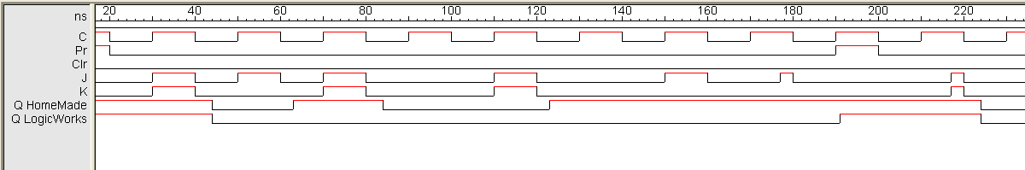

Now there are a lot of very interesting things happening here. From 30 to 40nS, both flip flops toggle normally, with a 4ns Tpd. Then from 40 to 60nS, the JK flip flop just goes on strike and ignores the input to set. Furthermore, from 110 to 120nS, the JK Flip Flop won’t even toggle anymore, or do anything as a matter of fact until it is preset at 190-200nS.Then it toggles once again fine if the inputs are kept for 3nS.

(I think it’s due to the fact that my computer has been running all weekend doing this assignment. Lol.)
But seriously, all the connections are fine on the circuit, the pin C is inverted, but the Flip Flop just won’t do what it’s told for some reason or another. I don’t know why. Could be a bug in the system .If it gives “Survey critical Error”-whatever it is- every second import timing, it might not be the best idea to mess around with pin timing and test the circuit to its max operating limits.

