Lab-6 Part-2

4-Algorithm

I-Fork calibration
Goal: To avoid that the forks in the “low” position be so low that one or both the wheels lose traction which would induce error in the odometer.

Algorithm: The forks are lifted then the motor moves the forks down until an approximate floor level, then coasts down until the floor stop the forks. We add 2mm height from the floor level and use it as “low” position

II-Sweeping
Goal: To sweep the area looking for the box

Algorithm: The robot does a sweep motion (black arrow) looking for the box within 100cm using the US sensor pointing to the right side. If it doesn’t “see” the box within this range (yellow) when it has moved 280 cm, it moves back to the x=0 line and 80 cm further to the right of the first sweep. It keeps on doing that motion until it “sees” the box.
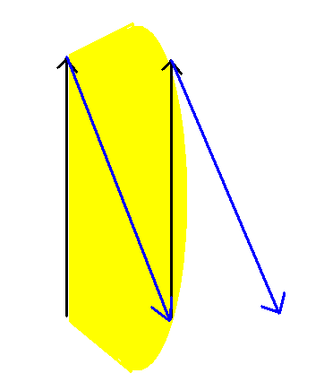

III-First track
Goal: To move the robot close enough to the box to justify a manual and fastidious optical sweep of the area

Algorithm: ************************how we see the box and compute location************
…
Then the robot moves to the bottom right of the box at an estimated location, with a voluntarly induced error to the right.
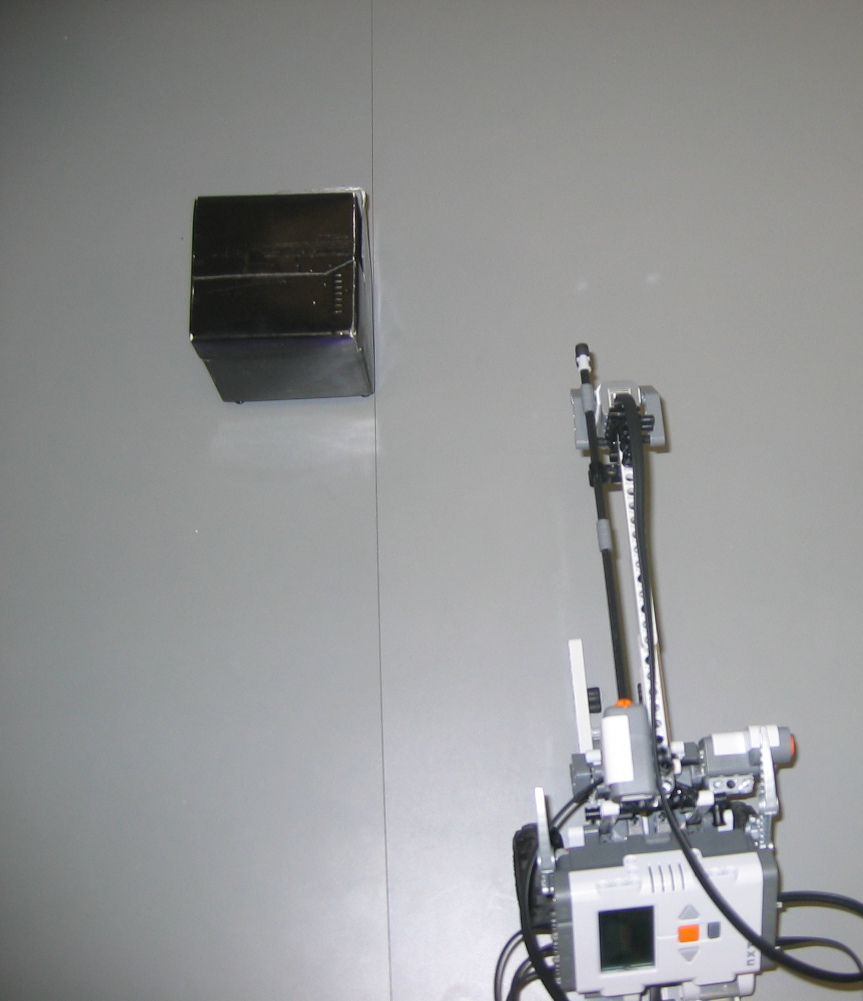

IV-Optical Scanning
Goal: To lock down the exact location of the box on the vertical (y) axis

Algorithm: Now trhat our robot is placed at a specific location with respect to the approximate box location, we begin a secondary sweep. With an optical sensor is attached to a boom extending far in front of the forks. 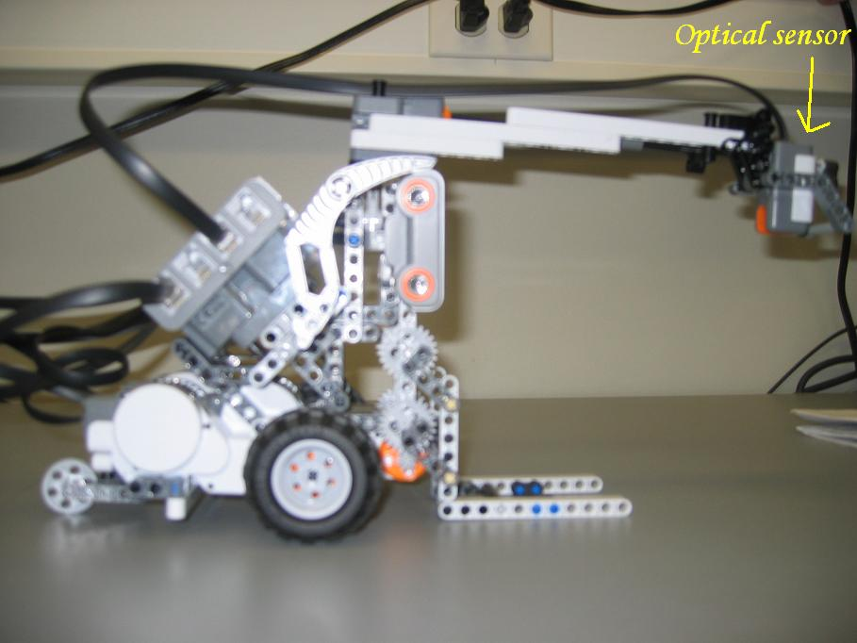Until the light sensor detects the box, we rotate counterclockwise, realign the Tribot then move forward a few inches and repeat the sequence.
Once the box is “seen”, we know pretty well where we are in relation to it, so the Tribot places itself in front if it, facing it.

V-Final Approach
Goal: to gain a precise alignment with the box befor we pick it up

Algorithm: Now that the Tribot is facing the box, we slowly move forward until the optical sensor detects the box then stop. We now know exactly how far we are form it. The we rotate left to detect the left boundary of the box (waiting until the box disappears off the light sensor’s sight), do the same thing for the roght side, and align the Tribot halfway between both headings. Now the Tribot is centered with the box and at a known distance, all we have left to do is move forward that distance and lift the forks.
VI-Move and Drop
Goal: Move the box to a specific location

Algorithm: rotate to orientation 7pi/4 rad (facing south east, as per lab specs), move 70.7cm (which puts us 50cm east and 50cm south of the original position), realign the box in the orientation in which it was picked up and drop it.

5-Code

6-Results
The results are great. Here is a video of the robot in action:
http://www.youtube.com/watch?v=ikOLO44Ve98

The accuracy of picking up the box is almost flawless, due to the different methods of scanning (i.e. US estimation of location and extensive area sweep with optical sensor pointing down).

7-Flaws/Improvments

One thing we added to the design is a shaft attached to the touch sensor which extends beyond the light sensor boom. The idea is to detect when the robot hits a wall and have code making the robot turn around in that event. This would enable the automatic scan of a square room of any size. The boom is at an elevation such that it’s above the box, to avoid conflicting code when close to the box. We didn’t have time/need to implement it for this lab.

One flaw we notice was the need of a counterweight. Since the breaking is abrupt before dropping the box, we had our robot tilt forward on a preliminary try. To compensate, we added weight on the back of the robot using a padlock. For the competition, we could potentially use a more elaborate and conventional counterweight.

As far as the general robot design goes, we do not intend to use this Tribot set up to solve the problem. The flaws in this design are too numerous to tackle such a different task with similar hardware that prefer to start the design from scratch instead of waisting days/weeks fixing a design which is doomed to fail from the beginning.

Navigation wise, instead of relying on the on board navigation software, we are going to use 2 light sensors looking at the lines on the ground. We also intend to stack the boxes on the robot and drop the stack at the target, which will require a completely new hardware design (i.e. probably not a forklift, and since we will be building stacks of 3, we can’t use the light sensor at the end of the boom) which makes it difficult, if not impossible to “suggest” improvement of this particular forklift design.

