1. Sensing the Box

Light sensor: Since the box is black and shiny, we found that the best setting for our setup was LIGHT_INACTIVE mode.
In this mode, we took 2 sets of readings, one when the box is flush parallel with the robot (best case scenario), and the other when the box is oriented 45 degrees from the robot (worst case scenario). In each set of reading, we looked at the value of the light sensor then the box was at the edge of the forks, half way, and fully in. (here shown when the box is parallel)
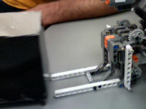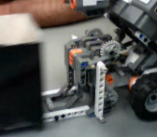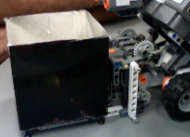
Flush | 45 deg | Flush | 45 deg | Flush | 45 deg
786 | 773 | 849 | 814 | 867 | 853

Based on this data, for lab 6a we used a threshold light reading of 850 to trigger the lift task, since we manually placed the box flush on top of the forks.

The light sensor is only useful for detecting the box once the forks of the forklift are about to go under the box. Before that, the box is too far to have any effect. The light sensor gives smoothly increasing values (would be decreasing if we were using percentage mode) as the box gets closer to the sensor.

The light sensor pretty much only sees what’s in front of it.

The problem with our scheme is that it depends on ambient light. We detect the presence of the box because the box casts a shadow onto the light sensor, reducing the amount of ambient light reaching the sensor. The lab where we’re doing the testing has pretty even lighting, which might make this task easier than it should be. To have robust detection of the box with the light sensor, we might have to devise a more dynamic algorithm which analyzes the changes in light values intelligently.

The light sensor shouldn’t fail under normal condition (constant ambient light in the room and no one putting their finger in front of it). Even if the tribot comes head to head with a wall, the light reading gets at worst to 820 on a shaded wall and 720 on an illuminated wall, both values far below the threshold value of 850.

Ultrasonic sensor:
The ultrasonic sensor is extremely sensitive to the orientation of the box. When a face of the box is perfectly facing the sensor, the box can be detected to a range of about 80 cm, in a field about +- 10 degrees from sensor-center. At closer distances, this field of vision becomes wider, but this is still only when the box is oriented perfectly for detection. When the box is oriented such that the corner is pointing toward the ultrasonic sensor, it is hard to reliably detect the box from any distance farther than 40 cm.
The ultrasonic sensor cannot measure any distance less than about 22 cm. After the box gets closer than that, the sensor continues to read 22 cm or fails entirely.

The wide field of vision shouldn’t be too big of a problem, because we can use averages to determine the most likely location of the box.

As always with the ultrasonic sensor, the sensor often drops out and gives a reading of 255 cm, making it less reliable than the light sensor.

2. The Lifting Mechanism

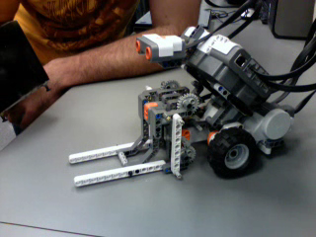
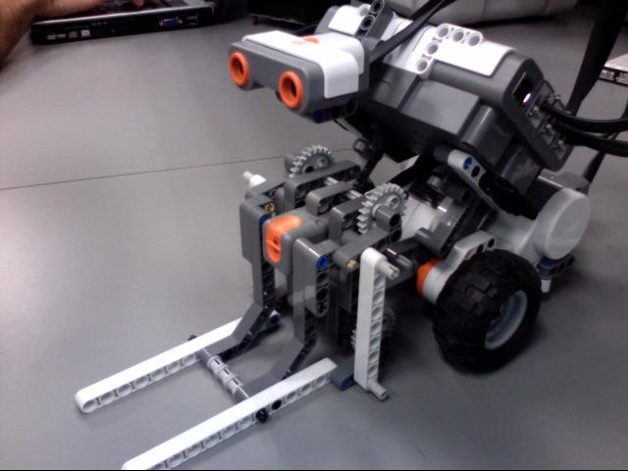
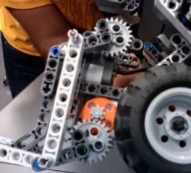
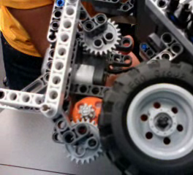
We designed a forklift mechanism based on the mathematical concept of the parallelogram. By connecting two parallel, identical cranks to parallel axles and linking their endpoints with a beam, turning one crank causes the other to turn, and the beam maintains its orientation. We connect the forklift platform to the beam so the forklift platform is always parallel to the ground.

In the above photos, the vertical white beam is actually redundant and only provides extra stability. The motor is also geared down on a 3:1 ratio, which gives us a more precise movement with higher torque for heavier loads, lower lifting speed for load stability at high motor power.

Here is the link for a video of the working machine:
http://www.youtube.com/watch?v=k9zG5HLRmjo

After some testing, we found that the lowest pair of gears is in contact with the floor at all times. While the tribot’s wheel still had some contact with the floor, there was horrible slipping which totally ruined the odometry of the robot. So we did a minor redesign to get the gears off the ground. Two side effects of the redesign were an increase in range of motion, and a reduction in part count.
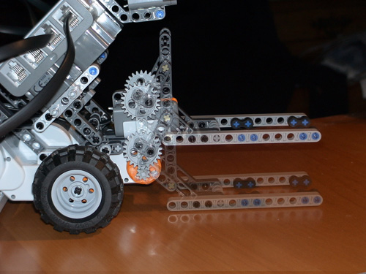
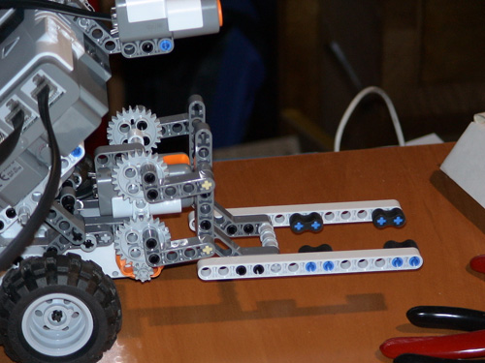

Capabilities and Limitations

Here are the dimensions of the forks:
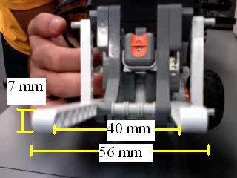
They stretch out 73 mm, so can accommodate any load that can place its center of gravity above them.

If the box dimensions increases, as long as the clearance is > 7mm from the floor, the forks can get under them. For the lift, the center of gravity has to be above the forks for a lift, so theoretically, we could accommodate a box of one edge at 73mm*2= 146mm, and the other as wide as wanted as long as it is centered on the forks. If we decrease the dimensions, we could build a “lego pallet”, comparable to commercial/industrial pallets, designed to fit our forks and lift any irregular shape that fits on it.

The vertical range of the forklift is about 5 cm, which is more than enough for this lab.

Because we geared down the motor, the mechanism is strong and could theoretically lift a fairly large weight. The actual limiting factor for load weight is robot balance. This leads into a complicated topic, which is the balance and center of gravity of the tribot. For the best maneuverability, the majority of the robot’s weight should be over the driven wheels, not over the caster wheel in the back. With a forklift, the center of gravity changes when a load is picked up – it shifts forward. We wanted our center of gravity to be above the tires both with and without a load (since slipping at any time is disastrous). So we placed the NXT brick such that with no load, the center of gravity is already close to the front. Because of this, very heavy loads will cause the robot to tip over. Our design is essentially tailored to the box we got to work with in the lab. If we ever need to work with a heavier load, we can shift the center of gravity towards the back, sacrificing a bit of maneuverability.

