ECSE 200 FEE
Practice exams

Tueseday April 19th 2005

(12/70)1. Answer each of the following questions; the circuits below are only needed for part (d)

Please note: Some parts contain more than one question to answer; and, you may use diagrams and/or examples to help clarify your answer if you like.
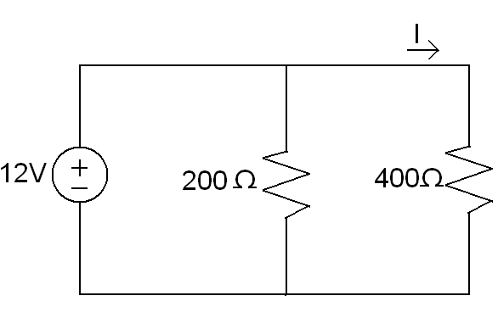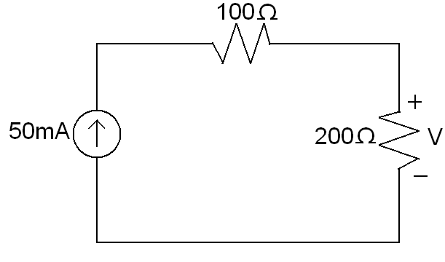

(2/12) (a) What is the model/definition of an ideal ammeter?

(2/12) (b) What is the model/definition of an indeal ohmmeter?

(4/12) (c) What are the two main types of measurement errors associated with using practical voltmeter? Clearly explain how these two errors arise in practical measurments.

(4/12) (d) Assume you have a passive ammeter with total internal resistance of 4Ω, and a passive voltmeter with a total internal resistance of 39.8k Ω. Find the values of the current I and the voltage V that would be measured if these two meters were used.
Note: show the meter models and circuit connections used for the measurments.

(28/70) 2. Consider the lumped-parameter circuit shown below. The element “D” is passive, and fully defined by the i-v characteristics provided. (Assume the other elements are linear)

(2/28) (a) Is the circuit element “D” ohmic? (Briefly and clearly explain why or why not.)

(4/28) (b) What is the value (or range of values) of the resistance of circuit element “D” over the ranges Vd=0V to Vd=15V? (Please be clear if you give more than one value.)

(6/28) (c) Assume that Is=6mA; R1 is a variable resistor (range 0 to ∞); and R2=1kΩ. Find the value of R1 by the source for that will cause the source to supply maximum power to the circuit. Also, find the value of the power supplied by the source for this optimal value of R1

(8/28) (d) Assume that Is=12mA; R1=1kΩ; and R2 is a variable resistor (range 0 to ∞). Find the value of R2 that would yield maximum power transfer to the resistor R2. Also, find the value of the power absorbed by element “D” for this optimal value of R2.

(8/28) (e) Find the value of the voltage labeled Vd, if Is=12mA, R1=1kΩ and R2 = 0Ω
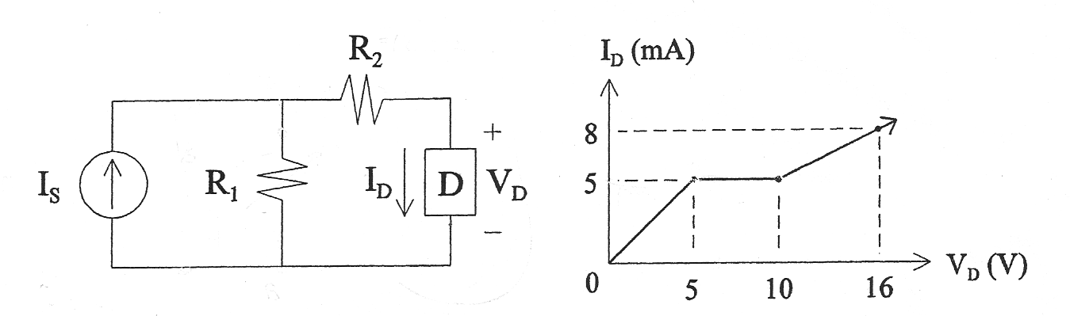

Answers:

1(a)
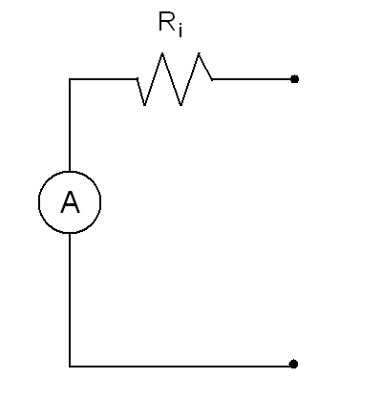
The ideal ammeter measures the exact value of the current that flows through it (with perfect accuracy), and the voltage across its terminals is always exactly zero (Ri = 0) when it is connected (in series) to the circuit for the measurement

1(b) Typically, an ohmmeter will feed a current through a resistor and measure the voltage drop. In the ideal model, that current is zero (the power supplied to the circuit by the meter is zero). Also, the meter will measure a resistance with perfect accuracy.

1(c)
- Precision error: arises due to the limited/finite level of measurement resolution possible with a practical meters (sometimes referred to as “round off” or “turnication”)
- Loading error: Due to the fact that the circuit is modified when we introduce the meter (especially for passive meters, which do not compensate for their presence). When connecting an ammeter, we are introducing a resistance to the current measured. When using a voltmeter, we are creating another path for the current to travel. With an ammeter, we are actively supplying power to the circuit.

1(d) Since we want to measure “I” as stated in the diagram, we need to connect the non-ideal ammeter in series with the 400 Ω resistor (on the same circuit branch). We can set the ground reference on the negative terminal of the voltage source.
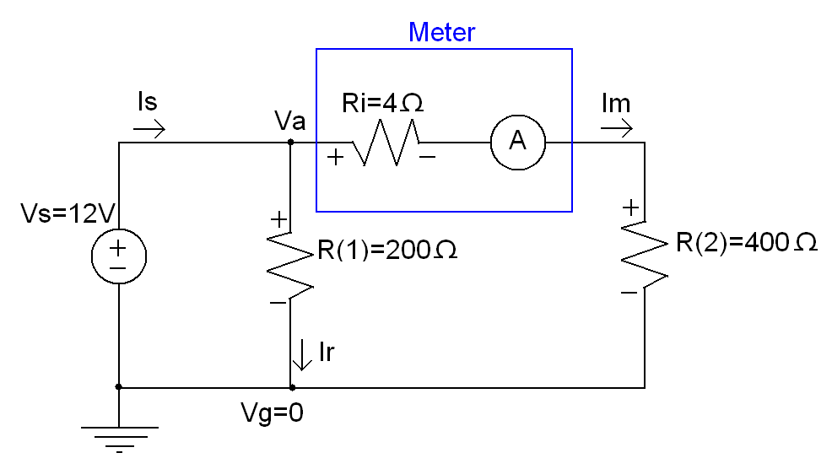

By KVL: Va-Vg=12V
The save 12V drop will occur on the other circuit branch
R=V/I
(Ri+R2) = (12V) / Im
Im = 404 Ω / 12V = 29.5mA
***************************
(If the meter didn’t interfere with the circuit; I=400Ω/12V=30mA)

The voltmeter will be connected in parallel with the 200Ω resistor. We know that the current source will feed 50mA to the node “a”, and all that current will be returning to node “b”.
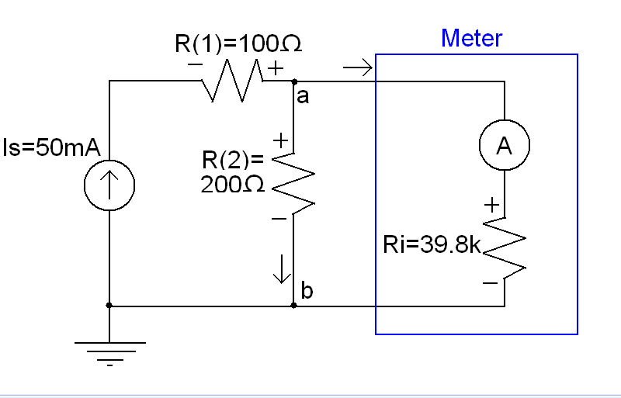

Req=R(2)//Ri = (200Ω)//(39 800Ω) = 199Ω
V = RI
Vab = Req x Is = 199Ω x 50mA = 9.95V
*********************
Had the meter been “perfect” V = RI = 200Ω x 50mA = 10V

2(a) In order to be ohmic, rhe resistance of a circuit element needs to be non-varying with time (always constant). By R=V/I, we can easily look at these two points: R=5V/5mA = 1kΩ and R=10V/5mA = 2kΩ. These values imply that the resistance between the devices’ terminals is not constant, therefore it is not ohmic.

2(b) There are 3 parts for this problem. Back to basic math, a function is “linear” when the slope is constant, s.t. Y= mX + b. In our case,
Y=>Id,
X=>Vd
R=V/I=X/Y= inverse of the slope.
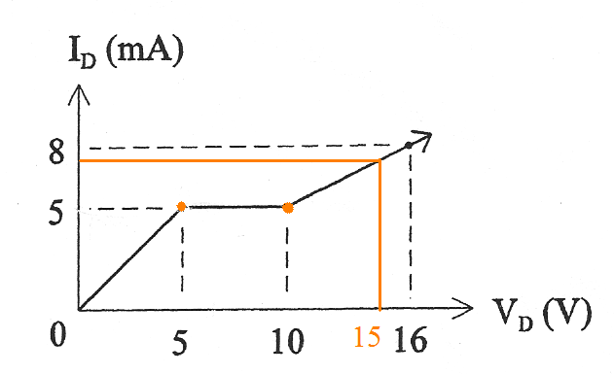
Between 0 and 5 Volts, the resistance is linear and given by R=V/I = 5V/5mA = 1000Ω
Between 10 and 16V, it is also linear and R=V/I = 16V/8mA = 10V/5mA = 2000Ω
Between 5V and 10V, we can see that the resistance starts at 1kΩ and climbs linearly to 2kΩ in the span of 5V. We can divide the 1000Ω increase by the 5V “time span” to get our constant. Then evaluate the initial conditions at 5V, R=1000Ω and arrive to the formula R = 1000Ω + 200Ω x (Vd – 5V)

2(c)
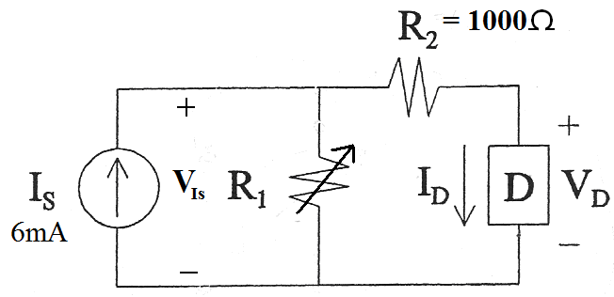
We know that “Is” is FIXED at 6mA. The voltage VIs will be given by V=R x Is.
Since P = VI and Is is fixed, the only way to increase the power output is by increasing VIs, therefore increasing the total resistance of the network as seen by Is.

Req = R1 + (1000Ω + Rd), so R1 has to be ∞
At this point, evaluating the remaining circuit is pretty straight forward:
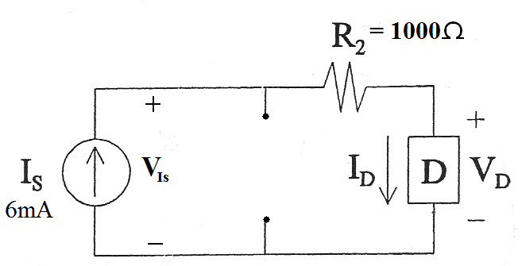

Id = Is = 6mA
By looking at the graph, Rd = 2kΩ
Rt = 1kΩ + 2 kΩ = 3kΩ
P = VI = RI^2 = 3000Ω x (0.006A)^2 = 0.108W = 108 mW

Conceptually: try to visualize what happens as soon as R1 is not ∞
If R1 is really small, say mΩ, most of the current will be flowing through that branch. Let’s getsimate 5:1. When 1mA flows through D, Rd = 1000Ω. So we have a low R1 and a low Rd, making a low Req when we actually want to maximize it. When R1 is really big, most of the current will flow through D. Once again using the same 5:1 ratio, Id is now 5mA, R1 = R1 and Rd = 2000Ω fixed (from the graph). From there, the only way to increase Req some more is by increasing R1.

1(d) By the maximum power transfer theorem, we need to set R2 = it’s Thevenin equivalent resistance.
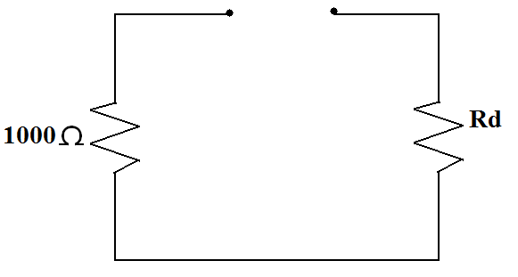
R2 = 1000Ω + Rd.
From the graph, 1000Ω < Rd < 2000Ω

We can look at both cases. When Rd = 2000Ω, R2 = 3000kΩ.
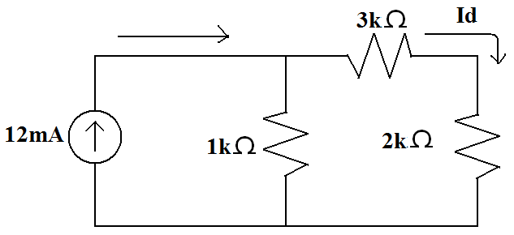

By current divider, Id = (1kΩ)/(1kΩ+2 kΩ+3 kΩ) x 12mA = 2mA
But from the graph, when Id=2mA, Rd = 1KΩ, so this solution does not workout based on our data

Let’s try the other boundary.
Presuming that Rd=1kΩ, in which case R2 = 1000Ω + Rd = 2kΩ

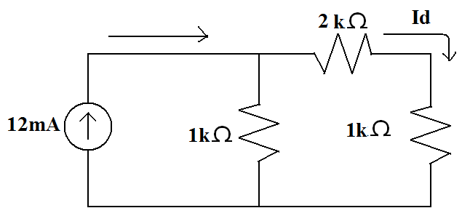
By current divider, Id = (1kΩ)/(1kΩ+2 kΩ+3 kΩ)

Ideal voltmeter
The ideal voltmeter measures the exact value of the voltage across it’s terminals (with perfect accuracy), and the current flow through the ideal voltmeter is always exactly zero whenm connected in series to make a measurement (Ri = ∞)

