2. Extended Specifications

In order for this product to beat the competition, special attention has been made to make the user interface unique and futuristic, unlike most electronic devices designers who have historically focused on functionality and performance. We can observe how successful this marketing technique has been with Apple, whose net income merely tripled in the past 3 years (yahoo finance).

In order to follow that crisp design trend and provide the user with an unforgettable experience, we intend to use a touch OLED screen as a primary user I/O interface. To achieve this illusion, we will use the IR cameras of a holographic keyboard, but instead of projecting a keyboard image, the keys will be displayed on the OLED screen.

3. Current State of the Art
The current state of the art in keyboards technology is the new holographic keyboards released by i-Tech [Virtual Laser Keyboard.com]
The basic principle behind the technology is 2 laser projections of a keyboard image coupled with two IR cameras. By superposing the finger image from both IR cameras, the processor uses basic geometry to extract the location of the finger. Using a ROM lookup table, every location is translated into the equivalent letter.

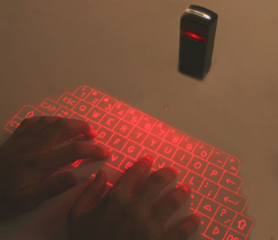

For our purpose, we will not be projecting a holographic picture of the keyboard. Instead, the IR cameras will be pointing on the screen and the screen itself will display the letters when this function is prompted by the user, giving the illusion of a “touch screen” while allowing us to use OLED technology for display (explained below)

As for display adaptors, current state of the art is Polymer based semiconductors, more specifically Organic LED (OLED) because of its great characteristics such as high brightness at low drive voltages (which will enable the user to read in direct sunlight and extend battery life), extra thin and light weight display, no viewing angle dependence.
[http audioholocs.com] and high contrast ratio (2002, Sony released a 27” OLED screen with a contrast ratio of 1,000,000:1 (not a typo!) Sony has just released an 11” model of its OLED that has 1024 x 600 pixels slathered across a 1M:1 contrast panel capable of 8-bit RGB color and covering more than 100% of the NTSC color palette. We intend to use this technology in our design.
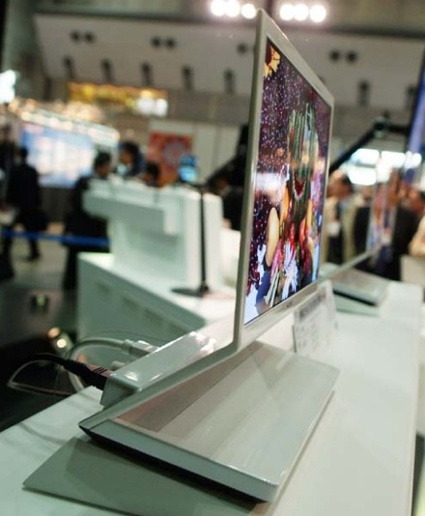
[Source: http:// Engagets.com]

4. Forecast of the State of the Art

For user input technologies, the future is definitely heading towards infra red technologies. We can observe its great potential with the popularity of the Nintendo Wii and the versatility of the technology. At this point, we have been able to mimic the I/O user interface observed in the popular movie Minority Report using simple technology and a Wii remote [ Johnny Chung Lee Wii Remote Project]

By implementing OLED technology from the beginning, we will be benefiting from the ease of integration of new developments in this technology. For example, we intend to eventually integrate a flexible display that would fold in your pocket (the technology already exists on smaller displays but is not available commercially)
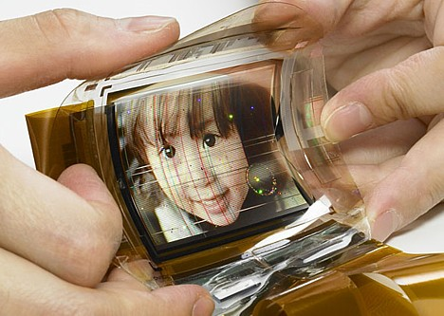
[Image from: Wired Blog]

5. Proposed Design

Costs:
At the present moment, the virtual keyboard is designed to communicate via the Bluetooth HID (Human Interface Device) and SPP (Serial Port Profile) services. (http://www.laser-keyboard.com/) and retails for around 160$.

Assuming that we will be mass producing it, we can alter the design to make the keyboard communicate with our machine using a built in PS/2 standard. By illuminating the need for wireless communication and holographic laser projection, we estimate a cost of 90$/units with a bulk discount. Using Moore’s law, this price should be reduced to roughly 15-20$ in 3 years time, when production starts.

The Sony 11’ OLED screen currently retails for $1750 [http://www.oled-info.com/introduction], but Sony has a tendency to overprice its products because of its good reputation (Vaios laptops are typically 50-70% more expensive than their Dell and Toshiba counterparts [http://www.bizrate.com/laptopcomputers/]), so we can price the technology at roughly 1100$. When purchasing bulk from the manufacturer, we can assume a cost of roughly 1000$, which by Moore’s law will be reduced to 120-200$ when production starts in 3 years.

[INFORMATION FOR BUS/DIAGRAM. DISCARD IF NOT NEEDED]
The PS/2 protocol requires 4 wires to operate: 2 power lines (+5V and GND) and 2 synchronous transmission lines (DATA and Clock) to communicate with the data bus. The data is sent 10 bits at a time: a start bit, the 7 bit ASCII letter code, a parity check bit and a stop bit.

6. The Size Weight and Power Consumption

Size and weight
Screen: Standard 8.5” x 11” (0.2959m x 0.2794m) display,
The 11” Sony TV+ stand weighs 4.3 pounds, so we estimate roughly 2 pounds for the display only.

Keyboard weight: 80g

0.37W for 50cd/m2 for full screen white color, so a 0.0827m^2 display will require at most 30.6 mW of power. Since OLED power consumption is highly dependent on the image movement therefore a still text image should reduce that consumption. [http://www.epn-online.com/page/15931/oled-display.html]

The laser keyboard battery runs at 3.6 Volts, with an expected life of 2 hours and a capacity of ~450 mAH. Since we estimate that 60% of that power is taken up by the holographic laser, our unit will consume roughly 320mW.

[virtual laser keyboard.com]
[epn online] for display

[] “Yahoo Finance” Yahoo.com/finance, March 16th, 2008 [Online]. Available:
http://ca.finance.yahoo.com/q/is?s=AAPL&annual . [Accessed: March 16th, 2008]

[] “Virtual Laser Keyboard” virtual-laser-keyboard.com/ March 14th, 2008 [Online]. Available:
http://www.virtual-laser-keyboard.com/ . [Accessed: March 16th, 2008]

[] “Audioholics” audioholics.com/education/display-formats-technology/organic-led-displays-oleds-the-next-trend , April 5th, 2008, [Online]. Available: http://www.audioholics.com/education/display-formats-technology/organic-led-displays-oleds-the-next-trend [Accessed: April 5th, 2008]

[] “Audioholics” audioholics.com/education/display-formats-technology/organic-led-displays-oleds-the-next-trend , April 5th, 2008, [Online]. Available: http://www.audioholics.com/education/display-formats-technology/organic-led-displays-oleds-the-next-trend [Accessed: April 5th, 2008]

[] “En Gadgets” engadget.com/2007/01/08/sonys-1-000-000-1-contrast-ratio-27-inch-oled-hdtv/, April 5th, 2008, [Online]. Available: http://www.engadget.com/2007/01/08/sonys-1-000-000-1-contrast-ratio-27-inch-oled-hdtv/ [Accessed: April 5th, 2008]

[] “Johnny Chung Lee Wii Remote Projects” cs.cmu.edu/~johnny/projects/wii/ , April 7th, 2008, [Online]. Available: http://www.cs.cmu.edu/~johnny/projects/wii/ [Accessed: April 7th, 2008]

[] “Wired blog” blog.wired.com/gadgets/2007/05/index.html , April 5th, 2008, [Online]. Available: blog.wired.com/gadgets/2007/05/index.html [Accessed: April 5th, 2008]

[] “Laser Keyboard” laser-keyboard.com/ , April 21st, 2008, [Online]. Available: http://www.laser-keyboard.com/ [Accessed: April 21st, 2008]

[] “Bizzrate” bizrate.com/laptopcomputers/ , April 5th, 2008, [Online]. Available: http://www.bizrate.com/laptopcomputers/ [Accessed: April 5th, 2008]

[] “OLED Info” info.com/introduction , April 5th, 2008, [Online], Available: http://www.oled-info.com/introduction [Accessed: April 5th 2008]

[] “EPN Online” epn-online.com/page/15931/oled-display.html, April 7th 2008, Available: http://www.epn-online.com/page/15931/oled-display.html [Accessed: April 7th, 2008]

