Quoted on the NYSE .DJI

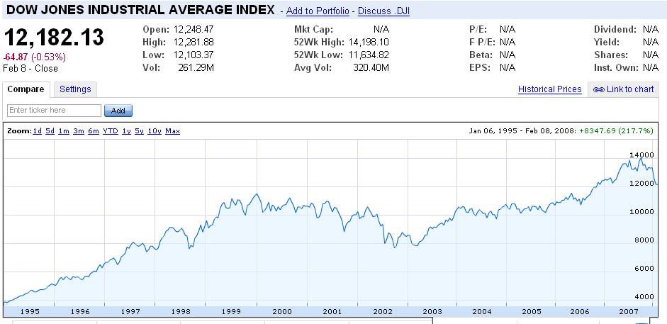

www.dj.com
Dow Jones and the Wall Street Journal

Dow Jones & Company is a subsidiary of News Corporation (NYSE: NWS, NWS.A; ASX: NWS, NWSLV; www.newscorp.com). Dow Jones is a leading provider of global business news and information services. Its Consumer Media Group publishes The Wall Street Journal, Barron's, MarketWatch and the Far Eastern Economic Review. Its Enterprise Media Group includes Dow Jones Newswires, Factiva, Dow Jones Client Solutions, Dow Jones Indexes and Dow Jones Financial Information Services. Its Local Media Group operates community-based information franchises. Dow Jones owns 50% of SmartMoney and 33% of Stoxx Ltd. and provides news content to radio stations in the U.S. Since 1882, the Dow Jones name has been synonymous with accuracy, integrity and trust.
Founded by Edward Davis Jones, Charles Henry Dow and Charles Milford Bergstresser, Dow Jones has been the benchmark by which other business- and financial-news organizations measure themselves.
 |  | 
Charles Dow | Edward Jones | Charles Bergstresser
The cornerstone of Dow Jones is its flagship publication, The Wall Street Journal, which also happens to be the world's leading business publication. The Journal, which was founded in 1889, has a total print circulation of 1.66 million.
But Dow Jones is much more. It is an organization of more than 7,000 full-time employees, dedicated to pursuing excellence in all of our Company's operations. In fact, the people of Dow Jones are at the center of our Virtuous Circle, whose success relies on the hard work and dedication of our employees.
The Company is comprised of four essential segments:

Consumer Media Group
- The Wall Street Journal.
- The Wall Street Journal Online at WSJ.com
- The Wall Street Journal Europe.
- The Wall Street Journal Asia.
- The Wall Street Journal Sunday.
- The Wall Street Journal Special Editions
- The Wall Street Journal Classroom Edition.
- The Wall Street Journal Radio Network
- Barron's
- Barron's Online
- MarketWatch
- Far Eastern Economic Review
Enterprise Media Group
- Dow Jones Newswires
- Factiva
- Dow Jones Indexes
- Dow Jones Financial Information Services
- Dow Jones Client Solutions
- Dow Jones Reprint & Permission Services
Local Media Group
Coast-to-coast group owned by Dow Jones that publishes eight daily and 14 weekly community newspapers with Internet sites.
Strategic Alliances
- SmartMoney
- Vedomosti
- STOXX

DJIA is part of the Enterprise media group

http://www.djindexes.com

Dow Jones Industrial Average
Overview
When Charles H.Dow first unveiled his industrial stock average on May 26, 1896, the stock market was not highly regarded. Prudent investors bought bonds, which paid predictable amounts of interest and were backed by real machinery, factory buildings and other hard assets.
Today, stocks are routinely considered as investment vehicles, even by conservative investors. The circle of investors has widened far beyond the Wall Street cliques of the past century to millions of everyday working men and women. These people are turning to stocks to help them amass capital for their children's college tuition bills and their own retirements. Information to guide them in their investment decisions is abundantly available.
The Dow Jones Industrial Average played a role in bringing about this tremendous change. One hundred years ago, even people on Wall Street found it difficult to discern from the daily jumble of up-a-quarter and down-an-eighth whether stocks generally were rising, falling or treading water. Charles Dow devised his stock average to make sense out of this confusion. He began in 1884 with 11 stocks, most of them railroads, which were the first great national corporations. He compared his average to placing sticks in the beach sand to determine, wave after successive wave, whether the tide was coming in or going out. If the average's peaks and troughs rose progressively higher,then a bull market prevailed; if the peaks and troughs dropped lower and lower, a bear market was on.
It seems simplistic nowadays with myriad market indicators, but late in the Nineteenth Century it was like turning on a powerful new beacon that cut through the fog. The average provided a convenient benchmark for comparing individual stocks to the course of the market, for comparing the market with other indicators of economic conditions, or simply for conversation at the corner of Wall and Broad Streets about the market's direction.
The mechanics of the first stock averages were dictated by the necessity of computing it with paper and pencil: Add up the prices and divide by the number of stocks. This application of grade-school arithmetic, while creative is hardly worthy of remembrance more than a century later. But the very idea of using an index to differentiate the stock market's long-term trends from short-term fluctuations deserves a salute. Without the means for the ordinary investor to follow the broad market, today's age of financial democracy (in which millions of employees are actively directing the investment of their own future pension money and as a result are substantial corporate shareholders) would be unimaginable.
Following the introduction of the 12-stock industrial average in the spring of 1896, Mr. Dow, in the autumn of that year, dropped the last non-railroad stocks in his original index, making it the 20-stock railroad average. The utility average came along in 1929 (more than a quarter-century after Mr.Dow's death at age 51 in 1902) and the railroad average was renamed the transportation average in 1970.
At first, the average was published irregularly, but daily publication in The Wall Street Journal began on Oct. 7, 1896. In 1916, the industrial average expanded to 20 stocks; the number was raised again, in 1928, to 30, where it remains. Also in 1928, the Journal editors began calculating the average with a special divisor other than the number of stocks, to avoid distortions when constituent companies split their shares or when one stock was substituted for another. Through habit, this index was still identified as an "average."
The 30 stocks now in the Dow Jones Industrial Average are all major factors in their industries, and their stocks are widely held by individuals and institutional investors. The DJIA accounts for approximately 23.8% of the total U.S. market, as measured by the Dow Jones Wilshire 5000 Index, as of December 13,2005.
Using such large, frequently traded stocks provides an important feature of the Industrial Average: timeliness. At any moment during the trading day, the Dow Jones Industrial Average is based on very recent transactions. This isn't always true with indexes that contain less-frequently traded stocks.
The Dow Jones Industrial Average is the most-quoted market indicator in newspapers, on TV and on the Internet. Because of its longevity, it became the first to be quoted by other publications. This practice became habit when Wall Street earned at least a mention in the general news each day, and habit became tradition when the post-World War II bull market galvanized the nation's attention. The Industrial Average became the indicator to cite if you were citing only one. Besides longevity, two other factors play a role in its widespread popularity: It is understandable to most people, and it reliably indicates the market's basic trend.

Averages Overview:

Dow Jones Averages Overview
The Dow Jones Industrial, Transportation and Utilities Averages are maintained and reviewed by editors of The Wall Street Journal. For the sake of continuity, composition changes are rare, and generally occur only after corporate acquisitions or other dramatic shifts in a component's core business. When such an event necessitates that one component be replaced, the entire index is reviewed. As a result, multiple component changes are often implemented simultaneously.
While there are no rules for component selection, a stock typically is added only if it has an excellent reputation, demonstrates sustained growth, is of interest to a large number of investors and accurately represents the sector(s) covered by the average.
Unlike the DJTA and DJUA, which include only transportation and utilities stocks, the DJIA is not limited to traditionally defined industrial stocks. Instead, the index serves as a measure of the entire U.S. market, covering such diverse industries as financial services, technology, retail, entertainment and consumer goods.
Calculation
The Dow Jones averages are unique in that they are price weighted rather than market capitalization weighted. Their component weightings are therefore affected only by changes in the stocks' prices, in contrast with other indexes' weightings that are affected by both price changes and changes in the number of shares outstanding.
When the averages were initially created, their values were calculated by simply adding up the component stocks' prices and dividing by the number of components. Later, the practice of adjusting the divisor was initiated to smooth out the effects of stock splits and other corporate actions.
The current divisors values are as follows: DJIA 0.123017848

