The Markley Division
MBA 628: Managerial Accounting Instructor: Dr. Juan J. Segovia
March 18, 2014

BLUE TOPAZ CONSULTING FIRM
Simon Foucher –Consultant
Geneviève Lavigueur – Consultant
Leo Pérez Saba – Final Draft Writer
Mohamed Shadi – Consultant
Kenny Somerville – Project Manager
Problem Definition
The Markley Division has an ineffective budgeting and control system that prevents management from fully understanding the causes of variances. As a consequence, management cannot apply proactive corrective measures in order to improve results.

Quantitative Analysis (Q1)
- Exhibit 1 displays a flexible budget together with unit costs. The contribution margin per unit of metal is twice that of plastic.
- Exhibit 2 shows the L2 breakdown of static budget variance into flexible budget and sales volume variances. The largest contributor of variances comes from flexible budget variance ($41,100U) as opposed to sales volume variance ($8,500F).
- Exhibit 3 demonstrates the L3 analysis of price, spending and efficiency variances. Except for the $39,000U due to the higher price paid for plastic materials, most of the variances come from efficiency. Moreover, efficiency variances are larger for plastic ($7,400U) than metal ($2,600U), while spending variances are almost negligible ($600U).
- Exhibit 4 shows the changes in finished goods and raw materials inventory. The net change in inventory of $49,600 is coincidently equal to manufacturing variances from standard, and will only affect the balance sheet and not the presented income statement.

Qualitative Analysis
- The major causes of Markley’s negative first quarter performance are purchasing price of plastic material and manufacturing waste (Q2a).
- Since the status report did not contain sufficient details regarding variances (L2 and L3 analyses), management was unable to implement corrective actions in manufacturing (Q2b).
- The higher than budgeted average selling price for plastic chairs ($10.50) is likely due to a decision made by management to increase the list price in order to account for higher raw material costs (Q2b).
- Sales were higher than budgeted for the lower CM item (plastic @14% sales), and lower than budgeted for the higher CM item (metal @27%). Management should look into changing prices and/or commission plans accordingly.
- A significant portion of the static variance can be assigned to purchasing because it is due to material costs. This could be the result of external factors (market prices, material quality, etc.) or internal factors (poor negotiation skills, smaller lot sizes, etc.).
- Since most of the efficiency variances come from waste, the company should research potential waste reduction initiatives (Six Sigma, Lean Manufacturing, aligning bonus structures, etc.).

Recommendation

Implement flexible budget practices and compare variances to actual results on a monthly basis in order to facilitate identification of corrective actions.

Gradually, over the course of a year, increase the selling price of plastic chairs to $11 and decrease the selling price of metal chairs to $14.

Adjust the standard cost per unit of plastic chairs to reflect the price increase in raw materials.

Exhibits

Exhibit 1 – Flexible Budget and Unit Cost Structure

 |  |  | PLASTIC
 |  |  |  |  |  |  | Budgeted |  | Sold
 |  |  | Volume (Units) |  |  |  | 50,000 |  | 60,000
Cost Driver | QTY
 |  |  |  |  |  |  | Budgeted/Unit |  | Flex Budget
Qty Sold | 60,000 |  | Revenues |  |  |  | $10.00 |  | $600,000
 |  |  | Less Manufacturing Variable Costs
Qty Made | 55,000 |  |  |  | Raw Materials |  | $5.00 |  | $275,000
Qty Made | 55,000 |  |  |  | DL |  | $1.00 |  | $55,000
Qty Made | 55,000 |  |  |  | Mfg Overhead |  | $2.00 |  | $110,000
 |  |  | Total Manufacturing Variable Costs |  |  |  | $8.00 |  | $440,000
 |  |  | Selling Variable Costs
$ Sold | 600,000 |  |  |  | Commissions (0.5% sales) |  | $0.50 |  | $30,000
$ Sold | 600,000 |  |  |  | AFDA (1% Sales) |  | $0.10 |  | $60,000
 |  |  | Total Selling Variable Costs |  |  |  | $0.60 |  | $90,000
 |  |  | Total Variable Cost |  |  |  | $8.60 |  | $530,000
 |  |  | Contribution Margin |  |  |  | $1.40 |  | $70,000
 |  |  | Other Costs
Qty Made | 55,000 |  |  |  | Fixed MFG Costs Plastic |  | $0.55 |  | $30,030
Qty Sold | 60,000 |  |  |  | Fixed SGA |  | $0.36 |  | $21,600
Qty Sold | 60,000 |  |  |  | Corporate Office Allocation |  | $0.18 |  | $10,500
 |  |  | Total Other Costs |  |  |  | $1.08 |  | $62,130
 |  |  | Division Operating Income |  |  |  | $0.32 |  | $7,870
 |  |  | CONTRIBUTION MARGING % SALES |  |  |  | 14%
 |  |  | METAL
 |  |  |  |  |  | Budgeted |  | Sold
 |  | Volume (Units) |  |  |  | 25,000 |  | 20,000
Cost Driver | QTY
 |  |  |  |  |  | Budgeted/Unit |  | Flex Budget
Qty Sold | 20,000 | Revenues |  |  |  | $15 |  | $300,000
 |  | Less Manufacturing Variable Costs
Qty Made | 22,500 |  |  | Raw Materials |  | $6.00 |  | $135,000
Qty Made | 22,500 |  |  | DL |  | $2.00 |  | $45,000
Qty Made | 22,500 |  |  | Mfg Overhead |  | $2.00 |  | $45,000
 |  | Total Manufacturing Variable Costs |  |  |  | $10.00 |  | $225,000
 |  | Selling Variable Costs
$ Sold | 300,000 |  |  | Commissions (0.5% sales) |  | $0.75 |  | $15,000
$ Sold | 300,000 |  |  | AFDA (1% Sales) |  | $0.15 |  | $45,000
 |  | Total Selling Variable Costs |  |  |  | $0.90 |  | $60,000
 |  | Total Variable Cost |  |  |  | $10.90 |  | $285,000
 |  | Contribution Margin |  |  |  | $4.10 |  | $15,000
 |  | Other Costs
Qty Made | 22,500 |  |  | Fixed MFG Costs Metal |  | $0.83 |  | $18,630
Qty Sold | 20,000 |  |  | Fixed SGA |  | $0.72 |  | $14,400
Qty Sold | 20,000 |  |  | Corporate Office Allocation |  | $0.35 |  | $7,000
 |  | Total Other Costs |  |  |  | $1.54 |  | $40,030
 |  | Division Operating Income |  |  |  | $2.56 |  | -$25,030
 |  | CONTRIBUTION MARGING % SALES |  |  |  | 27%

Exhibit 2 – Level 2 Analysis: Breakdown of static budget variance into flexible budget and sales volume variances.

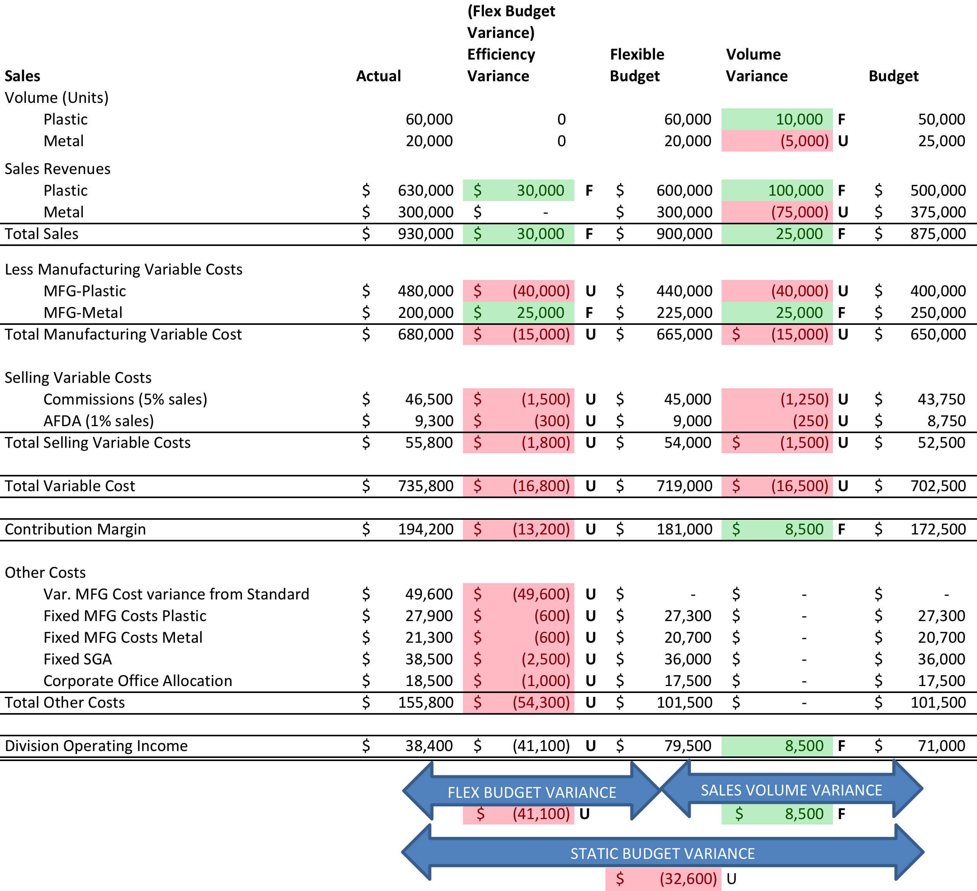

Exhibit 3 – Level 3 Analysis: Price, Spending and Efficiency Variances.
Sum of Variance | Column Labels
Row Labels | DL | DM | Fixed OH | Var OH | Grand Total
EFFICIENCY | $(600) | $(8,000) |  | $(1,400) | $(10,000)
METAL | $200 | $(3,000) |  | $200 | $(2,600)
PLASTIC | $(800) | $(5,000) |  | $(1,600) | $(7,400)
SPENDING |  |  | $(1,200) | $(600) | $(1,800)
METAL |  |  | $(600) | $(200) | $(800)
PLASTIC |  |  | $(600) | $(400) | $(1,000)
PRICE | $- | $(39,000) |  |  | $(39,000)
METAL | $- | $- |  |  | $-
PLASTIC | $- | $(39,000) |  |  | $(39,000)
Grand Total | $(600) | $(47,000) | $(1,200) | $(2,000) | $(50,800)

Item | Actual Quantity | Actual Price | Budgeted Price | Difference in price | Price Variance
Raw Materials - Plastic | 60,000 | $5.65 | $5.00 | $0.65 | $(39,000.00)
Raw Materials - Metal | 30,000 | $6.00 | $6.00 | $- | $-
DL - Price - Plastic | 9,300 | $6.00 | $6.00 | $- | $-
DL - Price - Metal | 5,600 | $8.00 | $8.00 | $- | $-
Item | Actual Input Used | Budgeted Allowed | Delta in units | Cost per unit | Efficiency Variance
Raw Materials - Plastic | 56,000 | 55,000 | 1,000 | $5.00 | $(5,000)
Raw Materials - Metal | 23,000 | 22,500 | 500 | $6.00 | $(3,000)
DL - Plastic | 9,300 | 9,167 | 133 | $6.00 | $(800)
DL Metal | 5,600 | 5,625 | -25 | $8.00 | $200
Variable MFG OH - Plastic | 9,300 | 9167 | 133 | $12.00 | $(1,600)
Variable MFG OH - Metal | 5,600 | 5625 | -25 | $8.00 | $200
Item | Total OH Cost | Variable cost per unit | Budgeted Variable cost per unit | Delta in cost per unit | Spending Variance
Plastic | 112000 | 12.04 | 12 | $(0.04) | $(400)
Metal | 45000 | 8.04 | 8 | $(0.04) | $(200)
Item | Actual | Budgeted | Variance
Plastic Fixed PH | $27,900 | $27,300 | $(600.00)
Metal Fixed OH | $21,300 | $20,700 | $(600.00)

Exhibit 4 – Changes in finished goods and raw materials inventory.
CHANGES IN FINISHED GOODS
Material | Var | Actual Manufactured | Actual Sold | QTY From INV | Unit Cost | Var
PLASTIC | $(40,000) | $55,000 | $60,000 | $5,000 | $8.00 | $(40,000)
METAL | $25,000 | $22,500 | $20,000 | $(2,500) | $10.00 | $25,000
CHANGES IN RAW MATERIALS
Material | Cost of new Inventory | Quantity Required | Quantity Purchased | Effect on stock | Material Cost | Cost of new Inventory
PLASTIC | $22,600 | $56,000 | $60,000 | $4,000 | $5.65 | $22,600
METAL | $42,000 | $23,000 | $30,000 | $7,000 | $6.00 | $42,000

