Simon Foucher

710 7722

Big spaceship:

Ready to go big?

*MBA 625 – Strategy in Action*

# Synopsis

# Analysis

## Market trends

The invention of digital media significantly transformed the relationship between consumers and their brands. Historically, companies had extremely limited ways of communicating with their existing and potential customers; there were limited major broadcasters, newspaper and billboards, and every brand competed for the same space. With digital media, the scarcity of contact opportunities has been lifted leaving endless possibilities; anyone can publish anything anywhere at any time. Brands no longer just compete with other brands for space in traditional media, they compete for people’s attention in all aspects of life, and are now also competing against people’s lives. This shifts focus towards not only crafting a compelling brand message, but forces companies to find new ways to engage customers.

The messages being conveyed also changed; with the ease of creation of videos with smartphones and publication via YouTube or Facebook, their popularity have significantly increased. Videos is a much more powerful communication media to convey ideas and emotions than static print.

This complete shift from scarcity to abundance of potential contact points happened (and is still happening) so rapidly that large corporations are still adapting. This shift left a gap in the market currently being filled by smaller but extremely agile companies such as Big Space Ship (“*BSS*”), which can rapidly assimilate new digital trends and leverage all available media to reach customers and convey brand messages.

## Competitive Landscape

Advertising landscape is dominated by large agencies on Madison Avenue. Those agencies have clear division of roles and operate via well-defined waterfall processes. Large agencies have many capabilities spanning from strategy to production, and will typically try to collect all advertising dollars (“Big Money”) from their clients.

The digital advertising space, because of how recent it is and lack of clearly defined work product and processes is dominated by much smaller companies. There has been some level of consolidation, but because creative firms tend to be more effective at quickly reacting to rapidly evolving environment when they are small, consolidation has been happening in the form of holding companies. Such holding companies will tend to grow via acquisition and manage a portfolio of 10 to 100 smaller firms operating in niche markets. The major holding companies are:

* + Interpublic
  + Omnicom
  + Publicis Group
  + WPP

Digital advertising is still not yet a properly defined industry. It will eventually reach standardization and when this happens, larger firms will most likely figure out how to be competitive in the digital space. Until then, BSS can somewhat be considered a one of the leaders in this restraint market.

## Business Model

### Client Acquisition

In terms of self-advertising, BSS has the advantage of benefiting from the breadth and depth of reach of their clients. The very nature of their business is showcasing the product of their work and effect it can have on brands. As such, instead on investing in self-advertising, BSS invests resources in ensuring original quality work which is showcase worthy. This created alignment with client’s goals and a win/win situation, where the client benefits from a successful campaign, and BSS benefits from having people seeing and talking about their creative work product. As such, most of BSS business comes from word of mouth.

Unlike traditional advertising firms that try to collect all add budget from a client, BSS invests significant effort in remaining focused and will only take on work that aligns with its core values. Clearly communicating their nonstandard approach to prospect business provides a first sense as to whether a potential client will be open to let BSS drive strategy as opposed to simply being an order taker.

BSS executes 2 types of engagements (50%/50%):

* Direct client engagement where it collaborates directly with the brands
* Work in collaboration with agencies, where it will execute the digital strategy and production for a much broader as campaign. This model has caused some issues in the past.

The company also shuns projects that involve competitive bidding and preparation to elaborate proposals. The problem with the bidding process is that bidding process involves a specific ask and a detailed answer, which does not fit the iterative creative process where BSS excels.

With 80% of business being turned away, BSS does potentially “leave some money on the table” and has the potential to tap into some easy growth.

### Strategy

* Competitive advantage: don’t copy; they have most compelling and aspirational way of connecting with consumers in a digital space, across multiple platforms
* Solution provider: not just website, but how to reach customers through various forms of media
* Between production (less strategy driven) and add agency
* Companies with 50ppl less are typically more production oriented
* Larger are more strategically driven
* Established firms have competitive limitations; hard to react quickly to change
* Target major Hollywood movies and large brands
* Scaling is often enemy of creativity
* Innovation is the success of the firm’s business model. Required close collaboration between team members.
* Selling creativity and innovation is a big challenge – don’t know it will work until you build it; selling a risk
* Mediocrity just sells a project, not a firm
* Change to innovate serves as a criterion in deciding to take on a particular project. Also increases the fun of the project

What are the key resources of the organization and how are they using them. How do they tie with the value proposition and the revenue generation model?

* Start going after larger contracts or repeat business, strategy would require to alter some key business practices. Compete aggressively to win contracts needs invest up-front in preparing bids and proposals (why bother if already turning down business?)

Plan to hire 2 managers to lead strategists and designer (matrix model)

* Dynamic teams / cross diciplinary collaboration / constant feedback & readjust
* Entertain customers rather than promoting. Build experience for the brand; start stories
* Many other agencies are order takers and manipulators of assets provided to them
* Always need to explore client’s goals rather than asks, and how to align available marketing assets to achieve goals
* Bottom up strategy
* Project begin with discovery: client say we need X, we ask why? What are you trying to accomplish? What is business goal?
* Complex nature of creative requires tight control over strategy and execution – could most likely not outsource execution to 3rd party or leave strategy to customer

### Internal Structure & Processes

Originally people were grouped by functions:

* Strategists
* Producers
* Designers
* Engineers

This was a great model to ensure maximizing use of resource and ease of scale, but it did

Previously grouped staff by function

* Not grouped by teams -> helps create identity and sense of ownership, but less learning
* Manage very well flow of work
* Survey all available material in order to assess the mission, audience and resources that would shape campaign
* Before, use to form teams ad-hoc whenever projects came in: dysfunctional results: growth make sit unworkable. Communication breakdowns become a problem
* Problem with organized by discipline is lack of communication, lack of visibility of resources and leads to territorialism if many projects in many stages
* Now organized into inter-disciplinary teams who stay together. 7 members; 4 teams and a floater of specialists (Copywriters,, QA, 3D artist, sound designer) who work with project teams (Spin off and scale)
* No hierarchy across teams
* Drawback-economic inefficiencies/organizational rigidity. Expert in one team can’t all collaborate, but positive is that creates local community
  + Can also have misalignment between project size and team size, leave teams with no work to do
  + Reduces shared knowledge – ppl might not be able to interact/learn. How to evolve staff? No cross pollinating.
* Traditional approach in agency is cascading / waterfall:
  + Strategy defines project scope
  + PM scope it and make it actionable
  + Design: Design make it visual
  + Engineering: make it function
  + Inefficient – changes are lengthy and lots of wasted work in iterations
* Flex approach

### People & Incentives

* All value is in human capital
* Focus on finding and nurturing talent. Create sustainable culture and develop effective leadership team
* Recruiting and retaining is always a challenge. Competing firms offer much larger salaries, need to attract with fun/culture. Emphasis on doing creative work and innovate at every project. Translates into lower margins to pay salaries
* Employees don’t need to switch from work to home
* Unlike big add agency, make little use of freelancers; focus on building permanent staff
* Struggle to hire Sr people because expensive
* 50 employees

Stabilized at 45-50 employees

### Financials

* Might need an infusion of capital for growth
* Can secure a good deal from investors
* Could go public but more suited for clearly defined products and processes, how to provide value to shareholders and differentiation to clients – would push towards agency model
* Standard model – sell out to holding company. Spoken to WPP, Omnicom, Interpublic Group. Holding co only cares about maintaining balance sheet – growth and profit targets.
* AKQA – privately held, sold to PE to protect against investor pressure
* Or could just grow organically
* $10M revenues (200k$/employee)

### Culture & Leadership

* High quality/high performance
* Laid back and intelligent
* Everyone challenges everyone to motivate to work harder
* Unlike corporation where everyone covers their ass.
* Not required to work long hours, they do it when a project calls for it => extremely motivated/passionate staff
* Commitment to openness
* Everyone is creative
* Universal creativity/inclusion. Ppl involved at every state of the project
* Small teams encourages collaboration
* Flexible and adaptable
* No middle management
* Mix of work and fun
* One key benefit of growth: create a ladder of opportunity for employees (is that the real driver) Talented employees without chance of advancement might want to eventually quit
* Top level management:
  + Lebowitz: drifted away from working on projects toward guiding the company as a whole
  + Hirsch
  + Prohaska
* No layer of mid management between leadership team and staff => closeness but unsalable
* Task of handling clients and maintaining high performance fell to people who worked directly in creating products
* Relied on technology – in the process of creating allocation tool to help Sr managers track stage of each project and availability of various project teams (why build in house? Focus creative resources –so scares-on creative projects)

# Problem Statement

Does the central problem gives you enough leeway to address most of the case? Where does central problem lead you? Narrows down road of resolution. Make sure you are addressing the real problem. Ex: café – not growth, Chinese subsidiary or CEO, central problem is lack of international expansion framework.

First, what are the core things wrong with organization? Then central problem.

* Can firm scale while maintaining alignment with competitive strategy and org design?
* Central challenge – remain boutique size while transcending boutique size
* Eger to expand beyond boutique, but growth is a side effect not a goal.
* Want to keep link between firm culture and people
* Do not measure success by how many people we are
* Could raise margins in many ways but would rather select work as long as it is sustainable
* Build reparation by delivering customized service, growth posed threat to that model
* But clear desire to start creating growth and increase revenues (CEO is confused)
* TO sustain current operations, 75 probably the cap ?(why is success not measured in headcount but caps growth using that metric)

# Alternatives

Take on more business?

Open new locations?

Become HoldCo?

Start going after larger contracts or repeat business, strategy would require to alter some key business practices. Compete aggressively to win contracts needs invest up-front in preparing bids and proposals (why bother if already turning down business?)

End partnership with traditional advertising firms – don’t need them to generate business, distances you from customers, lose creative ownership

With Pros/Cons

Become a holdco

Get acquired by a holdco

* Could open another office in London or San Fran if can infuse culture into that place
* New team model – expand agency by way of self-autonomous modules
* ? Had opened, assumed being closer to clients would have been benefit – real benefit is closeness to talent pool. Also, in one industry towns tend to have highly paid freelancers who bounce form one job to the other
* Adding more teams solves short term problem, but not long term,
* IN a position to turn away business, but market could soften
* Can’t just take on more business, need to generate right kind of business

Collaboraiton with large adds agencies = issues

With 80% of business being turned away, BSS does potentially “leave some money on the table” and has the potential to tap into some easy growth.

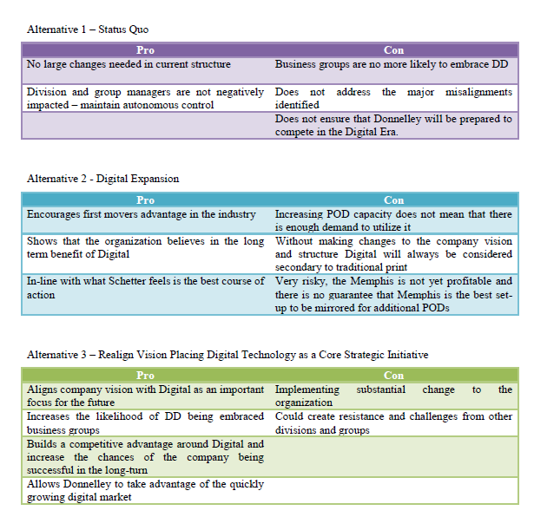

# Recommendation

By working in nimble, autonomous teams, each group can develop its own efficiencies and produce a better outcome for your business

# Implementation

Short

Structure

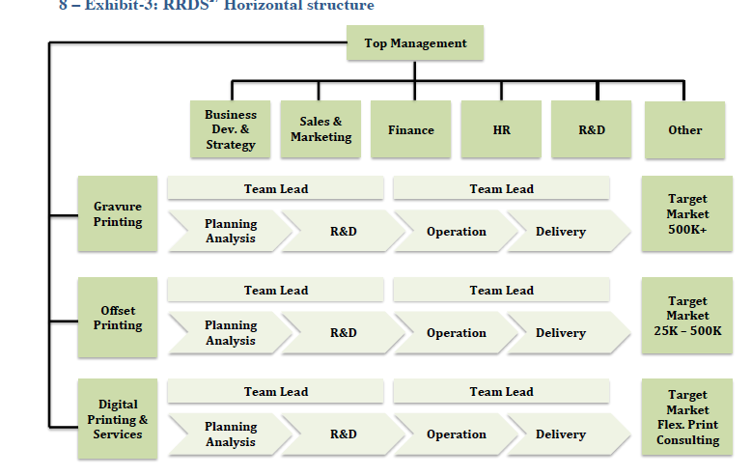

Medium

Long term

Metrics of success

* Peak: fill in 40 inquiries a week; not able to accommodate

