Profitability

In terms of profitability, both companies are generating positive returns, but Telus has been a better performer both in terms of gross margins and operating margins.

Figure 1: On the left Telus have superior Gross margins than Rogers. This is also reflected on the operating margins, on the right graph.
Observing the gross margins, we can also observe a decrease in the recent years, which reflects the increase in competition in this Oligopoly industry. With the Canadian federal government pushing towards more competition in Telcos, we can potentially expect margins to further be reduced in the next few years, but this should affect the market as a whole and not one company in particular.
This downwards trend is also observable in the Cash Realization Ratios. Both companies have seen reduced CRR over the past few years, with Telus over performing Rogers:

Figure 2: Cash Realization Ratios (CRR) has also been decreasing these past few years, Telus outperforming Rogers. We can also observe that Rogers has been generating more cash from Operations that Telus.
Yet even though Rogers’s CRR is lower, this is not due to lower cash from Operations, but rather from a higher Net Income. Roger’s cash generation from Operations is constantly superior to that of Telus, which is a positive thing. Furthermore, Rogers also outperforms Telus in terms of Earnings Per Shares:

Figure 3: Rogers outperforms Telus in EPS value and growth.
Not only is Rogers above Telus in net value of EPS, but the average growth in EPS for Rogers has been 12%, while only 8% for Telus.

Overall, even though Telus is running more profitable operations, Rogers has been able to outperform Telus with more cash generated from Operations, better EPS and a stronger EPS growth. Their lower profitability could be caused to more investments in technology which is a crucial component of a Telco company. From an investor’s perspective, the earnings generated per share is more important than gross margins, as long as it seems sustainable. This seems to be the case for Rogers, therefore even though Telus has better margins, Rogers is a better investment in terms of earnings, earnings growth and future growth potential.

Dividend Policies (½ page) - Simon

Both Rogers and Telus have been consistently paying dividends for a few years. There has been a shift in Roger’s dividend policy back in 2007/2008 when the company increased its dividend per share by a factor of 3 digit growth. Following this initial growth, dividend increases have been roughly equal for both companies, at roughly 10-11% annual growth since 2010.

Figure 4: On the left we can observe that following Roger’s change in policy, dividend per share of both companies have been raising constantly. On the right, we can see that following Roger’s triple digit dividend growth in 2007/2008, dividend growth for both companies have been stable at ~10% annually.

In terms of yield, since January 2012, both companies have been sharing an almost identical path ranging between roughly 3.5% and 4.5%.
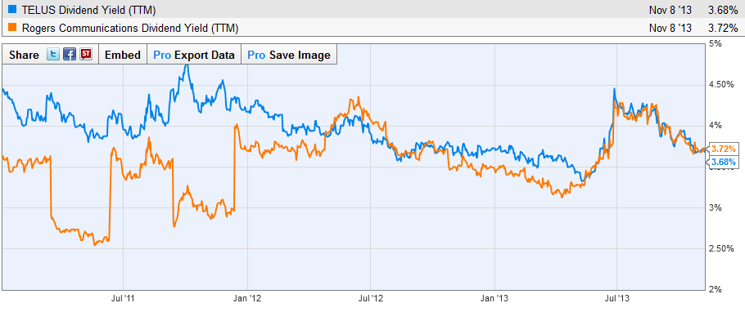
Figure 5: Historical divided yield. Since early 2012, Telus has been lagging behind Rogers, but since Telus’ summer split, both stock’s yields have been roughly at par.
Since both stocks have similar dividend yield and growth, other factors will need consideration to make a recommendation.
There has been a 2-for-1 stock split effective April 16, 2013 for Telus Shares. Although stock split does not bare any impacts on a company’s financial performance, they are typically followed by an increase in share price, which results in a reduced yield. This potentially explains the dip in Telus yield observed in summer 2013, and therefore a safe assumption is that the market has already adjusted itself to this new information.
In 2012, Rogers in its annual report reported a little over 2 billion dollars in free cash flows, demonstrating a gain of 8% over previous year, whereas Telus reported 1.3 billion dollars in FCF, which represents a 34% YOY growth. Based on these numbers, both companies seem to be generating sufficient cash in order to maintain their dividends, but Rogers, even though showing lower FCF growth, has more cash available to increase dividends. Also, Telus has had a payout ratio of roughly 60%, whereas Rogers has kept its payout ratio at roughly 50%. With a lower payout ratio, a higher net income and higher FCF, Roger’s financial position is much more likely to be able to support an increase in dividends than that of Telus.

Figure 6: Rogers Payout ratio is ~50%, while that of Telus is ~60%. Not only does Rogers have a smaller payout ratio, but it also has a higher net income, therefore potentially more capability to raise its payout ratio and thereby increasing dividends.

Base on the above analysis, from a dividend’s perspective, Rogers seems like a safer alternative than Telus. Rogers have historically demonstrated a will to improve dividend payments (with the massive increases of 2007/8), its operations generate more cash than Telus and their payout ratio is 10% lower, therefore Rogers is in a better position to potentially increase its dividend payment in the future than Telus.

