While the Report is expected to be comprehensive about the company’s strategic and financial situation and prospects, the Report should focus on the sustainability and governance practices of the company, as compared to the industry as well as other accepted benchmarks. As part of your report, you will include recommendations as to what governance practices need improvement and those which are highly satisfactory, with your rationale.

http://professor.business.ualberta.ca/randallmorck/~/media/business/FacultyAndStaff/FSA/RandallMorck/Documents/Research/Articles/DanielsMorckTheChallengeINDCAN.pdf

Voting Caps
Many corporations that are established by acts of parliament, such as chartered banks and privatized
crown corporations like Air Canada and PWA Corp. have legislative voting caps. These conditions,
laid out in the statutes that created these firms, make it illegal for any shareholder to own more than
minimal amounts of the firms' shares. In the case of Air Canada, the limit is 4%. For the banks, the
limit is 10%. Voting caps are merely extreme forms of poison pills.

http://www.ccgg.ca/site/ccgg/assets/pdf/Best_Practices_2009.pdf

Boards adopting majority voting
As of the date of this document, we are aware of the following 138 issuers (including those not
part of the S&P/TSX Composite) adopting a majority voting policy for its most recent director
elections:
(Air Canada)

Shareholder relations
- Air Canada Headquarter is located at Trudeau International Airport, a place far from downtown and not easily accessible via public transportation. Shareholder meeting held at ICAO office on University street, in the core of downtown to accommodate shareholders.
- Proxy voting made possible by mail, fax, and via internet

Auditors:
- PWC LLP has been Auditor for AC since April 1990 – best practive suggest to switch auditors from time to time to insure auditor neutrality and avoid frienships being built between the audirots and auditees, which could potentially result in conflicts of interests.

Board:
- Recently adopted majority voting policy, if more withheld than “for”, board member expected to offer his resignation to the Chairman. The situation will be analyzed by the Governance and Corporate Matters committee and the committee will make a recommendation for the board to accept it or not.
- Articles permit from 7 to 21 directors, currently have 9; good number.
- 10 meeting per year = goof meeting frequency; not minimalistic board
- Average teniure of directors is 4.6 years; with roughly 1/4 directors with <2 years teniure.
- 8 independent on 9 members = good independence. Only non independent director is <r. Rovinescu, the CEO
- There is a retirement policy, age 75, but the board can choose not to apply the limit and extend a director term passed the maximum age
- Almost perfect attendance; only 1 director missed one meeting last year.
- Directors are encouraged to follow continuous education, and their attendance to training is disclosed in the proxy
- Directors are chosen by a nomination committee with guidelines for nomination
- Formally discusses and reviews succession planning of all executives

Compensation
- Industry study performed to increase compensation according to peers included in the review
- Variable compensation to align behavior with strategy
- Clawback policy in place (adopted in 2011)
- Clear disclosure of compensation granted, accomplishements and targets used for executives

Shareholders:
- Only dsclosed significant Shareholder is Letko with 18.49% ownership of class B voting Shares (Canadian)
Dual Class Shares
- Class A and Class B have identical terms except that Class A – variable voting shares, have voting limitations for foreign owners
- Implemented to comply with the Air Canada Public Participation Act (ACPPA) and Canada Transportation Act (CTA)
  - CTA requires that 75% of voting rights of licensed Canadian Carriers be owned by Canadians.
  - ACPPA has a section that limits the voting interest of non-Canadian to 25%
- Investors can’t choose to buy A or B Shares, they are available as a function of weather the acquirer is Canadian (Class b), or a foreigners (Class A); a Canadian purchasing a Class A share will effectively convert it to a Class B and a foreigners purchasing a Class B will convert it into A
- The main difference is that for Class A variable voting shares, one share provides one vote unless ownership of Class A shares exceeds 25% or that there are more than 25% of Class A shares that exercise a vote, in which case the weight of the Class A shares vote will be scales to 25% and the weight of Class B shares increased accordingly

Fairly identical in terms of pricing:
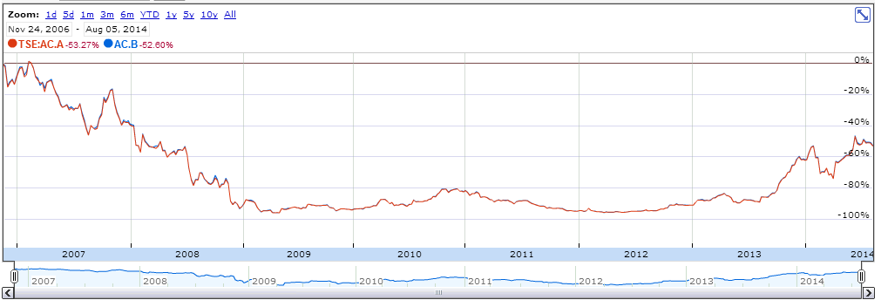
But there is a spread between the two classes:
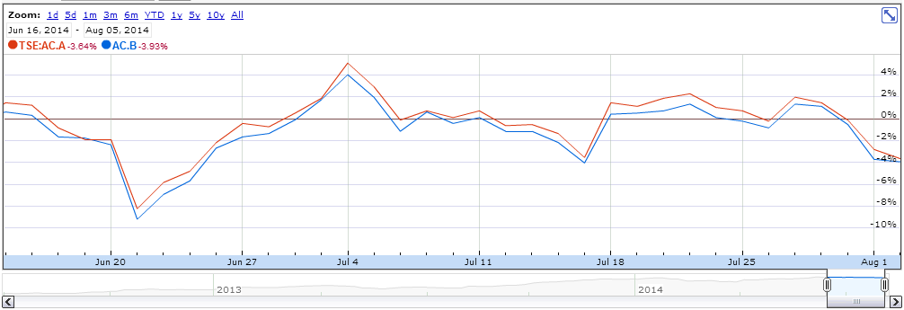

Most likely, as soon as the spread becomes significant enough to generate a profit after commission and overheads, a Canadian based arbiter performs a transaction to close the gap.

Interesting to observer that Class A, although prices similarly to Class B, are almost always priced higher, demonstrating that there is more investment appetite available abroad than within Canada.

COMPENSATION
- The CEO was offered in 2012 a 5M$ retention bonus. This bonus was not tied to any performance KPIs but rather an unconditional sign up bonus to be paid out if he remained employed for at least 3 years. Although the practive is legal, the verbiage used in the 2013 Proxy to disclose this bonus raises questions in terms of accountability of the board, more specifically the statements: "The recruitment of top corporate executives, including the CEO, is very competitive. [...] the Board of Directors was advised by an independent third-party consulting firm as to the terms of his compensation"

SUSTAINABILITY / RISK MANAGEMENT:
Dual Class Share – (enforced by ACPPA and CTA) ensure that voting interests is held in majority by Canadians -> Most likely have the best interest of important local issues like safety and environment. Ensures that company is not controlled by foreigner primarily concerned with margins who could potentially cut on safety/environment without material attachments to the social cots of potential accidents (ex: Like MMA in railroads)

