- Since IPO back in 2007, Shareprice has significantly decreased. The pronounced decrease in 2007 can potentially be attributable to the spike in oil process, and the 2008 decent attributable to the global recession
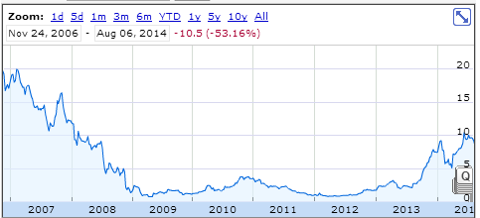
- Folloling this decline, the CEO was replaced with the current CEO, Calin Rovinescu, was appointed in Q2 2009, and has experience having been AC’s Chief Restructuring Officer following the bankruptcy protection
- Since his applintement, the stock has been keeping at par with competitors, until mid 2013 when it posted it’s first profitable earning statement since 2007 and started to significantly overperform it’s commercial rivals.

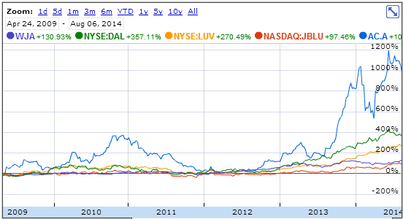
- Company is posting slow revenue growth. Although operating income has been positive since 2010, the Government had passed the Air Canada Pension Plan Funding Regulations in 2009, requiring the company to make significant contributions to defined benefit pension plans. The company came to an agreement with the GoC to fund the pension plan until 2020; the company will have to make payments of at least 150M$ into the fund, with an average of 200m$ annually in order to provide an aggregated 1.4B$ into the fund. Additionally, restrictions have been put in place for executive compensations.

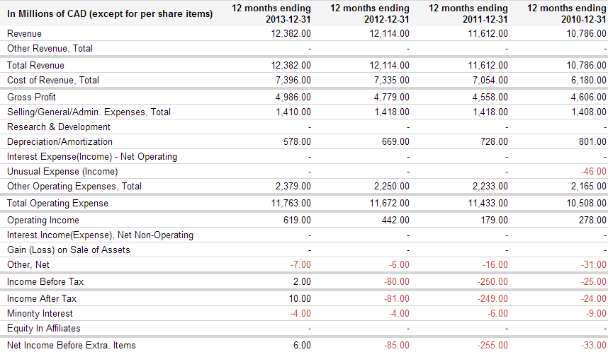
- Althoug currently profitable, the company still has an accumulated deficit of 2.3B$, and might have unproperly quantified liabilities towards pension funds
- Fuel prices are on the rise, and with more internet based meeting technologies, the future of airlines remains uncertain

Since 2007, Air Canada has been significantly underperforming compaired to most peers in the airlines industry. The following data was taken from google finance:
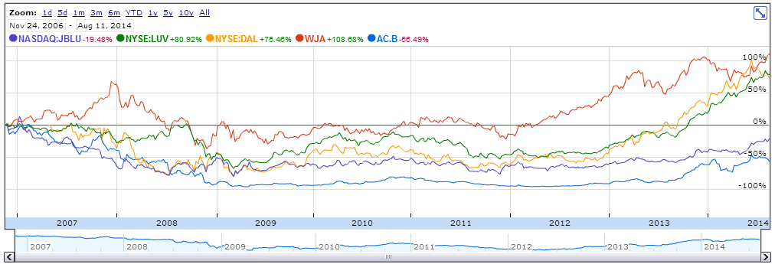

- Current CEO was appointed in

