FINA 695E
GE / Alstom Deal

Eduard Biller
Simon Foucher
Table of Contents
No table of contents entries found.

Companies Overview

GE

Alstom

Strategy in Merger

Timeline & Roadblocks

Post recession:

The Alstom stock, along with the industrial sector really overheated during the recession. Following the recession, the Alstom share took a dive from which it never really recovered:
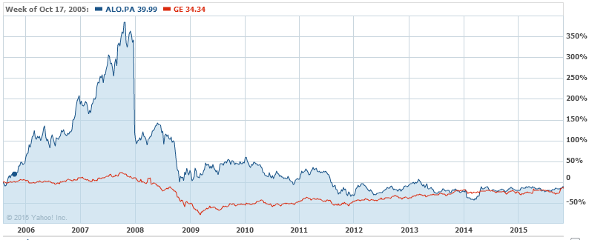

By the start of 2014, there was a rater pessimistic look for the industrial sector as a whole, and Alstom as a company. The company announces expected decrease in margins and cash flow, and announced its intention to divest ~3B$ in assets in order to generate cash to support its operations. This massive divestiture plan included a minority stake in its rail division.

It is likely at that moment that negotiations started between GE and Alstom. By the end of Q1, the industrial sector was showing signs of recovery.

In April 24th 2014, rumors circulated on press wires that GE and Alstom were discussing a potential deal. The rumors priced the transaction at ~13B Euros, the largest transaction ever conducted by GE. By that time, Bouygues was a majority shareholder of GE, owning 29% of shares. The rumors assessed that Bouygues was on board with the merger; the share price jumped by 18% overnight.

A few days later, rumors also hit that German industrial giant Siemens was also preparing a bid for Alstom. Siemens was to exchange part of its rail transport arm plus cash offer as good as GEs.
By April 30th, GE confirmed the bid at 12.4B Euros (17B$ US; 13.5B in EV and 3.4B$ in cash) for Alstom’s energy business division. GE also pledged to purchase Alstom’s Indian power division contingent to the deal closing.

The following Monday, Holland’s government stepped in, stating that it was not going to back GE’s bid. The Government’s main concern was a potential reduction in Alstom’s French activities following a takeover by a US firm, and pledged GE to transfer its rail division to Alstom. The government went as far as issuing a decree, which got nicknamed the “decret Alstom”, giving government veto right to decline takeovers for companies operating in national interests, such an energy and transport.

By mid-June, Siemens and Mitsubishi Heavy Industries (MHI) made a competing bid where Siemens was to acquire Alstom’s turbine activities and HMI would form a JV with Alstom with an acquisition of minority stakes in its nuclear, grid and hydro businesses.

This was quickly followed by a positive revision of GE’s bid, including a JV with Alstom’s turbine and nuclear power business as well as a promise to sell its rail business to Alstom. On June 20th, Siemens and HMI also upped their bids.

The government announced that it would evaluate both bids, and finally backed the GE offer and announced that it would take a 20% stake in the final entity, purchased from Bouygues. The latter’s regulatory issues with the French government regarding its telecom arm was used as leverage to convince them to accept the deal.

By early 2015, everything was under way for completion until the EU stepped in with objections. All regulatory hurdles were finally overcome; with regulatory approvals from over 20 countries, such that the deal was finally able to close in November 2015.

Aftermath

