This is a deterministic model
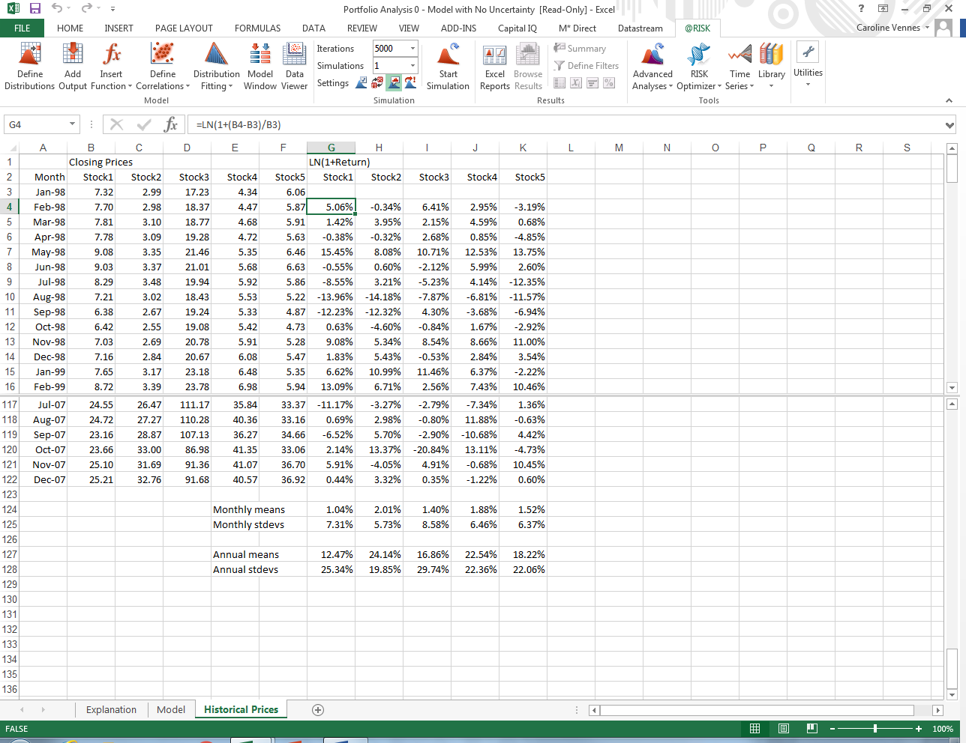
Continuously compounded return: ln(1+(b4-b3)/b3)

Invest a dollar in discrete return of 5% = 1*1.05 = 1.05
Continuous compounding = ln(1+0.05)/T = 1.048/T
Annual std dev = monthly std dev*square root of 12

Stock price when sold
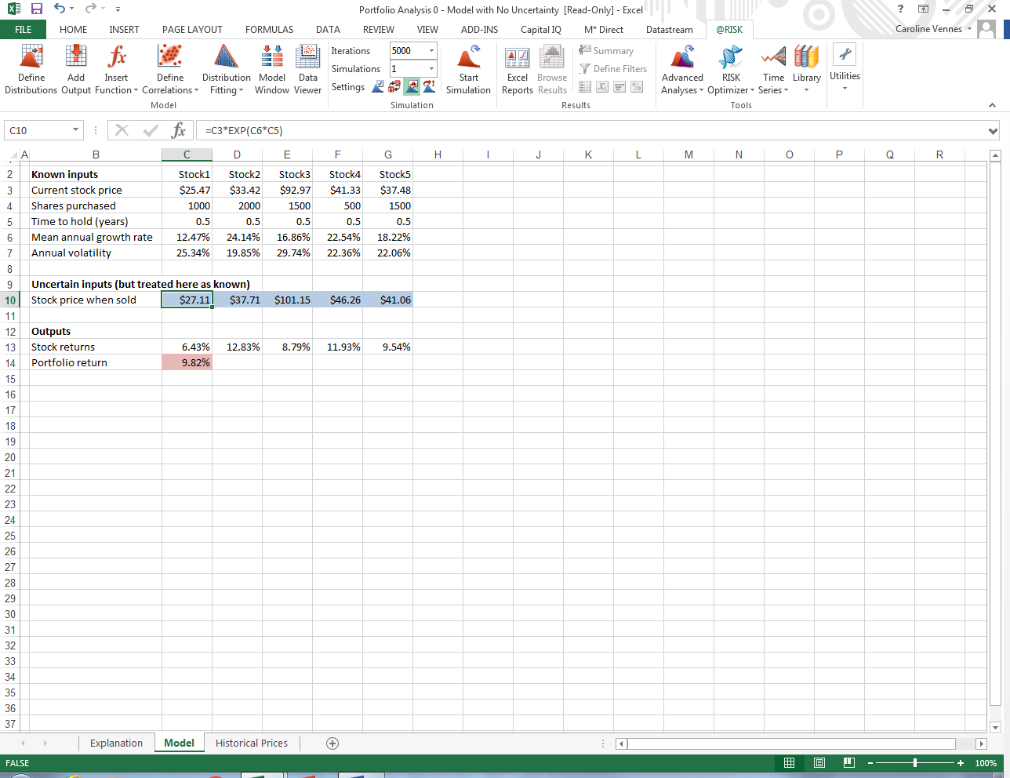

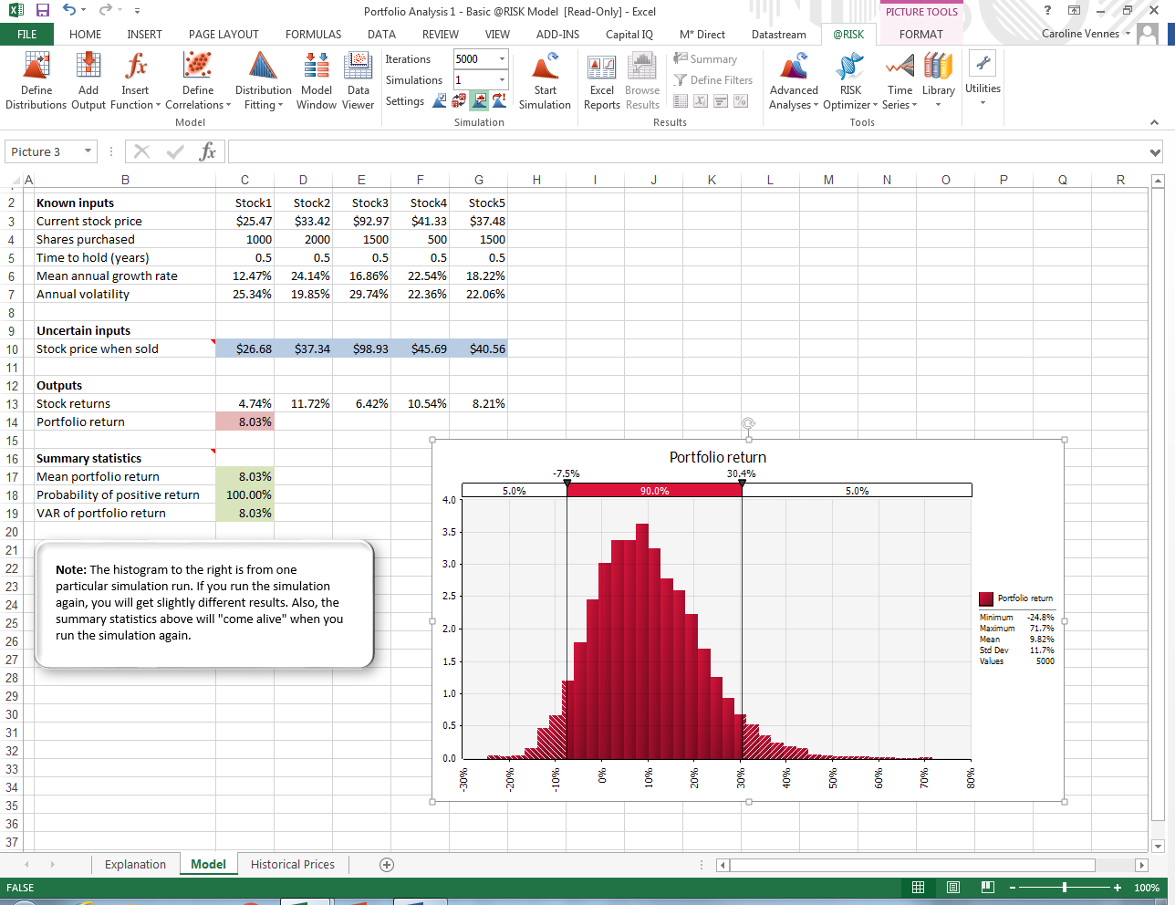
Inject some randomness:
Stock price when sold =C3*EXP((C6-0.5*C7^2)*C5+C7*SQRT(C5)*RiskNormal(0,1))
VAR of portfolio return =RiskPercentile(C14,0.05)

START SIMULATION
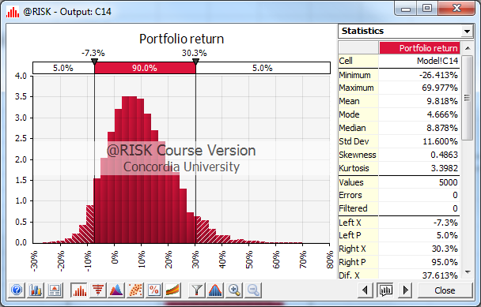
HISTORICAL PRICES
Select G4+ click on DISTRIBUTION FITTING = FIT
Update name + range
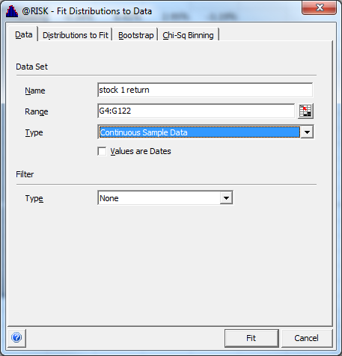
+ FIT
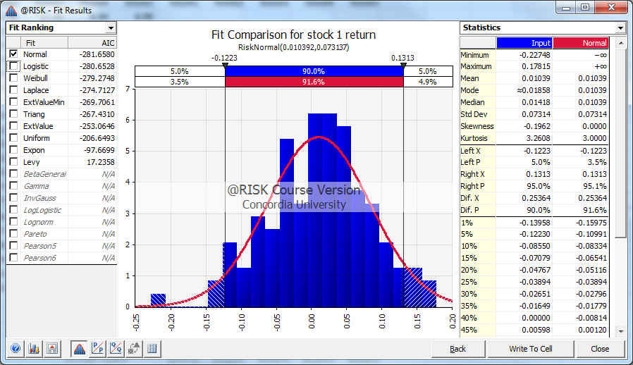
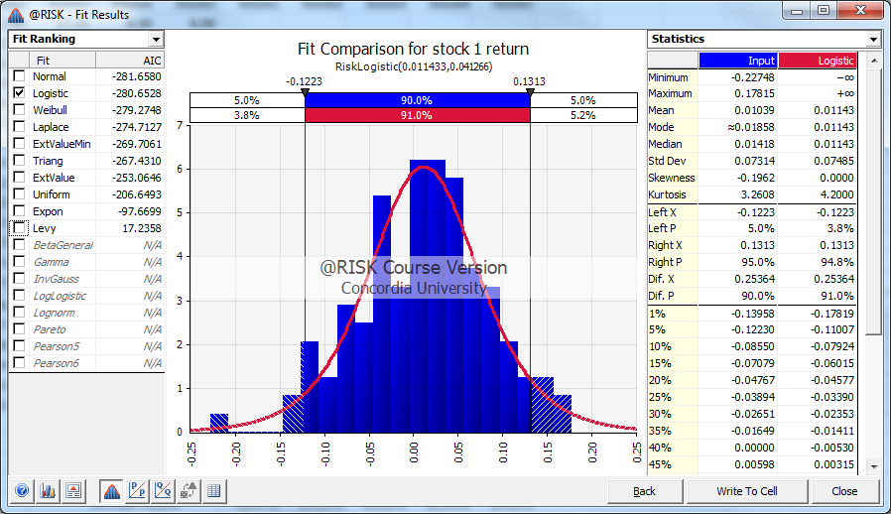
The one with the lowest AIC is the best one (Normal with -281)

Click WRITE TO CELL + NEXT + OK

Go to blank cell
Define correlation matrix
Add inputs + select 4 boxes of Stock price at expiration
Add random correlation number in boxes
Then click OK

