COPULAS

Definind variables for copulas
Select cell, click Define Distribution

Equivalent of typing this formula in the cell:
=RiskUniform(0.45,0.55,RiskStatic(0.5))
Drag distribution to other cells

Select the 3 cells containing the variables, then click define copulas

Select t copula and type in 0.7 (correlations)

Alternatively, select Clayton Copula

Then when you click on the cells, they are linked with the copula by their formula
A1: =RiskUniform(0.45,0.55,RiskStatic(0.5),RiskCopula(Copula1,1))
=RiskUniform(0.45,0.55,RiskStatic(0.5),RiskCopula(Copula1,2))
=RiskUniform(0.45,0.55,RiskStatic(0.5),RiskCopula(Copula1,3))

Set # iterations to 5000 then start simulation

Reverse engineer correlations if given results
Click Excel reports / Simulation data inputs: Shows you input data
Tells you best fit is uniform distribution (which is what was originally inputted into the variable
Fit then write to cell

Select second column/Distribution fitting

Could also fit copula:

Tells you Clayton is the best – retrieved all information that was originally inputted.
Write to spreadsheet – will write copula on excel

Application: Stocks, want to know correlation
Define Distributions:

Then select a uniform distribution

Now link them using the copula we just built.

Click in the copula
Edit copula, then attachement editor

Attach inputs – add cells just created
Select one of the input cells / Start simulation.

lick Scatter plot / Select all 3 inoput cells:

Have 3 stocks.

 | Stock 1 | Stock 2 | Stock 3
Mean Growth Rate | 12% | 18% | 25%
Volatility | 25% | 35% | 50%
Initial Stock Price | $ 20 | $ 30 | $ 40
# Shares Bought | 1000 | 750 | 500
Initial Portfolio Value | $ 62,500

Set:
G1=RiskNormal(0,1)
H1= RiskNormal(0,1)
I1= RiskNormal(0,1)

Select cells / define copulas

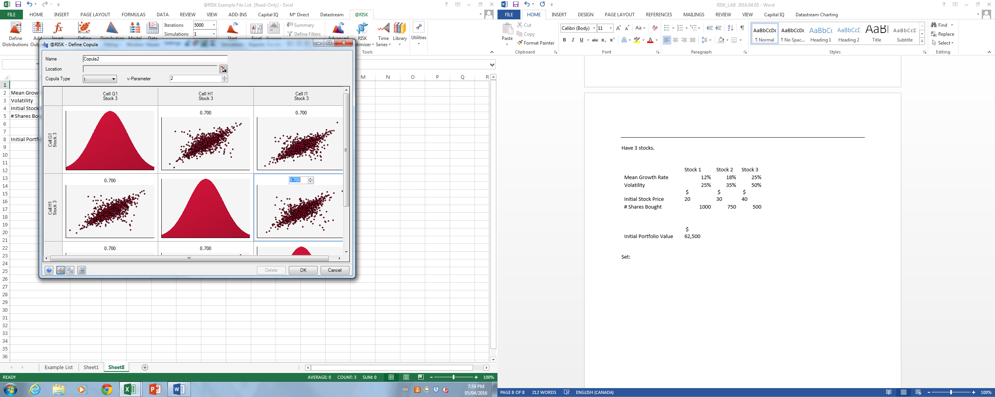

Set final stock price = [START_STOCK_PRICE]*exp(([GROWTH]-.5*[VOLATILITY]^2)*[TIME]+[VOLATILITY]*sqrt(TIME)^0.5*RISK_NORMAL)

Calculate ARR
Add output to the cell containing ARR:

Start simulation

What is the probability to make a loss?

Probability of a loss
=RiskTarget(G11,0)

Value at Risk for 99%
=RiskPercentile(ARR, 0.01)*INNITIAL_PORTFOLIO_VALUE

Change copula to Gaussian Copula. Chances of losing should be lower.
Click in the copula, define copula
Change to Gaussian Copula

T and Gaussian copulas should be fairly similar in terms of probability of default. But looking at the tails (99% VAR), should be more of a difference; Gaussian copula is more conservative (but t coppula is a more accurate description of stock market.

