Excel file:

TSE EWMA

Goal:
Maximize results by tweaking Lambda

File/options/add-ins
Manage Excel Add-ins/GO
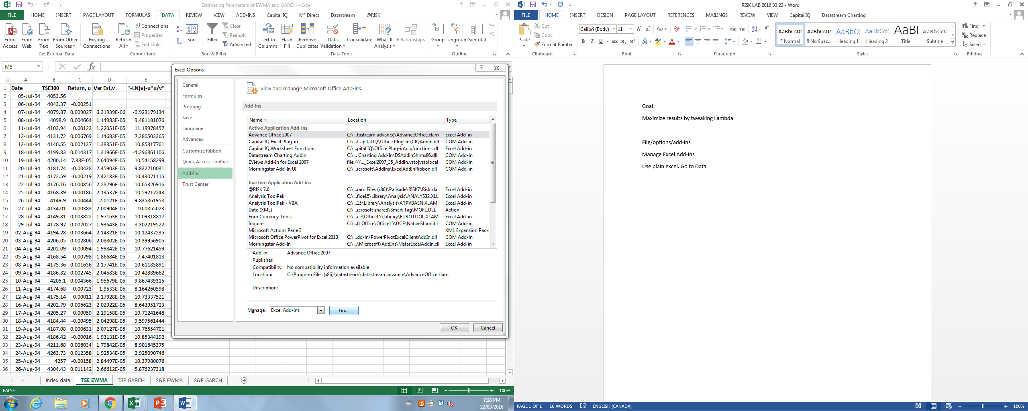
Add solver
Use plain excel. Go to Data, click Solver
Maximize Likelyhood by tweaking Lambda

TSE GARCH
Omega is a lot lower than Alpha, Beta about 10x that alpha. When solver is trying to tweak 3 value to maximize likelihood, then solver doesn’t work very well.

That’s why values are scaled to be close to each other:
omega*100000 | 0.395513425
alpha | 0.139320557
0.1*beta | 0.079280585

Place cursor in D5, this is the formula for GARSH
=$H$5+$H$7*D4+$H$6*C4*C4
H5=Omega
H7=, multiplied by yesterday’s estimated of return (D4)
Then column E to find the log likelihood, try to maximize it.

GO to solver, maximize H9 by changing H1:H3

VaRHistoricalSimulExample

Scenarios with Weights
As you progress in the past, weight should decline.
But have to take cumulative weights (this new weight + last weight)

Then sort by weight; what we have in Ranked Losses with Weights.

Data with Vol Ests

Scenarios 1 = DJIA₅₀₂ * DJIA₂/ DJIA₁

= DJIA₅₀₂ * DJIA₁ + (DJIA₂ - DJIA₁)
DJIA₁

Same as sigma502/sigma1

So for model, just scale sigma_{n}/sigma₁

Open precision tree

TO copy, click on node, copy sub tree

