Due in the class on March 29. (Postponed 1 week)

- (a) The current stock price is $50, the (instantaneous) expected growth rate is 12%, and the volatility is 30%. What is the probability that the stock price will be greater than $90 after 2 years? (5 marks)

S₀ = $50
μ = 12%
σ=30%
T=2
V = $90
P(S₂ > $90) = ?
P(S_{t} > V ) = N[ (ln(S₀/V) + (μ-σ²/2)T / σ√T ]
P(S₂ > $90) = N[ (ln($50/$90) + (.12-.3²/2)*2 / 0.3√2 ]
P(S₂ > $90) = N[ (-0.5878 +.15) / .4243 ]
P(S₂ > $90) = N[-1.03187] = 0.151

P(S₂ > $90) = 15.1%

(b) What is the stock price that has a probability of 25% of being exceeded in 18 months?

S₀ = $50
μ = 12%
σ=30%
T=1.5
V = ?
P(S_{1.5}> V) = 25%

V = S₀ exp[(μ-σ²/2)T – N⁻¹(q)* σ√T ]
V = $50 exp[(0.12-0.3²/2)1.5 – N⁻¹(0.25)* 0.3√1.5 ]
V = $50 exp[ 0.1125 – (-.674) * (0.3674) ]
V = $50 exp[ 0.36 ]
V = $50 * 1.434
V = $71.68

- (a) A binary option on the above stock pays $10 if the stock price is greater than $55 after 3 months. If the continuously compounded interest rate is 6%, what is the price of this binary option? (5 marks)
- Assume stock grows at Rf & find Risk Neutral P(S_{T}>V)
- Determine payoff at t=T
- Discount back at Rf rate to find derivative value

Probability of return
S₀ = $50
μ = Rf = 6%
σ=30%
T=1/4
V = $55

P(S_{t} > V ) = N[ (ln(S₀/V) + (Rf-σ²/2)T / σ√T ]
P(S_{1/4} > $55 ) = N[ (ln($50/$55) + (0.06-0.3²/2)/4) / 0.3√0.25 ]
P(S_{1/4} > $55 ) = N[ (-0.0953 + 0.00375) / 0.15 ]
P(S_{1/4} > $55 ) = N[ -0.6104 ]
P(S_{1/4} > $55 ) = 0.2708

EV of Payout @ t=3months
EV = PMT * P(S_{1/4} > $55 )
EV = $10 * 0.2708
EV = $2.71

Present Value of Payout
PV = FV * exp (-Rf*T)
PV = $2.71 exp (-0.06*1/4)
PV = $2.71 * 0.9851
PV = $2.67

Another option on the above stock pays $10 if after 1 year the stock price is between $60 and $70 and $15 if the stock price is greater than $70. What is the price of this option?

Probability of return
S₀ = $50
μ = Rf = 6%
σ=30%
T=1
V = $70
P(S₁ > $70)

P(S_{t} > V ) = N[ (ln(S₀/V) + (Rf-σ²/2)T / σ√T ]
P(S₁ > $70) = N[ (ln($50/$70) + (0.06-.3²/2)1 / 0.3√1 ]
P(S₁ > $70) = N[ (-0.33647 + 0.015) /0.3 ]
P(S₁ > $70) = N[ -1.071567 ]
P(S₁ > $70) = 0.141957

S₀ = $50
μ = Rf = 6%
σ=30%
T=1
V = $60
P(S₁ > $60)

P(S₁ > $60) = N[ (ln($50/$60) + (0.06-.3²/2)1 / 0.3√1 ]
P(S₁ > $60) = N[ (-0.18232 + 0.015) /0.3 ]
P(S₁ > $60) = N[-0.16732 ]
P(S₁ > $60) = 0.433559

P($60 > S₁ > $70) = P(S₁ > $60) - P(S₁ > $70)
P($60 > S₁ > $70) = 0.433559 - 0.141957
P($60 > S₁ > $70) = 0.2916

EV of Payout @ t=1yr
EV = PMT₇₀ * P(S₁ > $70) + PMT₆₀₋₇₀* P($60 > S₁ > $70)
EV = $15 * 0.14196 + $10 * 0.2916
EV = $2.13 + $2.92
EV = $5.05

Present Value of Payout
PV = FV * exp (-Rf*T)
PV = $5.05 exp (-0.06*1)
PV = $5.05 * 0.9418
PV = $4.76

- (a) Suppose the gain from a portfolio during six months is normally distributed with mean of $5 million and standard deviation of $15 million. What is the VaR of the portfolio at 99% level of confidence?

μ = $5M
σ = $15M
N⁻¹(99%) = -2.33

Let X be the gain of the portfolio,
then X ~ N($5M, $15M)
Y = (X- μ)/ σ
Y = (X – 5M$)/15M$

P(-2.33 < Y) = 99%
P(-2.33 < (X – 5M$)/15M$) = 99%

Solve for
-2.33 < (X – 5M$)/15M$
X > -2.33 * 15M$ + 5M$
X > 29.95M$

VaR with 99% confidence is 29.95M$

(b) Suppose that for a project, all outcomes from a loss of $20 million to gain of $40 million are equally likely. What is the VaR at the 95% confidence level?
(5 marks)
The loss of the project has uniform distribution extending form [-$20M, $40M]
Range
$40M – (-$20M) = $60M
5% of range = 5% of $60M = 3M$

Offset of range % from lower limit of range
-$20M + $3M = -$17M

The VaR at 95% is therefore:
$17M

- (a) The price of gold at the close of trading yesterday was $312 and its volatility was estimated to be 1.6% per day. The price at the close of trading today is $306. What is the estimate of volatility for tomorrow according to EWMA model with λ = 0.92? (Note: Volatility is std dev; the square root of Varinace-σ²) (5 marks)

λ = 0.92
Let:
- n = tomorrow
- n-1 = today
- n-2 = yesterday

Historical Volatility: 0.016 = √ σ²
Historical Variance: σ _{n-1}² = 0.016² = 0.000256

μ _{n-1} = (P_{n-1}-P_{n-2}) / P_{n-2}
μ _{n-1}= ($312 - $306) / $306
μ _{n-1}= -0.019230769

σ _{n}² = λ * σ _{n-1}² + (1- λ) * μ _{n-1}²
σ _{n}²= (0.92) * (0.016)² + (1-0.92) * (-0.019230769)²
σ _{n}²= (0.92) * (0.000256) + (0.08) * (0.000369822)
σ _{n}²= 0.00023552 + 0.000029586
σ _{n}²= 0.000265106

Volatility = sqrt (σ _{n}²)
Volatility = sqrt (0.000265106)
Volatility = 0.01628207

(b) For the above problem, what is the estimate of volatility for tomorrow according to GARCH(1, 1) model with ω = 0.0000027075, α = 0.05, and β = 0.92?

GARCH(p, q):
σ _{n}² = ω + α * $\sum_{1}^{q}{ }$μ _{n-q}² + $\sum_{1}^{p}{ }$β * σ _{n-p}²

GARCH(1, 1):
σ _{n}² = ω + α * $\sum_{1}^{q}{ }$μ _{n-q}² + $\sum_{1}^{p}{ }$ β * σ _{n-p}²
σ _{n}² = ω + α *μ _{n-1}² + β * σ _{n-1}²
σ _{n}² = (0.0000027075) + (0.05) * (-0.019230769)² + (0.92) * (0.016)²
σ _{n}² = (0.0000027075) + (0.05) * 0.000369822) + (0.92) * (0.000256)
σ _{n}² = (0.0000027075) + (0.0000184911) + (0.00023552)
σ _{n}² = 0.0002567186

Volatility = sqrt (σ _{n}²)
Volatility = sqrt (0.0002567186)
Volatility = 0.016022441

(c) For the above problem, what is the long-run average volatility?

α + β + γ = 1
γ = 1 - α - β
γ = 1 - 0.05 - 0.92
γ = 0.03

From GARCH Model:
ω = γ * V_{L}
V_{L} = ω / γ
V_{L} = 0.0000027075 / 0.03
V_{L} = 0.00009025

- Go to www.ca.finance.yahoo.com. Download the daily stock prices of Microsoft for the 2-year period from November 09, 2013 to November 09, 2015. To do this, enter the ticker symbol of Microsoft, which is MSFT, and click on Look Up. Then, under QUOTES, click on Historical Prices. Enter the date range and get the daily prices. Download the prices for the past three years. Work with the Adj. close prices to answer the following questions:

Please note that when you download the data for Microsoft, the data is sorted from the newest to the oldest. You have to first sort the data from the oldest to the newest (November 09, 2013 to November 09, 2015, in that order) before you can estimate the EWMA and GARCH(1, 1) models. (10 marks)

Estimate the parameters of EWMA and GARCH (1, 1) for Microsoft.

EWMA
Create column for Return: μ _{n-1} = (P_{n-1}-P_{n-2}) / P_{n-2}
Create column for Variance using EWMA: σ _{n}² = λ * σ _{n-1}² + (1- λ) * μ _{n-1}²
Create column for prob: -ln(σ²) - μ ²/ σ²
Set initial λ = 0.5
Set Likelihood = sum(prob)
Solve to maximize likelihood by tweaking λ with constraint λ < 1
Lambda = 0.975660393

GARCH(1, 1)
Create column for Return: μ _{n-1} = (P_{n-1}-P_{n-2}) / P_{n-2}
Create column for Variance using GARCH(1,1): σ _{n}² = ω + α *μ _{n-1}² + β * σ _{n-1}²
Create column for prob: -ln(σ²) - μ ²/ σ²
Set initial ω *100000 = 0.5, α = 0.5, β = 0.5
Set Likelihood = sum(prob)
Solve for to max(likelihood) by tweaking ω *100000, α & β *0.1

ω = 0.000002970244
α = 0.009245135999
β = 0.980548654662

Detailed work can be found in excel.
- Use the data in the spreadsheet “Data for Problem 6” to answer this question.
Suppose that a portfolio has (in $000S) invested 10,000 in DJIA, 15,000 in FTSE, 10,000 in CAC 40 and 15,000 in Nikkei 225.
- What is the 1-day 95% VaR using historical simulation?
(See Excel for work)
$257,581

- What is the 1-day 95% VaR using the weighting-of-observations? (use λ = 0.95)
(See Excel for work)
$553,300

- What is the 1-day 95% VaR using the volatility-updating? Use the EWMA to answer this question. But before you can estimate the VaR, you have to estimate the value of λ for each of the 4 indices.
(See Excel for work)
λ _{DJIA} = 0.970820596
λ _{FTSE 100} = 0.88877916
λ _{CAC 40} = 0.912240631
λ _{Nikkei 225} = 0.908807558

1-day 95% VaR = $1,455,427

- marks)

- Random variable V₁ is uniformly distributed with values between 0 and 2. Random variable V₂ is uniformly distributed with values between -2 and 4. Produce a cumulative joint probability distribution for V₁ and V₂ table using Gaussian copula with a correlation of 0.45.
V₂
V₁ | -1.00 | 1.50 | 3.00
0.40 | 0.071118 | 0.164032 | 0.191929
1.20 | 0.140778 | 0.421012 | 0.546092
1.80 | 0.164005 | 0.557033 | 0.77553

Note: Using a Guassian copula with a correlation of 0.45 does not imply that the random variable V₁ and V₂ will also have a correlation of 0.45. This is because the transformation between the given uniform random variables and the standard normal variables in non-linear. Generally, the copula correlation is not the correlation of variables combined into a joint distribution using the copula.
(5 marks)

First, for both variables, the normal value with the equivalent percentile was determined:

V1 | Percentile dist | Std Normal V1 |  | V2 | Percentile dist | Std Normal V2
0 | 0% |  |  | -2 | 0%
0.4 | 20% | -0.841621234 |  | -1 | 17% | -0.967421566
1.2 | 60% | 0.253347103 |  | 1.5 | 58% | 0.210428394
1.8 | 90% | 1.281551566 |  | 3 | 83% | 0.967421566
2 | 100% |  |  | 4 | 100%

Then, the bivariate macro was used with correlation of 0.45 in order to determine the joint probabilities at the required intersection points.

The following is the result:
 | V2
V1 | Values |  |  | -1 | 1.5 | 3
 |  | Percentile dist |  | 17% | 58% | 83%
 |  |  | Std Normal | -0.9674 | 0.2104 | 0.9674
 | 0.4 | 20% | -0.8416 | 0.071118 | 0.164032 | 0.191929
 | 1.2 | 60% | 0.2533 | 0.140778 | 0.421012 | 0.546092
 | 1.8 | 90% | 1.2816 | 0.164005 | 0.557033 | 0.77553

- The equity value is $6 million and the volatility of equity is 40%. The debt to be repaid in two years is $10 million. The risk-free rate is 5%. Given this information, what is the risk-neutral probability of default by the firm? (Book page 420)
- arks)
E₀ = V₀N(d₁) − De^{−rT} N(d₂)
d₁ = (ln(V₀/D) + (r+σ²/2)T) / σ√T
d₂ = d₁ - σ√T

The provided excel was used as a basis to calculate, using the following parameters:
E₀ = $6M
σ_{E} = 40%
Rf = 0.05
T = 2
D = $10M

Go to Options/Add-Ins/Manage Add-ins/Go
Add Solver
Solve to minimize E18 by tweaking V₀ and σ_{v}

Trial Value for V₀ 15.03646249

Trial Value for σ_{v} 0.161155559

Probability of default 0.017234493
- The following table has information about four stocks and your investments in these stocks.
Known inputs | Stock1 | Stock2 | Stock3 | Stock4
Current stock price | $27.00 | $31.00 | $36.00 | $45.00
Shares purchased | 100 | 200 | 200 | 400
Time to hold (years) | 1.0 | 1.0 | 1.0 | 1.0
Mean annual growth rate | 13.00% | 22.00% | 18.00% | 24.00%
Annual volatility | 16.00% | 25.00% | 21.00% | 30.00%

Your investment horizon is one year. Assume a constant correlation of 0.65 among the four stocks. Set the number of iterations to 5,000 in your simulation.
@RISK Correlations | Stock1 / Correlated stock prices in $C$11 | Stock2 / Correlated stock prices in $D$11 | Stock3 / Correlated stock prices in $E$11 | Stock4 / Correlated stock prices in $F$11
Stock1 / Correlated stock prices in $C$11 | 1
Stock2 / Correlated stock prices in $D$11 | 0.65 | 1
Stock3 / Correlated stock prices in $E$11 | 0.65 | 0.65 | 1
Stock4 / Correlated stock prices in $F$11 | 0.65 | 0.65 | 0.65 | 1

Answer is based on Portfolio Analysis 5 - Model with Correlated Stock Prices.xlsx
- Stock price, shares purchased, mean annual growth and volatility updated as per provided table (historical data sheet removed)
- Time to hold set to 1yr
- Correlation matrix updated to remove last row/column and all correlations set to 0.65
- Iterations set to 5000 / Simulation ran

Outputs
Independent stock returns | 12.43%
Correlated stock returns | 12.43%
Portfolio return with independence | 19.74%
Portfolio return with correlations | 19.74%
VAR confidence | 90.00%
Summary statistics with independence
Mean portfolio return | 24.05%
Probability of positive return | 88.00%
Probability of negative return | 12.00%
VAR of portfolio return | -1.77%
Summary statistics with correlations
Mean portfolio return | 24.06%
Probability of positive return | 78.89%
Probability of negative return | 21.11%
VAR of portfolio return | -10.57%
- What is the expected return (simple return) on your investment?

Mean portfolio return is 19.74%

- What is the probability that you would end up with a negative return?
21.11% with correlation
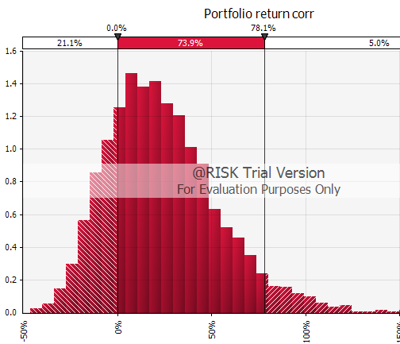

12.00% without correlation
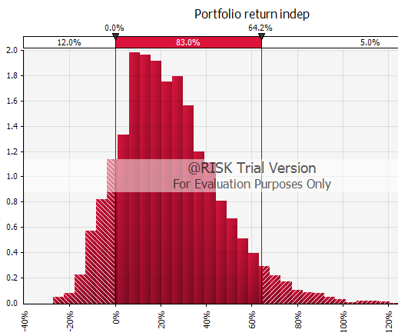

- What is the VaR at 90% level of confidence (in dollars)?

Known inputs | Stock1 | Stock2 | Stock3 | Stock4
Current stock price | $27.00 | $31.00 | $36.00 | $45.00
Shares purchased | 100 | 200 | 200 | 400
Value of investment | $2,700 | $6,200 | $7,200 | $18,000 | $34,100

Value of investment: 34,100$
Non-correlated VAR = -1.77% * 34,100$
Non-correlated VAR = $604.29

Correlated VAR = -10.57% * 34,100$
Correlated VAR = $3,603.73

- What is the probability that you will earn a return between 10% and 20%?
P(return < 20%) = 49.3%
P(return < 10%) = 35.2%
P(10% < return < 20%) = P(return < 20%) - P(return < 10%)
P(10% < return < 20%) = 14.1%

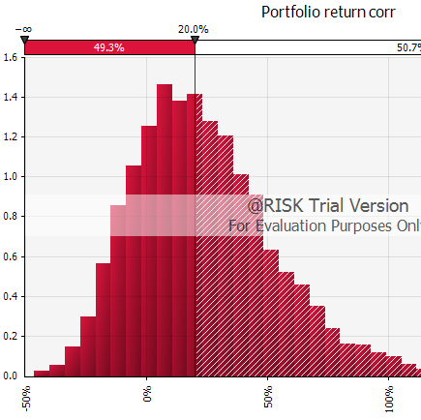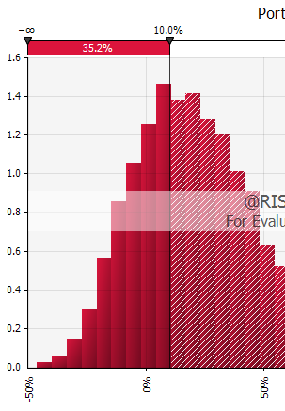

- What is the probability that you will earn a return greater than 30%?

Answer: 35.1%

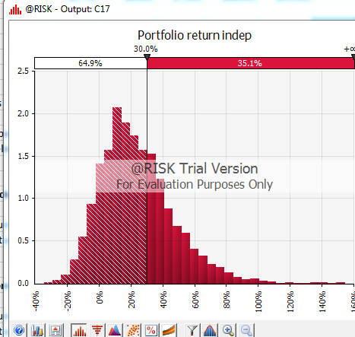
- marks)

- In the spreadsheet named Data on Returns of Financial Assets, you will find data on returns on Treasury bills, Treasury bonds, stocks, and inflation in columns L to P from the year 1946 to 2000. You are planning for your retirement and will be saving $10,000 for the next 40 years. A constant percentage of your money will be invested in Treasury bills, Treasury bonds, stocks.

- What should these percentages be so that you maximize the 5th percentile of the money you are likely to have (in present value terms) after 40 years? You decide not to invest more than 50% of you money in stocks.
To answer this question, sample from the given historical returns data. Use the dampening factor of 0.95. Set the number of iterations to 500 and the runtime to 3 minutes.
Based on the example: Planning for Retirement.xlsx

Set constraint such that stock % < 50% and sum(%) = 100%

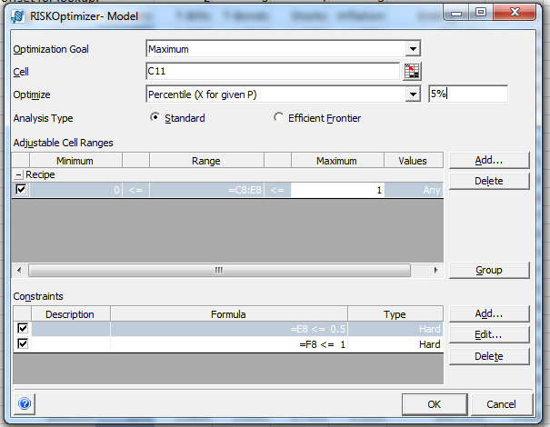

Decisions | T-Bills | T-Bonds | Stocks
Weights for portfolio | 0.0% | 50.0% | 50.0%

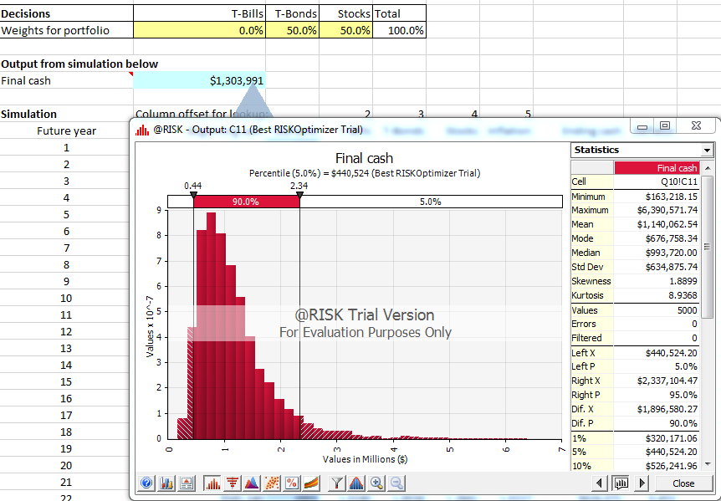

- What should the weights be if you want to maximize your expected value of your investment (in present value terms) after 40 years? Use the same constraints and setting above.

Same parameters as above, except target is max value:
Decisions | T-Bills | T-Bonds | Stocks | Total
Weights for portfolio | 0.0% | 50.0% | 50.0% | 100.0%

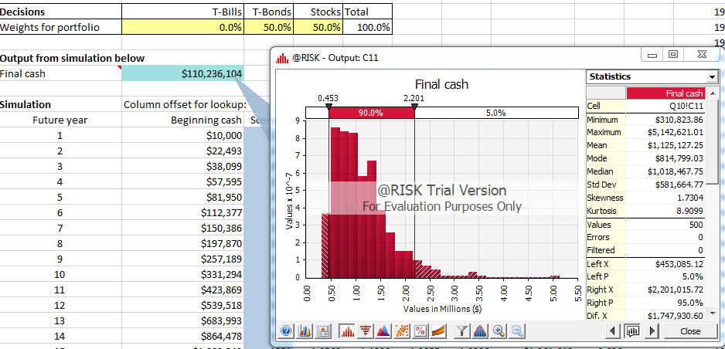
Answer:_____________________________

- What should the weights be if you want to minimize the probability that the value of your investment (in present value terms) after 40 years is less than $1 million?

Same as above except:
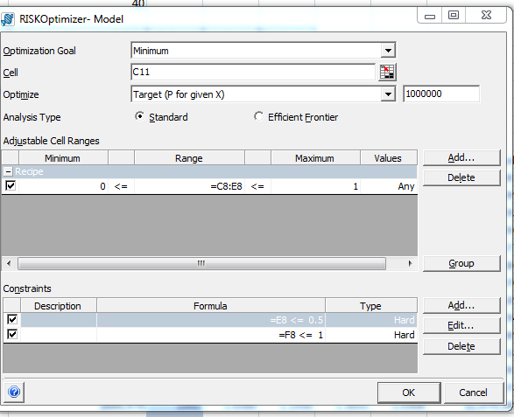

Decisions | T-Bills | T-Bonds | Stocks | Total
Weights for portfolio | 48.4% | 50.0% | 1.6% | 100.0%

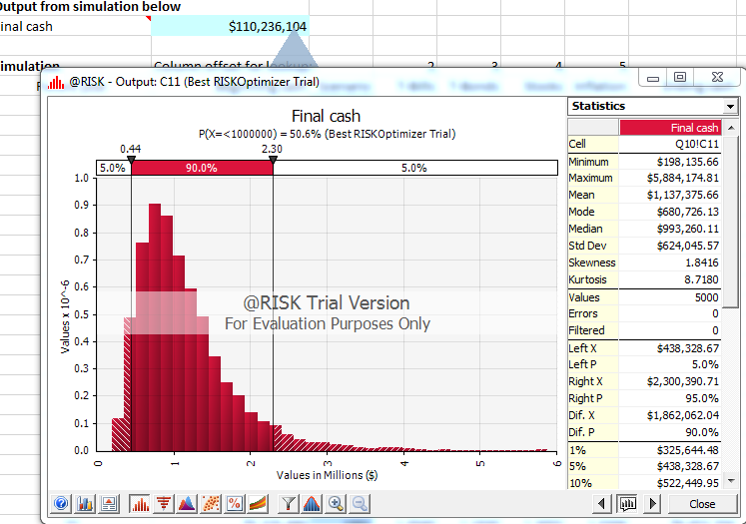
- The price of a certain stock is $40 and its volatility is 30%. The risk-free rate is 5%. The option maturity is 6 months and assume 260 trading days in a year. (10 marks)
Press F9; value updates. Click dice button to see values get updated
To determine the price using simulation, set the number of iterations to 5,000.

- Consider a down-and-out put barrier option with a strike price of $35 and a knock-out barrier of $25. What is the price of this option?

Definition: Option expires worthless, should a specified price level be exceeded.

Payoff:
IF(the smallest stock value falls below the knockout barrier) THEN payoff = 0.
ELSE IF(price on closing > strike price) THEN payoff = stock price on closing – strike price
ELSE (price on closing < strike price) therefore payoff = 0

Excel formula: =IF(MIN(G4:G133)<C6,0, MAX(G134-C5,0))

Answer:
payoff | $ 5.10
Price | $ 4.97

- Using the information above about the stock, what is the price of the option with the knock-in barrier of $25?

Definition: option contract that begins to function as a normal option ("knocks in") only once a certain price level is reached before expiration.

Payoff: =IF(MIN(G4:G133)<C6, MAX(G134-C5,0), 0)

Excel formula: =MAX(G133-C5,0)

Answer:
payoff | $ 0
Price | $ 0
(The stock price never crosses knock in barrier)

- Consider an up-and-out call barrier option with a strike price of $45 and the knock-out barrier of $55. What is the price of this option?

Definition: Barrier option that becomes worthless if the price of the underlying asset increases beyond a specified price level (the "knock out" price). If the up-and-out option stays below the knock out price, then the holder may be entitled to a payout.

Payoff:
IF(the largest stock value hits above the knockout barrier) THEN payoff = 0.
ELSE IF(price on closing > strike price) THEN payoff = stock price on closing – strike price
ELSE (price on closing < strike price) therefore payoff = 0

Excel formula: =IF(MAX(G4:G133)>C6,0, MAX(G133-C5,0))

Answer:
payoff | $ -
Price | $ -
(The stock price never crosses strike price)

- What is the price of an up-and-in barrier call option with a strike price of $45 and the knock-in barrier of $55?

Definition: An option that can only be exercised when the price of the underlying asset reaches a set barrier level.

Payoff:
Since the knock in is > that strike, hitting the knock in already implies that the strike price has been passed therefore that the option will payout.

IF(the largest stock value hits above the knock-in barrier)
THEN payoff = stock price on closing – strike price
ELSE (price on closing < knock-in) therefore payoff = 0

Excel formula: =IF(MAX(G4:G133)>C6, (G133-C5), 0)

Answer:
payoff | $ -
Price | $ -
(The stock price never crosses neither the strike price, nor the knock in barrier)

